PH 250B Week 13, Tab 3 Ungraded quiz - ANSWERS
Topic: Analyzing epidemiologic data - Part 1

Problem 1 (Fall 2017 250B Problem set)
Below is a Kaplan-Meier survival curve showing days to remission among patients treated with an experimental treatment (treatment 1- the blue line) or the standard of care (treatment 2- the red line).
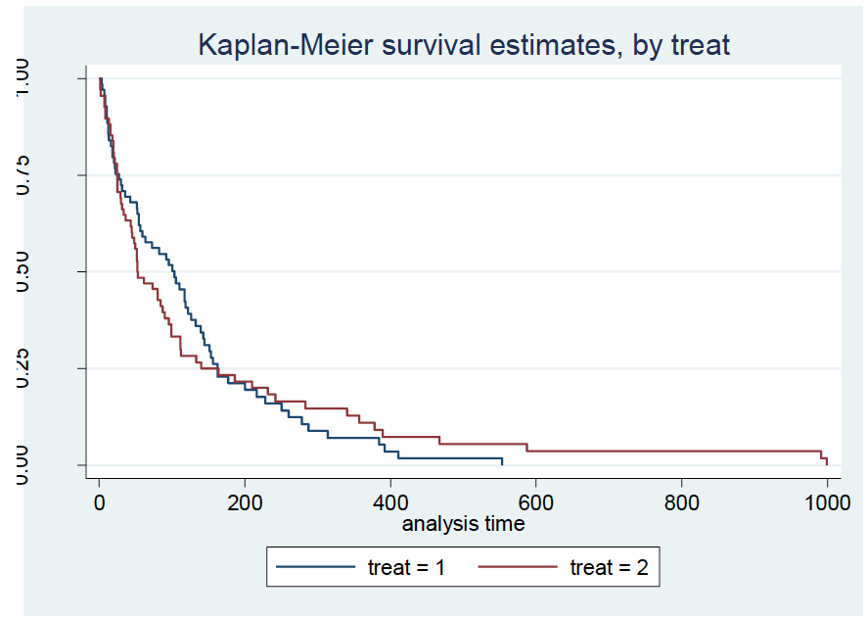
Answer the following questions about these data:
- Your colleague is considering modeling the data from this trial with Cox regression. Do you concur with his analysis plan? Discuss the assumptions of Cox regression to support your answer.
You should disagree with your colleague’s suggestion, because Cox regression relies on the assumption of proportional hazards—that the hazard ratio between the treatment arms is constant over time (the hazard in the exposed is a multiple of the baseline hazard (h1(t)=h0*B)). This is demonstrably false, because the curves cross and the distance between the curves changes over time. Therefore, the assumption is violated and you should not use Cox regression (at least not without accounting for the interaction with time).

- Another colleague is worried about the Cox model for these data because she suspects that the baseline hazard, h0(t), does not fit the appropriate distribution. How do you respond to the colleague?
The Cox model makes no assumption about the form or underlying distribution of the hazard. Therefore, the colleague’s concern is not an issue. The violation of the proportional hazards assumption is the problem here.

- What link function does the Cox proportional hazards model use?

The log link.

Problem 2. (Fall 2017 250B Problem set)

A Cox proportional hazards model examining whether the hazard of dying differs between two groups (Group 1 [no history of CHD] and Group 2 [history of CHD]) yielded the following results:
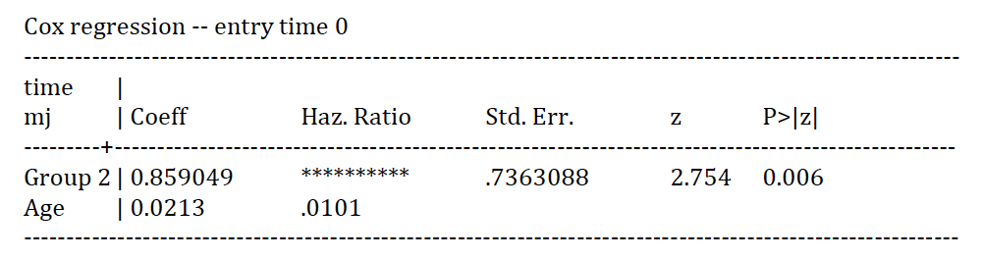
- Calculate and interpret the hazard ratio for Group 2.
HR = e^{0.859} = 2.361
Group 2 (history of CHD) has 2.36 times the hazard of dying of Group 1 (no history of CHD), adjusting for age.
- What type of analysis uses Cox proportional hazards models? What do these types of models “control” for, or take into account, that logistic regression for example doesn’t address?

Survival analysis
These types of models take into account time at risk

Problem 3. (Fall 2017 250B Practice exam problem set)
The Kaplan-Meier (unadjusted survival curves) curves in the graph below depict time-to-death (in days) in a study of lung cancer patients. Describe in 1-2 sentences what the two curves appear to show.
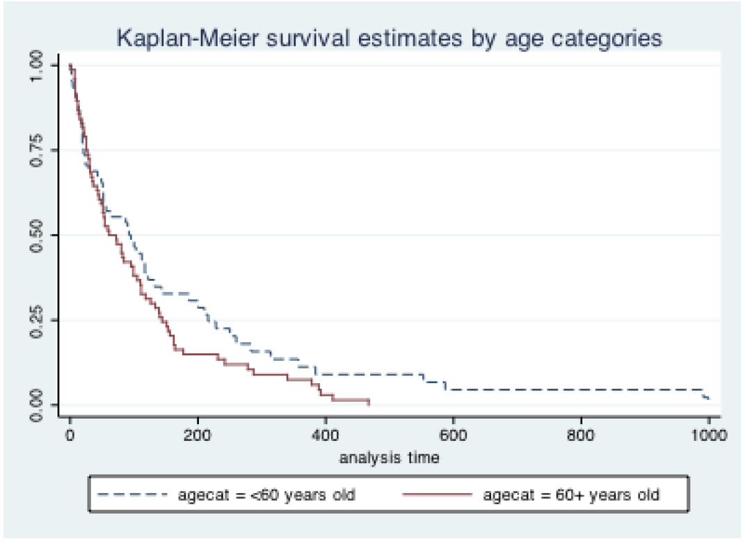
The curves appear to indicate that older cancer patients (those over 60 years old) have shorter average survival time than do younger cancer patients. Although the two curves are largely similar for most of the follow-up period, they diverge at the end and younger patients appear to survive longer than older patients.

Problem 4. (Fall 2017 250B Practice exam problem set)
The investigator conducts a Cox proportional hazards regression to ascertain whether age is associated with the hazard of death in this study population. The output from the regression is below. (Note: The young patients are the comparison/baseline group).

 | Hazard ratio | Std. Error | Z | P>|z| | 95% CI
Age (categorized) | 1.34 | 0.247 | 1.59 | 0.112 | (0.934, 1.92)

- Interpret this Hazard Ratio in words. (1 point)
The hazard of death among older lung cancer patients is 1.34 times the hazard of death among younger lung cancer patients.
- Using all the relevant information presented in the output above, in 1-2 sentences, state what you conclude about the relationship between age and the relative hazard of dying in lung cancer patients.
Although the HR is greater than 1.0, the 95% confidence interval includes the null value of 1.0, and its associated p-value is greater than the conventional level of significance (alpha=0.05). This indicates that the relationship between age and hazard of death among lung cancer patients is not statistically significant (we cannot exclude the role of chance).

Problem 5. (Fall 2017 250B Practice exam problem set)
Obstetricians are testing a treatment to increase conception rates among women diagnosed with infertility. They offer the treatment to a cohort of women and collect data on treatment, time to conception, and baseline age. Their results are shown below. (6 points)

Cox Proportional Hazards Regression Results
N=455, time at risk = 1505 months
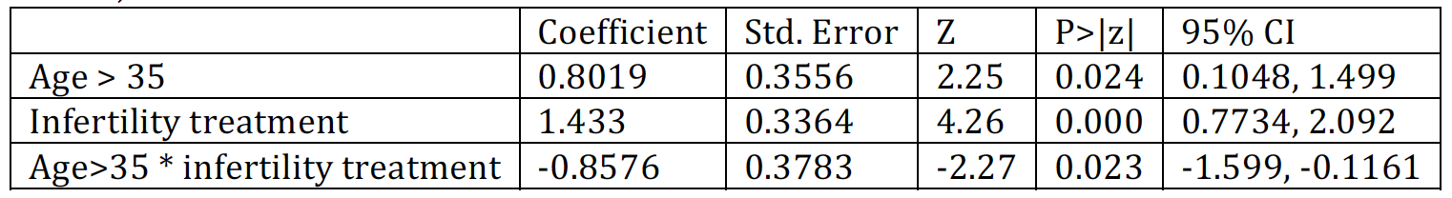
- Calculate a measure of association for the treatment among women over 35.
We can write this model as follows:
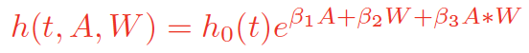

Where h(t) is the hazard of conception, A is infertility treatment, and W is an indicator of being over 35 years. To get the hazard ratio for treatment among women over 35, we divide the estimated hazard rate for women over 35 with treatment (A=1, W=1) by the hazard for women over 35 without treatment (A=0, W=1).
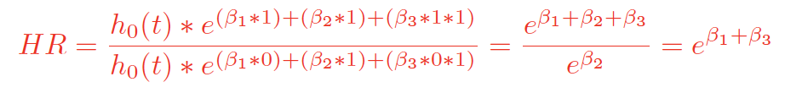

= exp(1.43-0.858)=exp(0.572)=1.77
Grading: 2 points, 1 for exponentiation and 1 for adding the right coefficients, -1 for bad math
- Interpret this result.
Among women over 35, exposure to this treatment was associated with 1.77 times the
‘hazard’ of getting pregnant.
Also ok: rate. Not ok: risk
Grading: 2 points. 1 for among women over 35, 1 for correct understanding that hazard = success (pregnancy) and correct wording.
Many people compared women over 35 to women under 35. This is incorrect given the
prompt in part a (calculate measure of association for the treatment among women over 35). This phrasing is asking for you to compare treated and over 35 to untreated and over 35.

Quite a few people said “adjusting for treatment” in their interpretation. This is nonstandard and probably confusing to most epidemiologists. We typically reserve the word “adjusting” for potential confounders. In this example, age would be the potential
confounder, not treatment. It is also incorrect to say “adjusting for the interaction”.

- Which of the following assumptions must hold for this result to be valid? Select all that apply.
i. The measure of association captures a constant ratio over time for any
combination of the covariates (age >35 and treatment).
ii. Women over 35 are exchangeable with women under 35 prior to receiving
treatment.
iii. Women withdrawing from the study have the same instantaneous potential of the
outcome as remaining women, conditional on age.

Grading: 3 points
Explanation (included here for students’ information, not as part of the required answer)
i. This is the definition of proportional hazards – the hazard ratio is constant between
two levels of exposure / covariates
ii. In this setting, we are estimating a stratum-specific HR, one that is only for women
over 35 and one for women under 35. We do not require exchangeable groups
across levels of this effect modifier. Remember in module 1, we talked about
reporting separate estimates when effect modification is present to reflect the fact
that the groups are hypothesized to be different from each other.
iii. This is the assumption of independent censoring applied to this study.

Problem 6. (Fall 2017 250B Exam 3)

Adapted from Yiu-hong Leung et al. Risk factors for community-associated methicillin-resistant Staphylococcus aureus infection in Hong Kong. Journal of Infection. 2012.

Background: The objective of this study was to identify risk factors for community-associated methicillin-resistant Staphylococcus aureus (CA-MRSA) infection in Hong Kong.
Methods: We carried out a matched case-control study. Cases and controls were pair matched based on sex and age. A total of 127 cases and 127 controls participated in the study.
Results: In 10 pairs, only the case practiced frequent handwashing, and in 26 pairs only the control practiced frequent handwashing. In 50 pairs, both the case and control practiced frequent handwashing.

The investigators want to assess whether the results are changed by additional control for chronic health conditions known to increase the risk of MRSA infection (such as diabetes). If preserving precision is a key priority, what specific analytic approach would you recommend? (1 point)

Conditional logistic regression

Grading:
½ point given for "logistic regression" or "multivariate regression"

