PH 250B Week 15, Tab 1 Ungraded quiz - ANSWERS
Topic: Systematic Review / meta-analysis

Problem 1. (Fall 2017 250B Problem set)
How does a systematic review differ from a meta-analysis?
A systematic review provides a qualitative assessment of epidemiologic evidence, but it does not have to include a quantitative analytic component. A meta-analysis involves the use of statistical techniques to pool the results of studies to derive an aggregate or pooled measure of effect.

Problem 2. (Fall 2017 250B Problem set)
Under what circumstances are meta-analyses problematic?
The primary concern with meta-analysis has to do with the statistical combination of studies with heterogeneous populations and methods. Studies may each be prone to different forms of bias that become difficult to assess or disentangle when pooled into one summary measure. Meta-analysis of observational studies is especially problematic due to variability in implementation and analysis. However, even in randomized trials, it can be difficult to combine measures.

Problem 3. (Fall 2017 250B Problem set)
When doing meta-analyses, either a fixed effects of random effects model can be used. List
one difference between these two models.
Fixed effects models assume that a single common effect underlies every study (i.e., if every study were infinitely large, all would demonstrate the same treatment effect). Also, these models are only generalizable to the populations used in the studies. Random effects models assume that individual studies are estimating different treatment effects. A random effects model increases the standard error of the overall estimate (and therefore the 95% confidence intervals).

Problem 4. (Fall 2017 250B Problem set)
The figure below is from the Nelson et al. (2009) article on mammography and breast
cancer. Answer the following questions based on the plot.
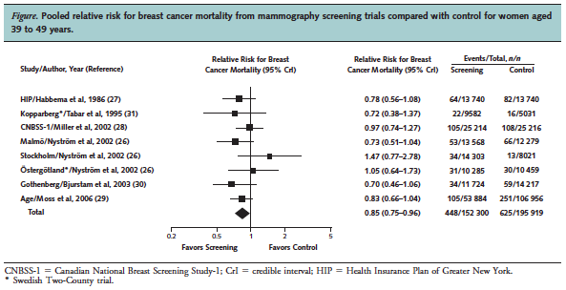

a. What kind of plot is this? What is one purpose of displaying results using this plot?
Forest plot. It is used to visually assess heterogeneity in the measure of association and
confidence intervals across studies and to show the individual and combined estimates of
Effect.

b. What does the diamond on the lowest row indicate? Interpret the corresponding
relative risk.
The diamond presents the combined estimate of the MoA based on the individual studies
listed. Combining results, women assigned to mammography had 0.85 times the risk of
breast cancer mortality compared to women that were not assigned to mammography
(95% CI 0.75-0.96).

c. Assess heterogeneity based on this plot. How would the presence of heterogeneity
affect the preferred analytic approach and the interpretation in part B?
Visually, the plot presents some evidence of heterogeneity (especially the Stockholm and
Ostergotland studies) but not very strong evidence. (This is a subjective conclusion and
open to debate since we are not providing results from statistical tests for heterogeneity. In
the original article, tests for heterogeneity did not suggest significant heterogeneity.)
If heterogeneity were present, we might choose a random effects model instead of a fixed
effects model for analysis. The interpretation of a single combined estimate would then be
somewhat suspect; it would be preferable to explore the sources of heterogeneity and
report summaries for more similar subsets of studies

Problem 5. (Fall 2017 250B Problem set)
The funnel plot below shows the relative risk estimates from studies conducted to
investigate the effectiveness of aspirin in preventing tumors in rats. Answer the following
questions based on the plot.
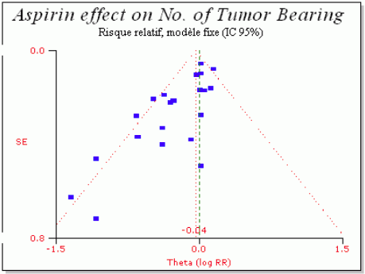
a. Consider the Y-axis. How do studies higher on the plot differ from studies further down?
The authors have used SE for the Y axis but plotted studies with larger SE lower and smaller
SE higher. The bigger the study (which means the lower the SE and higher precision), the
higher it is on the plot.

b. Do you think there is evidence for publication bias based on the plot provided? Why or
why not? Explain in 1-2 sentences.
There is evidence for publication bias. Smaller studies and studies showing a
harmful effect are missing. The absence of publication bias is indicated by a
relatively symmetrical (funnel-like) distribution of studies around the mean
association.

Problem 6. (Fall 2017 250B Practice exam problem set)
The following plot shows the results from a meta-analysis investigating the effect of male circumcision on rates of human papillomavirus infection among men.
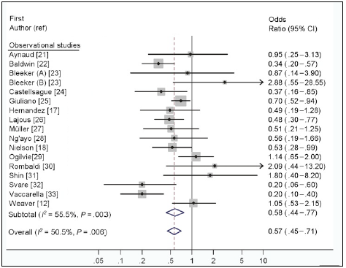

Source: Larke N, Thomas SL, dos Santos Silva I, Weiss HA. Male circumcision and Human Papillomavirus infection in men: A systematic review and meta-analysis. J Infect Dis 2011; 204 (9):1375-1390.

- In the meta-analysis conducted by the authors, do you think the weight of the second study (Baldwin et al.) would be larger or smaller than that of the first study (Aynaud et al.)? Explain your reasoning in 1-2 sentences. (1 point)
The Baldwin study has a larger square around its effect estimate, and it also has a much narrower confidence interval than the first study, indicating that is has a smaller variance and will therefore have a larger weight than the Aynaud study. For full credit, the students should say “larger” and use an explanation that invokes the study’s narrow confidence interval and/or large square. They are not required to mention the variance.

- These investigators used random-effects (RE) analyses to calculate their summary measures of association. What is the main assumption when estimating a random-effects measure of association? Choose the best answer below. (1 point)
i. It assumes that all studies are estimating the same underlying association.
ii. It assumes that if every study in the meta-analysis had >1000 participants, their measures of association would be the same.
iii. It assumes that not all studies in the meta-analysis were conducted in the same population at the same time.
iv. It assumes that the studies in the meta-analysis are estimating different underlying
associations.
Problem 7. (Fall 2017 250B Practice exam problem set)
The following plot summarizes trials testing the effect of streptokinase on cardiac deaths:
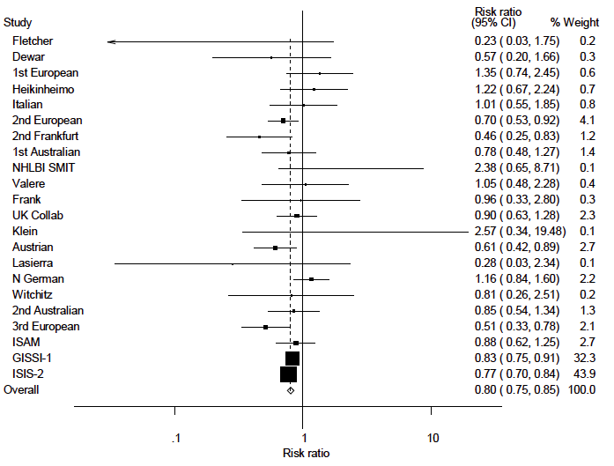
- What is the name of this type of plot? (1 point)
Forest plot
- How many trials demonstrated statistically significant results (p<0.05)? (1 point)
6 trials
- Which trial contributed the most weight to the meta-analysis? (1 point)
ISIS-2
- What is the most important factor that determines how much weight a study receives? (1 point)
Possible answers: variance, sample size, standard error, width of the confidence interval
- Does the overall summary risk ratio imply a protective or harmful effect of streptokinase? (1 point)
Protective

Problem 8. (Fall 2017 250B Practice exam problem set)
Name two strengths and two limitations of meta-analysis. (2 points)
Strengths - possible answers:
- Provides a single pooled summary statistic, something that the other approaches do not do
- The pooled summary statistic has increased precision relative to the individual studies in the meta analysis, because it has a higher “sample size”
- Can assess whether effect estimates differ by characteristics of study or study population
- Can provide context by looking at consistency, strength of association, dose-response relationships across different studies
- It is reproducible
- It is inexpensive

Limitations/challenges - possible answers:
- Time-consuming
- Almost always requires a team
- Limitations of the individual trials they attempt to combine: small sample size, bias, incomplete reporting
- For readers without training in meta-analyses (especially those who may want to use the information to inform clinical or PH practice), they can be hard to read or interpret due to reliance on statistical procedures

[0.5 points for each strength and limitation. Note: only the first two strengths and the first two limitations were scored].

Problem 9. (Fall 2017 250B Practice exam problem set)
Investigators conducted a meta-analysis of studies on breast cancer screening. Assume that this plot was made using the standard conventions for this type of plot described in this course.
- What is the name of the type of plot shown below? (1 point)
Forest plot
No credit for heterogeneity plot
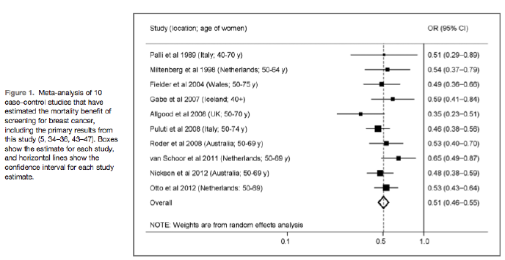
- What is the quantity shown on the x-axis? (1 point)
Odds Ratio (on log scale)
1 point for measure (note that you had to write OR, not solely measure of effect)

- What does the diamond indicate? What does the width of the diamond indicate? (2 points)
The pooled estimate of the OR across studies in the meta-analysis. The width of the
diamond indicates the 95% CI for the pooled OR.

1 point for pooled measured and 1 for correct 95% CI
-.5 for saying the diamond was precision or variance
- If you were to estimate a pooled measure of effect using these data, would you select a fixed-effects or a random effects model to calculate a summary measure of effect? Why? (2 points)
There is not much heterogeneity in this plot. The individual study estimates are clustered quite close to the pooled estimate, and all of the estimates are protective. Fixed effects assume that a single common association underlies every study and envisions the studies as being drawn from a potentially infinitely large set of studies with the same estimate of association. Random effects models allow that individual studies may estimate different associations, thus they are more conservative.

2 points for consistent selection of fixed or random effects model with description of heterogeneity in studies. Fixed effects model is consistent with no heterogeneity, and random effects with significant heterogeneity.
1 point if correct selection but no explanation or reference to the forest plot.

Problem 10. (Fall 2017 250B Practice exam problem set)
Examine the hypothetical funnel plots below. The measure of association in this hypothetical meta-analysis is the odds ratio. Open circles indicate small studies of inadequate quality whose results are biased toward the null effect. Assume that the measure of association is an odds ratio and that the pooled measure is protective.

- Match each funnel plot to the appropriate scenario. (3 points)
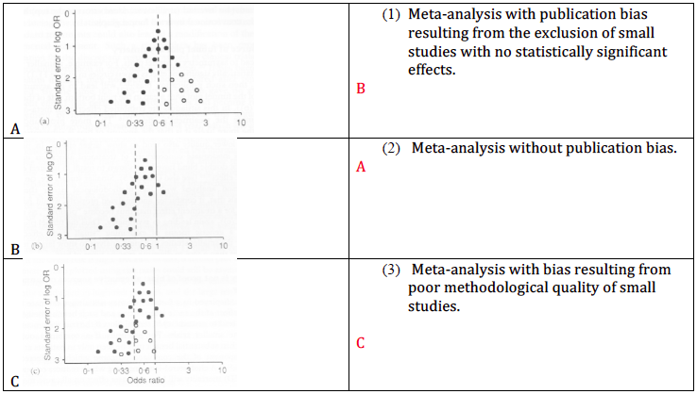

- What happens to the measure of association in graphs b and c? (2 points)
The OR is biased away from the null.

