PH 250B Week 3, Tab 4 Practice Problems
Topic: Measures of Disease

Problem 1. (Fall 2017 250B problem set)

You have received data from two Factories, A and B. You know the number of workers in each age group and the total number of observed deaths at each factory. You do not know who died, so you don’t know the age distribution of the deaths. You also have mortality rates from Factory C. Use the mortality rates from Factory C as the standard to do the following calculations.

- Calculate the expected number of deaths for factories A and B.

Factory A:

Age (yrs) | Population size | Standard (Factory C) Mortality Rate /1,000 | Expected deaths | Observed deaths
20-39 | 3,000 | 3
40-49 | 6,000 | 9
50-59 | 8,000 | 11
Total | 17,000 |  |  | 165

Factory B:

Age (yrs) | Population size | Standard (Factory C) Mortality Rate /1,000 | Expected deaths | Observed deaths
20-39 | 6,000 | 3
40-49 | 6,000 | 9
50-59 | 3,000 | 11
Total | 15,000 |  |  | 113

- Calculate the standardized mortality ratio (SMR) for each factory.

- Give your interpretation of each SMR. Can you compare the SMRs directly?

Problem 2. (Fall 2017 250B Practice Exam problem set)

You are told to more closely examine 2 mines in eastern China which have recently reported especially high rates of CLD. You are instructed to compare their CLD incidence to that of the general Chinese population.

Age group | Chinese pop. CLD cases/ 10,000 person-years | Population of Coal Mine 1 | Observed cases of CLD in Coal Mine 1 |  | Population of Coal Mine 2 | Observed cases of CLD
16-25 | 15 | 100 | N/A |  | 55 | N/A
26-30 | 24 | 220 | N/A |  | 135 | N/A
31-35 | 32 | 315 | N/A |  | 130 | N/A
36-40 | 19 | 110 | N/A |  | 60 | N/A
Total |  |  | 10 |  |  | 12

- Calculate the relevant standardization measure for Coal Mines 1 and 2.

- Interpret these standardization measures.

- One of your coworkers points out that Chinese coal mine workers are, on average, significantly younger than the general population, and that the current generation of young Chinese adults is far more likely than older Chinese adults to be heavy smokers. He suggests that this may account for your findings related to the CLD rates among the miners compared to the general population. If he’s right, would this be an age, period, or cohort effect?

- You therefore decide to calculate the SMRs comparing CLD in your town mines to the overall coal-miner population in China (as opposed to the general Chinese population). The SMRs you derive are 110 (for Coal Mine 1) and 132 (for Coal Mine 2). Why are these SMRs so different from the ones you derived in B?

Problem 3. (Fall 2017 250B Practice Exam problem set)
In general, why do epidemiologists bother using the SMR? [Circle all that apply]
- Sometimes we do not have the necessary data to calculate directly standardized rates
- SMRs are often used in occupational settings where numbers of cases are small and the calculated rates (and their variances) would be unstable.
- SMRs approximate a counterfactual idea
- After standardization, SMRs allow two study populations with different age structures to be compared.

Problem 4. (Fall 2017 250B Practice Exam problem set)
The investigators of a cohort study of women in the United States were curious about how the age-adjusted in-situ breast cancer incidence rates compare for white women and black women in their study. Below you will find the total study population stratified by age, as well as the incidence per 100,000 person-years for the study population, stratified by age and race.

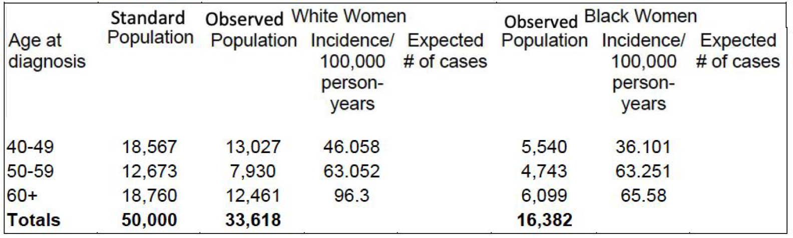
- The investigators are interested in comparing incidence of in-situ breast cancer for white women and for black women in their study. Calculate the age-adjusted incidence rate (per 100,000 person-years) for black women and for white women using the overall study population as the standard population.

- What type of standardization did you just conduct (direct or indirect standardization)?

- What is the counterfactual question you were asking by calculating these standardized measures?

