
PHW250B: Epidemiologic Methods II
Course Syllabus (Fall 2025)
Table of Contents
Course Description 2
Course Goals 2
Competencies developed in the course 2
Instructor Information 4
Course Format 4
Live Sessions (Optional) 6
Required Course Materials 7
Course Schedule 8
Course Deadlines 18
Course Grading 19
Course Requirements 19
Completion of Course Materials 19
Participation in Course Activities and Discussions 20
Exams 20
Policies 20
Due Dates 20
Artificial Intelligence Systems 20
Late Assignments 21
SPH Course Policies 21

Course Description
This 4 Unit introductory graduate course presents the principles and methods of epidemiology, including descriptive and analytic approaches to assessing the distributions of health, disease, and injury in populations and factors that influence those distributions. The emphasis is on developing an understanding of concepts, rather than quantitative methods, although basic calculations are involved. An introductory epidemiology course such as PHW250, PH150A, PH250A is a prerequisite for this course. Students who have not taken a prior introductory epidemiology course will need to put a substantial amount of extra time into studying each week in order to succeed in this course. This course shares the same content and learning objectives with the first half of its on-campus equivalent, PH250B. Please note that the details in this syllabus are subject to change. If you have any questions about the course, please contact the instructors for the most up-to-date information.

Course Goals
Upon successful completion of the course, students will have a solid understanding of and ability to complete the following:

− Apply causal frameworks to the assessment of causality in associations.
− Calculate and interpret measures of disease and association.
− Identify appropriate applications of measures of disease and association.
− Define the major study designs, including their strengths and weaknesses, and demonstrate their appropriate applications.
− Explain sources of bias in studies.
− Identify design and analysis approaches to reduce bias in studies.
− Assess the extent of bias in studies and calculate bias-corrected measures.
− Define, calculate, and interpret effect measure modification on different scales.
− Explain the purposes, mechanics, and limitations of matching in study designs.
− Identify and apply appropriate analytic techniques when matching is used in study designs.
− Identify and apply appropriate analytic techniques for study questions, and interpret coefficients
and other quantities estimated using these techniques.
− Define, calculate, and interpret power, sample size, confidence intervals, and p-values.
− State the purposes of screening, and calculate and interpret screening measures.
− Explain the purposes and process of systematic review and meta-analysis.

Competencies developed in the course
Upon successful completion of the course, students will have achieved the following competencies:

Competency | Applicable degree
Identify the principles and limitations of public health screening programs | 1-year MPH
Describe a public health problem in terms of magnitude, person, time, and place | 1-year MPH
Apply the basic terminology and definitions of epidemiology | 1-year MPH
Calculate basic epidemiology measures | 1-year MPH
Communicate epidemiologic information to lay and professional audiences | 1-year MPH
Draw appropriate inferences from epidemiologic data | 1-year MPH
Evaluate the strengths and limitations of epidemiologic reports | 1-year MPH
Demonstrate methodological expertise in selecting and formulating a research hypothesis, study design, obtaining or collecting epidemiologic data, data analysis, and interpreting/presenting in written and oral forms. | 2-year MPH
Interpret study findings, including critically identifying strengths and limitations of individual studies | 2-year MPH
Describe the nature of disease distributions in populations and the factors that influence these distributions | Master of science
Explain and discuss the strengths and weaknesses of the key study designs used in epidemiological research, i.e., cross-sectional, ecological, case-control, cohort, and experimental (field trials) designs, and the analytic approaches and techniques applicable to each design | Master of science
Analyze and address a given epidemiologic question, select the most appropriate study design and develop a detailed study proposal | Master of science
Critically evaluate the research questions, methods, analyses, and findings of epidemiological research reports and presentations | Master of science
Independently design and implement studies addressing epidemiologic problems | PhD

Instructor Information
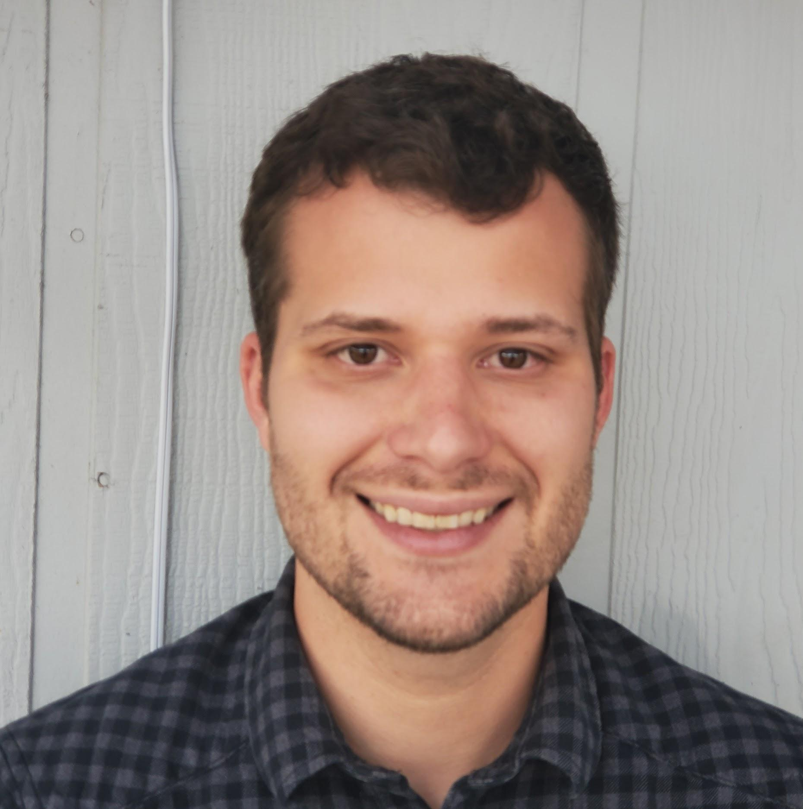 | Andrew Mertens, PhD MS MA  Instructor  amertens@berkeley.edu*
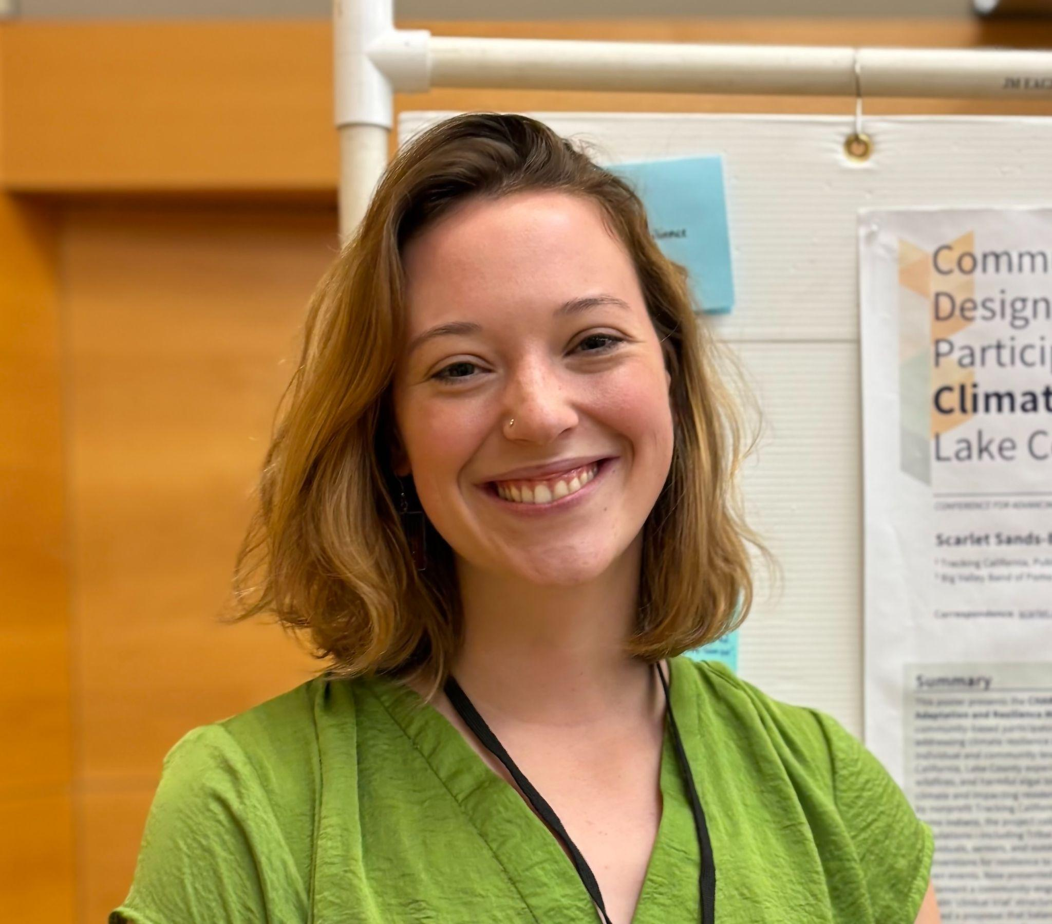 | Scarlet Bliss  Course facilitator  phw250bgsi@berkeley.edu*
 | Michelle Ruiz, MA.ed  Instructional designer  m.ruiz@berkeley.edu
*Please send personal questions to course facilitators or instructors via email, but post on Ed Discussions for all other course-related questions. For both Ed Discussions and E-mail, we will respond within 24 hours but may not be immediately available, so don’t wait to post questions until right before assignments are due.

Course Format
This is a 16-week course, and course materials are organized by week. On the bCourses website, we will organize material specific to each week of the course. Within each week’s page, there will be tabs with instructions for each topic covered that week. Each tab will include your assigned readings, video lectures, and practice problems to assess your knowledge of key concepts. The learning activities in this course include:

Asynchronous activities
- Refresher videos (optional). As mentioned above, PHW250, PH250A, or PH150A (or an equivalent introductory epidemiology course) are prerequisites for this course. We have included videos from PHW250 as optional refresher material at the beginning of each week that can be used to review concepts from introductory epidemiology.
- Readings. We have assigned readings from the two textbooks as well as peer-reviewed articles. Readings are often more technical than lecture materials and are intended to serve as reference materials.
- Video lectures. These videos cover core concepts for the course and align with assigned readings. Videos typically cover several learning objectives for a given topic.
- Practice problems (optional). We provide practice problem sets alongside most lecture videos. We strongly encourage students to complete these problems immediately after watching videos to cement their understanding. While these practice problems are not graded, they are core material for the course and closely resemble the types of questions included in the exams. We will provide solutions to these problems so students can assess their progress on their own.
- Podcast episodes (optional). In these podcast episodes, we interview Epidemiologists on studies they have conducted. These interviews provide students with an opportunity to learn about why certain studies were conducted, why a particular design was used, what the researcher’s main concerns were about the study, and how the study’s findings influenced policy and public health practice.
- Ed Discussions QA (optional). You may post questions you have about epidemiology concepts, general course questions, assignments, and practice problems on the Ed Discussion forum.
Synchronous activities
- Journal club Sessions (optional). Journal club sessions are held via Zoom. They are an opportunity to ask instructors and other students open-ended questions about a case study article and to get help with journal club assignments. Because these sessions will be held at scheduled times, they are optional, but we strongly encourage students to attend the sessions, and attendance will give extra credit.
- Discussion sessions (optional):
  - Dr. Mertens will host open discussion sessions from 5:10-6pm PT on Wednesdays of weeks without a journal club.
  - Scarlet Bliss will host open discussion sessions on Mondays from 5:10-6pm PT.
  - One-on-one office hours are available upon request with Dr. Mertens or Scarlet Bliss. Please schedule appointments by email at phw250bgsi@berkeley.edu.
- Proctored Exams. There will be three proctored exams throughout the course. An exam is "proctored" when it is overseen by a proctor who ensures the identity of the exam taker and the integrity of the test-taking environment. As an online student, proctoring entails joining a Zoom session, showing a government ID or student ID, and then taking the exam while being on camera until you complete the exam. We will offer two distinct online proctoring options to accommodate different needs and preferences. If you have any questions about the proctoring options, please reach out to our course instructional designer, Michelle Ruiz (m.ruiz@berkeley.edu).
  - Live proctoring: The live proctoring option will take place on a Sunday via Zoom, the schedule is listed below. In the proctoring session, you will have the opportunity to receive live help and communicate directly with the proctor (who is our course instructional designer) while taking the exam.
    - Proctored Exam 1 Week 5, Sunday, September 28, 12 pm–3 pm PT: Includes material through Week 4
    - Proctored Exam 2 Week 10, Sunday, November 2, 12 pm–3 pm PT: Includes material through Week 9
    - Proctored Exam 3 Final Week, Sunday, December 7, 12 pm–3 pm PT: Includes all course material
  - Self-proctoring: This option is available for students who are unable to attend the live proctoring session. Instructions for recording your exam can be found here. While this option does not offer live assistance, it allows you to choose the most convenient time for taking the exam.
Assessments
- Journal club assignments. These assignments primarily ask questions about case studies. You may ask for help answering questions in the journal club assignments during discussion sessions and during journal club sessions. You may also work with each other, but you must submit your assignment individually. If you work together, please indicate whether you worked with other students in the class (and list their names). We will post detailed solutions to each journal club assignment after all assignments are submitted. These assignments are graded on completion not accuracy, so it is your responsibility to review the solutions to ensure that you correctly answered the question.
- Exams. There will be three exams in this course. Each exam covers the cumulative material to that point in the course.

Live Sessions (Optional)
We will hold the following four optional live sessions via Zoom each week.

- Course facilitator discussion sessions: Mondays 5:10-6 PM: (Scarlet)
- Thursdays: 6:10 to 7 pm or 7:30 pm (Tuesdays some weeks due to holidays/instructor travel): Alternating Journal Club + instructor discussion sessions. (Andrew Mertens). 1 hour during discussion sections, 1.5 hours during journal clubs.

During the open discussion sessions, the instructional team will be available for any course content or logistic questions, and will also have practice problems to work through if students do not come with questions. Journal club sessions will be used to review the journal club readings and to work on the assignments in small groups with instructor support. Check bCourses for the date and Zoom link for each session. Journal clubs and discussion sessions/office hours will be recorded for other students who cannot join at the scheduled times. If no students are attending a synchronous session after the first 10 minutes, the session will end. Please notify the course facilitator or instructor beforehand if you plan to attend late due to scheduling conflicts so they know to stay on the Zoom line to take your questions.

Required Course Materials
Microphone/headset for your computer
Recommended textbooks:
Rothman, K.J., S. Greenland, and T.L. Lash. Modern Epidemiology. 3rd ed. 2008, Philadelphia, PA: Lippincott Williams & Wilkins. (ME3 in the reading list).
Szklo M, Nieto JF. Epidemiology: Beyond the Basics. 4th ed. 2019, Sudbury, MA: Jones and Bartlett.
In past iterations of this course, we have required the purchase of these two textbooks. We highly recommend purchasing them, especially if you are focusing on epidemiology in your graduate studies. Modern Epidemiology in particular is a useful reference as it is denser and more encyclopedic than Epidemiology: Beyond the Basics. This course can be completed without purchasing both textbooks, as many of the chapters have been scanned and included in weekly readers. Scans of the textbooks are available as well for online borrowing via UC BEARS (UCB Electronic and Accessible Reserves System). The loan period is 2 hours, though your loan can be renewed if another student hasn't checked it out after your loan period expires. You'll need to use your CalNet authentication to check out either book. Links to the textbooks are below. Prior to borrowing, please read additional information and instructions on using this resource here.
Modern Epidemiology 4th ed. (Rothman)
Epidemiology: Beyond the Basics 4th ed. (Szklo)
Note there is a limit to the number of students who can borrow the scanned textbooks at once, so purchasing your own copy will be more convenient.

Other readings:
Other readings include selected chapters from other textbooks and journal articles (see the reading list under Course Schedule below). Any required readings that are not in the two recommended textbooks will be posted on bCourses.
Videos and other resources are found on weekly course pages. A weekly course reader in PDF format which includes video transcripts and course readings will also be available on the course site for you to download.
During this course, you will be provided with links to PDF files of articles and other materials from the UC Berkeley Library Collection. Please make sure you understand and follow the University of California Library Conditions of Use.

Gradescope
We will be using Gradescope to manage the grading of journal club assignments, and exams will be taken in Gradescope. You will need to enroll in our course, via the link that will be sent to you by the instructors. Once enrolled, you can access gradescope either through its own webpage (www.gradescope.com) or via the individual assignments/assessments through bCourses. Once graded, you will be able to view the exact rubrics used, and submit any necessary requests for specific questions to be regraded (“regrade requests”). Regrade requests must be made within 48 hours of the grading release to be considered.

Course Schedule

Week 1: Course orientation August 24th- August 31st
Topic | Readings
Course overview | None, review introductory refresher videos as needed

Week 2: Causality September 1st-7th
Topic | Readings
Scope and history of Epidemiology | ME3, Chapter 1 (or ME4 Chapter 1)
Estimating causal effects | ME3, Chapter 2 (or ME4 Chapter 2)  Hernan “A definition of causal effect for epidemiological research” J Epidemiol Community Health 2004; 58:265–271
Directed acyclic graphs | ME3, Chapter 12 (or ME4 Chapter 3)  Greenland & Brumback. An overview of relations among causal modeling methods. International Journal of Epidemiology 2002;31:1030–1037  Pearl et al. Causal Inference in Statistics: A Primer. Wiley 2016. Section 1.4, 1.5.

Week 3: Measures of disease September 8th-14th
Topic | Readings
Age, period, and cohort effects | Szklo & Nieto Chapter 1 (Section 1.2)
Calculating incidence | Szklo & Nieto Chapter 2  ME3 Chapter 3 (or ME4 Chapter 4)  Supplementary readings:  Kleinbaum Chapter 6  Morgenstern et al. Measures of Disease Incidence Used in Epidemiologic Research. International Journal of Epidemiology 1980. 9(1):97-104.
Relationships between measures of disease | Szklo & Nieto Chapter 2  Supplementary reading:  Elandt-Johnson. Definition of Rates: Some remarks on their use and misuse. American Journal of Epidemiology 1975. 102(4):267-271.
Indirect standardization | Szklo & Nieto Chapter 7 Section 7.3.1-7.3.2
Journal Club 1 | Arnold et al. Acute Illness Among Surfers After Exposure to Seawater in Dry- and Wet-Weather Conditions. American Journal of Epidemiology 2017. 186(7):866-875.

Week 4: Measures of association September 15th-21st
Topic | Readings
Review of measures of association | ME3 Chapter 4 (or ME4 Chapter 5)  Szklo & Nieto Chapter 3
Appropriate measures of association for case-control studies | Szklo & Nieto Chapter 3, Section 3.4  Langholz. Case-Control Studies = Odds Ratios Blame the Retrospective Model. Epidemiology. 21(1)10-12.
Population attributable fractions and related measures of association | ME3 Chapter 4, pages 62-67 (or ME4 Chapter 5, pages 93-97)  Rockhill et al. Use and Misuse of Population Attributable Fractions. Am J Public Health 1998; 88(1).
The hazards of hazard ratios | Hernan. The Hazards of Hazard Ratios. Epidemiology. 21(1)13-15.  Supplementary reading:  Manson et al. Estrogen plus Progestin and the Risk of Coronary Heart Disease. N Engl J Med 2003;349:523-34.
Causal perspective on measures of association | ME3 Chapter 4, page 59-62 (or ME4, pages 87-90)  Supplementary reading:  Maldonado & Greenland. Estimating causal effects. International Journal of Epidemiology 2002;31:422–429  Poole. On the Origin of Risk Relativism. Epidemiology. 21(1)3-9.

Week 5: Cohort studies and Exam 1 September 22nd-28th
Topic | Readings
Cohort studies | ME3 Chapter 6-7 (or ME4 Chapter 6, pages 104-115 and Chapter 7)  Grimes & Schulz. Cohort studies: marching towards outcomes. Lancet 2002; 359: 341–45.  Samet & Muñoz. Evolution of the Cohort Study. Epidemiologic Reviews. 1998. 20(1)1-14.
Evaluating and reporting cohort studies | STROBE Checklist for Cohort Studies  Supplementary reading:  von Elm et al. The Strengthening the Reporting of Observational Studies in Epidemiology (STROBE) Statement: Guidelines for Reporting Observational Studies. 2007; 4(10):e296.  Vandenbrouke et al. Strengthening the Reporting of Observational Studies in Epidemiology (STROBE): Explanation and Elaboration 2007; 4(10):e297.
Case study: The Surfer Health Study | Arnold et al. Acute Illness Among Surfers After Exposure to Seawater in Dry- and Wet-Weather Conditions. American Journal of Epidemiology 2017; 186(7):866–875.
Journal Club 2 | Arnold et al. Acute Illness Among Surfers After Exposure to Seawater in Dry- and Wet-Weather Conditions. American Journal of Epidemiology 2017. 186(7):866-875.  Manson et al. Estrogen plus Progestin and the Risk of Coronary Heart Disease. N Engl J Med 2003;349:523-34.
Exam 1

Week 6: Trials September 29th-October 5th
Topic | Readings
Types of randomized trials  Equivalence trials  Cluster-randomized trials | Jadad, Chapters 1-3.  Stolberg HO, Norman G, Trop I. Randomized controlled trials. AJR. 2004;183:1539-44.
Evaluating and reporting randomized trials | Moher D, Schulz KF, Altman DG. The CONSORT statement: revised recommendations for improving the quality of reports of parallel-group randomised trials. Lancet. 2001;357(9263):1191-4.  CONSORT Checklist 2010.  Supplementary reading:  Schünemann et al. Handbook for grading the quality of evidence and the strength of recommendations using the GRADE approach. 2013. http://gdt.guidelinedevelopment.org/app/handbook/handbook.html  Leung et al. Impact of patient education on influenza vaccine uptake among community-dwelling elderly: a randomized controlled trial. Health Education Research 2017;32(5):455–464.
Case studies | Luby et al. Effects of water quality, sanitation, handwashing and nutritional interventions on diarrhoea and child growth in rural Bangladesh: A cluster randomized trial. (2018) Lancet Global Health 6(3): e302–e315. DOI:10.1016/S2214-109X(17)30490-4 (2018).  Null et al. Effects of water quality, sanitation, handwashing, and nutritional interventions on diarrhoea and child growth in rural Kenya: a cluster-randomised controlled trial. (2018) Lancet Global Health 6(3): e316–e329. DOI:10.1016/ S2214-109X(18)30005-6

Week 7: Case-control studies October 6th-12th
Topic | Readings
Case-control study designs | ME3 Chapter 8 (or ME4 Chapter 8)  Szklo & Nieto Section 1.4.2  Wacholder et al. Selection of controls in case-control studies: principles. American Journal of Epidemiology. 1992. 135(9)1019-1028.  Wacholder et al. Selection of controls in case-control studies: types of controls. American Journal of Epidemiology. 1992. 135(9)1029-1041.  Wacholder et al. Selection of controls in case-control studies: design options. American Journal of Epidemiology. 1992. 135(9)1042-1050.  Supplementary reading:  Rodrigues & Kirkwood. Case-Control Designs in the Study of Common Diseases: Updates on the Demise of the Rare Disease Assumption and the Choice of Sampling Scheme for Controls. 1990. International Journal of Epidemiology. 19(1)205-213.
Evaluating and reporting case-control studies | STROBE Checklist for Case-Control Studies
Case studies | Reingold et al. Risk Factors for Menstrual Toxic Shock Syndrome: Results of a Multistate Case-Control Study. 1989; 11(1):S35-S42.
Journal Club 3 | Null et al. Effects of water quality, sanitation, handwashing, and nutritional interventions on diarrhoea and child growth in rural Kenya: a cluster-randomised controlled trial.Lancet Global Health 2018. 6(3): e316–e329.  Reingold et al. Risk Factors for Menstrual Toxic Shock Syndrome: Results of a Multistate Case-Control Study. 1989; 11(1):S35-S42.  Optional: Luby et al. Effects of water quality, sanitation, handwashing and nutritional interventions on diarrhoea and child growth in rural Bangladesh: A cluster randomized trial. Lancet Global Health 2018. 6(3): e302–e315.

Week 8: Cross-sectional and ecological studies October 13th-19th
Topic | Readings
Cross-sectional studies | Supplemental reading:  Hudson et al. The Cross-Sectional Cohort Study: An Underutilized Design. Epidemiology 2005;16: 355–359.
Evaluating and reporting cross-sectional studies | STROBE Checklist for Cross-sectional Studies
Cross-sectional case studies | Burnham et al. Mortality after the 2003 invasion of Iraq: a cross-sectional cluster sample survey. Lancet 2006; 368: 1421–28.
Ecological studies | ME3 Chapter 25 or ME4 Chapter 30
Ecological case studies | Ahern et al. Acute changes in community violence and increases in hospital visits and deaths from stress-responsive diseases. Epidemiology. 2018; DOI: 10.1097/EDE.0000000000000879.

Week 9: Bias and exam 2 October 20th-22nd
Topic | Readings
Information bias, selection bias, and generalizability | ME3, Chapter 9 pages 134-147 (or ME4 Chapter 13 pages 286-299 and Chapter 14 pages 314-321)  Szklo & Nieto Chapter 4  Grimes & Schulz. Bias and causal associations in observational research. Lancet 2002; 359: 248–52.  Supplementary reading  Hernan & Cole. Invited Commentary: Causal Diagrams and Measurement Bias. Am J Epidemiol 2009; 170(8):959-962.
Diagnosing bias using DAGs

Week 10: Confounding October 23rd-November 2nd
Topic | Readings
Confounding | ME3, Chapter 9 pages 128-134 (or ME4 Chapter 12)  Szklo & Nieto Chapter 5
Using DAGs to identify confounding | Pearl et al. Causal Inference in Statistics: A Primer. Wiley 2016. Sections 2.4-2.5, 3.3. Accessible online: https://ebookcentral.proquest.com/lib/berkeley-ebooks/detail.action?docID=4383483  Supplementary reading  Greenland et al. Causal diagrams for epidemiologic research. Epidemiology 1999. 10(1)37-48.
Negative controls | Supplementary reading  Lipsitch M, Tchetgen ET, Cohen T. Negative controls: a tool for detecting confounding and bias in observational studies. Epidemiology. 2010 May;21(3):383–8.
Journal Club 4 | Arnold et al. Acute Illness Among Surfers After Exposure to Seawater in Dry- and Wet-Weather Conditions. American Journal of Epidemiology 2017. 186(7):866-875.  Arnold et al. Implications of WASH Benefits trials for water and sanitation – Authors' reply. 2018. 6(6):PE616-7.  Reingold et al. Risk Factors for Menstrual Toxic Shock Syndrome: Results of a Multistate Case-Control Study. 1989; 11(1):S35-S42.
Exam 2

Week 11: Effect modification November 3rd - 9th
Topic | Readings
Biologic interaction, statistical interaction, effect modification | ME3, Chapter 5 (or ME4 Chapter 26, pages 619-643)  Szklo & Nieto, Chapter 6 & Appendix C  Jewell. Statistics for Epidemiology. Chapter 10.
Causal perspective on effect modification
Additive scale measures of interaction | Supplementary Reading  Vanderweele & Knol. Tutorial on Interaction. Epidemiol Methods 2014 3(1):33-72.

Week 12: Matching and screening November 10th-16th
Topic | Readings
Matched designs | ME3, Chapter 11 (or ME4 Chapter 6, pages 121-135)  ME3, Chapter 16, pages 283-288 (or ME4 Chapter 18, pages 436-441)  Case study: Arnold et al. Causal inference methods to study nonrandomized, preexisting development interventions. PNAS December 28, 2010. 107 (52) 22605-22610; https://doi.org/10.1073/pnas.1008944107  Supplementary Reading  Costanza. Matching. Prev Med 1995 24:425-433.
Overmatching and matched analysis
Screening | ME3, Chapter 32  Szklo & Nieto, Section 8.4  Grimes and Schulz. Uses and abuses of screening tests. Lancet 2002; 359: 881–84.
Journal Club 5 | Luby et al. Effects of water quality, sanitation, handwashing and nutritional interventions on diarrhoea and child growth in rural Bangladesh: A cluster randomized trial. Lancet Global Health 2018. 6(3): e302–e315.  Reingold et al. Risk Factors for Menstrual Toxic Shock Syndrome: Results of a Multistate Case-Control Study. 1989; 11(1):S35-S42.

Week 13: Analyzing epidemiologic data - Part 1 November 17th-23rd
Topic | Readings
Univariable and bivariable analyses | Szklo Chapter 7, Section 7.1-7.3
Multivariable linear, log-linear and logistic regression models | Szklo Chapter 7, Section 7.4.1 - 7.4.3, 7.4.5  ME3, Chapter 20, Pages 392-395 (or ME4 pages 482-485)
Survival and matched case control analyses | Szklo Chapter 7, Section 7.4.4, 7.4.6

Week 14: Analyzing epidemiologic data - Part 2, Statistical inference, sample size and power November 24th-30th
Topic | Readings
Modern epidemiologic analysis approaches | Szklo Chapter 7 Section 7.5.2  Supplementary Reading  Snowden et al. Implementation of G-Computation on a Simulated Data Set: Demonstration of a Causal Inference Technique. Am J Epidemiol 2011; 173(7):731-738.  Austin. An Introduction to Propensity Score Methods for Reducing the Effects of Confounding in Observational Studies. Multivariate Behavioral Research 2011; 46:3, 399-424  Schuler and Rose. Targeted Maximum Likelihood Estimation for Causal Inference in Observational Studies. Am J Epidemiol 2016; 185(1):65-73.
Statistical inference | ME3, Chapter 10 (or ME4 Chapter 15)  Note: sections on likelihood intervals and Bayesian intervals can be skipped if not of interest
Sample size and power | Merrifield & Smith. Sample size calculations for the design of health studies: a review of key concepts for non-statisticians. NSW Public Health Bulletin 2012;23(7–8).  Supplementary Readings  Selvin S. Statistical Analysis of Epidemiologic Data. Chapter 3: Statistical power and sample-size calculations. Oxford University Press, 1996.  Whitley E, Ball J. Statistics review 4: Sample size calculations. Critical Care. 2002;6:335-341
Journal Club 6 | Luby et al. Effects of water quality, sanitation, handwashing and nutritional interventions on diarrhoea and child growth in rural Bangladesh: A cluster randomized trial. Lancet Global Health 2018. 6(3): e302–e315.  Arnold et al. Acute Illness Among Surfers After Exposure to Seawater in Dry- and Wet-Weather Conditions. American Journal of Epidemiology 2017. 186(7):866-875.

Week 15: Systematic review / meta-analysis December 1st-7th
Topic | Readings
Systematic reviews & Meta-Analyses | ME3, Chapter 33 (chapter dropped in ME4)  Egger. Where now for meta-analysis? International Journal of Epidemiology 2002;31:1–5.  Hedges & Vevea. Fixed- and Random-Effects Models in Meta-Analysis. Psychological Methods. 1998;3(4):486-504.
Population intervention effects | Westreich et al. Causal Impact: Epidemiological Approaches for a Public Health of Consequence. American Journal of Public Health. 2016;106(6):1011-1012.  Supplementary reading  Ahern et al. Predicting the Population Health Impacts of Community Interventions: The Case of Alcohol Outlets and Binge Drinking. Am J Public Health. 2016;106(11):1938-1943.
Spillover effects | Benjamin-Chung J et al. 2018. Spillover effects in epidemiology: parameters, study designs and methodological considerations. Int J Epidemiol 47(1):332-347.
Transparency and reproducibility | Ioannidis. Why Most Published Research Findings Are False. PLOS Med 2(8)0696-0701.
Week 16: Exam 3 December 8th-14th
Topic | Readings/review

Careers in epidemiology optional discussion | Optional, during instructor session
Exam 3 | Exam covering material from the entire course

Course Deadlines
Assignments must be completed in bCourses before 11:59 pm Pacific Time each Monday unless otherwise noted.
 | Week 1  8/25–8/31 | Week 2 9/1-7 | Week 3 9/8-14 | Week 4 9/15-21 | Week 5 9/22-28 | Week 6 9/29-10/5 | Week 7 10/6-12 | Week 8 10/13-19
Journal club |  |  | JC session 1 |  | JC session 2 |  | JC session 3
Journal club assignment |  |  |  |  | JC 1 due 9/22  Monday of Week 5 |  | JC 2 due 10/06  Monday of Week 7
Exams |  |  |  |  | Proctored Exam 1

 | Week 9 10/20-26 | Week 10 10/27-11/2 | Week 11 11/3-9 | Week 12 11/10-16 | Week 13 11/17-23 | Week 14  11/24-11/30 | Week 15  12/1-7 | Final  12/8-14
Journal club |  | JC session 4 |  | JC session 5 |  | JC session 6 |  | -
Journal club assignments | JC 3 due 10/21  Monday of Week 9 |  |  | JC 4 due 11/10  Monday of Week 12 |  | JC 5 due 11/24  Monday of Week 14 |  | JC 6 due 12/8  Monday of final week
Exams |  | Proctored  Exam 2 |  |  |  |  |  | Proctored  Exam 3

Course Grading
Journal club assignments 25% (6 assignments,4.167 % each) Graded based on completion
Exams (3 total) 25% each (75% total)
Journal club attendance+participation 0.25% extra credit for each session attended
Course evaluation 1% added to the grade of the first and third exams for all students if there is a >70% response rate (for mid-course and final evaluations, respectively)

Students earning points in the following overall percentage ranges will earn a grade at least as high as:
A+/A/A-: 90-100%
B+/B/B-: 80-89%
C+/C/C-: 70-79%
D+/D/D-: 60-69%
F: <60%
Grades are required by the University and most of you will use them appropriately as a motivational tool. The focus of this course is on what you learn, not on your grade. Nobody (other than yourself) in three months or three years will or should care what your grade in an epidemiology course was; they will and should care about how well you are trained and what you have accomplished subsequent to the course using your epidemiologic skills. Focus on maximizing your methodological training while you are here and the grading will not be an issue. If you have concerns about your performance in the course, please feel free to reach out to course facilitators or instructors to discuss how to improve your experience/learning in the course.
S/U (satisfactory/unsatisfactory) grading is permitted for this course. There are no differences in the course requirements for students who choose this option. Students who choose this option will be graded in the same manner as their classmates and the graders will not know the students’ grading option—S will appear on transcripts for grades of B- or above.

Course Requirements

Completion of Course Materials
Students are expected to complete all exams and journal club assignments. We view ungraded activities (readings, videos, practice problems, etc.) as optional and recommend that students use the materials that are most effective for their style of learning.

Participation in Course Activities and Discussions
There are three main types of interaction in this course: journal club, course facilitator sessions, Ed Discussions, and discussion sessions.
Journal Club: As described above
Question and Answer on Ed Discussion Forum: We also encourage students to post and answer questions about course material in the Ed Discussion Forum in bCourses. We will respond within 24 hours but may not be immediately available, so don’t wait to post questions until right before assignments are due.
Discussion sessions: Students may also discuss course topics and ask questions of course facilitators during their regularly scheduled discussion sessions or schedule office hours with instructors and course facilitators as needed.

Exams
All exams are taken individually and are remotely proctored. Each week of an exam will have several windows to take the exam in a remotely proctored environment to accommodate different time zones and student schedules. The exams in this course are closed-notes and cover the cumulative content to that point in the course. Details about the length of the exam and the materials you will be allowed to use during the exam will be posted on the course site.

Policies

Due Dates
Journal Club Assignments must be completed in bCourses/Gradescope before 11:59 pm Pacific Time each Monday unless otherwise noted. The exams must be completed during specific proctored time periods (multiple offered for Please check the online course calendar for details.

Artificial Intelligence Systems
We recognize the growing importance and utility of Artificial Intelligence (AI) language models, such as ChatGPT. However, to maintain academic integrity and ensure the effectiveness of the learning process, the following policy has been established regarding the use of these tools:
Permissible Uses:
Students are permitted to use AI language models for study purposes, such as understanding course material, clarifying concepts, or preparing for exams. AI tools can also be used for personal learning and exploration of topics related to the course, as long as this does not directly contribute to graded assignments.
Prohibited Uses:
The use of AI language models is strictly prohibited during examinations. This includes any form of assessment where students are required to demonstrate their individual understanding and knowledge without external assistance. In addition, AI language models must not be used for completing Journal Club assignments, as these tasks are designed to evaluate your critical thinking and analysis skills.
Submitting any part of an assignment statement to an online AI platform for solution or guidance is not permitted.
Guidance and Clarification:
If there is any doubt or confusion about the appropriateness of using AI tools for a specific purpose in this course, students are encouraged to consult with the teaching team before proceeding. Instances of uncertainty about whether a task falls under permissible use will be addressed on a case-by-case basis by the teaching team.

Late Assignments
This is a fast-paced course with content that builds upon prior content each week, so we encourage students to meet deadlines for assignments. Please communicate with instructors using email if you will not be able to meet course deadlines ahead of the deadlines. If a student does not receive permission from instructors for a late submission in advance of a deadline to notify them of a late submission, the following deductions from your total score will apply:
− One day late (includes any submission from 1 minute to 24 hours after the deadline) – 5% of your total score will be deducted
− Two days late (includes any submission 24-48 hours after the deadline) – 20% of your total score will be deducted
− Three or more days late (includes any submission 48+ hours past the deadline) – no credit

SPH Course Policies
Descriptions of and relevant campus links to SPH school wide course policies on Disability Support Services, Accommodation of Religions Creed, Course Evaluations, Academic Integrity can be found at:
https://berkeley.box.com/s/knh3rbk9ikgvmca4ymy93msgj9bkebq5
Note: In this course we will read and engage with resources and research that illustrate key epidemiology methods and foundational study designs. However, these materials may also classify populations and study participants by gender, race, ethnicity, and other social identities in ways that may be limiting and inaccurate to real lived experiences and identities. As public health practitioners, we want to be intentional and proactive about inclusive language and practice.

