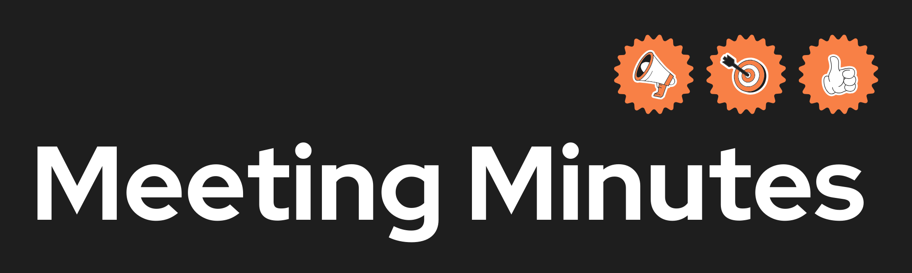

|  |  |
| --- | --- |
| **Date and Time** | 19/02/2025 at 19:00, 22/02/2025 at 20:00 |
| **Project Name** | FitXchange |
| **Meeting Goal** | * Discuss the purpose of each diagram based on user stories * Share feedback on provided diagrams * Modify and prepare new updates |
| **Facilitator** | Hala Bakhtiar |
| **Note taker** | Mahboub Rezaei |
| **Attendees** | * **19/02/2025: Hala Bakhtiar, Evan Balson, Mahbouba Rezaei** * **22/02/2025: Hala Bakhtiar, Mahbouba Rezaei, Evan Balson, Niwhar Amin** |
| **Roundtable Updates (each group member to contribute)** |  |
| **Discussion points** | * **Purpose of each diagram based on user stories.** * **Review and provide feedback on existing diagrams** * **Identify areas for improvement and modifications** * **Assign updates and next steps** |
| **Actions (list tasks and assign a group member)** | * Design Wireframes -> Evan, Mahbouba * Features of application -> Evan * Class Diagram -> Evan * ER Diagram -> Evan * Use Case Diagram -> Hala * User Stories -> Hala * Activity Diagram -> Mahbouba * Sequence Diagram -> Niwhar |

Next step:

Commit the final task before meeting

Review diagrams and provide feedback

Updates will be made based on team discussion