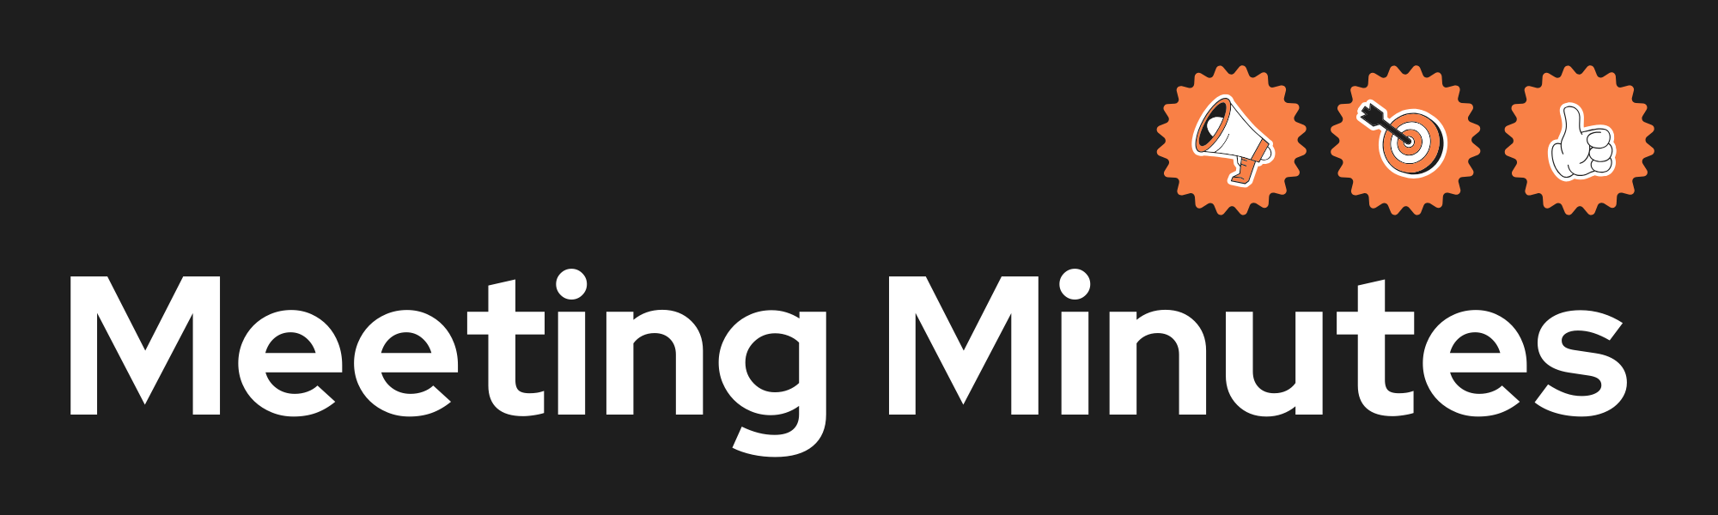

|  |  |
| --- | --- |
| **Date and Time** | **25/03/2025 13:00-14:00pm**  **30/03/2025 18:00-19:00pm**  **03/04/2025 17:30 – 18:30pm**  **07/04/2025 16:00 – 17:00pm**  **09/04/2025 20:00 – 21:00pm** |
| **Project Name** | FitXchange |
| **Meeting Goal** | **25 March 2025**   * Finalize and complete the presentation draft. * Begin UI/UX and login/registration improvements.   **30 March 2025**   * Shift to individual task ownership. * Plan task deadlines and update GitHub activity accordingly.   **31 March 2025**   * Assign and schedule smaller and bulk tasks for Sprint 4. * Set task deadlines: 1st April (small), 5th April (bulk).   **3 April 2025**   * Finalize presentation structure and slide responsibilities. * Confirm site-wide improvement priorities and Canva access.   **7 April 2025**   * Plan post-presentation coding priorities. * Clarify dashboard, filter logic, and registration improvements.   **9 April 2025**   * Final review and completion of the presentation. * Confirm readiness for delivery and Q&A preparation. |
| **Facilitator** | Hala Bakhtiar  Evan Balson |
| **Note taker** | Mahbouba Rezaei  Niwhar Amin |
| **Attendees** | * 25/03/2025 13:00-14:00pm **(Hala Bakhtiar, Mahbouba Rezaei, Evan Balson, Niwhar Amin)** * 30/03/2025 18:00-19:00pm   **(Hala Bakhtiar, Mahbouba Rezaei, Evan Balson)**   * 03/04/2025 17:30- 19:00pm   **(Hala Bakhtiar, Mahbouba Rezaei, Evan Balson)**   * 07/04/2025 16:00 – 17:00pm **(Hala Bakhtiar, Mahbouba Rezaei, Evan Balson, Niwhar Amin)** * 09/04/2025 20:00 – 21:00pm **(Hala Bakhtiar, Mahbouba Rezaei, Evan Balson, Niwhar Amin)** |
| **Roundtable Updates (each group member to contribute)** |  |
| **Discussion points** | **25 March 2025**   * **Complete the presentation by Friday 28th March.** * **Finalize UI/UX changes (e.g., logo position, font updates, prompts).** * **Implement password hashing and login improvements.** * **Review/adjust registration form and dashboard details.**   **30 March 2025**   * **All members to independently pick up tasks.** * **No more code handovers—everyone must contribute directly via GitHub.** * **Choose tasks based on detailed documentation.** * **Share estimated completion dates for each selected task.**   **31st March 2025**   * **Smaller Tasks (due 1 April by 6 PM):** * **Login – Niwhar** * **Registration – (unspecified)** * **Browse Landing Page – Niwhar** * **Cart – Mahbouba** * **Bulk Tasks (due 5 April):** * **User Dashboard** * **Outfit Listing View** * **Site-wide tasks** * **Admin View – Hala**   **3rd April 2025**   * **Finalized team responsibilities for completing the presentation before coding begins.** * **Confirmed presentation headings (e.g., Project Management, Architecture, User Testing).** * **Outlined site-wide feature updates: remove secondary logos, implement in-app messaging, improve feedback prompts.** * **Reviewed assigned sections for the presentation and Canva access; set full draft deadline.**   **7th April 2025**   * **Discussed upcoming coding tasks starting post-presentation completion.** * **Highlighted registration, login, and dashboard changes (e.g., cookie handling, optional image uploads, success messages).** * **Set priorities for dashboard features like update profile pop-ups and wishlist/order linking.** * **Agreed on filters and display logic for Browse, Cart, Checkout, and Order History pages.**   **9th April 2025**   * **Presentation finalized and reviewed in full, including application demo and testing results.** * **Final checks on Canva presentation slides and alignment with group branding and wireframes.** * **Confirmed CI Workflow and unit testing sections were complete.** * **Presentation ready for delivery – team prepped for Q&A and group introduction.** |
| **Actions (list tasks and assign a group member)** | **Hala**   * Slide 10 * New Listing Page * Administrator File   **Niwhar**   * Login Page * Browse Landing Page * Order History Page   **Mahbouba**   * Cart Page * Checkout Page * Delivery Feature   **Evan**   * Favourites Page * AI API Integration * Lender Listing View |