Bankrate was founded in 1976 as Bank Rate Monitor, a print publisher for the banking industry. Our experience has fueled our reputation as the premier financial authority. When you visit Bankrate.com, the reviews, guides and educational content have been developed by leading personal finance experts. Bankrate’s product comparison tools, calculators and educational content help over 100 million consumers make smarter financial decisions each year. No matter where you are in your financial journey, Bankrate can help you reach your goals.

One area Bankrate specializes in is personal loans. Bankrate’s goal is to help match the best lending partner for each individual customer. To do that, we collect information about the customer to understand who would be the best fit. We want to maximize the likelihood someone will be approved for the loan at the best “deal” possible.

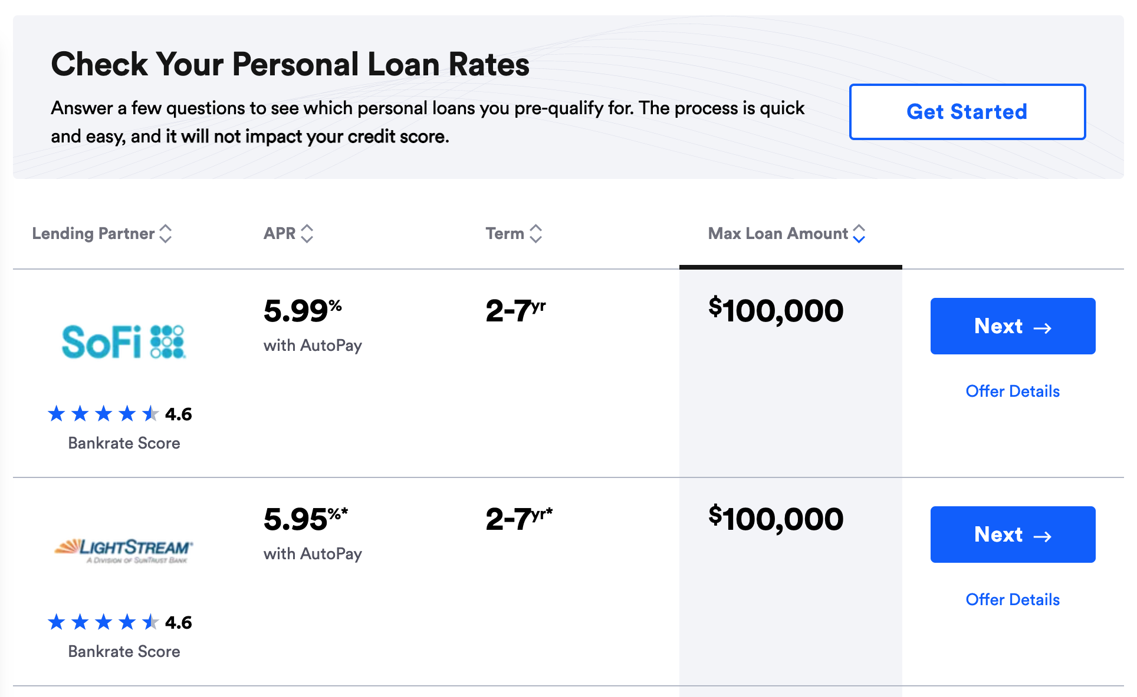

In this case, let’s imagine we have three lending partners, “A”, “B”, and “C”. In this scenario, let’s imagine that each lender is providing the same offer. However, for each approval, lender A provides us **$250**, lender B pays us **$350**, and lender C pays us **$150**.

For 100K of our customers, we have collected a set of data in hopes to understand what variables are most important in determining approvability. We believe if we collect the right information, we will be able to show the appropriate lender to each customer to maximize **approval rate** and **revenue**. The team knows there are many possible data points that we could collect to help us better understand the likelihood of someone approving for the loan, but they started with this list for now.

This data has been recently collected from the website and the leadership team has asked you to help make sense of it. They want to know if they can increase **revenue per application** by matching certain groups of customers to specific lenders.

There are three broad categories that they would like you to investigate. These questions should be used as thought starters - please be creative with how you analyze and explore each question, leveraging relevant **statistics and visualizations** where applicable.

If the team reviews your assessment and decides to move forward, the final step in the interview process would include the opportunity to talk through your assessment live with an interviewer for 45 minutes. Please be prepared at that time to showcase your results using the tool of your choice and to discuss your findings during the interview session.

1. Explore the variables relationship with approvability:
   1. *Possible things to consider:* Which variables are the most helpful in understanding if a customer is going to be approved or denied for a loan? Are there certain variables that are not useful to collect? Are there anyfeature modifications or transformationsthat would improve the predictive power of a variable?
2. Tell us about the lenders approval rates:
   1. *Possible things to consider:* What is each Lender’s average approval rate? Are there any clear differences between the three different lenders on what type of customers they approve? Are there variables that reliably predict a user’s approval likelihood for a particular lender?
3. Evaluate which customers we should match to each lender to maximize Revenue Per Application:
   1. *Possible things to consider:* Are there groups of customers that would be a better fit for a different lender? How much incremental revenue could we make if we matched lenders to certain groups of customers more appropriately? What considerations should we have in mind if we planned to match customers with lenders in real time?

You will have 24 hours to complete this assignment - but note that most submissions are completed in 3-4 hours. Feel free to use any tool to answer these questions. Please submit both your answers and your work used to get to those answers for the three categories in an exported file type that our assessment reviewers can easily access (PDF, HTML, Excel, Screenshots, Powerpoint). Make sure that your work is legible and able to be referenced for your answers.

Data Dict:

**User ID** - unique ID to represent the customer who submitted the application (string)

**Application** - count of application - each row is 1 application submitted (int)

**Reason** - the purpose for requesting a loan (string)

**Loan Amount** - the loan value size (int)

**FICO Score** - score used to make credit risk decisions (int)

**FICO Score Group** - categorical grouping of FICO scores in the five common buckets (string)

**Employment Status** - current employment designation for the customer applying for the loan (string)

**Employment Sector** - categorical representation of the industry the customer works in (string)

**Monthly Gross Income** - the amount of money the user makes pre-taxes and deductions (int)

**Monthly Housing Payment** - how much a month do they pay in housing costs (int)

**Ever Bankrupt or Foreclose** - has the customer ever had to file for bankruptcy or had a foreclosure on their house (bool)

**Loaner** - the lending partner (string)

**Approved** - did the customer get approved for the loan or not (bool)

**Bounty** - how much did we get paid for the application - only occurs on an approval (int)

Please feel free to create new columns or variable groupings to aid in your analysis.