Web Development

Student Name: Evan Scully
AIT Student number: A00266219
Assignment: Sprint 1
Date of Submission: 16/11/2020

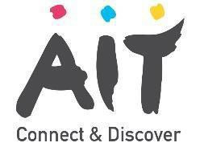
STUDENT PLAGIARISM DISCLAIMER FORM

PLAGIARISM DISCLAIMER

STUDENT NAME: Evan Scully

STUDENT NUMBER: A00266219

PROGRAMME: Cloud Computing

YEAR: 3

MODULE: Web Development

LECTURER: James Byrne

ASSIGNMENT TITLE: Sprint 1

DUE DATE: 16/11/2020

DATE SUBMITTED: 16/11/2020

ADDITIONAL INFORMATION:

I understand that plagiarism is a serious academic offence, and that AIT deals with it according to the AIT Policy on Plagiarism.
I have read and understand the AIT Policy on Plagiarism and I agree to the requirements set out therein in relation to plagiarism and referencing. I confirm that I have referenced and acknowledged properly all sources used in preparation of this assignment. I understand that if I plagiarise, or if I assist others in doing so, that I will be subject to investigation as outlined in the AIT Policy on Plagiarism.
I understand and agree that plagiarism detection software may be used on my assignment. I declare that, except where appropriately referenced, this assignment is entirely my own work based on my personal study/or research. I further declare that I have not engaged the services of another to either assist in, or complete this assignment.

Signed: Evan Scully

Dated: 16/11/20

