PHP Exercise 4 Part 3

Adding a row to the database from the web app.
- In index.php add a link under the table to “Add a product”. This link should take you to a new form e.g. add_product_form.php
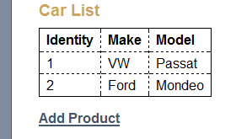
- Code the add_product_form.php page e.g.
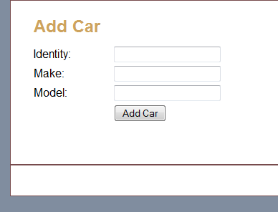

- When the form is submitted (via a post) a php page called add_product.php should be called. add_product.php should

<?php
// Get the product data

// Validate inputs check that not empty
//If empty go back to form – can set error msg if you want if
// If valid, add the product to the database
require_once('database.php');
//

// Display the Car List page by including index.php
?>

