PHP Exercise 4 Part5

Editing a row/item from the database via the web app.
- Update index.php so that an “Edit” button is added to each row in the table. The table cells with the Edit button should contain a form. The key or identifier of each row must be included as a hidden field. When the form is submitted a new php file called edit_product_form.php is called.
edit_product_form.php should be similar to the add_product_form except the values for each text box should be populated so that the user can change them. Identity should not be allowed to be overwritten. (disable the input from changing) The data from edit_product_form.php should be submitted to a file called edit_product.php which will execute the SQL UPDATE query on the specified row in the database.
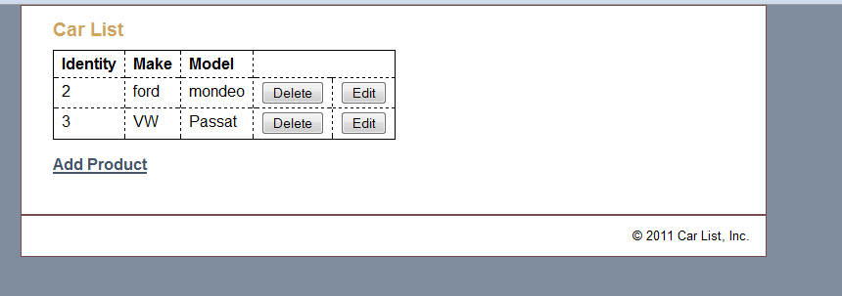
- Example of the code for the Edit button.
<td><form action="edit_product_form.php" method="post">
<input type="hidden" name="id"
value="<?php echo $car['id']; ?>" />
<input type="submit" value="Edit" />
</form></td>

