PHP Exercise 4 – Part 1 Working with mysql database
Write a PHP file
- Connects to a MySql database

Ref : slides Lecture #3

Part 1 Display all the rows in a database
- Install PHP plugin in Netbeans and create a new php project. The directory location for the project should be in the htdocs folder.
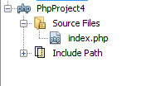
- Setup a database in MySql with one table and add a few rows to the table. E.g.
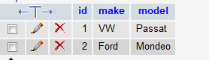
For this exercise you can use datatype varchar for the fields in the database. Make sure you have one field (e.g. id) indicated as primary key.

3. Write a php file that creates a connection to the database. See example. Database name, username and password have to be specified.
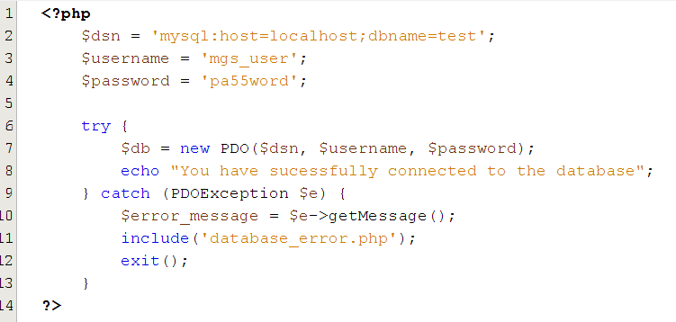

4. Create a separate file database_error.php that will display an error is an exception is thrown. See example.
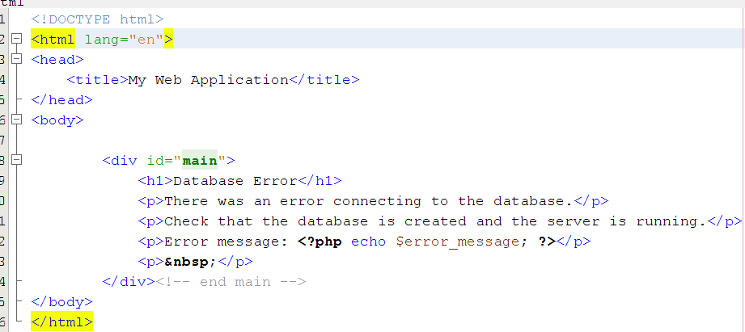
5. Run the file in the browser. If the connection was created the browser should display
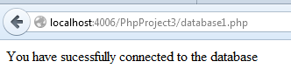

6. If an error occurred then the error message should be displayed in the browser.
