PHP Exercise 4 Part4

Deleting a row/item from the database via the web app.
- Update index.php so that a “Delete” button is added to each row in the table. The table cells with the Delete button should contain a form. The key or identifier of each row must be included as a hidden field. When the form is submitted a new php file called delete_product.php is called
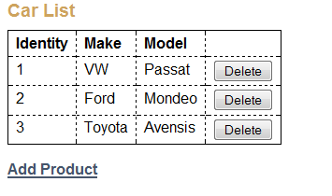
- Example of the code for the Delete button.
<td><form action="delete_product.php" method="post">
<input type="hidden" name="id"
value="<?php echo $car['id']; ?>" />
<input type="submit" value="Delete" />
</form></td>
- Write the code for delete_product.php.
<?php
// Get id from $_POST array
// Delete the car from the database by using database.php and
// using a DELETE query. See slides for example of delete
// display the Car List page again by including index.php
?>

