MM-VAE: A Multimodal Variational Autoencoder for Anemia Screening via CBC Indicators and Blood Smear Imagery
Fengxun Liu  School of Computing and Data Science  Xiamen University Malaysia  Sepang, 43900, Malaysia  SWE2309525@xmu.edu.my | Xiaolin Li*  Department of Clinical Laboratory  the Second Affiliated Hospital of Nanchang University  Nanchang, Jiangxi, China  ndefy21158@ncu.edu.cn
*Corresponding author

Abstract—Anemia is one of the most prevalent hematologic disorders worldwide. In clinical screening, Complete Blood Count (CBC) and peripheral blood smear microscopy capture complementary aspects of anemia-related abnormalities: quantitative hematological indices and visual morphological features. Existing methods largely rely on single-modal data, leaving this complementarity underexploited. This paper proposes a patient-level anemia screening framework based on a Multimodal Variational Autoencoder (MM-VAE), which integrates CBC structured indicators and red blood cell microscopy image embeddings into a shared latent space via a Product-of-Experts (PoE) mechanism and is trained end-to-end with a joint reconstruction and classification objective. On the AneRBC dataset, MM-VAE shows a consistent advantage over both unimodal baselines and the Concat Fusion baseline, achieving a mean F1-score of 0.786 ± 0.007 and a mean Receiver Operating Characteristic – Area Under the Curve (ROC-AUC) of 0.856 ± 0.021 across five random seeds, with stronger cross-seed stability than all comparisons. Further, the ablation results of Hemoglobin (HGB) suggest that the model is not relying on the presence of a single dominant feature, and the missing-modality experiments demonstrate that the PoE mechanism is providing good predictive power without one modality.
Keywords—Anemia screening, multimodal learning, variational autoencoder, Product-of-Experts, complete blood count, blood smear microscopy
I. INTRODUCTION
Anemia is one of the most common hematologic disorders in the world and remains a major global health burden. In clinical screening, CBC is one of the primary diagnostic methods for assessing anemia. Indicators such as HGB, Red Blood Cell (RBC), Hematocrit (HCT), Mean Corpuscular Volume (MCV), Mean Corpuscular Hemoglobin (MCH), Mean Corpuscular Hemoglobin Concentration (MCHC), and Red Cell Distribution Width – Coefficient of Variation (RDW-CV) reflect the state of red blood cells and the hematopoietic system. Peripheral blood smear microscopy can further provide important morphological information, including variations in red blood cell size, shape, and staining intensity. Together, CBC indicators and blood smear images capture complementary aspects of anemia-related abnormalities: quantitative hematological changes and visual morphological patterns.
Recent advances in deep learning have significantly improved both medical image analysis and clinical data modeling. Prior studies have shown that deep neural networks can leverage non-invasive visual signals for anemia screening and classify red blood cell morphology from microscopic images with high precision ^{[1, 2]}. The public release of the AneRBC dataset further provides a standardized basis for multimodal research in computer-aided anemia detection ^{[3]}. It includes red blood cell microscopy images, CBC reports, and morphological annotations, fitting to explore joint modeling of the two modalities.
With these advances still largely adopting single-modal data. The CBC-based methods are clinically interpretable but, in some instances, may tend to over-rely on highly predictive indicators such as HGB, potentially obscuring subtler hematological signals. Image-based methods can capture diagnostic morphological changes, yet their performance is often constrained by small dataset size, staining variability, and limited feature expressiveness. These limitations suggest that single-source data may be insufficient to fully characterize the multidimensional pathological features of anemia. There is, in short, clear information complementarity between structured hematological indicators and red blood cell images that existing methods have not fully exploited.
Against this background, this study investigates whether an MM-VAE combining VAE-based latent-space regularization with a supervised classification objective can outperform unimodal and late-fusion baselines, and whether it learns genuine cross-modal complementarity beyond reliance on a single dominant feature such as HGB.
This study proposes a patient-level anemia screening framework based on MM-VAE, which fuses CBC structured indicators and RBC microscopy image embeddings into a shared latent space via a PoE mechanism, trained end-to-end under a joint objective combining reconstruction and classification supervision.
This study designs a mask-based CBC reconstruction loss and a Kullback–Leibler (KL) warm-up training strategy. The PoE fusion mechanism naturally supports missing-modality inference without retraining separate models for different missing-data scenarios.
This study systematically verifies the model's cross-modal complementarity and inference robustness through an HGB ablation experiment and a missing-modality experiment, and quantifies the stability advantage of MM-VAE over Concat Fusion via multi-seed evaluation.
II. RELATED WORK
A. Computer-aided detection of anemia
Computer-aided detection of anemia mainly relies on structured blood indicators, medical images, or a combination of both. Traditional clinical screening is usually based on CBC, among which indicators such as HGB, RBC, HCT, MCV, MCH, MCHC, and RDW-CV can reflect hematological changes related to anemia. In recent years, machine learning and deep learning methods have been used in blood sample data analysis to improve the automation of anemia detection and classification ^{[4]}.
In addition to structured indicators such as CBC, imaging modalities are increasingly being used for anemia screening. Some studies try to extract anemia-related visual features from fundus images, conjunctiva images or red blood cell microscopic images, and combine image information with structured clinical data for non-invasive anemia detection ^{[5]}. Such studies show that anemia-related information not only exists in numerical blood indicators but also may be reflected in visual morphological changes.
However, existing methods remain limited. CBC-based approaches rely heavily on strong indicators such as HGB, while image-based methods are constrained by image quality and limited generalization. Crucially, the complementary relationship between CBC reports and blood smear microscopy images has not been systematically modeled at the patient level.
B. Erythrocyte microscopy image analysis
Micrographic images of blood smears can directly present morphological characteristics such as the size, shape, color, and arrangement of red blood cells, which are closely related to anemia and other blood diseases. The AneRBC data set provides an open benchmark for the diagnosis of computer-aided anemia ^{[3]}. The data set also contains microscopic images of red blood cells, CBC reports, and morphological reports, making it suitable for exploring multimodal modeling methods.
In the analysis of red blood cell microscopy images, the deep learning model has been used to identify specific anemia-related morphological abnormalities ^{[6]}. Alagu et al. proposed a deep learning framework for sickle cell anemia detection on erythrocyte blood smear images, combining with the feature selection strategy to improve the model performance, indicating that the microscopic image of red blood cells contains disease-related morphological information that can be learned by the deep model ^{[7]}.
It is still difficult to fully cover all the information required for anemia screening by relying on red blood cell images alone. Image modality can provide morphological clues, and CBC characteristics can provide quantitative hematological evidence, and the two have a clear complementarity. However, the existing image analysis research focuses more on the morphological classification of single diseases and lacks joint modeling with CBC quantitative indicators. How to integrate the two types of heterogeneous data into a unified representation space under the patient-level framework is still a problem that has not been fully solved.
C. VAE and multimodal representation learning
The VAE is an important generative representation learning model. Its core idea is to map the input data to the latent distribution through the encoder and then reconstruct the input from the latent variables through the decoder ^{[8]}. VAE can learn a continuous and structured latent space, so it is often used for tasks such as feature learning, generative modeling, and unsupervised anomaly detection. In the medical scene, its adaptability to high-dimensional, heterogeneous, and noise-containing data gives it strong application potential.
For multi-modal data, Wu and Goodman proposed to use the product-of-experts mechanism to integrate the posterior distributions from different modalities ^{[9]}. The framework supports both weakly supervised settings and missing-modality scenarios. Compared with simple feature splicing, this method integrates multi-modal information at the latent distribution level, so that shared latent variables can encode the complementary features of each modal at the same time. In medical applications, multimodal VAE has been used for multi-source data fusion. For example, Suvon et al. applied it to cardiac hemodynamic instability detection, demonstrating the practical feasibility of MM-VAE for heterogeneous medical data modeling ^{[10]}.
Existing multimodal fusion methods usually include early fusion, late fusion and shared latent representation learning. The first two implementations are relatively simple, but the deep relationship between CBC numerical features and blood smear image features may not be fully modeled. In contrast, multimodal representation learning based on VAE can integrate different modes in the latent space and reflect the degree of deviation of the sample from the normal distribution by reconstructing the abnormal score formed by the error and KL dispersion. Although multimodal VAE has shown potential in multi-source data modeling, it still lacks full exploration in the anemia screening task of fusing CBC reports and red blood cell microscopy images.
III. METHODOLOGY
A. Research framework
This study develops an overall experimental framework for patient-level anemia screening. The primary objective is to evaluate the performance of unimodal methods, simple fusion methods, and the proposed multimodal variational autoencoder on a binary anemia classification problem. This project uses the AneRBC data set. The overall experiment workflow consists of the following steps: Data Preparation, Feature Representation, Baseline Model Training, Multi-modal Model Training, and Performance Evaluation (Testing Stage).
This study builds the baseline model, the CBC-only model, the Image-only model and the simple fusion baseline model to realize the modeling design as shown in Figure 1. These models are employed to evaluate the diagnostic ability of single-modality methods and direct multimodal fusion methods MM-VAE is proposed as a multimodal model, which simultaneously learns the CBC features and image representations in a shared latent space under a combined reconstruction and classification objective. This study also presents two further experiments under alternate input scenarios (HGB ablation and missing-modality inference) to evaluate the stability and robustness of the model to capture complementary information across modalities. In this framework, the proposed method can be systematically investigated regarding classification accuracy, cross-modal complementarity, and robustness.

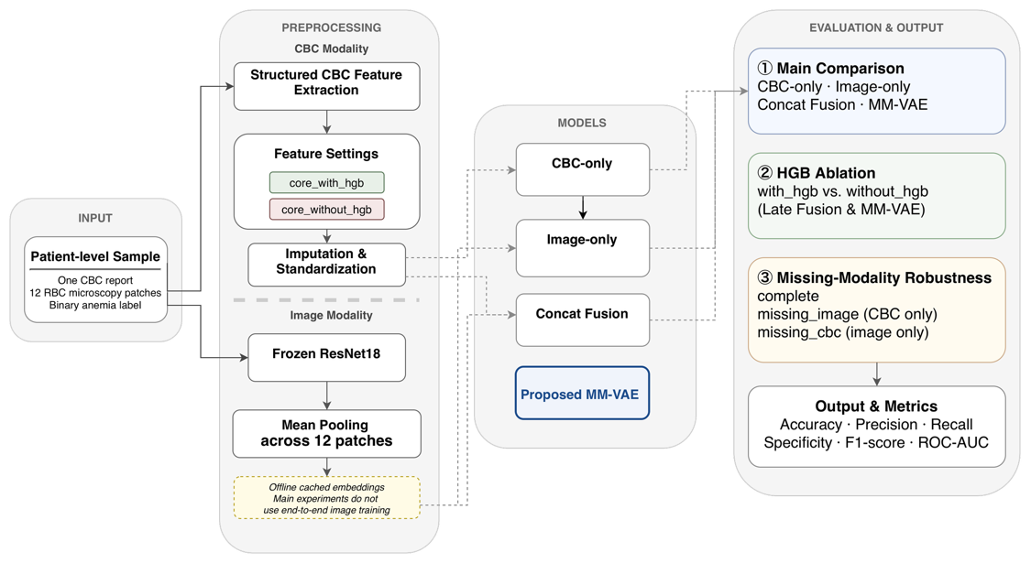
Figure 1. Overall framework of the proposed patient-level anemia screening system (Photo credit: Original).

B. Data preparation and preprocessing
This study adopts patient-level modeling. Each sample matches one original case, including one CBC report, twelve RBC patch images from the same case, and a binary label. To ensure independence across the experimental division, the training, validation, and test sets are determined before patch images are loaded. Therefore, all patches from the same case fall into a single subset with none crossing into another. The project uses stratified sampling, splitting the data into training, validation, and test sets at a 70/15/15 ratio.
For the CBC modality, structured indicators are parsed into a patient-level feature table. Two configurations are used: core_with_hgb and core_without_hgb. Compared to the former one, the latter drops HGB to test whether the model over-relies on it. Each feature also carries a missingness flag, 1 if observed and 0 if missing, forming the cbc_mask vector. Missing values are imputed with the training-set median. CBC features are then standardized using the training set's mean and standard deviation, and the same transform is applied to validation and test sets.
For image modality, raw patches are not fed directly into training. A frozen Residual Network with 18 layers is used to extract patch features first, then the twelve patches per case are mean-pooled into a single patient-level image embedding. While freezing the backbone and mean pooling sacrifices some discriminative capacity, this design is motivated by the small dataset size, which makes end-to-end fine-tuning prone to overfitting, and by the need to isolate fusion mechanism differences across experiments rather than conflating them with encoder-level variation.
C. Model design
To systematically compare different modeling strategies on patient-level anemia screening, this paper sets up five methods: a rule-based baseline, CBC-only, Image-only, Concat Fusion, and proposed MM-VAE. The rule-based baseline classifies using an HGB threshold and serves as a clinical heuristic reference. CBC-only performs supervised binary classification using only structured CBC features. Image-only classifies using only the patient-level image embedding. Concat Fusion first encodes the CBC features, then concatenates them with the image embedding at the feature level before classification, serving as a simple multimodal fusion baseline.
It should be noted that any learning-based model taking CBC input also receives cbc_mask by default. That means, CBC-only, Concat Fusion, and MM-VAE all use the imputed and standardized CBC values, but they can also draw explicitly on each indicator's missingness status. This reduces the information loss that missing-value handling might otherwise introduce. Image-only, by contrast, uses only the image embedding and has no access to CBC missingness information.
As shown in Figure 2, the proposed MM-VAE takes CBC features, the missingness indicator vector, and the patient-level image embedding as input. Two separate encoders estimate latent distribution parameters for the two modalities, and a PoE mechanism fuses them into a shared latent space. From the resulting latent variable, the model jointly performs CBC reconstruction, image embedding reconstruction, and anemia classification. Compared with direct feature concatenation, this design enables the model to capture cross-modal consistency and complementarity within a unified representation space, while also supporting inference under missing modalities.

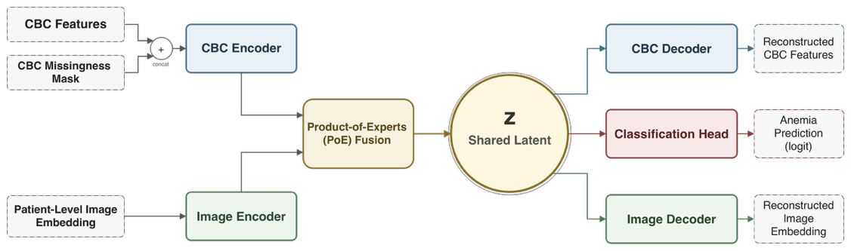
Figure 2. Architecture of the proposed MM-VAE model (Photo credit: Original).

D. Training strategy, experimental setup, and evaluation metrics
For the training strategy, the objective function of MM-VAE consists of CBC reconstruction loss, image reconstruction loss, KL divergence loss, and classification loss. Its overall form is given as:
$L=L_{cbc}+αL_{img}+βL_{kl}+λL_{cls}$ (1)
Here, $L_{img}$, $L_{kl}$, and $L_{cls}$ respectively constrain image embedding reconstruction, regularization of the shared latent space, and anemia binary classification performance. Earlier versions of the framework assigned equal weight to all CBC dimensions during reconstruction. The current implementation instead applies a mask-based reconstruction loss for $L_{cbc}$, computed using cbc_mask. This means reconstruction error is calculated only over the CBC indicators that were actually observed. This prevents the model from being overly driven by the imputed values themselves during training. All learning models are trained with the Adam optimizer, with early stopping based on validation set performance. To stabilize the learning of the latent variable, MM-VAE applies a KL warm-up strategy in the early stages of training, gradually increasing the weight of the KL term.
The experimental design is summarized in Table 1, and it consists of three experiments: a main comparison experiment, where all MM-VAE models were tested, an HGB ablation experiment that tests two feature configurations (with_hgb and without_hgb) with the same architecture to verify genuine cross-modal complementarity, and a missing-modality robustness experiment in which three inference modes (complete, missing_image, missing_cbc) were evaluated without retraining in a single unified MM-VAE.

Table 1. Quantitative performance comparison.
ID | Model | CBC | Image | HGB | Purpose
G0 | Rule-based | HGB only | N/A | Yes | Clinical baseline
G1 | CBC-only | core_with_hgb | N/A | Yes | Unimodal (with HGB)
G2 | CBC-only | core_without_hgb | N/A | No | Unimodal (without HGB)
G3 | Image-only | N/A | Embedding | No | Unimodal image
G4 | Concat Fusion | core_without_hgb | Embedding | No | Fusion baseline (no HGB)
G5 | MM-VAE | core_without_hgb | Embedding | No | Proposed (no HGB)
G6 | Concat Fusion | core_with_hgb | Embedding | Yes | Fusion baseline (with HGB)
G7 | MM-VAE | core_with_hgb | Embedding | Yes | Proposed (with HGB)

In this paper, the problem of anemia screening is presented as a binary classification problem and assessed with accuracy, precision, recall, specificity, F1 score, and ROC-AUC. Recall is the proportion of anemic samples correctly identified, and Specificity is the proportion of healthy samples correctly identified. The overall ranking performance of the model is measured by the ROC-AUC. The model is selected based on the results of the validation set, and the final results are published on the test set patient-level predictions.
IV. RESULTS AND ANALYSIS
A. Main comparison experiment
The following 5 methods were compared under the core_with_hgb setting, which is summarized in Figure 3. For the rule-based baseline, the rule set was re-evaluated using the full test set of 150 cases (after missing HGB values were imputed), as was done for the learning-based models. Each model was trained using five random seeds, with their results reported as mean ± standard deviation.

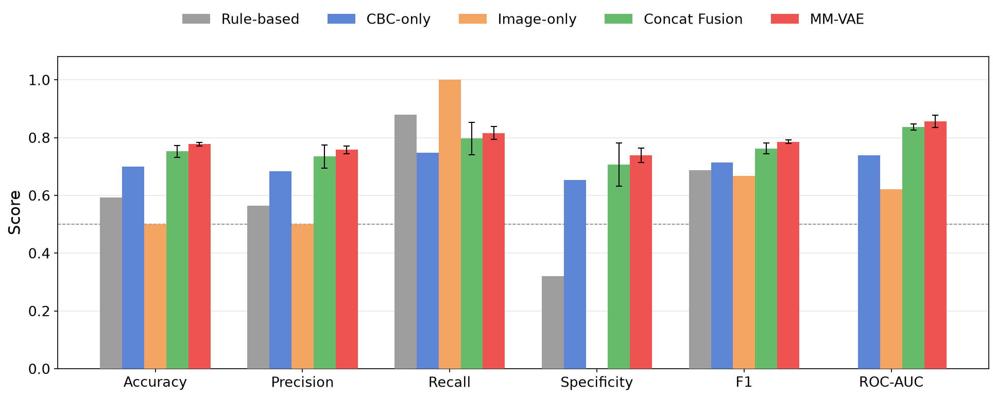
Figure 3. Results under the core_with_hgb setting (Photo credit: Original).

The rule-based baseline performed very poorly on the accuracy of recall, as it performed at the lowest level of 0.8800, while specificity was very poor at 0.3200, which is a typical trade-off for a fixed clinical threshold, where sensitivity is optimized at the expense of accuracy. CBC-only had a more balanced discrimination with 0.7000 accuracy and an F1 of 0.7134. On all the metrics, Concat Fusion was better than both unimodal baselines. MM-VAE further enhanced its performance with an accuracy of 0.7773, an F1 of 0.7856, a ROC-AUC of 0.8561, and a slightly smaller standard deviation among seeds.
As observed in Section 3.2, the Image-only model failed to achieve any negative values in the classifier, resulting in an all-positive model with a recall score of 1.0000 and a specificity score of 0.0000. This restriction will be re-encountered in Section 4.3.
While there is still formal significance testing to come between MM-VAE and Concat Fusion, the multi-seed results suggest that MM-VAE consistently outperforms Concat Fusion. The benefit of multimodal learning over unimodal screening is clearly established, as is also the additional stable benefit from the shared latent model over simple concatenation.
B. HGB ablation experiment
Removing HGB from the CBC input tests whether each model leans on one dominant feature or genuinely integrates complementary information. Figure 4 shows result of CBC-only, Concat Fusion, and MM-VAE with and without HGB.

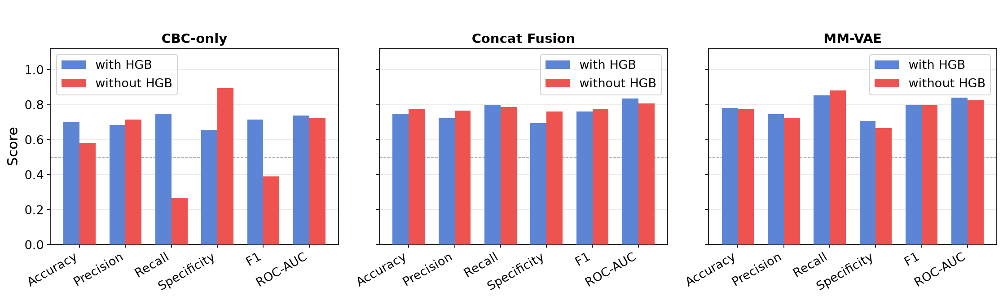
Figure 4. Performance under with_hgb and without_hgb configurations (Photo credit: Original).

CBC-only deteriorated sharply. When HGB was removed from the model, F1 dropped from 0.7134 to 0.3883, and recall dropped from 0.7467 to 0.2667, with specificity increasing to 0.8933, indicating a significant shift in prediction to the negative class.
MM-VAE barely moved. F1 went from 0.7950 to 0.7952, and ROC-AUC eased from 0.8390 to 0.8234. Most importantly, the recall–specificity tradeoffs of MM-VAE were relatively well balanced: the recall of MM-VAE increased slightly from 0.8533 to 0.8800, while the specificity of MM-VAE decreased slightly from 0.7067 to 0.6667; a change that was quite small and orders of magnitude smaller than the virtually complete distributional collapse observed in CBC-only. This stability is the best proof that MM-VAE effectively extracts complementary information from the image modality, instead of relying on a single dominant feature.
Concat Fusion was more mixed. After removing HGB, accuracy and F1 slightly improved while ROC-AUC decreased from 0.8339 to 0.8063. Unlike ROC-AUC, accuracy and F1 are dependent on a fixed threshold and can improve just due to the shift of the decision boundary. Its drop indicates that the discriminative power of Concat Fusion decreased; to a certain extent, it's just a threshold effect. The result of the more convincing MM-VAE is more impressive, in that it performed equally well on the threshold-independent ROC-AUC.
The three models showed different behaviors when removing the HGB: MM-VAE is the most stable. It validates the idea that it captures a latent space of cross-modal complementarity with real clinical usefulness.
C. Missing-modality robustness experiment
A further test is whether the PoE-based MM-VAE still produces meaningful predictions when one modality is missing at inference time. To match Section 4.1, this evaluation used the core_with_hgb version of MM-VAE under three modes: complete, missing_image, and missing_cbc. The results are shown in Figure 5.

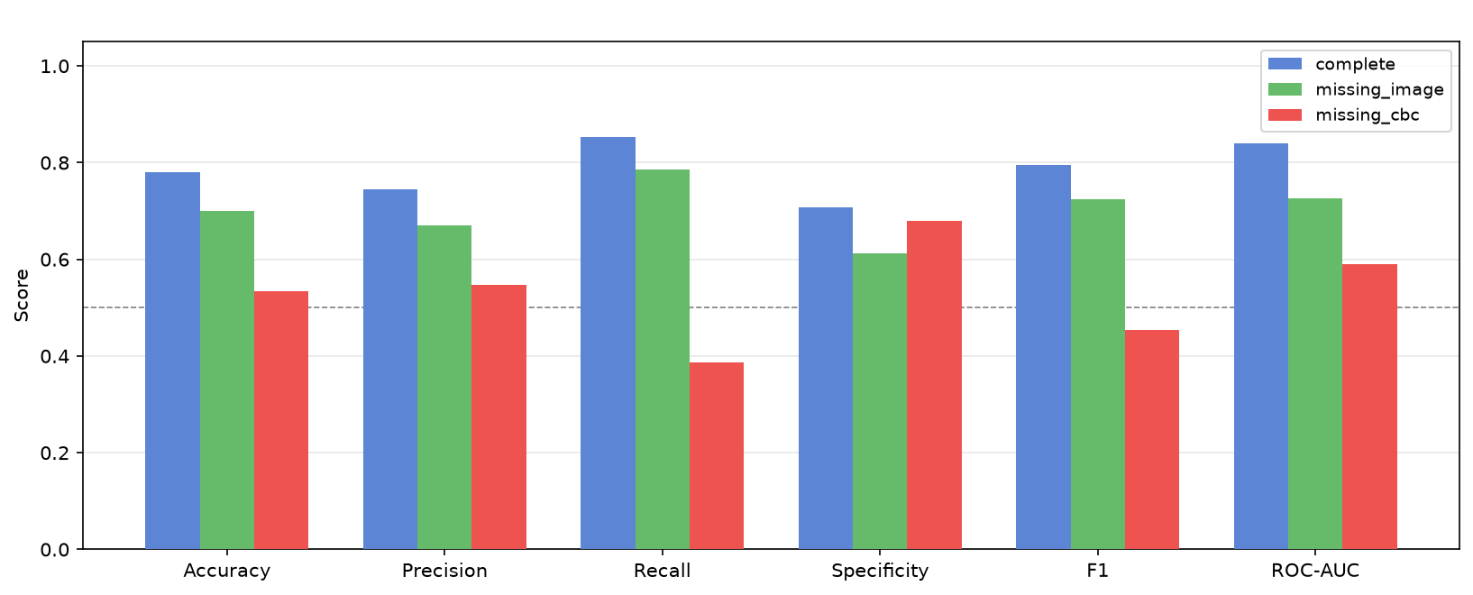
Figure 5. Missing-modality inference results of MM-VAE under core_with_hgb (Photo credit: Original).

As per the expectation, the complete mode was performing well. The image modality had a moderate impact on performance when it was removed. With an accuracy of 0.7000 and an ROC-AUC of 0.7262, much higher than chance, the PoE mechanism is robustly structured to the absence of an image modality.
The same story did not apply to the removal of CBC. Accuracy fell to 0.5333, F1 to 0.4531, and ROC-AUC to 0.5892. The model didn't fail, but the drop is significant, indicating that MM-VAE is heavily relying on the CBC branch.
This asymmetry is not a failure of the PoE mechanism itself. It has the same limitation as the Image-only baseline (Section 4.1), which was the all-positive predictor. There is not a strong enough stand-alone discriminative signal in the current image representation. When used in combination with CBC, the image modality fits well into MM-VAE; however, currently, the image branch alone is not a good enough modality for reliable screening, which will be an interesting direction to pursue in the future.
V. CONCLUSION
Most current computer-aided anemia detection approaches are single-modal approaches, and it is challenging to utilize the complementary information between structured CBC data and microscopy images of red blood cells. This paper introduces a patient-level anemia screening framework by a VAE for jointly modeling both modalities in a shared latent space and binary classification of anemia under combined reconstruction and classification supervision.
Experimental results show that multimodal modeling performs better than unimodal baselines. MM-VAE outperformed Concat Fusion across all six evaluation metrics and exhibited smaller variance across random seeds. The HGB ablation experiment further showed that MM-VAE suffered only limited performance degradation after HGB removal, while the CBC-only baseline deteriorated substantially. It suggests that the model draws on complementary information from the image modality rather than depending primarily on a single dominant diagnostic feature. The missing-modality experiment also showed that the PoE mechanism can maintain reasonable predictive ability when the image modality is absent. Though performance declined more sharply when CBC was removed, indicating that the image modality, in its current form, does not yet carry sufficient standalone discriminative signal to support independent diagnostic decisions — a limitation attributable to the frozen mean-pooled image representation rather than the fusion mechanism itself.
This study has several limitations. The frozen mean-pooled image representation limits standalone image discriminative power. Experiments were conducted on a single dataset, and label approximation error may be introduced due to the use of a uniform HGB threshold without sex-stratified severity analysis.
Future work includes exploring fine-tuned image encoders or patch-level attention mechanisms to strengthen image-modality discriminative capacity, external validation on larger multi-center datasets, and latent-variable correlation analyses to improve interpretability and clinical relevance.
REFERENCES
[1] A. Zhang et al., Prediction of anemia using facial images and deep learning technology in the emergency department. Front. Public Health 10, 964385 (2022)
[2] L. Alzubaidi, M.A. Fadhel, O. Al-Shamma, J. Zhang, Y. Duan, Deep Learning Models for Classification of Red Blood Cells in Microscopy Images to Aid in Sickle Cell Anemia Diagnosis. Electronics 9(3), 427 (2020)
[3] M. Shahzad et al., AneRBC dataset: a benchmark dataset for computer-aided anemia diagnosis using RBC images. Database 2024, baae120 (2024)
[4] N.B. Bahadure, R. Khomane, A. Nittala, Anemia detection and classification from blood samples using data analysis and deep learning. Automatika 65(3), 1163–1176 (2024)
[5] N. Sehar, N. Krishnamoorthi, C. Vinoth Kumar, Deep Learning Model-Based Detection of Anemia from Conjunctiva Images. Healthc. Inform. Res. 31(1), 57–65 (2025)
[6] Ş. Kılıç, Attention-Based Dual-Path Deep Learning for Blood Cell Image Classification Using ConvNeXt and Swin Transformer. J. Imaging Inform. Med. 39(1), 564–582 (2025)
[7] S. Alagu, K. Ganesan, A novel deep learning approach for sickle cell anemia detection in human RBCs using an improved wrapper-based feature selection technique in microscopic blood smear images. Biomed. Eng. Biomed. Tech. 68(2), 175–185 (2023)
[8] D.P. Kingma, D.J. Rezende, S. Mohamed, M. Welling, Semi-supervised learning with deep generative models, in Proceedings of the 28th Conference on Neural Information Processing Systems (NeurIPS), Montreal, Canada, December 8–13 (2014), vol. 27
[9] M. Wu, N. Goodman, Multimodal generative models for scalable weakly-supervised learning, in Proceedings of the 32nd Conference on Neural Information Processing Systems (NeurIPS), Montreal, Canada, December 3–8 (2018), vol. 31, pp. 5580–5590
[10] M.N.I. Suvon et al., Multimodal Variational Autoencoder for Low-cost Cardiac Hemodynamics Instability Detection. arXiv preprint arXiv:2403.13658 (2024)

