

zts-3002-tr-*-n01

Five-pin soil multiparameter sensors

Product Manual

|  |  |
| --- | --- |
| 1 | **outlined** |

The five-plug soil multiparameter sensor is a **stable performance high sensitivity,** fast response, stable output, applicable to a variety of soils. **It is an important tool for observing and researching the occurrence, evolution and improvement of saline soils as well as water and salt dynamics. By measuring the dielectric constant of soil, it can directly and stably reflect the real moisture content of various soils. It can measure the volume percentage of soil moisture, which is a soil moisture measurement method in line with current international standards.** Can be buried in the soil for a long time, resistant to long-term electrolysis, corrosion-resistant, vacuum potting, completely waterproof.

|  |  |
| --- | --- |
| 2 | **specificities** |

(1) The sensor is designed to be compact.

(2) High measurement accuracy, fast response speed and good interchangeability.

(3) Good sealing, can be used directly buried in the soil, and is not subject to corrosion.

(4) Less impact of soil quality, wide range of application areas.

(5) Accurate measurement, reliable performance, ensuring normal operation and high data transmission efficiency.

|  |  |
| --- | --- |
| 3 | **Scope of application** |

It is suitable for **temperature and humidity, conductivity and PH testing in soil moisture monitoring, scientific experiment, water-saving irrigation, greenhouse, flower and vegetable, grass pasture, soil quick test, plant culture, sewage treatment and fine agriculture.**

|  |  |
| --- | --- |
| 4 | **Product Information** |

**4.1 Technical parameters**

Measured parameters: soil conductivity (EC value), temperature, moisture, PH, NPK **(measured and entered by national standard method instruments)**

Measurement range: 0-20,000μS/cm, **-40~80℃, 0-100%, 3~9PH, 0-2999 mg/kg(mg/L)**

Measurement accuracy: **±3%FS in the range of 0-10,000us/cm; ±5%FS in the range of 10,000-20,000us/cm,** @ (brown soil, 60%RH,25℃), ±0.5℃, ±2% in the range of 0-50%, @ (brown soil, 30%,25℃) ±3% in the range of 50-100%, @ (brown soil, 60%,25℃), ±0.3PH Typical accuracy **≤5% (based on actual measuring instrument)**

Resolution: 1μS/cm, **0.1°C, 0.1 per cent, 0.1, 1 mg/kg (mg/L)**

Output signal: RS485 (ModBus-RTU protocol)

Supply voltage: 4.5~30V DC

Operating range: -30°C to 70°C

Stabilisation time: 1 second after power-on

Response time: <1 second

Note: The performance data stated above were obtained under test conditions using our test system and software. In order to continuously improve our products, we reserve the right to change design features and specifications without prior notice.

**4.2 Physical parameters**

Pin length: 55mm, φ3mm

Pin material: 316L stainless steel

Sealing material: ABS engineering plastic, epoxy resin, waterproof grade IP68

Cable specification: 2 metres as standard (other cable lengths can be customised, up to 1200 metres)

Load capacity: voltage output: output resistance ≤250Ω; current output: ≤600Ω

**4.3 Product Selection**

|  |  |  |  |  |  |
| --- | --- | --- | --- | --- | --- |
| ZTS- |  | | | | Company code |
|  | 3002- |  | | |  |
|  | TR- |  | | Soil testing housings |
|  | THNPKPH- |  | Temperature Moisture Nitrogen Phosphorus Potassium PH |
| ECTHNPKPH- |  | ConductivityTemperatureMoistureNitrogenPhosphorusPotassiumPH |
| THPH- |  | Temperature Moisture PH |
| ECTHPH- |  | ConductivityTemperatureMoisturePH |
|  | N01 | RS485 (Modbus-RTU protocol) |

|  |  |
| --- | --- |
| 5 | **Form Factor** |

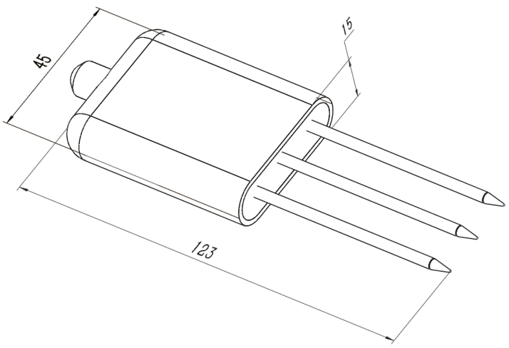

|  |  |
| --- | --- |
| 6 | **Usage** |

The device can be connected to a variety of devices containing differential inputs such as data collectors, data acquisition cards, remote data acquisition modules, etc. The wiring is described in the following figure:

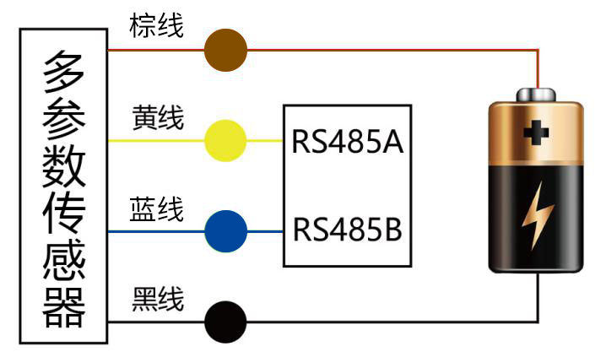

|  |  |
| --- | --- |
| 7 | **Data conversion methods** |

RS485 signal (default address 01):

Standard Modbus-RTU protocol, baud rate: 4800; parity bit: none; data bit: 8; stop bit: 1

**7.1 Change of address**

Example: change the address of a sensor with address 1 to 2, master → slave

|  |  |  |  |  |  |  |  |
| --- | --- | --- | --- | --- | --- | --- | --- |
| original address | function code | Start register high | Start Register Low | Start Address High | starting address low | CRC16 low | CRC16 high |
| 0X01 | 0X06 | 0X07 | 0XD0 | 0X00 | 0X02 | 0X08 | 0X86 |

If the sensor receives correctly, the data is returned in the original way.

Note: If you forget the original address of the sensor, you can use the broadcast address 0XFF instead. When using 0XFF, the master can only connect one slave, and the return address is still the original address, which can be used as an address query method.

**7.2 Querying data**

register address

|  |  |  |  |  |
| --- | --- | --- | --- | --- |
| register address | PLC or Configuration Address | element | rig | Description of definitions |
| 0000 H | 40001 (decimal) | moisture content | read-only (computing) | Real-time value of moisture content (expanded by a factor of 10) |
| 0001 H | 40002 (decimal) | temperature value | read-only (computing) | Temperature real-time values (10 times larger) |
| 0002 H | 40003 (decimal) | conductivity | read-only (computing) | Conductivity real time value |
| 0003 H | 40004 (decimal) | PH value | read-only (computing) | PH real time (expanded tenfold) |
| 0004H | 40005 (decimal) | Provisional value of nitrogen content | fill out or in (information on a form) | Nitrogen value or test value being written1 |
| 0005H | 40006 (decimal) | Provisional value of phosphorus content | fill out or in (information on a form) | Phosphorus value written or tested2 |
| 0006H | 40007 (decimal) | Provisional values of potassium content | fill out or in (information on a form) | Potassium value written or tested3 |
| 0007 H | 40008 (decimal) | salinity | read-only (computing) | Real-time salinity values (indicative only) |
| 0008 H | 40009 (decimal) | Total Dissolved Solids TDS | read-only (computing) | Real-time TDS values (indicative only) |
| 0022 H | 40035 (decimal) | Temperature coefficient of conductivity | fill out or in (information on a form) | 0-100 corresponds to 0.0 per cent to 10.0 per cent  Default 0.0 per cent |
| 0023 H | 40036 (decimal) | salinity factor | fill out or in (information on a form) | 0-100 corresponds to 0.00-1.00  Default 55 (0.55) |
| 0024 H | 40037 (decimal) | TDS coefficient | fill out or in (information on a form) | 0-100 corresponds to 0.00-1.00  Default 50 (0.5) |
| 0050 H | 40081 (decimal) | Temperature calibration value | fill out or in (information on a form) | Integers (expanded by a factor of 10) |
| 0051 H | 40082 (decimal) | Moisture content calibration value | fill out or in (information on a form) | Integers (expanded by a factor of 10) |
| 0052 H | 40083 (decimal) | Conductivity Calibration Values | fill out or in (information on a form) | integer (math.) |
| 0053 H | 40083 (decimal) | PH calibration value | fill out or in (information on a form) | integer (math.) |
| 04E8 H | 41001 (decimal) | Nitrogen content staging value coefficients in the upper sixteenth place | fill out or in (information on a form) | floating point  (IEEE754 standard Floating-point) |
| 04E9 H | 41002 (decimal) | Nitrogen content interim value factor lower 16 digits | fill out or in (information on a form) |
| 04EA H | 41003 (decimal) | Deviation from provisional values of nitrogen content | fill out or in (information on a form) | integer (math.) |
| 04F2 H | 41011 (decimal) | Phosphorus content provisional value factor high 16 | fill out or in (information on a form) | floating point  (IEEE754 standard Floating-point) |
| 04F3 H | 41012 (decimal) | Phosphorus content provisional value factor lower 16 | fill out or in (information on a form) |
| 04F4 H | 41013 (decimal) | Deviation from the provisional value for phosphorus content | fill out or in (information on a form) | integer (math.) |
| 04FC H | 41021 (decimal) | Potassium content provisional value coefficients in the upper sixteenth place | fill out or in (information on a form) | floating point  (IEEE754 standard Floating-point) |
| 04FD H | 41022 (decimal) | Potassium content transient value coefficient low sixteenth position | fill out or in (information on a form) |
| 04FE H | 41023 (decimal) | Deviation from provisional values of potassium content | fill out or in (information on a form) | integer (math.) |
| 07D0 H | 42001 (decimal) | device address | fill out or in (information on a form) | 1~254 (factory default 1) |
| 07D1 H | 42002 (decimal) | Device Baud Rate | fill out or in (information on a form) | 0 for 2400  1 for 4800  2 for 9600 |

1: When the write operation is not performed on the 0004H register, the value in the register is f1 (conductivity measurement value), and after the write operation is performed on the 0004H register, the register stores the written value.

2: When the write operation is not executed in the 0005H register, the value in the register is f2 (conductivity measurement value), and after the write operation is executed in the 0005H register, the register stores the written value.

3: When the write operation is not executed in the 0006H register, the value in the register is f3 (conductivity measurement value), and after the write operation is executed in the 0006H register, the register stores the written value.

Query the data of the conductivity temperature moisture PH value sensor (address 1), master → slave

|  |  |  |  |  |  |  |  |
| --- | --- | --- | --- | --- | --- | --- | --- |
| address | function code | Start register address high | Start register address low | Register length high | Register length low | CRC16 low | CRC16 high |
| 0X01 | 0X03 | 0X00 | 0X00 | 0X00 | 0X04 | 0X44 | 0X09 |

If the sensor receives correctly, the following data is returned Slave → Master

|  |  |  |  |  |  |  |  |  |
| --- | --- | --- | --- | --- | --- | --- | --- | --- |
| address code | function code | Return validity  byte count | water value | temperature value | conductivity value | PH value | check digit  low byte | check digit  high byte (computing) |
| 0x01 | 0x03 | 0x08 | 0x02 0x92 | 0xFF 0x9B | 0x03 0xE8 | 0x00 0x38 | 0x57 | 0xB6 |

Temperature calculations:

Temperature data is uploaded as complementary code when the temperature is below 0 °C.

Temperature: FF9B H (hex) = -101 => Temperature = -10.1°C

Moisture Calculations:

Moisture: 292 H (hexadecimal) = 658 => Moisture content = 65.8 per cent, i.e., 65.8 per cent volumetric soil moisture content.

Conductivity calculations:

Conductivity: 3E8 H (hexadecimal) = 1000 conductivity = 1000 us/cm

PH calculation:

PH: 38H (hex) = 56 => PH = 5.6

|  |  |
| --- | --- |
| 8 | **Precautions for use** |

Warnings

圆圈斜杠符号Failure to follow the wiring sequence may result in damage to the device and the instrument to which it is connected.

圆圈斜杠符号Input power exceeding the maximum access power of the unit will cause damage to the unit.

attention

* Please read this manual completely before use.
* Do not attempt to insert the probe into stones or hard clods of earth as this may damage the probe.

jinggao When moving the sensor out of the soil, do not tug directly on the cable.

The sensor probe should be inserted into the soil/substrate sufficiently to minimise handling errors and improve measurement accuracy.



jinggao It should be calibrated before each measurement, and it is recommended to calibrate it every 1 month for long-term use, and the frequency of calibration should be adjusted according to different application conditions (soil quality, moisture content, salt content, acidity and alkalinity of the application, etc.).