**\*Business Requirement for BiFrost Games**

**Contents**

1. System Overview 2

2. Requirements Scope 2

2.1 In Scope 2

2.2 Out of Scope 2

3. Functional Requirements 3

3.1 UML Use Case Diagram 3

3.2 UML Use Case Specifications 4

4. Non-Functional Requirements 11

5. Data Model 11

6. UI Screen Mockups 12

**Table of Figures**

Figure 1 - UML Use Case Diagram 3

Figure 2 - Data Model Diagram 11

Figure 3 - Cart 12

Figure 4 - Login Screen 13

## System Overview

We are creating a website that will be able to have video games posted and sold. A shopping cart will be implemented so customers can add multiple games to the cart and buy them in one transaction. The games will be able to be sorted by console. Customers must make a account to save their order history and be able to place the order.

## Requirements Scope

### 2.1 In Scope

The customer must be able to:

R01 Signup/Login

R02 Search/Sort items by category/user ratings/location

R03 Add items to a shopping cart

R04 Choose amount of selected item

R05 Pay using secure payment system

R06 Send purchase confirmation email

R07 View purchase history

The client must be able to:

R07 add/remove items

R08 Must provide a consistent look and feel across the user interface

R09 Uses free open source software

R10 Have the system fully tested and running in 8 weeks

### 2.2 Out of Scope

Searchbar to find specific items.

Comment section for each item.

## Functional Requirements

The customer must be able to browse items and select category filters.

An item must be able to be added to, or removed from the shopping cart.

The customer can purchase the contents of the cart using a secure payment system.

The customer can have an account on the system.

The customer can view their purchase history.

The client can edit/add/remove products on the system.

### 3.1 UML Use Case Diagram

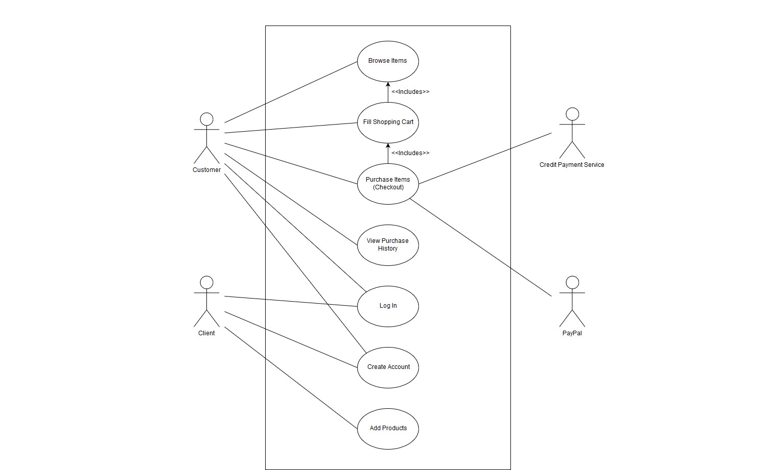

**Figure 1 - UML Use Case Diagram**

### 3.2 UML Use Case Specifications

|  |  |  |  |
| --- | --- | --- | --- |
| **Use Case Name:** | Customer can sort items with dropdown | **Use Case**  **ID:** | UC001 |
| **Primary Actor:** | Customer | | |
| **Description:** | A dropdown appears, the products are sorted and displayed depending on which category the customer picks. | | |
| **Triggering Event:** | Customer wishes to filter and sort to find a certain product | | |
| **Steps Performed (Main Path)** | | | |
| **1.** The Customer is presented with a selection of categories. | | | |
| **2.** The Customer can select one of the displayed categories. | | | |
| **3.** The System filters and sorts the products based on which category was picked. | | | |
| **4.** The System displays the sorted products. | | | |
| **Extensions or Alternate Scenarios** | | | |
| 1a. Customer clicks somewhere other than the dropdown. Dropdown closes. | | | |
| 2a. Customer picks a category with no products. Tell the customer there are no products in this category. | | | |
| 3a. System encounters a problem retrieving products. Display appropriate error message. | | | |
| **Pre-Conditions:** | 1. The system contains categories for products. | | |
| **Post-Conditions:** | 1. The Customer can view the filtered products. | | |
| **Assumptions:** | 1. Anyone can view products | | |
| **Success Guarantee:** | **1.** The Customer has selected one category. | | |
| **Outstanding Issues:** | 1. Does the system have items in the selected category? 2. If there is an error in receiving the appropriate products? Does the System display an error message? | | |
| **Priority:** | High | | |

|  |  |  |  |
| --- | --- | --- | --- |
| **Use Case Name:** | Add item to cart | **Use Case ID:** | UC002 |
| **Primary Actor:** | Customer | | |
| **Description:** | Select and add item to your shopping cart from the browse page | | |
| **Triggering Event:** | Customer selects the add to cart button beside the chosen item. | | |
| **Steps Performed (Main Path)** | | | |
| 1. Customer selects add to cart beside chosen item | | | |
| 2. Customer is prompted to view cart or continue shopping | | | |
| 3a.Customer chooses view cart, goes to the cart page | | | |
| 3b. Customer chooses continue shopping, prompt disappears and more items can be added to cart | | | |
| 4.The system adds the item to the cart and saves it | | | |
| **Extensions or Alternate Scenarios** | | | |
| 1a. “Must login” is displayed. Prompt Login with option to create account | | | |
|  | | | |
| **Pre-Conditions:** | 1. Customer must be logged into an account | | |
| **Post-Conditions:** | 1. Customer has added an item to the cart | | |
| **Assumptions:** | 1. A customer/Client isn’t already logged in | | |
| **Success Guarantee:** | 1. Prompt with confirmation and option to view cart | | |
| **Outstanding Issues:** | 1. If the user not logged in. Should prompt to sign up. | | |
| **Priority:** | High | | |

|  |  |  |  |
| --- | --- | --- | --- |
| **Use Case Name:** | Purchase Items | **Use Case ID:** | **UC003** |
| **Primary Actor:** | Customer | | |
| **Description:** | The customer completes an online transaction to purchase the items in their shopping cart. | | |
| **Triggering Event:** | The customer clicks on a button on their shopping cart page to confirm the purchase. | | |
| **Steps Performed (Main Path)** | | | |
| 1. The customer is prompted to fill in shipping & billing information | | | |
| 2. The customer is prompted to fill in credit card info, or use PayPal | | | |
| 3. The selected payment service processes the transaction | | | |
| 4. The system confirms that the purchase is successful | | | |
| 5. The system sends the customer a confirmation email, and adds the order history to the customer account | | | |
| **Extensions or Alternate Scenarios** | | | |
| 1a. The customer does not have an account, so they are directed to create an account before completing the purchase | | | |
| **Pre-Conditions:** | 1. The customer must be connected to the system  2. The customer has added at least 1 item to their shopping cart  3. The customer has a valid payment method for the selected payment service  4. The customer has enough money to complete the transaction  5. The items they have ordered are in stock | | |
| **Post-Conditions:** | 1. The customer has successfully ordered the items | | |
| **Assumptions:** | 1. The customer has a valid user account | | |
| **Success Guarantee:** | 1. The order has been placed | | |
| **Outstanding Issues:** | **1.** The payment service is unable to complete the transaction | | |
| **Priority:** | High | | |

|  |  |  |  |
| --- | --- | --- | --- |
| **Use Case Name:** | View Purchase History | **Use Case ID:** | **UC004** |
| **Primary Actor:** | Customer | | |
| **Description:** | Customer can see past purchases | | |
| **Triggering Event:** | Customer wants to view purchase history. | | |
| **Steps Performed (Main Path)** | | | |
| 1.The customer clicks on order history | | | |
| 2.The customer is presented with list of his old purchases | | | |
| 3.The customer select one from the orders. | | | |
| 4.The customer can choose one of his past purchases | | | |
| **Extensions or Alternate Scenarios** | | | |
| 4a. Go to link/page/game | | | |
| 4b. Page with this game was deleted. Generate error message. Ask to try find the similar game | | | |
|  | | | |
|  | | | |
| **Pre-Conditions:** | 1. The customer must be logged in 2. The customer must have previous purchases | | |
| **Post-Conditions:** | 1. Customer choose one of his previous games | | |
| **Assumptions:** | 1. Customer is logged in and has purchased products | | |
| **Success Guarantee:** | 1. Customer check his history of games | | |
| **Outstanding Issues:** | 1. **Does the system display all of the orders** | | |
| **Priority:** | Low | | |

|  |  |  |  |
| --- | --- | --- | --- |
| **Use Case Name:** | Log In | **Use Case ID:** | UC005 |
| **Primary Actor:** | Customer/Client | | |
| **Description:** | Access to personal account and settings by username and password | | |
| **Triggering Event:** | Client wants to Edit Products/Customer wants to access cart or purchase history | | |
| **Steps Performed (Main Path)** | | | |
| 1. Customer/Client enters username | | | |
| 2. Customer/Client enters password | | | |
| 3. Customer/Client clicks “Log In” button | | | |
| 4. Customer is able to access cart and purchase history/Client can alter or add products | | | |
|  | | | |
| **Extensions or Alternate Scenarios** | | | |
| 3a. “The Username or Password is invalid” is displayed. Fields cleared. Go To Step 1 | | | |
| 4a. “The Username does not exist.” is displayed. Go To Step 1 | | | |
| **Pre-Conditions:** | 1. Customer must have signed up previously/Client must have pre-existing account | | |
| **Post-Conditions:** | 1. Customer/Client has access to account | | |
| **Assumptions:** | 1. A customer/Client isn’t already logged in | | |
| **Success Guarantee:** | 1. “Log In Successful” displayed on screen | | |
| **Outstanding Issues:** | 1. If the user doesn’t exist. Should prompt to sign up. | | |
| **Priority:** | High | | |

|  |  |  |  |
| --- | --- | --- | --- |
| **Use Case Name:** | Create Account | **Use Case ID:** | **UC006** |
| **Primary Actor:** | Customer | | |
| **Description:** | The customer creates a user account to make purchases. | | |
| **Triggering Event:** | The customer clicks on a button create a new account. | | |
| **Steps Performed (Main Path)** | | | |
| 1. The customer is prompted to fill in the account information | | | |
| 2. The system creates the account | | | |
| 3. The system sends a validation email to the customer | | | |
| 4. The customer confirms their registration via the confirmation email | | | |
| **Extensions or Alternate Scenarios** | | | |
| 1a. The customer gives some invalid account info, and is prompted to try again | | | |
| **Pre-Conditions:** | 1. The customer must be connected to the system  2. The customer has a valid email address | | |
| **Post-Conditions:** | 1. The customer has a user account | | |
| **Assumptions:** | 1. The customer has a valid email address | | |
| **Success Guarantee:** | 1. Your account has been created! | | |
| **Outstanding Issues:** | 1. The customer does not receive the confirmation email | | |
| **Priority:** | High | | |

|  |  |  |  |
| --- | --- | --- | --- |
| **Use Case Name:** | Client can add products | **Use Case ID:** | **UC007** |
| **Primary Actor:** | Client | | |
| **Description:** | The client can use this to add products listed on the website. | | |
| **Triggering Event:** | Client wishes to add his products on the website. | | |
| **Steps Performed (Main Path)** | | | |
| **1.** The Client chooses to add | | | |
| **2.** The Client is prompted to add a picture, category, and a product description | | | |
| **3.** The System saves the information to the database | | | |
| **4.** The System displays the added product and confirms it has been added. | | | |
| **Extensions or Alternate Scenarios** | | | |
| 2a. The Client doesn’t put anything in any fields, Display appropriate error message. | | | |
| 3a. The System doesn’t save the product information, display appropriate error message. | | | |
| **Pre-Conditions:** | 1. Client is logged in to add products. | | |
| **Post-Conditions:** | 1. The Clients product is displayed on the website and saved. | | |
| **Assumptions:** | 1. Only the Client can add products | | |
| **Success Guarantee:** | **1.** The Client has added a product. | | |
| **Outstanding Issues:** | **1.** Is there an error in saving the product to the database? Does the system display an appropriate error message? | | |
| **Priority:** | High | | |

## Non-Functional Requirements

The system will be built using apache web server

The front end will be coded using html, css and javascript

The middle-end will be built with PHP

The database will be built using Oracle SQL

The system must provide a consistent look and feel across the user interface

The system will use free open source software

The system must be fully tested and running in 8 weeks

## Data Model

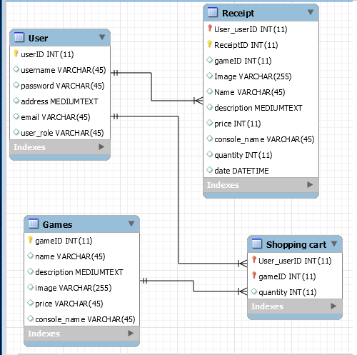

## UI Screen Mockups



