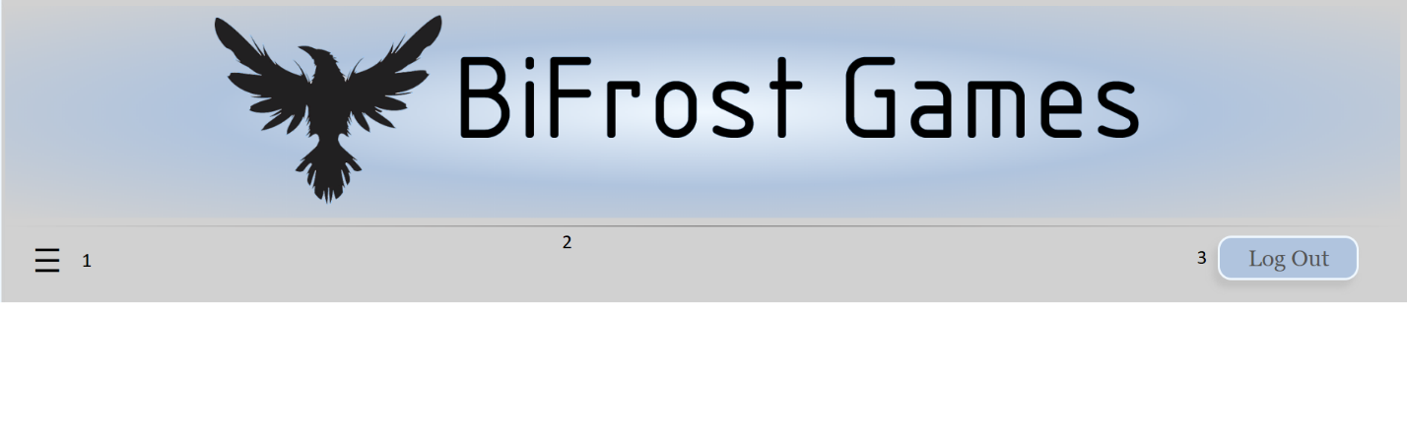

1. Opens the Navigation Sidebar
2. Header goes to products page
3. Log Out/Login to account

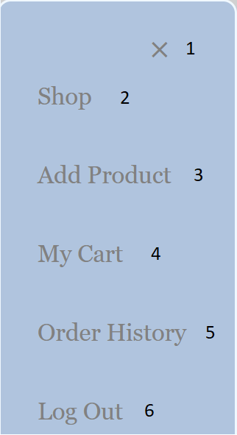

1. Closes the Sidebar
2. Goes to the products page
3. Add a new product (Admin Only)
4. View your Cart
5. View your Order History
6. Logout/Login to account

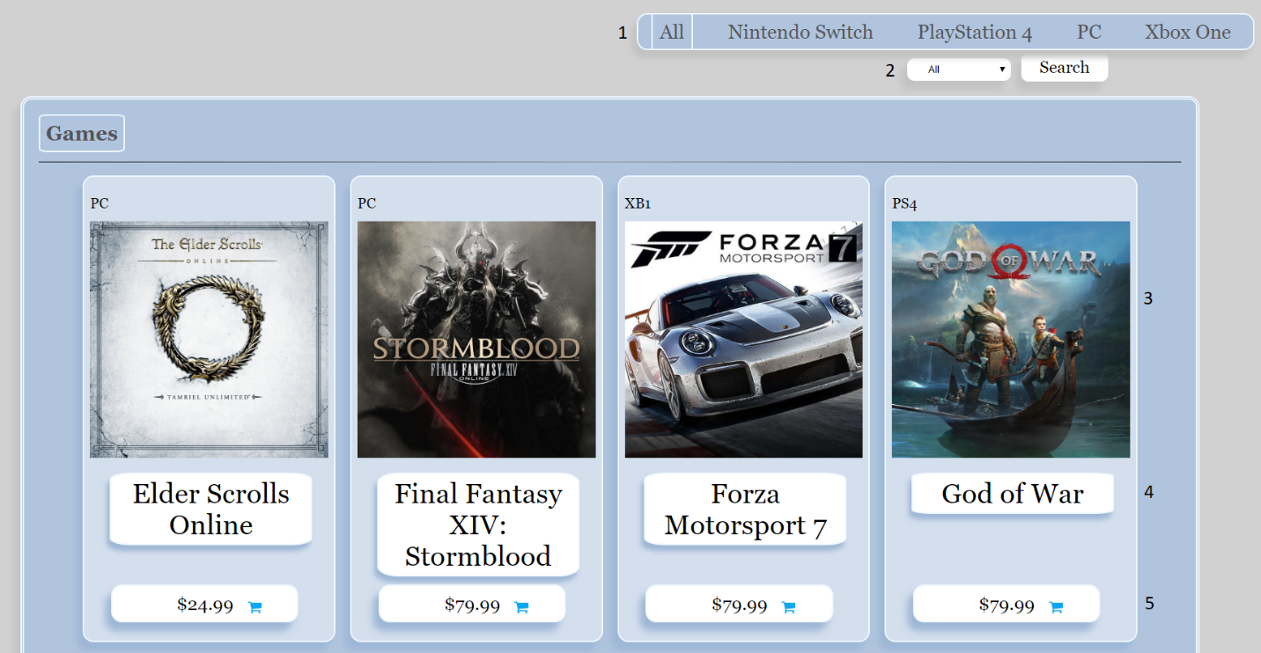

1. Select console category
2. Select Sub-Category
3. Image links to individual product page
4. Title links to individual product page
5. Price and Cart adds the item to your cart

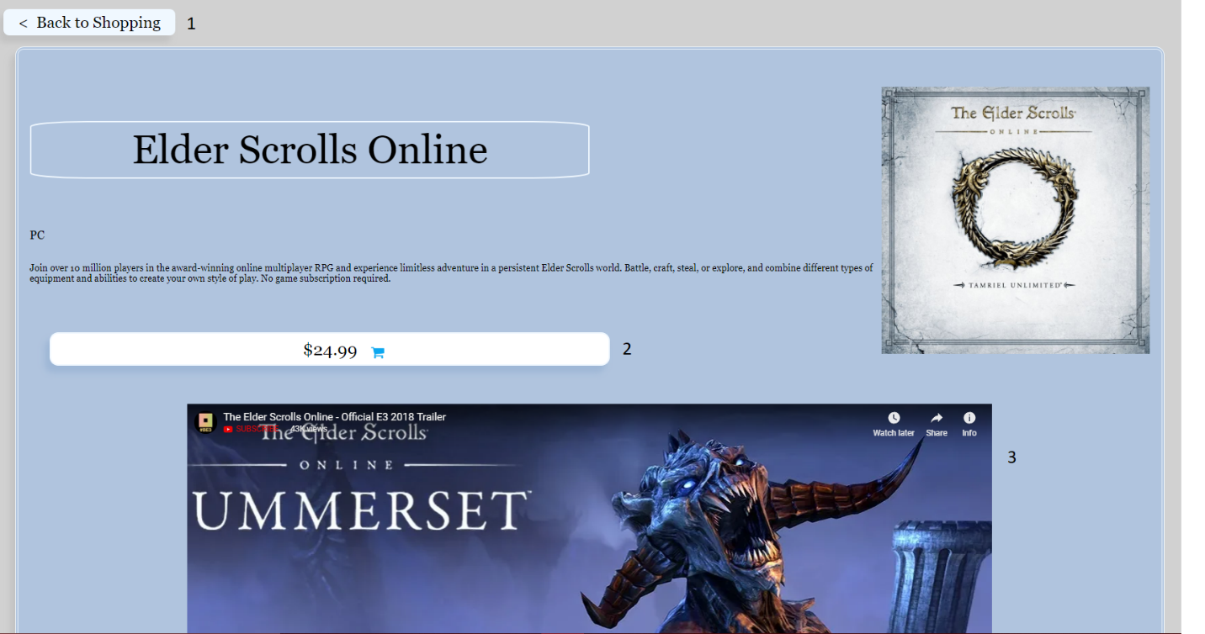

1. Go back to the products page button
2. Price and Cart adds the item to your cart
3. YouTube trailer for the game