Touchstone 3: Visual Design and Responsive Layout
STUDENT EXEMPLAR
Name | Evan Escajeda
CourseU | Introduction to Web Development
Date | 11/5/2026
Selected Client | North Star Bakery

Section 1: Preview Link and GitHub Link
Paste the GitHub Repository Link:
Working Project/Preview Link:

Section 2: Design Explanation

Respond to each prompt below. Focus on explaining your design decisions.

Your responses should reference specific elements from your website. General descriptions without examples may receive reduced credit.

Note: Your design should use 2 to 4 colors and no more than 2 font families, applied consistently across all pages.

Client Alignment

Explain how your design choices support your selected client’s goals and audience. Include at least one specific example from your website.
I believe the design choices support my selected client because of the warm, friendly, family owned style within the entire website. I also attempted to make the important features of the website such as products and mission statement clear and concise as shown within the “About” page and “Index.” Lastly I ensured users would know exactly how to get a certain product and the specific hours that the store is open.

Color Palette
The main colors are cream (#FFF8F0), brown (#6B3E26), peach (#D88C5A), and charcoal (#2F2A26). List the 2 to 4 main colors you used (you may include hex codes). Explain how these colors support your client’s tone and ensure readability. Include one example of where you applied these colors.
The main colors within the website are an orange-cream (#ffd79e), and light black (#38251b). These colors are supportive of the clients warm, welcoming, and friendly tone. The colors also contribute to the easy readability of the site with a sharp contrast of the two colors.

Typography

Identify the font or font pair you used. Explain how your choices support readability and create visual hierarchy. Include one example of how you used font size, weight, or style.
I utilized Georgia and Arial in order to establish a clear hierarchy. Furthermore, my text size also contributed to promoting an easy-to-read hierarchy for the ability to skim and still understand the given information. Lastly a good example of this is within the “Index” page, you’ll notice the “Featured Item of the Week” and “Hours and Location” which gives the user the most important parts of the page first.

Responsive Design

Describe how your layout adapts across screen sizes. Include at least one specific example of a layout, spacing, or content change.
Depending on the layout the site will adapt to the users device. This is done through either shrinking or stretching the given information to fit the device size. A good example of this change is within lines 92-98 to support mobile devices while allowing unlimited image sizes (or stretching) for large devices

Design Challenge

Describe one design challenge you encountered. Explain how you addressed it and what change you made.

The biggest challenge I had while designing this website was regarding adaptation to differing device sizes. Many syntax errors we’re present as well as a misunderstanding to how it actually worked. This problem was addressed by further studying and eventually adding an unlimited width property (stretching) to each element, as well as adding a conditional response (shrinking) for mobile devices.

Section 3: Submission Checklist
X Updated HTML files
X External CSS file
X Working preview link = https://84nqb4q4-5500.usw3.devtunnels.ms/
X Consistent color palette (2–4 colors)
X Consistent typography (1–2 fonts)
X Styles applied across all pages
X Flexbox used in layout
X At least one media query
X Readable text with sufficient contrast
X Completed design explanation

Section 4: Screenshot
I chose my mobile layout!
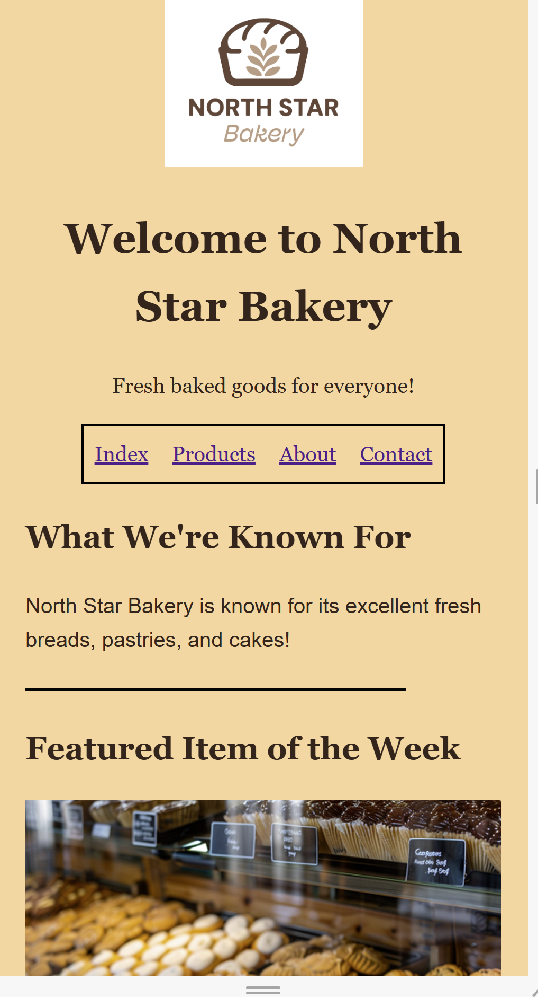

Section 5: Final Review
X All pages display correctly
X Navigation works across all pages
X Layout adjusts across screen sizes
X Design is consistent and readable

