**Proposal for ECE 4513 Final Project 2022**

**Names & IDs:** Yifan WU 119010341, Yulong DAI 119010054, Yifan WANG 119010317

**Title:** Bring old videos back to life -- Customized video colorization

**Description:**

Image colorization is the process of estimating RGB colors for grayscale images or video frames to improve their aesthetic and perceptual quality. Deep learning techniques for image colorization have progressed notably over the last decade. Our project aims to raise a colorization method for portraits videos, which has an interactive interface to allow users to color hair, skin, clothes, and background for portrait. Specifically, image segmentation and end-to-end deep learning techniques will be used in the project.

**Task and goal**

Here, we propose a *User Guided Video Colorization* based on color palette. The system enables to recognize all important parts of image. The user can depict any part of the person in any color. In this way, an old video is revitalized and turned into a new color video.

**Dataset and experiment**

Our dataset is the Hollywood2 dataset used in Bo, Zhang’s paper. [1] The dataset consists of portraits videos collected mainly from movie clips.

The video will be divided into frames. In each frame the photo will be segmented into our normalized semantic framework and be processed into different image layers. Different layers will be colorized in reference to the corresponding exemplar uploaded by the user.

The colorization algorithm contains two processes. The first is to build a semantic correspondence map and generate an aligned color reference, which yields a warped color image and a confidence map. Then we use our colorization network to combine the confidence map along with the last frame to colorize the next frame.

**Expected results**

The input image will be first divided into 4 parts, hair, skin, clothes, and background. Then users can feel free to select a reference image for each of these parts. The proposed algorithm can color the input image based on the reference image. See Figure 1, different reference images will lead to different results.

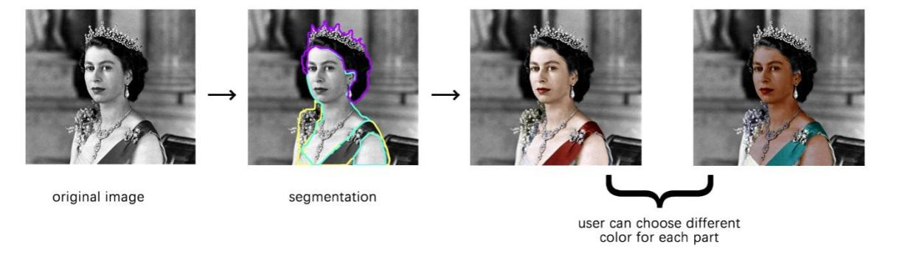

Figure 1. Example image and its different outputs

**Tentative Timeline/To-do lists:**

Nov 14 – Nov 17: Investigation

Nov 17 – Nov 20: Build up codebase and get down to datasets

Nov 21 – Dec 01: Develop segmentation and colorization idea

Dec 02 – Dec 09: Experiments

Dec 10 – Dec 15: Develop the interactive interface

**Reference:**

1. Zhang, B., He, M., Liao, J., Sander, P. V., Yuan, L., Bermak, A., & Chen, D. (2019). Deep exemplar-based video colorization. In Proceedings of the IEEE/CVF Conference on Computer Vision and Pattern Recognition (pp. 8052-8061)