**Task Manager Website**

1. Project Summary

1.1 Project Overview

The Task Management System is a comprehensive solution designed to assist individuals or teams in efficiently organizing, tracking, and managing tasks or projects. It offers a user-friendly interface accessible via web browsers or mobile applications, allowing users to create, assign, prioritize, and monitor tasks in real-time.

A project management system streamlines project management, coordinates project team membership, improves productivity, and ensures efficiency, making it an essential tool for individuals and organizations managing projects of all sizes and complexities on any of these

1.2 Project Scope

Project management systems are designed to provide comprehensive solutions for individuals or teams to plan, track and manage tasks or projects effectively. Here is an overview of the main features and functionality of the project:

User authentication: The system provides a secure login mechanism where users can authenticate with a username and password. This ensures that only authorized individuals have access to the system.

Creating and assigning tasks: Users can create new tasks in the system, assign them to team members, and assign deadlines. Tasks can be broken down by task, priority, or status, allowing for better planning and prioritization.

Job Monitoring and Monitoring: The system allows users to monitor the progress of projects in real time. Users can view project status, view completed tasks, and identify pending or past due tasks, to better track project progress.

Discussion and interaction: Users can collaborate with team members by sharing job descriptions, editing notes or attachments, and discussing topics related to the project on the forum of the This creates effective communication and teamwork.

Reminders and notifications: The system sends reminders and notifications to users about upcoming deadlines, activities, or changes in work status. This helps users stay informed and allows tasks to be completed in a timely manner.

Customization and personalization: Users have the ability to customize the workflow. This includes tailoring work breakdowns, priorities, and reporting formats to individual or team needs.

Reporting and Analytics: The system generates special reviews and analytics to provide insights into venture overall performance, crew productiveness, and venture development. Users can analyze records to identify traits, bottlenecks, or regions for improvement, permitting better decision-making.

Integration and Accessibility: The task management machine seamlessly integrates with other tools or programs along with calendars, emails, and challenge management software. It is offered across more than one gadgets, along with desktop computers, drugs, and smartphones, making sure flexibility and comfort for users.

2.0 General Description

2.1 Product Functions Overview

**Types of users/actors**

**1.Team Leader**

2.Team Members

**Admin features**

1. Create new projects
2. Add these projects to the dashboard
3. Add team members

**Student features**

1. View the projects
2. Send completed work to leader
3. Communicate with other members

2.**2     User interface Design**

Design using paper and pencil and upload here.  Label the screens properly

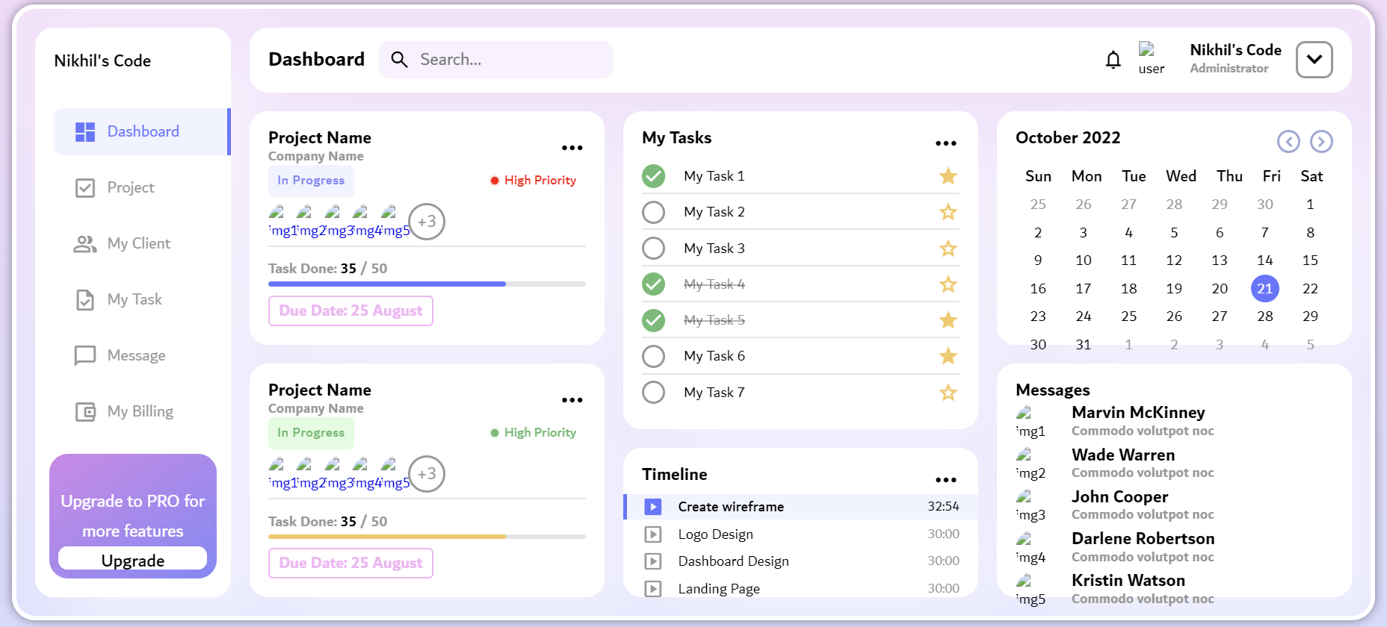

 This image needs to draw as a rough sketch and submitted in the report

2.3    **Link to the developer’s website**

This is your personnel website and should have your resume designed well