**Geodatabase/Fire History Lab – Total Marks**

**Q1: (2) deduct 0.5 for each wrong answer**DMB_POP_PN_point = Canada_Cities  
DRPMFFRZNS_polygon = BC_fire_districts  
H_FIRE_PLY = Historical_fire  
HWY_PRFLS = highways  
main_BC_boundary = BC_boundary

**Screenshot of the Catalog pane (2)  
-must show entire Lab2 folder and expand the geodatabse to show all layers have been imported**

**Q2:** Input features: BC cities, Clip features: BC boundary **(2)**

**Q3: 4185**

**Q4: Lightning**

**Q5: 2018, 680**

**Q6: 2018, 1350807 ha**

**Q7: Kamloops Fire Centre, Merritt Fire Zone**

**Q8: Prince George, 1206**

**Q9: Cariboo total 3044153 ha, Northwest mean 4575 ha**

**Q10: Line chart showing sum of burned area in ha over time with correctly labeled axes. (3)**

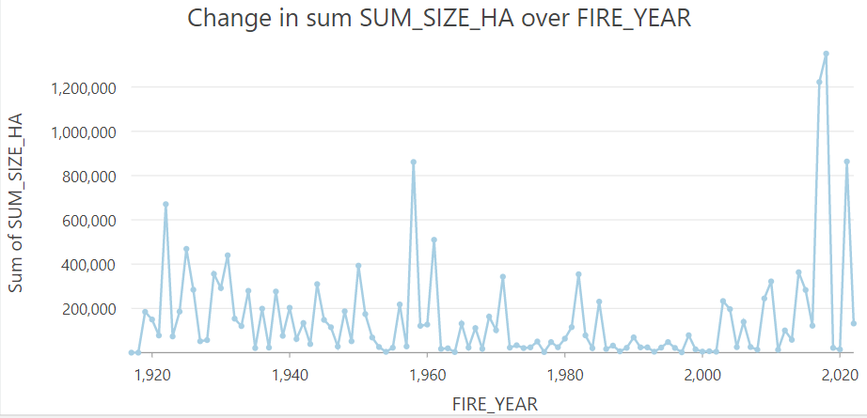

**-They should be able to describe some of the patterns below (do not have to include as much detail for full marks): (5)**

**They can note that prior to the 1970’s there is fluctuating annual burned area, perhaps a couple years with large burned areas but overall no trend. Starting in the 1970’s you can see the effect of fire suppression resulting in very low total burned area between 1970’s to early 2000’s. Next they should note a sequence of very high annual burn areas in 2017, 2018 and 2021 which are all in the top 5 annual burned area for the entire time period! They can relate these intense fire seasons to the impacts of climate change as well as historic fire suppression in BC, and the accumulation of flammable debris. They can also note that fire suppression is intimately linked with colonization and the removal of Indigenous peoples from land management across BC who had been practicing fire management for 1000’s of years.**

**Final map (15)**

**-must include title, legend, scalebar, north arrow, inset map**