# ClassTreeAssign1

## Mod 4 Assin 1

### Evan Hildreth

library(tidyverse)

## -- Attaching packages --------------------------------------- tidyverse 1.3.1 --

## v ggplot2 3.3.5 v purrr 0.3.4  
## v tibble 3.1.6 v dplyr 1.0.7  
## v tidyr 1.2.0 v stringr 1.4.0  
## v readr 2.1.2 v forcats 0.5.1

## -- Conflicts ------------------------------------------ tidyverse_conflicts() --  
## x dplyr::filter() masks stats::filter()  
## x dplyr::lag() masks stats::lag()

library(tidymodels)

## Registered S3 method overwritten by 'tune':  
## method from   
## required_pkgs.model_spec parsnip

## -- Attaching packages -------------------------------------- tidymodels 0.1.4 --

## v broom 0.7.12 v rsample 0.1.1   
## v dials 0.1.0 v tune 0.1.6   
## v infer 1.0.0 v workflows 0.2.4   
## v modeldata 0.1.1 v workflowsets 0.1.0   
## v parsnip 0.1.7 v yardstick 0.0.9   
## v recipes 0.1.17

## -- Conflicts ----------------------------------------- tidymodels_conflicts() --  
## x scales::discard() masks purrr::discard()  
## x dplyr::filter() masks stats::filter()  
## x recipes::fixed() masks stringr::fixed()  
## x dplyr::lag() masks stats::lag()  
## x yardstick::spec() masks readr::spec()  
## x recipes::step() masks stats::step()  
## * Dig deeper into tidy modeling with R at https://www.tmwr.org

library(caret)

## Loading required package: lattice

##   
## Attaching package: 'caret'

## The following objects are masked from 'package:yardstick':  
##   
## precision, recall, sensitivity, specificity

## The following object is masked from 'package:purrr':  
##   
## lift

library(rpart)

##   
## Attaching package: 'rpart'

## The following object is masked from 'package:dials':  
##   
## prune

library(rpart.plot)  
library(RColorBrewer)

heart_disease <- read_csv("heart_disease-1.csv")

## Rows: 918 Columns: 12

## -- Column specification --------------------------------------------------------  
## Delimiter: ","  
## chr (5): Sex, ChestPainType, RestingECG, ExerciseAngina, ST_Slope  
## dbl (7): Age, RestingBP, Cholesterol, FastingBS, MaxHR, Oldpeak, HeartDisease

##   
## i Use `spec()` to retrieve the full column specification for this data.  
## i Specify the column types or set `show_col_types = FALSE` to quiet this message.

heart_disease <- heart_disease %>% mutate(Sex = as_factor(Sex)) %>%   
 mutate(ChestPainType = as_factor(ChestPainType)) %>%   
 mutate(RestingECG = as_factor(RestingECG)) %>%   
 mutate(ExerciseAngina = as_factor(ExerciseAngina)) %>%   
 mutate(HeartDisease = as_factor(HeartDisease)) %>%   
 mutate(HeartDisease = fct_recode(HeartDisease, "No" = "0", "Yes" = "1"))

### Task 1

set.seed(12345)  
tearing_my_heart_up <- initial_split(heart_disease, prop = 0.7, strata = HeartDisease)  
heart_disease_training <- training(tearing_my_heart_up)  
heart_disease_testing <- testing(tearing_my_heart_up)

### Task 2

heart_disease_recipe1 <- recipe(HeartDisease ~ ., heart_disease)  
  
Tree_model <- decision_tree() %>%   
 set_engine("rpart", model = TRUE) %>%   
 set_mode("classification")  
  
heart_disease_wflow1 <-   
 workflow() %>%   
 add_model(Tree_model) %>%   
 add_recipe(heart_disease_recipe1)  
  
heart_disease_fit <- fit(heart_disease_wflow1, heart_disease_training)  
  
heart_disease_pluck <- heart_disease_fit %>%   
 pull_workflow_fit() %>%   
 pluck("fit")

## Warning: `pull_workflow_fit()` was deprecated in workflows 0.2.3.  
## Please use `extract_fit_parsnip()` instead.

rpart.plot(heart_disease_pluck)

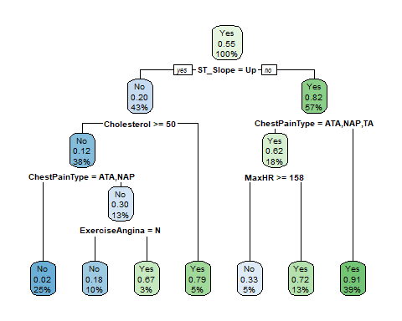

### Task 3

heart_disease_fit$fit$fit$fit$cptable

## CP nsplit rel error xerror xstd  
## 1 0.57491289 0 1.0000000 1.0000000 0.04389406  
## 2 0.06620209 1 0.4250871 0.4250871 0.03463635  
## 3 0.01742160 2 0.3588850 0.3588850 0.03240139  
## 4 0.01219512 4 0.3240418 0.3902439 0.03350407  
## 5 0.01000000 6 0.2996516 0.3937282 0.03362154

The CP value that corresponds with the smallest xerror value (0.3588850) is 0.01742160.

### Task 4

set.seed(123)  
folds <- vfold_cv(heart_disease_training, v = 5)  
  
heart_disease_recipe2 <- recipe(HeartDisease ~., heart_disease) %>%  
 step_dummy(all_nominal(),-all_outcomes())  
  
tree_model2 <- decision_tree(cost_complexity = tune()) %>%   
 set_engine("rpart", model = TRUE) %>%   
 set_mode("classification")  
  
  
heart_disease_grid <- grid_regular(cost_complexity(), levels = 25)  
   
heart_disease_wflow2 <-   
 workflow() %>%   
 add_model(tree_model2) %>%   
 add_recipe(heart_disease_recipe2)  
  
heart_disease_res <-   
 heart_disease_wflow2 %>%   
 tune_grid(  
 resamples = folds,  
 grid = heart_disease_grid  
 )  
  
heart_disease_res

## # Tuning results  
## # 5-fold cross-validation   
## # A tibble: 5 x 4  
## splits id .metrics .notes   
## <list> <chr> <list> <list>   
## 1 <split [513/129]> Fold1 <tibble [50 x 5]> <tibble [0 x 1]>  
## 2 <split [513/129]> Fold2 <tibble [50 x 5]> <tibble [0 x 1]>  
## 3 <split [514/128]> Fold3 <tibble [50 x 5]> <tibble [0 x 1]>  
## 4 <split [514/128]> Fold4 <tibble [50 x 5]> <tibble [0 x 1]>  
## 5 <split [514/128]> Fold5 <tibble [50 x 5]> <tibble [0 x 1]>

heart_disease_res %>%  
 collect_metrics() %>%  
 ggplot(aes(cost_complexity, mean)) +  
 geom_line(size = 1.5, alpha = 0.6) +  
 geom_point(size = 2) +  
 facet_wrap(~ .metric, scales = "free", nrow = 2)

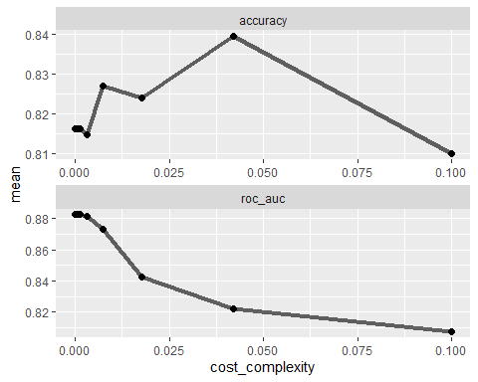 ### Task 5 Looking at the above graphs it appears that CP value ~ 0.04 looks to provide the optimal accuracy value.

### Task 6

best_tree_HDR <- heart_disease_res %>%  
 select_best("accuracy")  
  
best_tree_HDR

## # A tibble: 1 x 2  
## cost_complexity .config   
## <dbl> <chr>   
## 1 0.0422 Preprocessor1_Model24

final_wf <-   
 heart_disease_wflow2 %>%   
 finalize_workflow(best_tree_HDR)  
  
final_fit_HDR = fit(final_wf, heart_disease_training)  
  
tree_HDR = final_fit_HDR %>%   
 pull_workflow_fit() %>%   
 pluck("fit")

## Warning: `pull_workflow_fit()` was deprecated in workflows 0.2.3.  
## Please use `extract_fit_parsnip()` instead.

rpart.plot(tree_HDR, tweak = 1.5)

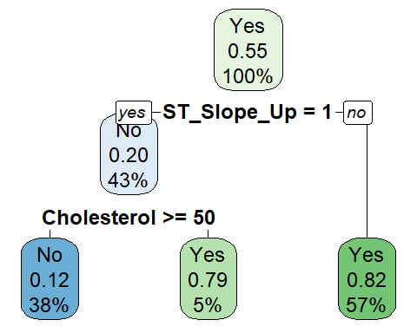

### Task 7

HDR_predict <- predict(final_fit_HDR, heart_disease_training, type = "class")  
head(HDR_predict)

## # A tibble: 6 x 1  
## .pred_class  
## <fct>   
## 1 No   
## 2 No   
## 3 No   
## 4 No   
## 5 No   
## 6 No

confusionMatrix(HDR_predict$.pred_class, heart_disease_training$HeartDisease, positive = "Yes")

## Confusion Matrix and Statistics  
##   
## Reference  
## Prediction No Yes  
## No 213 29  
## Yes 74 326  
##   
## Accuracy : 0.8396   
## 95% CI : (0.8088, 0.8671)  
## No Information Rate : 0.553   
## P-Value [Acc > NIR] : < 2.2e-16   
##   
## Kappa : 0.6705   
##   
## Mcnemar's Test P-Value : 1.455e-05   
##   
## Sensitivity : 0.9183   
## Specificity : 0.7422   
## Pos Pred Value : 0.8150   
## Neg Pred Value : 0.8802   
## Prevalence : 0.5530   
## Detection Rate : 0.5078   
## Detection Prevalence : 0.6231   
## Balanced Accuracy : 0.8302   
##   
## 'Positive' Class : Yes   
##

Running a confusion matrix on the mode (prior to it being plucked) we find that the model has an accuracy of 0.8396.

### Task 8

Blood <- read_csv("Blood.csv")

## Rows: 748 Columns: 5

## -- Column specification --------------------------------------------------------  
## Delimiter: ","  
## dbl (5): Mnths_Since_Last, TotalDonations, Total_Donated, Mnths_Since_First,...

##   
## i Use `spec()` to retrieve the full column specification for this data.  
## i Specify the column types or set `show_col_types = FALSE` to quiet this message.

Blood <- Blood %>% mutate(DonatedMarch = as_factor(DonatedMarch)) %>%   
 mutate(DonatedMarch = fct_recode(DonatedMarch, "No" = "0", "Yes" = "1"))

### Task 9

set.seed(1234)  
Blood_spilt <- initial_split(Blood, prop = 0.7, strata = DonatedMarch)  
Blood_training <- training(Blood_spilt)  
Blood_testing <- testing(Blood_spilt)

set.seed(1234)  
blood_folds <- vfold_cv(Blood_training, v = 5)  
  
blood_recipe <- recipe(DonatedMarch ~., Blood) %>%  
 step_dummy(all_nominal(),-all_outcomes())  
  
blood_model <- decision_tree(cost_complexity = tune()) %>%   
 set_engine("rpart", model = TRUE) %>%   
 set_mode("classification")  
  
  
blood_grid <- grid_regular(cost_complexity(), levels = 25)  
   
blood_wflow <-   
 workflow() %>%   
 add_model(blood_model) %>%   
 add_recipe(blood_recipe)  
  
Blood_res <-   
 blood_wflow %>%   
 tune_grid(  
 resamples = blood_folds,  
 grid = blood_grid  
 )  
  
Blood_res

## # Tuning results  
## # 5-fold cross-validation   
## # A tibble: 5 x 4  
## splits id .metrics .notes   
## <list> <chr> <list> <list>   
## 1 <split [418/105]> Fold1 <tibble [50 x 5]> <tibble [0 x 1]>  
## 2 <split [418/105]> Fold2 <tibble [50 x 5]> <tibble [0 x 1]>  
## 3 <split [418/105]> Fold3 <tibble [50 x 5]> <tibble [0 x 1]>  
## 4 <split [419/104]> Fold4 <tibble [50 x 5]> <tibble [0 x 1]>  
## 5 <split [419/104]> Fold5 <tibble [50 x 5]> <tibble [0 x 1]>

Blood_res %>%  
 collect_metrics() %>%  
 ggplot(aes(cost_complexity, mean)) +  
 geom_line(size = 1.5, alpha = 0.6) +  
 geom_point(size = 2) +  
 facet_wrap(~ .metric, scales = "free", nrow = 2)

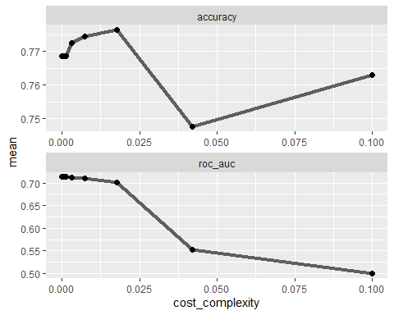 Looking at the chart above, it seems the cp value of roughly ~0.020 possesses the highest accuracy rating.

best_bloody_tree <- Blood_res %>%  
 select_best("accuracy")  
  
best_bloody_tree

## # A tibble: 1 x 2  
## cost_complexity .config   
## <dbl> <chr>   
## 1 0.0178 Preprocessor1_Model23

Bloody_final_wf <-   
 blood_wflow %>%   
 finalize_workflow(best_bloody_tree)  
  
bloody_fit = fit(Bloody_final_wf, Blood_training)  
  
Bloody_tree_fit = bloody_fit %>%   
 pull_workflow_fit() %>%   
 pluck("fit")

## Warning: `pull_workflow_fit()` was deprecated in workflows 0.2.3.  
## Please use `extract_fit_parsnip()` instead.

rpart.plot(Bloody_tree_fit, tweak = 1.5)

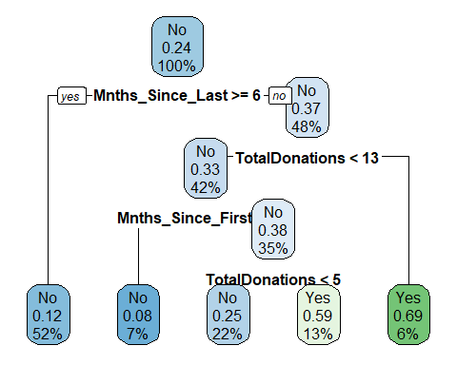 ### Task 11

Blood_predict <- predict(bloody_fit, Blood_training, type = "class")  
head(Blood_predict)

## # A tibble: 6 x 1  
## .pred_class  
## <fct>   
## 1 Yes   
## 2 Yes   
## 3 Yes   
## 4 Yes   
## 5 Yes   
## 6 Yes

confusionMatrix(Blood_predict$.pred_class, Blood_training$DonatedMarch, positive = "Yes")

## Confusion Matrix and Statistics  
##   
## Reference  
## Prediction No Yes  
## No 361 63  
## Yes 38 61  
##   
## Accuracy : 0.8069   
## 95% CI : (0.7704, 0.8399)  
## No Information Rate : 0.7629   
## P-Value [Acc > NIR] : 0.009214   
##   
## Kappa : 0.4263   
##   
## Mcnemar's Test P-Value : 0.016936   
##   
## Sensitivity : 0.4919   
## Specificity : 0.9048   
## Pos Pred Value : 0.6162   
## Neg Pred Value : 0.8514   
## Prevalence : 0.2371   
## Detection Rate : 0.1166   
## Detection Prevalence : 0.1893   
## Balanced Accuracy : 0.6983   
##   
## 'Positive' Class : Yes   
##

With the blood dataset and the blood model (essentially the same as the tree_model2 just renamed) we get an accuracy of 0.8069 which is slightly lower than the accuracy received on the heart_disease dataset (0.8396 accuracy).

In addition, while the P value for both datasets with the model is significant, it is much better on heart disease dataset than the blood one.