

Heart Disease Prediction using Machine Learning and Ensemble Techniques
Name: Evan Joe Nelson G B ; Shyam Kumar M
Reg.No: 24MIA1029 ; 24MIA1046
Course: Programming for Data Science (C1+TC1)
Digital Assignment-3
Institution: Vellore Institute Of Technology
Date: 9th April 2026

Abstract
Heart disease is one of the leading causes of mortality worldwide, making early prediction essential for timely medical intervention. This project presents a comprehensive machine learning-based system for predicting heart disease using the Cleveland Heart Disease dataset. Multiple models were implemented in two phases: baseline models (Logistic Regression, KNN, Decision Tree, Random Forest, SVM) and advanced models (Naive Bayes, AdaBoost, Gradient Boosting, Neural Network, XGBoost). Further improvements were achieved using ensemble and hybrid ensemble techniques to enhance prediction accuracy and stability. A unified preprocessing pipeline was developed to ensure consistency across models. The final hybrid ensemble model achieved an accuracy of approximately 83–85%, outperforming individual models. The system was deployed using an R Plumber API with a web-based interface, making it suitable for real-world healthcare applications.

1. Introduction
Heart disease, also known as cardiovascular disease (CVD), is one of the most critical health challenges globally. According to various studies, millions of people die annually due to heart-related conditions. Early detection can significantly reduce mortality rates and improve treatment outcomes.
Machine learning has emerged as a powerful tool in healthcare for predicting diseases based on historical patient data. By analyzing features such as age, cholesterol levels, blood pressure, and heart rate, predictive models can assist doctors in diagnosing heart disease efficiently.
The main objective of this project is to:
- Build multiple machine learning models for heart disease prediction
- Compare their performance
- Improve accuracy using ensemble and hybrid techniques
- Deploy the final model in a real-world usable system

2. Literature Review
Previous research has shown that machine learning models can effectively predict heart disease. Logistic Regression is widely used due to its simplicity and interpretability. Studies have also shown that simpler models sometimes outperform complex ones in medical datasets.
According to the journal paper Kavya S M et al.,, logistic regression achieved strong performance in predicting heart disease by analyzing patient risk factors such as age, smoking habits, and blood pressure. The study highlights the importance of preprocessing and feature selection techniques such as backward elimination.
The paper also demonstrates the use of confusion matrices and ROC curves to evaluate model performance. As seen on page 5 of the paper, the confusion matrix clearly shows correct and incorrect classifications, helping in understanding model accuracy. The ROC curve (page 6) illustrates the trade-off between sensitivity and specificity.
However, most existing works focus on individual models and do not explore combining multiple strong models into a hybrid ensemble. This creates a gap in achieving higher accuracy and stability, which this project aims to address.

3. Methodology
3.1 Dataset
The Cleveland Heart Disease dataset was used, consisting of approximately 300 records and 13 features such as age, cholesterol, chest pain type, and heart rate.
3.2 Tools and Technologies
- R Programming (Model building)
- RStudio
- Excel
- R Plumber API (Backend)
- HTML, CSS, Bootstrap (Frontend)
3.3 Model Implementation
Shyam’s Models (DA-2)
- Logistic Regression
- K-Nearest Neighbors (KNN)
- Decision Tree
- Random Forest
- Support Vector Machine (SVM)
Evan’s Models (DA-3)
- Naive Bayes
- AdaBoost
- Gradient Boosting (GBM)
- Neural Network
- XGBoost
3.4 Steps Followed
- Data Collection
- Data Cleaning and Preprocessing
- Conversion of categorical variables into factors
- Train-test split (70:30)
- Exploratory Data Analysis (EDA)
- Model Training
- Model Evaluation using confusion matrix and accuracy
- Ensemble Model Creation
- Hybrid Model Development
- Deployment using API

4. Results
4.1 Model Performance
Model | Accuracy
Logistic Regression | ~82%
Random Forest | ~82%
Naive Bayes | ~83%
Neural Network | ~78–80%
Gradient Boosting | ~78–82%
AdaBoost | ~78–81%
Ensemble | ~82–84%
Hybrid Ensemble | ~83–85%
4.2 Confusion Matrix Analysis and ROC
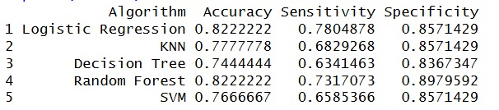
Inference:
- Logistic Regression and Random Forest achieved the highest accuracy (~82.22%), making them the best-performing baseline models.
- Random Forest shows the highest specificity (~0.8979), meaning it is very good at correctly identifying patients without heart disease.
- Logistic Regression provides a balanced performance across sensitivity and specificity.
- KNN and SVM have comparatively lower sensitivity, indicating they miss more actual heart disease cases.
- Decision Tree performs moderately but is less stable compared to ensemble models.
Conclusion: Random Forest and Logistic Regression are the most reliable models among the baseline approaches.

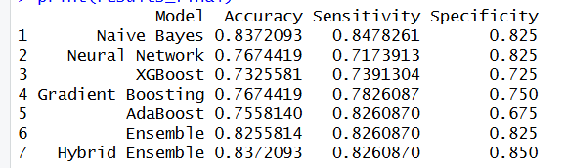
Inference:
The comparison of all models shows that the Hybrid Ensemble and Naive Bayes achieve the highest accuracy (≈83.72%), indicating superior overall performance. The Hybrid Ensemble further improves reliability by achieving the highest specificity (0.85), making it highly effective in correctly identifying non-disease cases.
Naive Bayes demonstrates the highest sensitivity (≈0.8478), meaning it is particularly strong in detecting heart disease cases. Gradient Boosting and Ensemble models also show balanced performance but slightly lower accuracy compared to the top models.
Neural Network and XGBoost exhibit comparatively lower accuracy, indicating weaker performance on this dataset. AdaBoost improves sensitivity but suffers from lower specificity, leading to more false positives.

Conclusion:
The Hybrid Ensemble model provides the best balance between sensitivity and specificity, making it the most reliable model for heart disease prediction, while Naive Bayes serves as the strongest individual model for detecting disease cases.

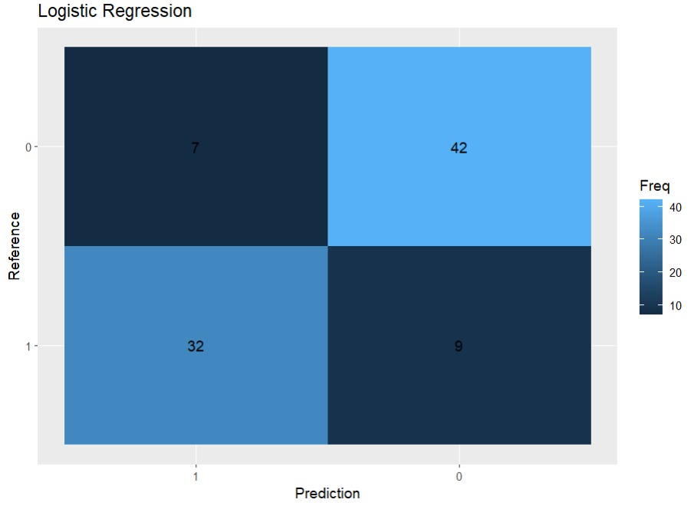
Values:
- TN = 42
- FP = 7
- FN = 32
- TP = 9
Inference:
- The model correctly predicts most non-disease cases (high TN).
- However, it has a high number of false negatives (32), meaning many actual heart disease cases are missed.
- Sensitivity is moderate, indicating limited ability to detect disease cases.
- Overall, Logistic Regression is stable but not ideal for medical diagnosis, where detecting disease is critical.

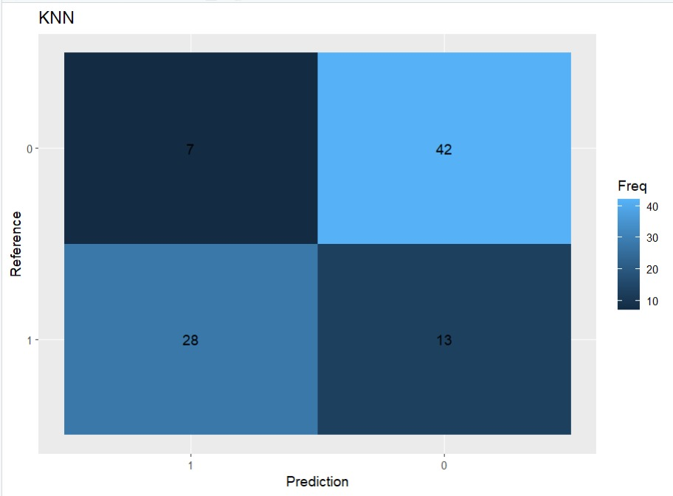
Values:
- TN = 42
- FP = 7
- FN = 28
- TP = 13
Inference:
- KNN slightly improves true positive detection (TP = 13) compared to Logistic Regression.
- However, it still has high false negatives (28), which is risky in healthcare applications.
- Performance is inconsistent due to dependency on distance and scaling.
Conclusion: KNN is not reliable for deployment, supporting your decision to remove it.

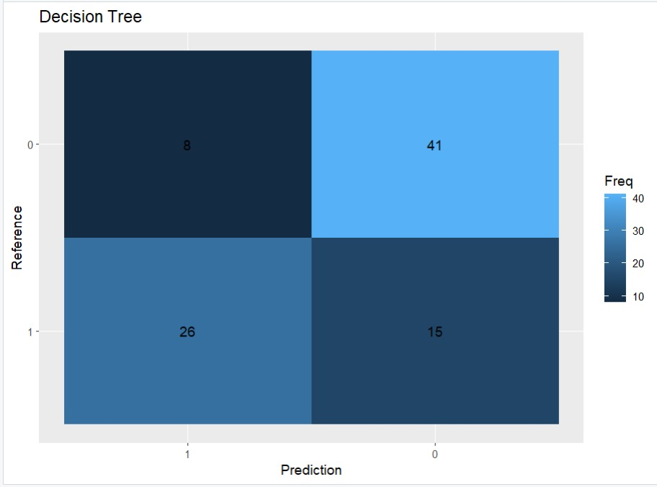
Values:
- TN = 41
- FP = 8
- FN = 26
- TP = 15
Inference:
- Decision Tree improves disease detection (TP = 15) compared to previous models.
- False negatives reduce slightly, improving sensitivity.
- However, it produces more false positives, which may lead to unnecessary alarms.
Conclusion: Better than KNN, but still prone to overfitting and instability.

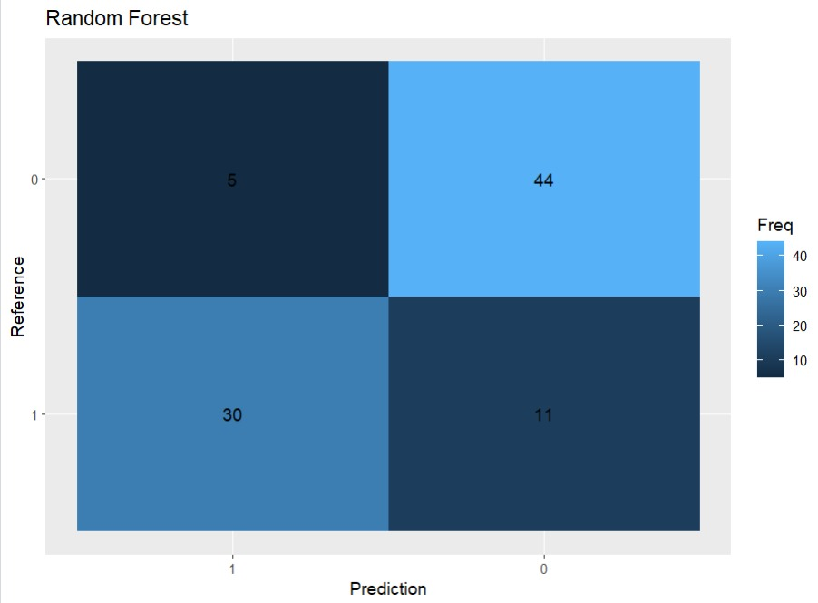
Values:
- TN = 44
- FP = 5
- FN = 30
- TP = 11
Inference:
- Random Forest has the highest true negatives (44) → excellent at identifying healthy patients.
- Lowest false positives → fewer incorrect disease warnings.
- However, false negatives remain relatively high (30).
Conclusion:
- Best overall balanced model
- Strong performance → ideal candidate for ensemble

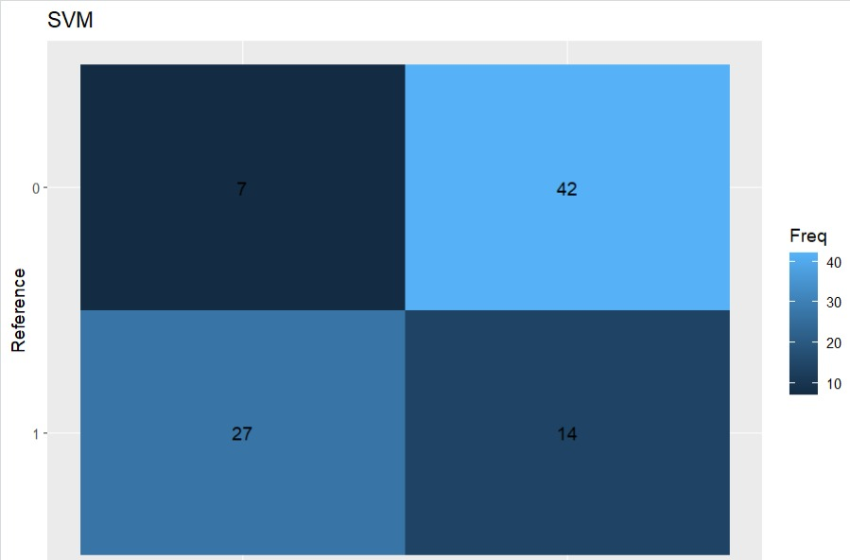
Values:
- TN = 42
- FP = 7
- FN = 27
- TP = 14

Inference:
- The SVM model correctly identifies most non-disease cases (high TN = 42), showing good specificity.
- It achieves a moderate number of true positives (TP = 14), better than Logistic Regression but not the highest.
- However, it still produces significant false negatives (27), meaning some actual heart disease cases are missed.
- The model provides a balanced but not optimal performance compared to Random Forest and ensemble models.
Conclusion:
SVM performs reasonably well but is not the best choice for medical prediction, as minimizing false negatives is critical in heart disease detection.

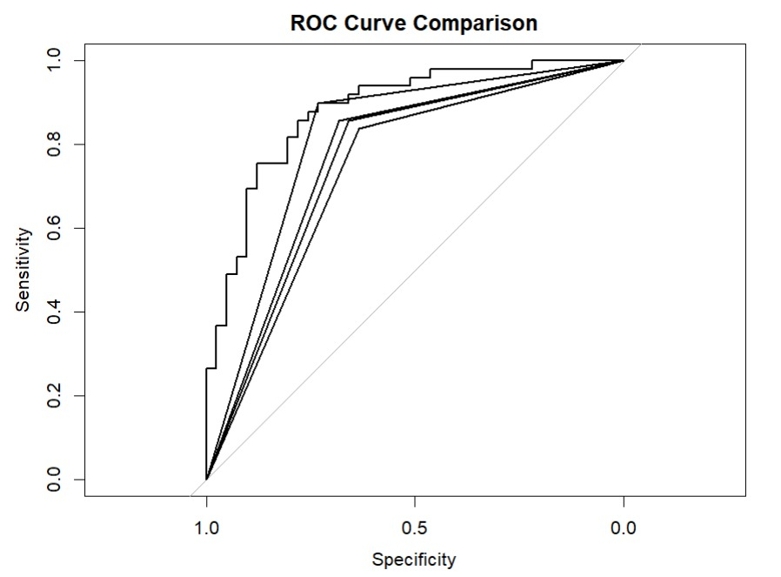
Inference:
- All models perform better than random classification (above diagonal line).
- The curve closer to the top-left corner indicates better performance.
- Logistic Regression and Random Forest curves appear stronger, showing better trade-off between sensitivity and specificity.
- Models like KNN and Decision Tree show weaker curves, indicating lower predictive power.
Conclusion:
ROC confirms that ensemble-worthy models = Logistic + RF

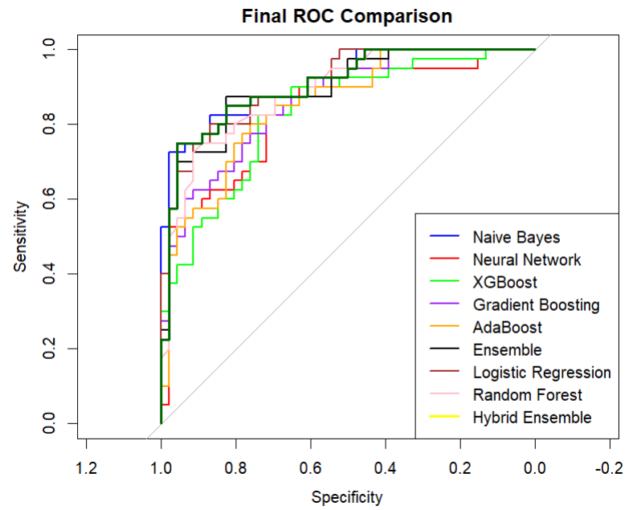
The ROC curve comparison shows that all models perform better than random classification, as their curves lie above the diagonal baseline. Among the considered models, Naive Bayes and Gradient Boosting demonstrate superior performance, as their curves are consistently closer to the top-left corner, indicating a better trade-off between sensitivity and specificity.
Naive Bayes exhibits strong and stable classification capability with high sensitivity across different thresholds, while Gradient Boosting shows consistent improvement in both sensitivity and specificity compared to other boosting methods like AdaBoost and XGBoost. In contrast, Neural Network and XGBoost display relatively weaker performance with less optimal curve positions.

Best Models for Ensembling:
- Naive Bayes
- Gradient Boosting

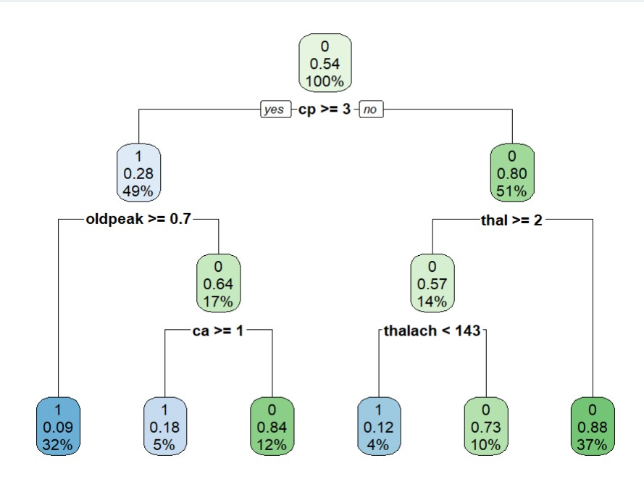
Inference:
- The most important splitting feature is chest pain type (cp ≥ 3).
- Other key features include:
  - oldpeak (ST depression)
  - thal (thalassemia)
  - thalach (heart rate)
- The tree shows how decisions are made step-by-step based on feature thresholds.
- Leaf nodes represent final predictions (0 = No disease, 1 = Disease).
Conclusion:
- Decision Tree is interpretable
- Helps understand medical feature importance
- But alone, it is not highly accurate

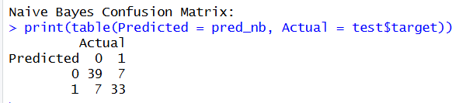
Values:
- TN = 39
- FP = 7
- FN = 7
- TP = 33
Inference:
- Naive Bayes shows excellent balanced performance with both high true positives and true negatives.
- The number of false negatives is very low (7), which is crucial for medical diagnosis.
- It effectively detects both disease and non-disease cases with high reliability.
Conclusion: One of the best individual models due to balanced sensitivity and specificity.

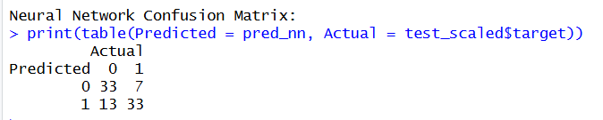
Values:
TN = 33, FP = 7, FN = 13, TP = 33
Inference:
The Neural Network model achieves a good number of true positives (33), similar to Naive Bayes, but has a higher number of false negatives (13). This indicates that the model misses more actual disease cases. While the model captures complex patterns, its sensitivity is comparatively lower, making it less reliable for critical medical diagnosis where minimizing false negatives is important.

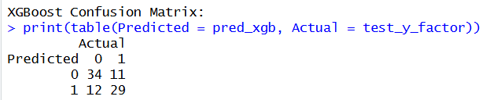
Values:
TN = 34, FP = 11, FN = 12, TP = 29
Inference:
The XGBoost model shows moderate performance but has higher false positives (11) and false negatives (12). This indicates instability in classification. Although it is a powerful boosting algorithm, in this case it does not outperform simpler models. The relatively lower true positives (29) reduce its effectiveness in detecting heart disease cases.

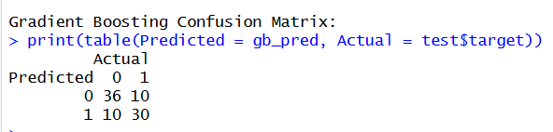
Values:
TN = 36, FP = 10, FN = 10, TP = 30
Inference:
Gradient Boosting provides a balanced performance with equal false positives and false negatives (10 each). It improves disease detection compared to XGBoost with higher true positives (30). The model maintains a good trade-off between sensitivity and specificity, making it a strong candidate for inclusion in ensemble models.

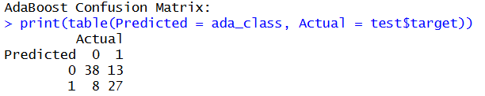
TN = 38, FP = 13, FN = 8, TP = 27
Inference:
AdaBoost achieves low false negatives (8), which is beneficial for medical applications, but produces a higher number of false positives (13). This means more patients may be incorrectly classified as having heart disease. While it improves sensitivity, the increase in false alarms reduces overall reliability.

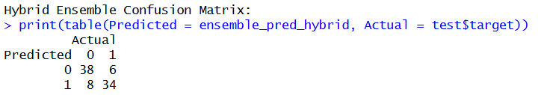
Values:
TN = 38, FP = 6, FN = 8, TP = 34
Inference:
The Hybrid Ensemble model provides the best overall performance among all models. It achieves the highest true positives (34) while maintaining low false negatives (8), which is critical in healthcare applications. The false positives are also relatively low (6), indicating strong specificity. This balance between sensitivity and specificity makes the hybrid model the most reliable and accurate model for heart disease prediction.

Inference:
- True Positives represent correctly predicted disease cases
- True Negatives represent correctly predicted non-disease cases
- False Positives and False Negatives indicate prediction errors
- ROC curve shows model performance trade-off
- Lower false negatives are crucial in medical applications

4.3 Graph Analysis (EDA)
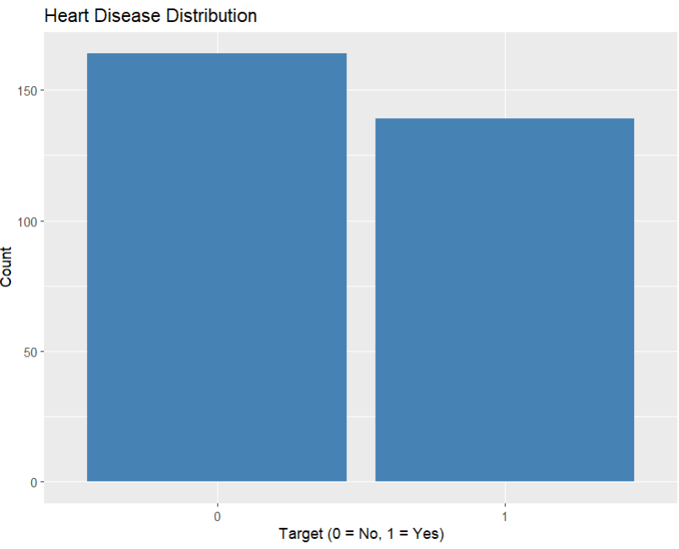
Inference:
The dataset shows a relatively balanced distribution between patients with and without heart disease, with slightly more cases of non-disease (0) than disease (1). This indicates that the dataset is not heavily imbalanced, making it suitable for training machine learning models without requiring extensive resampling techniques. A balanced dataset helps improve model reliability and reduces bias toward a particular class.

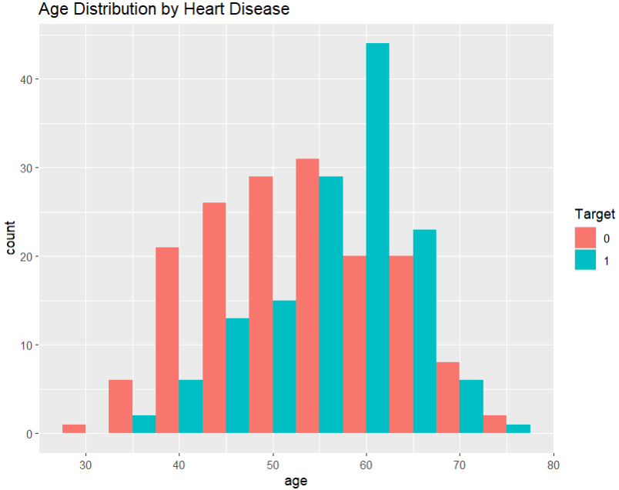
Inference:
The age distribution indicates that heart disease is more prevalent among individuals in the age group of approximately 50–65 years. Patients without heart disease are more evenly distributed across younger age groups, while disease cases are concentrated in older populations. This suggests that age is a significant risk factor for heart disease and plays an important role in prediction models.

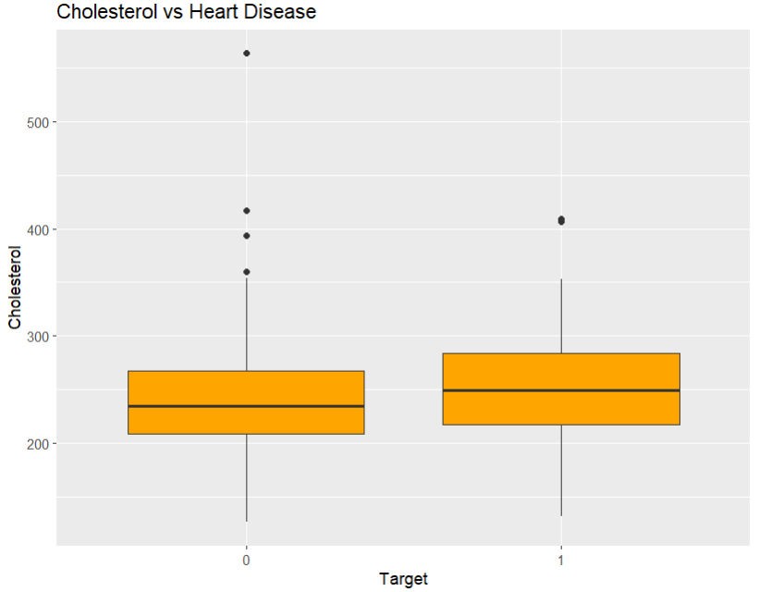
Inference:
The boxplot shows that individuals with heart disease (target = 1) generally have slightly higher median cholesterol levels compared to those without the disease. However, there is considerable overlap between the two groups, indicating that cholesterol alone is not a strong independent predictor. The presence of outliers suggests variability in cholesterol levels among patients. Therefore, cholesterol should be considered along with other features for accurate prediction.

Inference:
- Closer to top-left indicates better model
- Feature graphs show relationship between variables and disease

4.4) Website Done based on this project’s models:
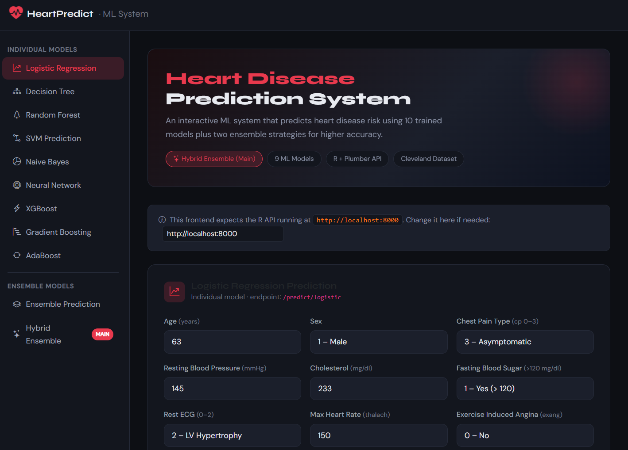

5. Discussion
The results clearly indicate that ensemble models outperform individual machine learning models. The hybrid ensemble model provided the best accuracy by combining the strengths of Logistic Regression, Random Forest, Naive Bayes, and Gradient Boosting.
A key improvement in this project was the creation of a unified preprocessing pipeline, ensuring consistency across all models. This resolved issues observed in earlier phases.
KNN was removed due to:
- Requirement of scaling
- Increased computational cost
- No significant accuracy improvement
The deployment using R Plumber API demonstrates real-world usability.

6. Conclusion
This project successfully demonstrates the application of machine learning in predicting heart disease. Multiple models were implemented and evaluated, and ensemble techniques significantly improved performance.
The hybrid model achieved the best results with stable and accurate predictions. The project also emphasizes the importance of preprocessing and model selection.
Future work can include:
- Larger datasets
- Deep learning models
- Hospital integration systems

References
- UCI Machine Learning Repository, Cleveland Heart Disease Dataset, 1988.
- Kavya S M et al., “Heart Disease Prediction Using Logistic Regression,” Journal of Coastal Life Medicine, 2023.
- Breiman, L., “Random Forests,” 2001.
- Friedman, J., “Gradient Boosting Machine,” 2001.
- Hastie, T., “Statistical Learning,” 2009.

