Evan Joseph

CIS 310, Program 3, 3/6/2017

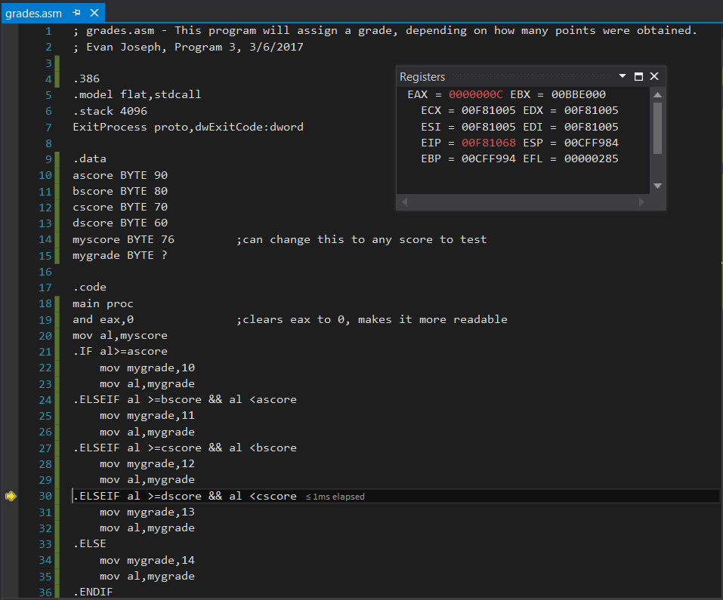

myscore is 76, so a C is assigned.

myscore is 91, so an A is assigned.

