Mobile Phone Project
Software Design Specification

Version 1.0
Revision History
Date | Version | Description | Author
05/07/15 | 0.1 (Beta) | Initial version | Evan, Kimberly
08/01/15 | 1.0 (Apple Pie) | Initial release version | Evan, Kimberly
08/08/15 | 1.1 (Apple Pie MR1) | Bug Fixes | Evan, Kimberly

Table of Contents

- INTRODUCTION 4
  - PURPOSE 4
  - SCOPE 4
  - DOCUMENT’S INTENDED AUDIENCE 4
- SYSTEM OVERVIEW 5
  - MAJOR DESIGN ATIFACTS 5
  - FUNCTIONAL REQUIREMENT 5
  - SUPPORTING MATERIALS 5
  - DEFINITION AND ACRONYMS 5
- DESIGN CONSIDERATIONS 6
  - ASSUMPTION 6
  - CONSTRAINTS 6
  - SYSTEM ENVIRONMENT 6
  - DESIGN METHODOLOGY 6
  - ANTICIPATION DURING DEVELOPMENT 6
  - RISK AND FUTURE DESIGN CHANGES 7
- ARCHITECURAL DESIGN 7
- DATABASE DESIGN………………………………………………………8
- USER INTERFACE 9
- SCENARIO 11
- LESSON LEARNED 12
Introduction

  - Purpose
The purpose of this project is to analyze the requirements of the software development for UPH. Alongside that, this project designs, implements and maintains the software development, which is designated to help in monitoring this software according to the requirements specified by the client.

  - Scope
This software will be a simulation of a mobile phone in accordance to Java programming language. There are four features presented in this software, namely, SMS, phone, phonebook, and calculator. This software was made to help users get used to mobile phone technology.
The tools and technique that will be used to design this software are as follow:
- Notepad++: This is a software that helps with the coding of the software.
- Java Development Kit (JDK): Development environment for building the software.
- Java Runtime Environment (JRE): Set of programming tools for developing the software.

  - Document’s Intended Audience
This document is written to address Mr. Robertus Hudi in order to fulfill the needs of the software documentation and to evaluate the project.

- SYSTEM OVERVIEW
  - MAJOR DESIGN ARTIFACTS
These are the major design artifacts in the software:
- SMS: This allows the mobile phone simulator to create, edit and receive text messages.
- Phone: This allows the mobile phone simulator to type in a contact’s number and calls them.
- Phonebook: This allows the mobile phone simulator to save a particular contact’s number and retrieve them whenever needed.
- Calculator: This allows the mobile phone simulator to calculate basic arithmetics in accordance to user’s input.
- FUNCTIONAL REQUIREMENTS
Functional requirements of the mobile phone project software are as follow:
  - JRE 5 or higher installed on the computer.
  - OS supports GUI and Windows Manager.
  - OS supports command prompt / terminal.
  - OS supports button clicking.
  - OS supports memory and storage.
- SUPPORTING MATERIALS
Books Reference
Alongside online resources, we have considered books as reference as well. This is the book that we have used during the design of the system:
- Joyce Farrell (2014). Java Programming. 7th ed. Boston: Course Technology.

- DEFINITION AND ACRONYMS
JDK: Java Development Kit.
JRE: Java Runtime Environment.
OS: Operating System.
GUI: Graphical User Interface.

- DESIGN CONSIDERATIONS
  - ASSUMPTION
There are several assumptions used in this design, the assumptions are:
  - The installation of JRE and JDK in the Operating System, which allows JRE and JDK able to execute this system.

  - CONSTRAINTS
There are several constraints and consideration that was taken into account as follow:
- The aesthetic concept of the system is very limited as it depends on the limited graphical design ability of our team.
- The pictures that was used in the system is not original, which means that some was taken from the internet.
- The time period for which this system should be done. It limits the capability of the team to maximize their effort before their given due date time.

  - SYSTEM ENVIRONMENT
The development process of this system is based on Java Programming Language and notepad. This software would work in an environment where:
- JDK is installed.
- JRE is installed.
  - DESIGN METHODOLOGY
UML Approach Design: Using UML language for diagram designs here.
  - ANTICIPATION DURING DEVELOPMENT
- Bug fixes and testing.
- Backing up files in GitHub, so that we can continue developing even the hardware is bricked.
- Use latest version of Java.

  - RISK AND FUTURE DESIGN CHANGES
- Security
Some programs could move some code to the same class as a private declarator, making private identifiers accessible.

4. ARCHITECTURAL DESIGN
Concise class diagram of Mobile Phone in Java:
Main Menu

Phonebook
Phone
Calculator
SMS

Class architecture in Mobile Phone.
Software Structure | Units | Components
Module | Java Files | Main Menu, Phonebook, Phone, Calculator, SMS
Conceptual | Functions | Calculator, storing data, deleting data, character counter, sms writer, phone simulator, clock.
Physical | Hardware | Hardware requirements for Java 8
Uses | JRE&JDK | Jframe, Jbutton, JGUI, Icon, Jmenu JtextArea, JtextField
Data Flow | Phonebook | Storing and deleting data in a file, read and write

This software is built in
- Programming language : Java Script.
- Java Interface language
- Data manipulation layers using file input and output.

5. Database Design
Phonebook
This table is used to store data in phonebook app.

Field | Type
Num | char(12)
Name | char(35)
Remarks:
1. Num is the phone number, used as the primary key
2. Name is the name of the contact stored.
SMS
This is used for SMS app.

Field | Type
SMSContent | String
CharCount | int
SMSCount | int
Remarks:
1. SMSContent is the contents of the SMS (used as the primary key)
2. CharCount is the number of characters in SMSContent.
3. SMSCount is the number of SMS in the SMSContent (1 SMS is 160 characters)

6. USER INTERFACE
1. MAIN MENU

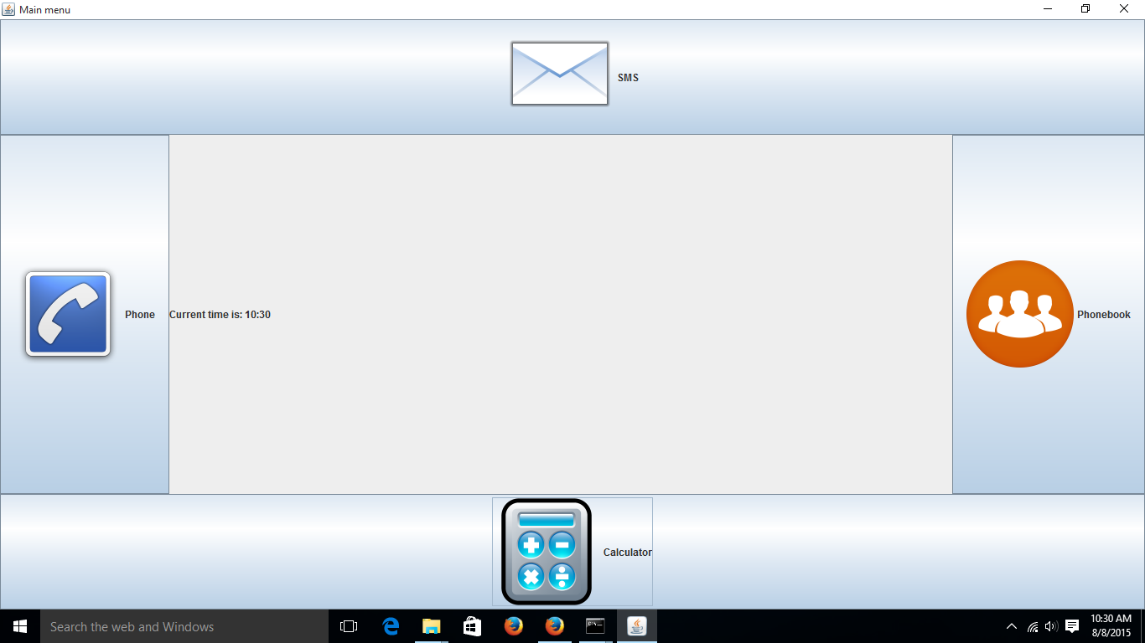

2. SMS
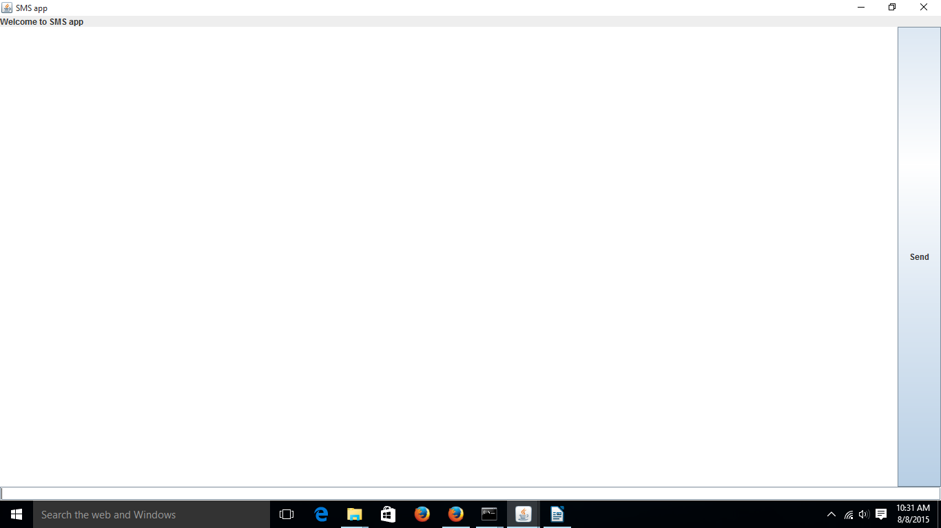

3. PHONEBOOK

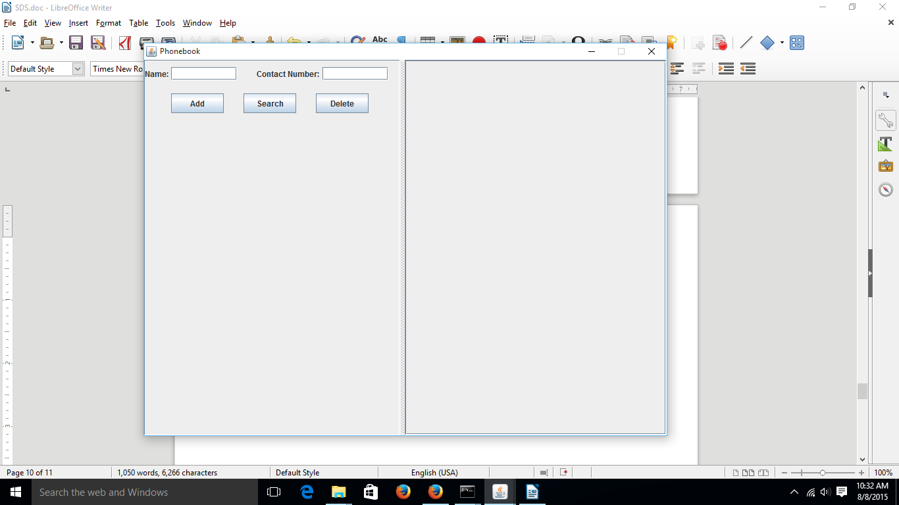

4. PHONE

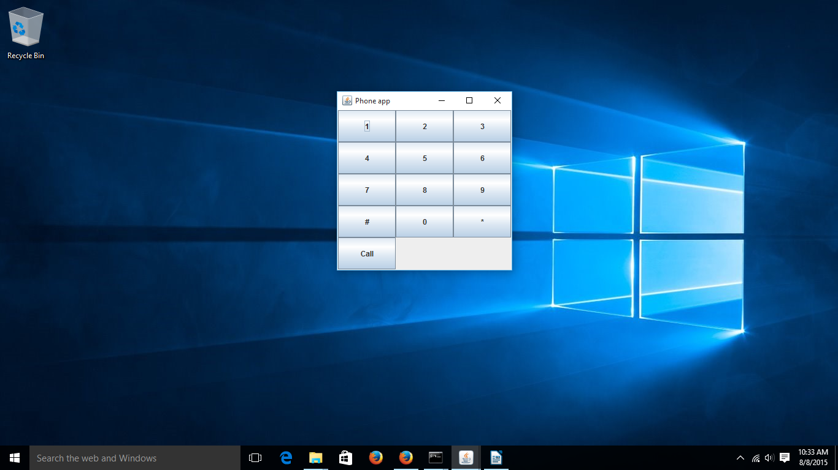

5. CALCULATOR
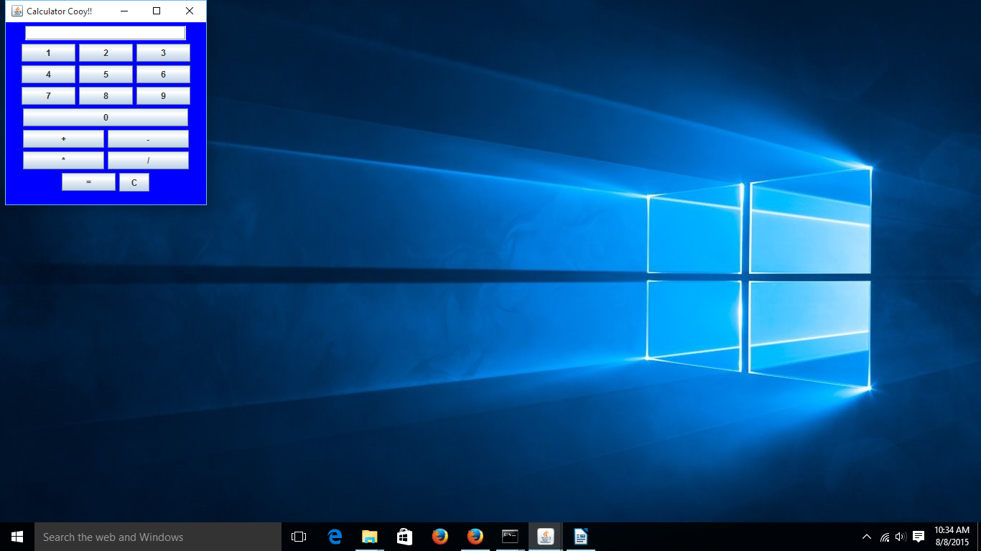

6. SCENARIOS
Actor:
Evan Kurnia Alim, Kimberly Oesman
Role:
Evan Kurnia Alim as the root maker.
Kimberly Oesman as the leaf maker.
Assumption and dependencies:
- The 4 features are connected one another in the main menu.
- There is only one driver file, and it is separated from the main menu.
- 1 SMS is 160 characters.
- Clock is real clock time from the computer.
- Most of the things is just simulated.

7. LESSON LEARNED
  - Learning Java Programming.
  - Learning how to fix a bug.
  - Learning how to add some improvements.
  - Learning how to make a software properly.
  - Learning how to work as a team.

