**Twitter Threads**

**AI & Education Group 1**

**Thread 1:**

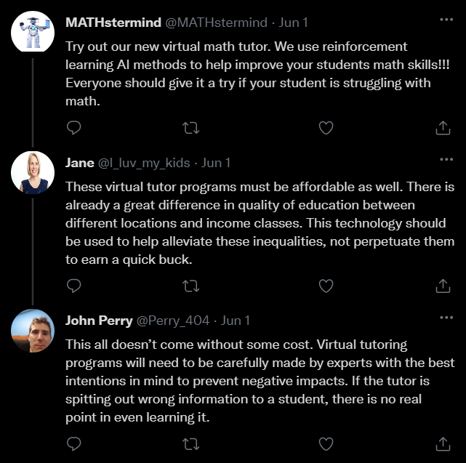

**Thread 2:**

