(I tested the command in another window but then copied a bunch of empty space over…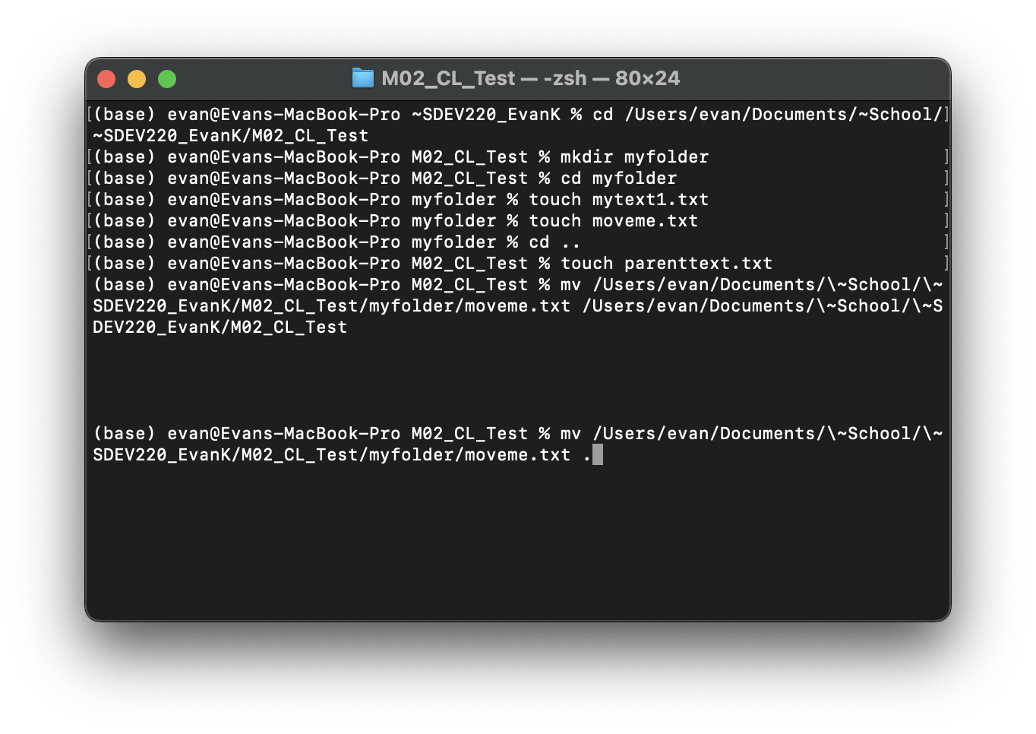 Then I tried a better way to do it thats shown lower)