全真模拟面试题
Hang Seng Bank IT Associate Director Mock Interview · 中英对照 + 推荐答案 + 图解

题目索引｜Question Index
共 25 道主问题、19 组追问。点击题目跳转至对应答案；Word／WPS 如提示，请按住 Ctrl 单击。
第一部分：开场与动机（Opening & Motivation）
Q1 请你简单介绍一下自己。
Tell me about yourself.
↳ 追问：What's your biggest achievement?
Follow-up: "What's your biggest achievement?"
Q2 为什么选择恒生银行？为什么是这个岗位？
Why Hang Seng? Why this role?
↳ 追问：你对恒生的了解？
Follow-up: "How much do you know about Hang Seng?"
Q3 讲讲你做过最复杂的项目。
Walk me through the most complex project you've led.
↳ 追问：附 AIP 架构图（见第三部分 Q9）可直接讲图。追问"What was YOUR role exactly?"
Follow-up: "What was YOUR role exactly?"
第二部分：领导力与项目管理（Leadership & Delivery）
Q4 你怎么管理 20 多人的团队？
How do you manage a 20-plus engineering team?
↳ 追问：How do you delegate without losing control?
Follow-up: "How do you delegate without losing control?"
Q5 简历说你负责项目预算和交付，具体怎么做的？
You own project budget and delivery — how exactly?
↳ 追问：预算被砍 20% 怎么办？
Follow-up: "What if the budget is cut by 20%?"
Q6 讲一个延期或失败的项目。
Tell me about a project that failed or was delayed.
Q7 香港、内地、全球团队协作有冲突怎么处理？
How do you handle cross-region, cross-cultural team conflicts?
↳ 追问：If HK and Guangdong teams disagree on a technical approach?
Follow-up: "If HK and Guangdong teams disagree on a technical approach?"
Q8 团队成员绩效不达标怎么办？
How do you handle an underperformer?
↳ 追问：Have you ever fired anyone?
Follow-up: "Have you ever fired anyone?"
第三部分：技术深挖（Technical Deep-Dive）
Q9 AIP 为什么能把交付从几个月降到几天？技术上是怎么办到的？
How exactly did AIP cut integration delivery from months to days?
↳ 追问：What if a new protocol appears?
Follow-up: "What if a new protocol appears?"
Q10 从 MuleSoft 迁到开源栈，37+ 组件下线，怎么做到不影响业务？
Migrating off MuleSoft and decommissioning 37+ components — how did you avoid business impact?
↳ 追问：How did you convince stakeholders to fund the rebuild?
Follow-up: "How did you convince stakeholders to fund the rebuild?"
Q11 讲讲你用 Spring AI 做的 AIOps，具体怎么实现的？
Tell me about your Spring AI-based AIOps. How does it actually work?
↳ 追问：How do you prevent the LLM from hallucinating a wrong root cause?
Follow-up: "How do you prevent the LLM from hallucinating a wrong root cause?"
Q12 DDQ 项目还在 PoC，为什么敢写上简历？RAG 怎么防幻觉？
Your DDQ project is still a PoC — why put it on the CV? How does RAG prevent hallucination?
Q13 PPmoney 日峰值 20 万申请，系统怎么扛住的？
PPmoney peaked at 200,000 daily applications — how did the system survive?
↳ 追问：如果流量再涨 10 倍？
Follow-up: "What if traffic grows 10x?"
Q14 微服务最大的坑是什么？分布式事务怎么处理？
What's the biggest pitfall of microservices? How do you handle distributed transactions?
↳ 追问：How do you ensure idempotency?
Follow-up: "How do you ensure idempotency?"
第四部分：微信生态（WeChat Ecosystem）—— 岗位核心
Q15 你对微信生态的了解有多深？我看你主要是后端和平台背景。
How deep is your WeChat ecosystem experience? Your background is mostly backend/platform.
↳ 追问：对方深入问细节（如 code2session 流程、订阅通知 vs 客服消息）
Follow-up: If they probe deeper (code2session flow, subscription vs customer-service messages), answer from the six chapters of the WeChat Ecosystem Crash Course; if you truly don't know, say "I'd need to confirm against the official docs, but my understanding is…" — never bluff.
Q16 如果让你负责恒生的微信生态，你会怎么规划技术架构？
If you owned Hang Seng's WeChat ecosystem, how would you architect it?
↳ 追问：预算有限先做哪块？
Follow-up: "With a limited budget, which part first?"
Q17 快问快答：放款提醒用哪种微信消息？小程序登录怎么保安全？
Quick fire: which message type for loan disbursement alerts? How do you secure mini-program login?
↳ 追问：客服消息 48 小时窗口怎么利用？
Follow-up: "How do you use the 48-hour customer-service window?"
第五部分：合规与生产保障（Compliance & Operations）
Q18 恒生做微信生态，客户数据跨境怎么处理？PDPO 和 PIPL 你了解吗？
How would you handle cross-border customer data for Hang Seng's WeChat ecosystem? What do you know about PDPO and PIPL?
↳ 追问：If business wants mainland WeChat data analyzed in HK?
Follow-up: "If business wants mainland WeChat data analyzed in HK?"
Q19 简历提到你是 IT Service Owner，具体做什么？
Your CV mentions you serve as IT Service Owner — what does that actually cover?
↳ 追问：SLA 没达标怎么办？
Follow-up: "What if the SLA is missed?"
Q20 生产出重大事故（如微信渠道交易中断），你的处理流程？
A major production incident — WeChat channel transactions down. Walk me through your response.
↳ 追问：How do you prevent recurrence?
Follow-up: "How do you prevent recurrence?"
Q21 怎么向非技术的高管解释一个技术方案？
How do you explain a technical solution to non-technical executives?
第六部分：战略与收尾（Strategy & Closing）
Q22 如果你入职，前 90 天怎么做？
What would your first 90 days look like?
↳ 追问：What if you find the current architecture is a mess?
Follow-up: "What if you find the current architecture is a mess?"
Q23 你认为 AI 在恒生的渠道业务里能怎么落地？
Where can AI create value in Hang Seng's channel business?
Q24 你最大的短板是什么？
What's your biggest weakness?
Q25 你有什么问题想问我们？
Do you have any questions for us?

第一部分：开场与动机（Opening & Motivation）
Q1 请你简单介绍一下自己。
Tell me about yourself.
考察点：英语流利度、结构化表达、与岗位的匹配度——90 秒内讲完，讲到点子上
推荐答案（中）：见前页 90 秒英文稿。要点：不要从大学讲起；按「现状定位 → 旗舰战绩 → 管理维度 → 创新 → 连接岗位」五段式；最后一句必须是“为什么这个岗位适合我”——把话题引到你的主场。
Answer (EN): Use the 90-second script on the previous page. Structure: current role → flagship achievement (AIP) → management scope (PM, budget, 20+ team) → innovation (AIOps, DDQ) → why this role (WeChat ecosystem). End with the role fit, then STOP and let them probe.
可能追问：What's your biggest achievement? → 答 AIP，用数字：months to days、90% less code、37+ legacy components decommissioned、50%+ cost reduction。
Follow-up (EN): "What's your biggest achievement?" → AIP, with numbers: months to days, 90% less code, 37+ legacy components decommissioned, 50%+ cost reduction.
Q2 为什么选择恒生银行？为什么是这个岗位？
Why Hang Seng? Why this role?
考察点：动机真实性、对恒生业务的了解、职业规划稳定性——切忌只谈“平台大”
推荐答案（中）：三层回答：① 业务认同——恒生是香港最大的本地银行之一，又是汇丰集团成员，既有本地银行的灵活性，又有集团级的技术与合规体系，渠道数字化（尤其微信生态触达大湾区客户）是明确的战略方向；② 岗位匹配——这个岗位正好坐在我三条主线的交点上：平台工程（AIP 证明过）、AI 落地（AIOps/DDQ 在手）、微信生态（PPmoney 实战 + 自营公众号）；③ 个人成长——我希望把在集团内做全球平台的经验，用到一个离客户更近、能直接看到业务影响的产品型银行里。
Answer (EN): Three layers. First, business conviction: Hang Seng combines the agility of a leading local Hong Kong bank with the governance of the HSBC Group, and channel digitization — especially WeChat for reaching Greater Bay Area customers — is a clear strategic direction. Second, role fit: this role sits exactly at the intersection of my three proven tracks — platform engineering (AIP), AI adoption (AIOps and the DDQ PoC), and the WeChat ecosystem (PPmoney plus my own official account). Third, growth: I want to apply global platform experience to a bank closer to end customers, where I can see direct business impact.
可能追问：你对恒生的了解？→ 准备：恒生 1933 年创立、汇丰集团成员、香港本地龙头之一、跨境理财通参与者；面试前浏览恒生官网最新数字渠道新闻，引用一条很加分。
Follow-up (EN): "How much do you know about Hang Seng?" → Prepare: founded in 1933, an HSBC Group member, one of Hong Kong's leading local banks, a Wealth Management Connect participant; citing one recent digital-channel news item from Hang Seng's official site earns real points.
Q3 讲讲你做过最复杂的项目。
Walk me through the most complex project you've led.
考察点：架构思维、叙事能力、能否把复杂系统讲简单——这是技术总监岗的核心能力
推荐答案（中）：答 AIP。三段式：① 问题——AMG 全球业务有数百个上下游系统互联，每个集成都定制开发，交付以月计、重复建设严重；② 方案——从零到一设计微服务集成平台：协议适配层屏蔽 SMB/HTTP/JMS/SFTP/SOAP 等连接复杂性，路由/转换/事件/加密等核心服务配置化复用，新业务接入只需配置不写代码；③ 结果——700+ feed、日均 60+ GB、交付从数月到数天、代码量降 90%，并用开源技术重建下线 37+ 遗留组件、成本降 50%+。复杂度的关键不在技术，在于跨 US/HK/UK 等多个市场的 stakeholder 协调和零停机迁移。
Answer (EN): AIP, our Tier-1 global integration platform. The problem: hundreds of upstream and downstream systems in HSBC's asset management business were interconnected with bespoke point-to-point integrations — months per delivery, massive duplication. The solution: I designed a microservices-based platform from scratch — protocol adapters shield connectivity complexity (SMB, HTTP, JMS, SFTP, SOAP, ODBC, SMTP), and routing, transformation, event and crypto services are configuration-driven and reusable, so onboarding a new feed is configuration, not coding. The result: 700+ feeds, 60+ GB daily, delivery cut from months to days, 90% less code, and we decommissioned 37+ legacy components by rebuilding on open source, cutting costs by over 50%. The hardest part was not the technology — it was coordinating stakeholders across multiple markets and migrating with zero downtime.
可能追问：附 AIP 架构图（见第三部分 Q9）可直接讲图。追问"What was YOUR role exactly?" → 区分清楚：架构设计我主导、核心组件与团队共同开发、roadmap 和预算我负责——诚实且突出。
Follow-up (EN): "What was YOUR role exactly?" → Distinguish clearly: I led the architecture design, co-developed core components with the team, and owned the roadmap and budget — honest yet prominent.

第二部分：领导力与项目管理（Leadership & Delivery）
Q4 你怎么管理 20 多人的团队？
How do you manage a 20-plus engineering team?
考察点：管理体系感、授权能力、人才培养——副总监岗管人权重很高
推荐答案（中）：三层机制：① 结构——按业务域分 pod（PPmoney 时期分风控 IT、移动端、营销工具三个团队），每个 pod 有 tech lead，我管 lead 不管每个人，避免成为瓶颈；② 节奏——OKR 定方向、sprint 管执行（我任 Scrum Master）、每日站会暴露阻塞、季度 1-on-1 谈成长；③ 培养——新人导师制（业务+技术双导师），code review 和技术分享会沉淀标准。衡量标准：我不在的一周，团队照样正常交付。
Answer (EN): Three mechanisms. Structure: I organize by pods — at PPmoney it was Risk IT, Mobile, and Marketing Tooling — each with a tech lead. I manage leads, not individuals, so I never become the bottleneck. Rhythm: OKRs set direction, sprints drive execution (I served as Scrum Master), daily standups surface blockers, quarterly one-on-ones focus on growth. Growth: a buddy system pairing new hires with both business and technical mentors, plus code reviews and tech sharing to institutionalize standards. My litmus test: the team delivers normally during the week I'm away.
可能追问：How do you delegate without losing control? → 答"授权 + 检查点"：任务拆到 sprint 粒度，关键设计必须过 review，用指标（交付速率、缺陷率）而非盯人来管理。
Follow-up (EN): "How do you delegate without losing control?" → Delegation plus checkpoints: break work into sprint-level tasks, require reviews for key designs, and manage by metrics (velocity, defect rate) — not by watching people.
Q5 简历说你负责项目预算和交付，具体怎么做的？
You own project budget and delivery — how exactly?
考察点：PM 实战真实性——这是你新加的内容，必被验证
推荐答案（中）：预算侧：年度预算按人力（自有+外包）、license、云资源三类编制，按季度滚动 review，偏差超 10% 要分析原因并调整；AIP 用开源重建替代 Mule 的决策，直接依据就是 license 成本测算——50%+ 的成本下降就是这么算出来并兑现的。交付侧：需求进来先估规模和优先级（和 business owner 对齐），拆成 sprint 级任务排期，用燃尽图跟踪，风险提前两周预警而不是到期才报。一句话：预算要能说清每一分钱的去向，交付要让 stakeholder 永远没有意外。
Answer (EN): On budget: I structure the annual budget into three lines — headcount (internal plus contractors), licenses, and cloud resources — reviewed quarterly on a rolling basis, with variance analysis whenever deviation exceeds 10%. The decision to rebuild AIP on open source instead of Mule was driven exactly by this license cost analysis, and the 50%-plus cost reduction was the measured outcome. On delivery: incoming requirements are sized and prioritized with business owners, broken into sprint-level tasks, tracked with burndown, and risks are flagged two weeks early — never at the deadline. My principle: every dollar must be explainable, and stakeholders should never be surprised.
可能追问：预算被砍 20% 怎么办？→ 答优先级重排：保生产稳定和合规项，砍 nice-to-have 需求，用自动化降人力成本——AIP 配置化本身就在降边际成本。
Follow-up (EN): "What if the budget is cut by 20%?" → Reprioritize: protect production stability and compliance items, cut nice-to-haves, and reduce labor cost through automation — AIP's configuration-driven design already lowers marginal cost.
Q6 讲一个延期或失败的项目。
Tell me about a project that failed or was delayed.
考察点：诚实度、复盘能力、STAR 结构——编造完美履历是大忌
推荐答案（中）：（STAR 结构，按你的真实经历微调细节）S——GTRF 时期某 Open API 项目，客户方（外部平台）对接排期依赖对方技术团队；T——我要在季度末交付 MVP；A——中期发现对方环境联调窗口远少于预期，我立即做三件事：把联调依赖后置、先用 mock 服务完成我方测试、每周与对方技术 lead 对齐并升级到双方管理层拿到固定联调窗口；R——MVP 按期交付，但更重要的是我从此在每个项目启动会就锁定“外部依赖清单 + 联调窗口”，这个习惯后来写进了团队交付 checklist。教训：技术项目最大的风险往往不在技术，在依赖管理。
Answer (EN): Structure it with STAR. Situation: an Open API project at GTRF depended on an external platform's technical team for integration testing. Task: deliver the MVP by quarter-end. Action: when I found their testing windows were far scarcer than planned, I de-coupled the dependency — we completed our side against mock services, I set up a weekly sync with their tech lead, and escalated to both managements to secure fixed integration windows. Result: MVP shipped on time; more importantly, I institutionalized an 'external dependency register plus locked testing windows' into every project kickoff since. The lesson: the biggest risk in technical projects is rarely technical — it's dependency management.
⚠ 雷区 这题不能答"没有失败过"。选一个真实、后果可控、有明确改进产出的案例；永远不要选"代码写崩导致资损"这类触碰银行红线的事故来讲。
Q7 香港、内地、全球团队协作有冲突怎么处理？
How do you handle cross-region, cross-cultural team conflicts?
考察点：这是恒生 panel 的核心关切——你要管的就是跨境协作
推荐答案（中）：我的原则：先对齐目标，再对齐方案，最后对齐时间表。真实例子：AIP 要下线某个遗留组件时，某个市场的团队担心影响他们的本地报表，直接反对。我的做法：① 先约 1-on-1 听清他们真正担心的点（不是组件本身，是报表 SLA）；② 用数据说话——提供并行运行期的对比报告证明新链路指标不劣化；③ 给退路——保留一个月回退窗口。最后对方主动支持下线。跨文化上，香港同事重书面确认和正式流程，内地团队重效率快速迭代，全球团队重时区礼仪——会议纪要和 action item 永远书面化，这是对三方都有效的最低公分母。
Answer (EN): My principle: align on the goal first, then the approach, then the timeline. A real example from AIP: when we planned to decommission a legacy component, one market team objected. In a one-on-one I found their real concern was not the component but their report SLA. So I ran a parallel-run comparison proving the new pipeline was not worse on any metric, and offered a one-month rollback window. They ended up actively supporting the decommissioning. Culturally: Hong Kong colleagues value written confirmation and formal process, mainland teams value speed, global teams value timezone etiquette — written minutes and action items are the common denominator that works for all three.
可能追问：If HK and Guangdong teams disagree on a technical approach? → 答：让设计原则和度量数据仲裁，而不是让职级仲裁；必要时小流量灰度验证，用结果说话。
Follow-up (EN): "If HK and Guangdong teams disagree on a technical approach?" → Let design principles and metrics arbitrate, not seniority; when needed, validate with a small-traffic canary and let the results speak.
Q8 团队成员绩效不达标怎么办？
How do you handle an underperformer?
考察点：管理成熟度——香港面试官很看重“既有标准又有人情味”
推荐答案（中）：四步走，全程书面化：① 诊断——1-on-1 搞清楚是能力问题、态度问题还是错配问题（岗位错配最常见也最好解决）；② 明确期望——给出具体、可衡量、有期限的改进目标（不是“你要努力”，而是“这两个 sprint 内独立交付 X 模块，缺陷率低于 Y”）；③ 给支持——配对导师、调整任务难度、增加 review 频次；④ 按结果决策——达标则回归正常轨道，不达标按公司流程处理，同时复盘自己的招聘和培养环节。底线：对低绩效的容忍是对高绩效者的不公平，团队氛围比同情更重要。
Answer (EN): Four steps, all documented. Diagnose: in a one-on-one, find out whether it's a capability issue, an attitude issue, or a mis-fit issue — mis-fit is most common and most fixable. Set expectations: specific, measurable, time-bound improvement goals — not 'work harder', but 'deliver module X independently within two sprints with defect rate below Y'. Support: assign a mentor, adjust task difficulty, increase review frequency. Decide by results: if they meet the bar, back to normal; if not, follow the formal process — and I review my own hiring and coaching in parallel. The bottom line: tolerating underperformance is unfair to high performers; team morale matters more than leniency.
可能追问：Have you ever fired anyone? → 如实回答；若没有，答"我处理过改进案例，结果是…"，并强调预防（招聘把关+早期反馈）优于处理。
Follow-up (EN): "Have you ever fired anyone?" → Answer honestly; if not, say "I've handled performance-improvement cases, and the outcome was…", emphasizing that prevention — hiring bar plus early feedback — beats termination.

第三部分：技术深挖（Technical Deep-Dive）
Q9 AIP 为什么能把交付从几个月降到几天？技术上是怎么办到的？
How exactly did AIP cut integration delivery from months to days?
考察点：这是你最旗舰的数字，面试官一定会验证真伪——必须能拆解到架构层面
推荐答案（中）：三个杠杆：① 抽象——把集成拆成「连接 + 路由 + 转换 + 投递」四个正交关注点，每个都做成可复用组件（协议适配器、Routing Service、Transformation Service、Generic Producer/Consumer），新需求 = 组合已有组件而不是从头写；② 配置驱动——接入参数（协议、格式、映射规则）全部外置成配置，新 feed 上线改配置不发版；③ 自助化——Dashboard + 注册中心让业务方自助注册和监控，消灭沟通等待。传统模式 80% 的时间花在重复写连接代码和跨团队等待上，我们把这两件事都消灭了。
Answer (EN): Three levers. Abstraction: we decomposed integration into four orthogonal concerns — connectivity, routing, transformation, delivery — each as a reusable component (protocol adapters, Routing Service, Transformation Service, Generic Producer/Consumer). A new requirement means composing existing components, not writing new code. Configuration-driven: all onboarding parameters — protocol, format, mapping rules — live in configuration, so a new feed goes live with config changes, not a release. Self-service: the Dashboard and Registration Center let business users onboard and monitor themselves, eliminating communication latency. In the old model, 80% of the time went into rewriting connectivity code and waiting on other teams; we eliminated both.
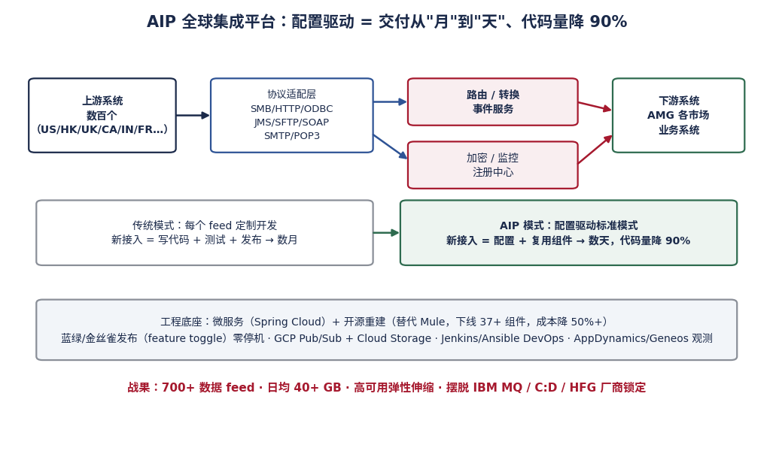
图 1：AIP 架构 —— 协议适配屏蔽复杂性，配置驱动标准模式
可能追问：What if a new protocol appears? → 答：接入层加一个新适配器即可，核心不动——这是开闭原则；我们就是这样陆续支持 SMB/ODBC/SOAP 等协议的。
Follow-up (EN): "What if a new protocol appears?" → Just add a new adapter at the connectivity layer; the core stays untouched — the open-closed principle. That is exactly how we added SMB, ODBC and SOAP over time.
Q10 从 MuleSoft 迁到开源栈，37+ 组件下线，怎么做到不影响业务？
Migrating off MuleSoft and decommissioning 37+ components — how did you avoid business impact?
考察点：风险管理、迁移方法论——银行最在意的就是迁移出事
推荐答案（中）：四步法，步步可回退：① 平行建设——新平台先建好，老平台照跑，零切换压力；② 按 feed 灰度迁移——从低风险、低流量的 feed 开始，每迁一个并行运行验证（数据对账：新老链路输出逐字段比对），稳定期过后才切下一个；③ feature toggle 兜底——所有切换点都有开关，出问题秒级回退，这也是为什么我们能做到所有小版本零停机；④ 最后才下线——组件停写后观察一个完整业务周期（月结/季结都跑过）才真正下线。37+ 个组件没有一个是“大爆炸式”下线的。
Answer (EN): Four steps, each reversible. Build in parallel: the new platform was fully built while the old one kept running — zero cutover pressure. Migrate feed by feed: start with low-risk, low-volume feeds, run old and new in parallel with field-by-field data reconciliation, and only proceed after a stabilization period. Feature toggles as the safety net: every switch point has a toggle, so rollback is seconds — that's how all our minor releases shipped with zero downtime. Decommission last: a component was only retired after a full business cycle — month-end and quarter-end included — ran clean on the new stack. Not one of the 37+ components was decommissioned big-bang style.
可能追问：How did you convince stakeholders to fund the rebuild? → 答：用 ROI 说话——license 费用 + 维护人力 + 交付速度损失算成钱，迁移成本摊到 18 个月内回本；先迁 3 个 feed 打样验证再要全量预算。
Follow-up (EN): "How did you convince stakeholders to fund the rebuild?" → Speak ROI: quantify license fees, maintenance headcount and delivery-speed loss in money; the migration pays back within 18 months; pilot three feeds first, then ask for the full budget.
Q11 讲讲你用 Spring AI 做的 AIOps，具体怎么实现的？
Tell me about your Spring AI-based AIOps. How does it actually work?
考察点：AI 工程化真实性——区分“玩过 demo”和“上过生产”
推荐答案（中）：链路：生产错误日志（Splunk/应用日志）→ Spring AI 分析引擎调用 LLM → 同时检索两个上下文：代码仓库（定位出错代码位置）和变更记录 CR（关联最近发布）→ 根因推理 → 预警里直接附“疑似根因 + 相关 CR + 建议处理动作”，联动 Geneos/AppDynamics 告警通道。价值：传统排查靠值班工程师翻日志猜原因，几十分钟到几小时；现在 AI 秒级给出排查起点。关键工程决策：① 用 Spring AI 而不是裸调 API——与现有 Spring 技术栈无缝集成，团队维护成本低；② 输出结构化（根因/相关 CR/建议三段），值班工程师一眼能用；③ 人是最后一环——AI 给建议，工程师确认后执行。
Answer (EN): The pipeline: production error logs from Splunk and application logs flow into a Spring AI analysis engine that calls an LLM with two retrieval contexts — the code repository, to locate the failing code, and the change request history, to correlate recent releases. It then performs root-cause reasoning and emits/trigger an alert containing the suspected root cause, the related CR, and recommended remediation, integrated with our Geneos/AppDynamics alerting channels. The value: manual troubleshooting took tens of minutes to hours; now AI provides the starting point in seconds. Three key engineering decisions: we chose Spring AI over raw API calls because it integrates seamlessly with our Spring stack, so the team can maintain it; the output is structured — root cause, related CR, suggested action — so the on-call engineer can act immediately; and a human stays in the loop — AI recommends, engineers confirm and execute.
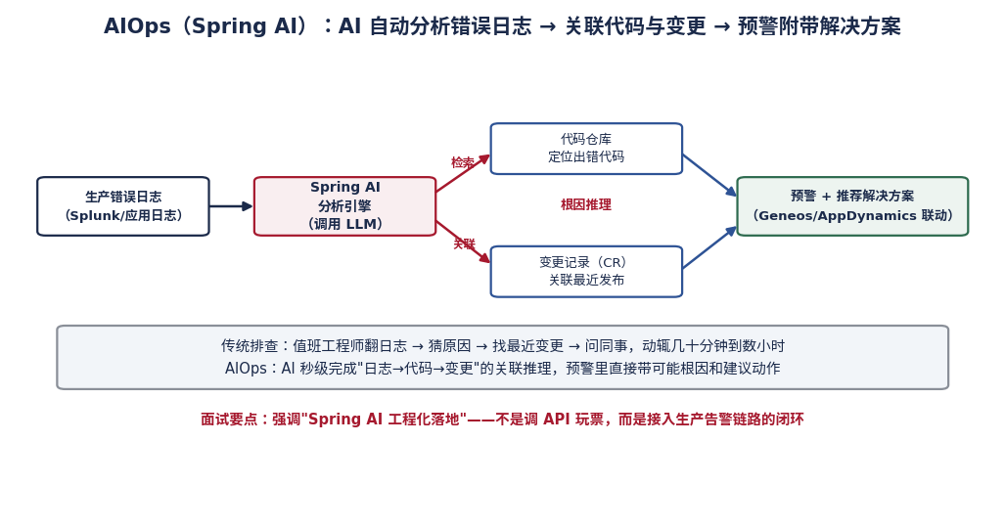
图 2：AIOps 链路 —— 日志 → Spring AI → 关联代码与变更 → 预警附解决方案
可能追问：How do you prevent the LLM from hallucinating a wrong root cause? → 答：检索增强（只基于真实代码和 CR 记录推理）+ 置信度标注 + 人审闭环；并说明误报率如何随反馈迭代下降。
Follow-up (EN): "How do you prevent the LLM from hallucinating a wrong root cause?" → Retrieval grounding — reasoning only over real code and CR records — plus confidence tagging and a human review loop; explain how the false-positive rate drops with feedback iterations.
Q12 DDQ 项目还在 PoC，为什么敢写上简历？RAG 怎么防幻觉？
Your DDQ project is still a PoC — why put it on the CV? How does RAG prevent hallucination?
考察点：诚实边界 + 技术深度——这题答好了反而加分
推荐答案（中）：为什么写：① 它代表我真实在做 AI 落地而不只是谈论 AI——从 use case 调研到架构到交付 PoC 是完整闭环；② 我明确标注 PoC 阶段，诚实是底线。防幻觉三层设计：① 检索增强——答案只能基于向量库里的历史 DDQ 权威文档生成，不许自由发挥；② 引用溯源——每条答案附出处段落，人工复核时能一键核对原文，这在尽调场景是刚需（可解释比聪明重要）；③ 人工兜底——PoC 阶段定位是“AI 起草 + 人复核”，不是全自动。下一步计划：扩大知识库覆盖、建准确率评估基线、再谈生产化。
Answer (EN): Why include it: first, it proves I actually ship AI, not just talk about it — from use-case research through architecture to a working PoC is a complete loop; second, I clearly label it as PoC — honesty is the baseline. The anti-hallucination design has three layers: retrieval grounding — answers are generated only from authoritative historical DDQ documents in the vector store, no free generation; citation traceability — every answer carries its source passage, so reviewers can verify against the original in one click, which is a hard requirement in due diligence where explainability beats cleverness; and human-in-the-loop — at PoC stage the positioning is 'AI drafts, humans review', not full automation. Next steps: broaden the knowledge base, build an accuracy evaluation baseline, then discuss productionization.
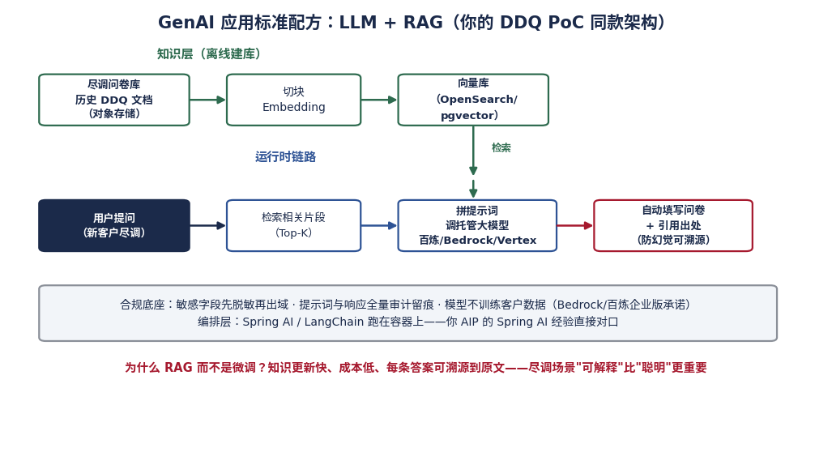
图 3：DDQ RAG 架构 —— 离线建库 + 运行时检索增强 + 合规底座
⚠ 雷区 被问 PoC 时绝对不能吹成"已上线投产"。正确姿态：明确阶段 + 讲清验证结果 + 给出生产化路径——成熟的管理者反而更可信。
Q13 PPmoney 日峰值 20 万申请，系统怎么扛住的？
PPmoney peaked at 200,000 daily applications — how did the system survive?
考察点：高并发实战——互联网经历是你相对纯银行背景候选人的差异化优势
推荐答案（中）：四层组合拳：① 接入层——负载均衡 + 应用无状态化，任意节点可水平扩展；② 缓存——Redis 挡热点读（产品信息、额度展示），数据库前面加一层“零钱抽屉”；③ 异步削峰——申请提交后非核心链路（通知、用户资料、大数据征信、决策引擎回调结果等）全部走 RabbitMQ 异步，洪峰蓄在队列里匀速消费；④ 数据层——读写分离 + 热点表拆分。同时全链路压测常态化：每次大促前按峰值 2 倍压测找瓶颈。结果：日峰值 20 万+ 申请、月放款 10 亿+，系统稳定；风控自动化上线后机器审批率 98%，放款从 1 天缩到 3 分钟。
Answer (EN): Four layers. At the edge: load balancing plus stateless applications, so any node scales horizontally. Caching: Redis absorbs hot reads — product info, limit displays — a 'cash drawer' in front of the database. Async buffering: after an application is submitted, all non-critical paths — Notifications, user profiles, big-data credit data, and decision engine callback results. — go through RabbitMQ; the queue absorbs the spike and consumers drain it at their own pace. Data tier: read-write splitting plus hot-table partitioning. And we institutionalized full-link load testing at twice the expected peak before every campaign. The outcome: 200k-plus daily peak applications, one billion RMB monthly lending, and after the automated risk platform launched, 98% machine approval with time-to-lend cut from one day to three minutes.
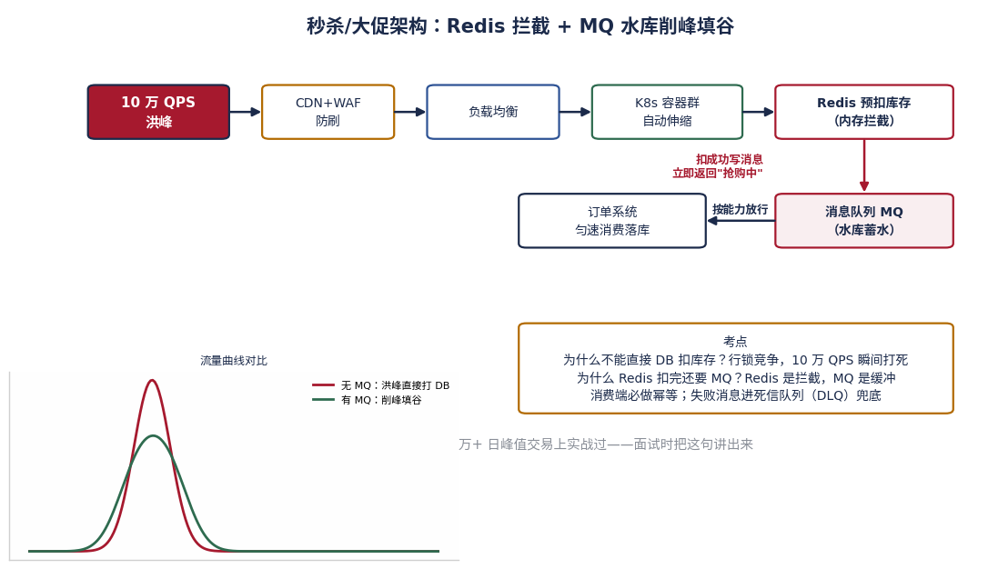
图 4：高并发通用打法 —— Redis 拦截 + MQ 削峰填谷（云计算速成图解同款）
可能追问：如果流量再涨 10 倍？→ 答：分库分表 + 单元化部署 + 弹性伸缩到云上——并主动提"这就是为什么我后来持续学习云架构并考了 AWS SA Professional"。
Follow-up (EN): "What if traffic grows 10x?" → Sharding, cell-based deployment and elastic scaling to cloud — and proactively add: "that's exactly why I kept investing in cloud architecture and earned the AWS Solutions Architect Professional certification."
Q14 微服务最大的坑是什么？分布式事务怎么处理？
What's the biggest pitfall of microservices? How do you handle distributed transactions?
考察点：架构成熟度——只有踩过坑的人才答得具体
推荐答案（中）：最大的坑不是技术，是“拆错了”：服务边界没按业务域（DDD）划清楚，结果分布式单体——每次改动跨 5 个服务联调，比单体还慢。我在 PPmoney 整合 6 个孤岛时的教训：先按业务域划界（申请/客户/订单/额度/风控/财务），再谈技术栈。分布式事务按场景选方案：① 强一致需求（账务核心）——不拆，留在单体/单库，别为难自己；② 可最终一致（积分、通知）——本地消息表/事务消息（RocketMQ 事务消息）+ 幂等消费；③ 跨服务长流程（放款流程）——Saga 模式，每步带补偿动作，配合 Activiti 工作流管理状态机。原则：能最终一致就别强一致，能单体就别分布——分布式是成本，不是荣誉。
Answer (EN): The biggest pitfall isn't technical — it's wrong boundaries. If you don't split along business domains with DDD, you get a distributed monolith: every change requires joint debugging across five services, slower than the monolith you started with. When I consolidated six silos at PPmoney, we drew boundaries by business domain first — application, customer, order, quota, risk, finance — and chose the tech stack second. For distributed transactions, match the scenario: strict consistency (core accounting) — don't split it, keep it in one database, don't fight that battle; eventual consistency (rewards, notifications) — transactional outbox or RocketMQ transactional messages plus idempotent consumers; long cross-service flows (the lending pipeline) — Saga with compensating actions, with Activiti managing the state machine. The principle: prefer eventual consistency when you can, prefer a monolith when you can — distribution is a cost, not a badge of honor.
可能追问：How do you ensure idempotency? → 答：业务唯一键（订单号）去重 + 数据库唯一索引兜底 + 消费端状态机校验。
Follow-up (EN): "How do you ensure idempotency?" → Dedup by a business unique key (order number), a database unique index as backstop, and consumer-side state-machine validation.

第四部分：微信生态（WeChat Ecosystem）—— 岗位核心
Q15 你对微信生态的了解有多深？我看你主要是后端和平台背景。
How deep is your WeChat ecosystem experience? Your background is mostly backend/platform.
考察点：这是最可能被挑战的一题——考验诚实 + 迁移能力，绝不能硬装专家
推荐答案（中）：诚实打底 + 三层证明：① 工程实战——PPmoney 时期我参与过公众号对接、粉丝管理和消息推送（模板消息/客服消息），支撑 App、微信、H5 三端获客，理解 openid/unionid 身份体系和消息触达规则；② 运营体感——我自己运营公众号 meta_study，对内容触达、用户增长、后台能力有一手的运营视角，这是纯工程师没有的；③ 学习准备——我已经系统性梳理了微信生态技术体系（账号体系、网页授权、订阅通知、小程序 code2session、企业微信会话存档），今天我们可以往深里聊任何一块。我的定位不是“微信运营专家”，而是“能把微信生态工程化、平台化的人”——这恰恰是技术总监岗需要的。
Answer (EN): Honesty first, then three layers of proof. Engineering practice: at PPmoney I worked on official account integration, follower management and message push — template and customer-service messages — supporting user acquisition across App, WeChat and H5, so I understand the OpenID/UnionID identity model and messaging rules. Operator intuition: I run my own official account, meta_study, which gives me first-hand insight into content reach, user growth and backend capabilities that pure engineers lack. Prepared depth: I've systematically studied the ecosystem's technical stack — account system, OAuth web authorization, subscription notifications, mini-program code2session login, WeCom message archiving — and I'm happy to go deep on any of them today. My positioning is not 'WeChat operations expert' but 'the person who can engineer and platform-ize the WeChat ecosystem' — which is exactly what an Associate Director role needs.
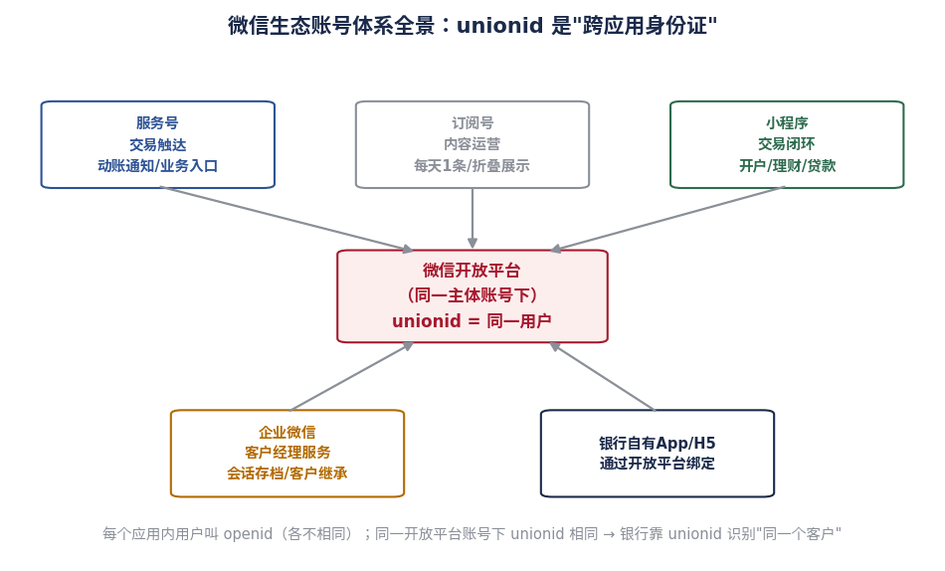
图 5：微信账号体系 —— openid 是门牌号，unionid 是跨应用身份证号（详见《微信生态技术速成图解》）
可能追问：对方深入问细节（如 code2session 流程、订阅通知 vs 客服消息）→ 按《微信生态技术速成图解》六章作答；被问到不会的，答"这个细节我需要确认官方文档，但我的理解是…"——不乱编。
Follow-up (EN): If they probe deeper (code2session flow, subscription vs customer-service messages), answer from the six chapters of the WeChat Ecosystem Crash Course; if you truly don't know, say "I'd need to confirm against the official docs, but my understanding is…" — never bluff.
Q16 如果让你负责恒生的微信生态，你会怎么规划技术架构？
If you owned Hang Seng's WeChat ecosystem, how would you architect it?
考察点：压轴题——考察平台思维、合规意识、与你 AIP 经验的迁移
推荐答案（中）：一句话哲学：把 AIP 的思路搬到微信生态——屏蔽渠道复杂性，业务团队只管创新。四层架构：渠道层（服务号/小程序/企业微信/H5）快速迭代；接入层 API 网关统一鉴权、限流、验签；能力层沉淀共享服务——统一身份中心（unionid 打通客户主档）、消息中心（订阅授权/渠道路由）、AI 服务（智能客服/RM 助手/RAG）、合规内容引擎；核心系统层（核心银行/CRM/信贷）通过 API 化封装接入——这正是 AIP 在干的事。合规横切四层：PDPO/PIPL 数据脱敏、全链路审计、企业微信会话存档。新增渠道（如视频号）只需接入层加适配器。
Answer (EN): One-line philosophy: bring the AIP philosophy to the WeChat ecosystem — shield channel complexity so business teams just innovate. Four layers. Channel layer: official accounts, mini-programs, WeCom, H5 — iterate fast. Gateway layer: one API gateway for OAuth2 authentication, rate limiting, signature verification. Capability layer: shared services — a unified identity center keyed on UnionID linking to the customer master, a messaging center handling subscription consent and channel routing, AI services for smart customer service and RM assistants with RAG, and a compliant content engine. Core banking layer: core banking, CRM and credit systems connected through API wrappers — exactly what AIP does today. Compliance cuts across all four layers: PDPO/PIPL data masking, full audit trails, WeCom message archiving. A new channel like Channels (视频号) then only needs one new adapter at the gateway.
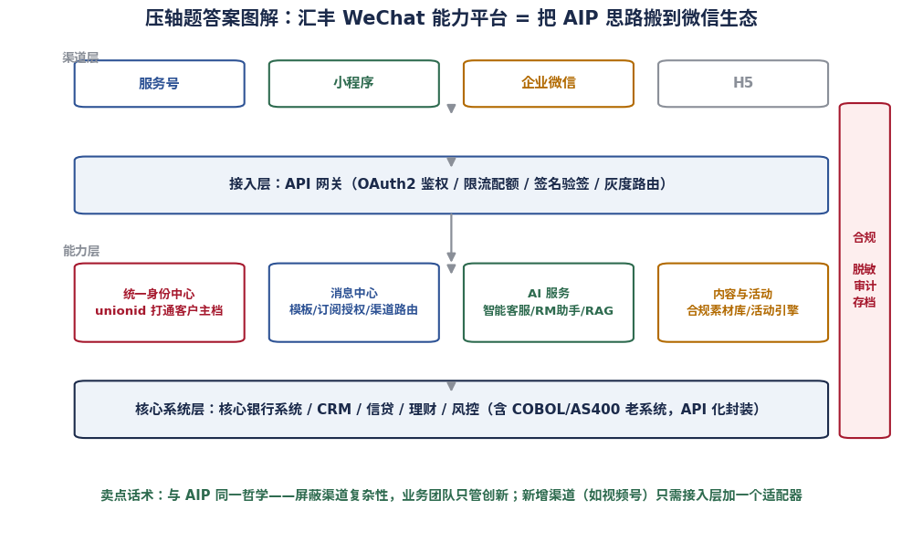
图 6：恒生 WeChat 能力平台四层架构 —— 把 AIP 思路搬到微信生态
可能追问：预算有限先做哪块？→ 答：统一身份中心 + 消息中心——它们是其他一切能力的地基，且直接支撑合规要求（消息触达留痕）。
Follow-up (EN): "With a limited budget, which part first?" → The unified identity center plus the messaging center — they are the foundation for everything else and directly support compliance (auditable message reach).
Q17 快问快答：放款提醒用哪种微信消息？小程序登录怎么保安全？
Quick fire: which message type for loan disbursement alerts? How do you secure mini-program login?
考察点：真实手感——这类细节题用来验证你是否真的准备过
推荐答案（中）：① 放款/还款/动账提醒 → 订阅通知（原模板消息）：需用户先订阅授权、模板需微信审核、交易类触达的主力通道，可靠且合规留痕；授权引导要自然嵌进开户流程，而不是生硬弹窗。② 小程序登录安全四红线：code 一次性且 5 分钟过期（防重放）；secret 只存服务端配置中心/KMS、定期轮换；session_key 不下发前端；敏感操作（支付/绑卡）二次鉴权（OTP/支付密码）。
Answer (EN): First: disbursement, repayment and transaction alerts go through Subscription Messages (formerly Template Messages) — they require prior user opt-in, templates are pre-approved by WeChat, and they're the reliable, auditable channel for transactional notifications; the opt-in should be embedded naturally into the onboarding journey, not a pop-up. Second, four red lines for mini-program login: the code is single-use and expires in five minutes to prevent replay attacks; the app secret lives only server-side in a config center or KMS with rotation; the session_key is never sent to the front-end; and sensitive operations like payment or card-binding require secondary authentication such as OTP.
可能追问：客服消息 48 小时窗口怎么利用？→ 答：用户互动后的 48 小时内做咨询应答和服务跟进，超时则不能主动发——营销触达要走订阅通知或企业微信。
Follow-up (EN): "How do you use the 48-hour customer-service window?" → Handle inquiries and service follow-ups within 48 hours of user interaction; beyond that, proactive messaging is not allowed — marketing reach goes through subscription messages or WeCom.

第五部分：合规与生产保障（Compliance & Operations）
Q18 恒生做微信生态，客户数据跨境怎么处理？PDPO 和 PIPL 你了解吗？
How would you handle cross-border customer data for Hang Seng's WeChat ecosystem? What do you know about PDPO and PIPL?
考察点：合规意识——恒生岗位必考，内地+香港双法域
推荐答案（中）：框架：香港适用 PDPO（个人资料私隐条例），内地适用 PIPL（个人信息保护法），内地数据出境还有专门的评估/标准合同要求。工程落法四条：① 数据本地化——内地客户的个人信息存储和处理留境内（如微信生态数据在内地区域），香港客户数据在香港，按法域分区部署；② 最小化收集——能用 snsapi_base 静默授权拿身份就不弹窗收资料；③ 出域先脱敏——跨境分析场景（如集团级报表）只传脱敏/聚合后的数据，AIP 的数据脱敏网关就是这个角色；④ 全链路留痕——采集同意记录、访问审计、会话存档（企业微信），监管检查可回溯。原则：架构设计第一天就把合规当需求，不是事后补丁。
Answer (EN): The framework: Hong Kong falls under PDPO, the mainland under PIPL, with dedicated assessment or standard-contract requirements for cross-border transfer of mainland data. Four engineering practices: data residency — mainland customers' personal information is stored and processed within the mainland (WeChat ecosystem data in mainland regions), Hong Kong data in Hong Kong, deployed per jurisdiction; data minimization — if snsapi_base silent authorization suffices for identity, don't pop a consent window for more; mask before transfer — for cross-border analytics like group-level reporting, only masked or aggregated data crosses, which is exactly the role of AIP's data-masking gateway; end-to-end traceability — consent records, access audits, WeCom message archiving, so any regulator inquiry is answerable. The principle: compliance is a day-one requirement in the architecture, never a patch.
可能追问：If business wants mainland WeChat data analyzed in HK? → 答：可以，但走脱敏/聚合 + 出境合规评估通道；原始个人信息不过境。给业务合规的替代方案，而不是只说"不行"。
Follow-up (EN): "If business wants mainland WeChat data analyzed in HK?" → Possible, but only through masking or aggregation plus the cross-border compliance assessment; raw personal information never crosses. Offer the business a compliant alternative instead of just saying no.
Q19 简历提到你是 IT Service Owner，具体做什么？
Your CV mentions you serve as IT Service Owner — what does that actually cover?
考察点：服务管理真实性——ITIL 是银行运维管理的通用语言，新增内容必被验证
推荐答案（中）：ITSO 是对服务的全生命周期负责：① SLA 管理——定义并守住可用性指标，定期向业务和监管层汇报达成率；② 可用性与容量规划——按业务增长预测扩容（季末/大促峰值），提前准备资源而不是出事再补；③ 事件/变更/问题管理（Incident/Change/Problem）——事件要快恢复，变更要过评审控风险，问题管理找根因防复发；④ 预算控制、风险与审计合规——服务成本归因、风险入册、审计证据随要随有。落到 AIP：700+ feed、日均 60+ GB 的 Tier-1 服务，我对它的可用性数字向全球 stakeholder 负责。
Answer (EN): An ITSO owns the full service lifecycle. SLA management: define and defend availability targets, and report attainment regularly to business and oversight functions. Availability and capacity planning: forecast growth and secure capacity ahead of peaks such as quarter-end, not after an incident. Incident, change and problem management: incidents demand fast restoration; changes go through formal review to control risk; problem management finds root causes to prevent recurrence. And budget control, risk and audit compliance: cost attribution per service, risks on the register, audit evidence always ready. On AIP this means I am personally accountable to global stakeholders for the availability of a Tier-1 service carrying 700+ feeds and 60+ GB daily.
可能追问：SLA 没达标怎么办？→ 答：透明通报 + 根因分析 + 改进计划入册跟踪；可用性目标要和成本平衡——99.9% 和 99.99% 的成本差一个量级，用业务影响定目标，而不是越高越好。
Follow-up (EN): "What if the SLA is missed?" → Transparent reporting, root-cause analysis, and a tracked improvement plan; availability targets must balance cost — 99.9% versus 99.99% differs by an order of magnitude, so set the target from business impact, not from vanity.
Q20 生产出重大事故（如微信渠道交易中断），你的处理流程？
A major production incident — WeChat channel transactions down. Walk me through your response.
考察点：应急成熟度、communication 意识——银行面试官必考
推荐答案（中）：五步走，黄金原则是“先止血、再定位、后复盘”：① 止血（0-15 分钟）——值班机制触发，第一时间降级/回退（feature toggle 秒级回滚，这正是我们 AIP 的建设价值），恢复服务优先于找原因；② 通报——按 severity 向上和业务方通报现状 + 预计恢复时间，香港监管要求的重大事件上报流程同步启动；③ 定位——监控（AppDynamics/Geneos）+ AIOps 辅助缩小范围；④ 修复验证——灰度恢复，观察指标正常再全量；⑤ 复盘（48 小时内）——无指责文化（blameless postmortem），输出根因、时间线、action items，落实到人和期限。两个坚持：事故期间所有决策有记录；对客户的影响通报由业务和客服统一出口，技术不直接对外。
Answer (EN): Five steps, with the golden rule: stop the bleeding first, diagnose second, review last. Contain (0-15 min): the on-call process triggers, we degrade or roll back immediately — feature toggles let us roll back in seconds, which is exactly why we built them into AIP; restoring service beats finding the cause. Communicate: notify management and business by severity with current status and ETA; regulator-facing major-incident reporting kicks off in parallel. Diagnose: monitoring via AppDynamics/Geneos plus our AIOps assistant narrows the scope. Fix and verify: recover gradually, watch metrics, then full traffic. Review within 48 hours: blameless postmortem — root cause, timeline, action items with owners and deadlines. Two rules I insist on: every decision during the incident is logged; customer-facing communication goes out through business and service channels only, never directly from engineers.
可能追问：How do you prevent recurrence? → 答：action items 分级（P0 当周修复）、进 backlog 跟踪关闭、同类风险横向排查（grep 全平台）、补充监控盲区。
Follow-up (EN): "How do you prevent recurrence?" → Grade the action items (P0 fixed within the week), track closure in the backlog, sweep platform-wide for the same risk pattern, and fill the monitoring blind spots.
Q21 怎么向非技术的高管解释一个技术方案？
How do you explain a technical solution to non-technical executives?
考察点：沟通翻译能力——副总监岗一半时间在做这件事
推荐答案（中）：三招：① 讲钱和风险，不讲技术——不说“我们用 RAG 架构”，说“这个方案能把每份尽调问卷的人工从数小时降到分钟级，且每条答案可溯源、过得了合规检查”；② 用类比——我给高管解释 AIP 时说“它像物流中心：以前每个供应商自己送货（点对点集成），现在统一进物流中心中转，新供应商接入即插即用”；③ 给选择题不给问答题——方案 A 快但贵、方案 B 省但慢，附带我的推荐和理由，让管理层做决策而不是做阅读理解。反面教材：把架构图原样搬上汇报页。
Answer (EN): Three techniques. Talk money and risk, not technology: instead of 'we use a RAG architecture', say 'this cuts manual effort per datafeeds from months to days, with every answer traceable to source — audit-proof by design'. Use analogies: I explained AIP to executives as 'a logistics hub: previously every supplier delivered goods themselves — point-to-point integration; now everything routes through one hub, and a new supplier is plug-and-play'. Offer choices, not essays: Option A is fast but costs more, Option B is cheaper but slower, here's my recommendation and why — let management decide, not decode. The anti-pattern: pasting an architecture diagram onto a slide for executives.

第六部分：战略与收尾（Strategy & Closing）
Q22 如果你入职，前 90 天怎么做？
What would your first 90 days look like?
考察点：落地规划能力——高管面必考，节奏感比野心重要
推荐答案（中）：三段节奏：第 1-30 天「听」——盘点现有渠道工作负载并按数据敏感度分级（PDPO/PIPL 映射），与业务、合规、安全、各市场团队 1-on-1，理解痛点和既有约束；不动任何生产系统。第 31-60 天「打样」——选一个低风险高可见度的场景做灯塔项目（如某类交易通知的订阅化改造，或智能客服 PoC），同时建好合规基线（IAM、加密、审计）和度量体系；用一个小胜利建立信任。第 61-90 天「平台化起步」——把身份、消息等共性能力收敛成平台 roadmap，向管理层交付「现状评估 + 90 天成果 + 一年规划 + 预算需求」。原则：不折腾核心、先出价值、用数据要资源。
Answer (EN): Three phases. Days 1-30, listen: inventory all channel workloads, classify by data sensitivity with PDPO/PIPL mapping, hold one-on-ones with business, compliance, security and market teams — understand pain points and constraints. Touch nothing in production. Days 31-60, prove: pick one low-risk, high-visibility lighthouse project — for example, converting a class of transactional notifications to subscription messages, or a smart-service AI PoC — while establishing the compliance baseline (IAM, encryption, audit) and metrics. One small win buys trust. Days 61-90, platformize: consolidate shared capabilities like identity and messaging into a platform roadmap, and deliver to management a package of current-state assessment, 90-day results, one-year plan and budget ask. The principles: don't churn the core, deliver value early, use data to earn resources.
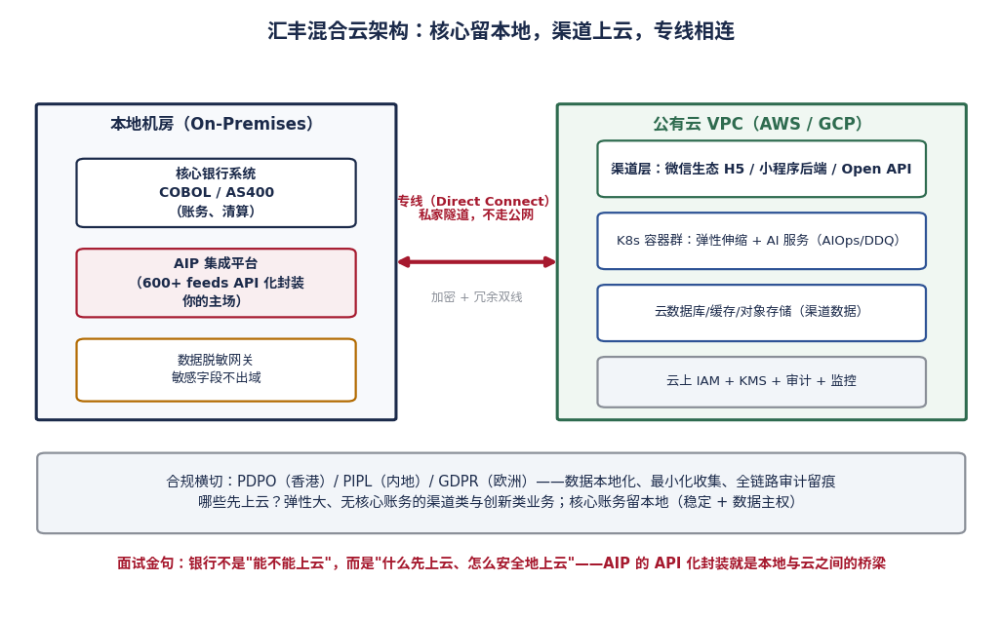
图 7：恒生混合云底座 —— 核心留本地、渠道上云、专线相连（可配合此图讲规划）
可能追问：What if you find the current architecture is a mess? → 答：先理解"为什么长成这样"（历史原因往往合理），再提演进式改造方案；推翻重来是最后选项——我在 AIP 下线 37+ 组件用的就是渐进式。
Follow-up (EN): "What if you find the current architecture is a mess?" → First understand why it grew this way — historical reasons are usually rational — then propose evolutionary improvement; a big-bang rewrite is the last resort, and that is exactly how I decommissioned 37+ components on AIP.
Q23 你认为 AI 在恒生的渠道业务里能怎么落地？
Where can AI create value in Hang Seng's channel business?
考察点：AI 战略视野——结合你的 AIOps/DDQ 实战，拒绝空谈
推荐答案（中）：按“价值÷风险”排序四个梯队：第一梯队（低风险高价值，马上做）——研发与运维提效：AIOps 日志分析（我已落地）、代码辅助、测试生成；第二梯队——内部知识服务：DDQ 这类 RAG 问答（我有 PoC）、合规/产品知识库助手，人审闭环所以风险可控；第三梯队——客户经理赋能：企业微信侧边栏 AI 话术建议、客户意向识别，素材全部来自合规库，AI 起草人确认；第四梯队（谨慎推进）——直接对客的智能客服：从 FAQ 和导流做起，敏感交易必须转人工，全程会话存档。原则：AI 对人辅而不是对人替，合规红线内的场景先规模化。
Answer (EN): Four tiers, ranked by value over risk. Tier one, low risk high value, do now: engineering and operations productivity — AIOps log analysis, which I've already shipped, plus coding assistance and test generation. Tier two, internal knowledge services: RAG-based Q&A like the DDQ PoC, compliance and product knowledge assistants — safe because humans review the output. Tier three, RM empowerment: AI pitch suggestions and intent detection in the WeCom sidebar, all content sourced from the compliant library, AI drafts and humans confirm. Tier four, proceed carefully: customer-facing smart service — start with FAQ and routing, sensitive transactions must hand off to humans, with full message archiving. The principle: AI assists people, not replaces them; scale first within compliance-safe scenarios.
Q24 你最大的短板是什么？
What's your biggest weakness?
考察点：自我认知——忌“我太追求完美”这类假弱点，也忌真硬伤
推荐答案（中）：真实但不致命：我的强项在平台和后端工程，前端/移动端工程深度相对弱——我带过移动端团队，能评审方案、能把关质量，但让我手写 React Native 排障不如专业同事快。我的应对：① 用人——团队里放强的前端 lead 并充分授权；② 补短——我自己写 React/Vue 做过 AIP Dashboard，保持“看得懂、评得准”的水平；③ 这个岗位视角——技术总监的价值在技术判断和团队组合，不在个人手写每种技术栈。我在学的方向：大模型应用工程（Agent、评估体系），因为这会重塑渠道开发方式。
Answer (EN): Real but not fatal: my strength is platform and backend engineering; my front-end and mobile depth is comparatively weaker — I've led mobile teams, I can review designs and gate quality, but hand-debugging React Native is slower for me than for a specialist. How I manage it: I staff strong front-end leads and delegate genuinely; I keep myself at a 'can read, can judge' level — I built the AIP Dashboard in React/Vue myself; and at this level, a director's value is technical judgment and team composition, not personally writing every stack. What I'm actively learning: LLM application engineering — agents, evaluation frameworks — because it will reshape how channel software is built.
⚠ 雷区 不要选"英语不好""管理经验少"这类岗位硬伤当弱点；也不要把优点包装成缺点。选"真实、不致命、有改进动作"的。
Q25 你有什么问题想问我们？
Do you have any questions for us?
考察点：格局与关注点——问错问题（薪资加班）会毁尾
推荐答案（中）：准备三个，按面试官级别选用：① 问业务——“恒生微信生态目前最重要的业务目标是什么？是获客、活跃度还是交易转化？”（显关心业务而非只关心技术）；② 问组织——“这个岗位成功的标准是什么？一年后您希望我交出什么？”（显结果导向）；③ 问挑战——“目前团队在微信生态推进中最大的瓶颈是技术、合规还是跨团队协作？”（显你愿意啃硬骨头，还能顺势再接一次自己的经验）。不问：薪资福利加班（HR 环节谈）、能百度到的公司信息。
Answer (EN): Prepare three, pick by the interviewer's seniority. Business: 'What is the top business goal for Hang Seng's WeChat ecosystem right now — acquisition, engagement, or transaction conversion?' Organization: 'What does success look like for this role — what would you want me to have delivered in twelve months?' Challenge: 'What's the biggest bottleneck in advancing the WeChat ecosystem today — technology, compliance, or cross-team collaboration?' Never ask about salary, benefits or overtime at this stage, or anything Googleable.

附录：考前 30 分钟清单
- 90 秒英文自我介绍——脱稿说两遍（第一页）
- 数字弹药库过一遍：700+ feeds / 60+ GB / months→days / 90% / 37+ / 50%+ / 20 万峰值 / 98% / 1天→3分钟 / 10 亿/月
- AIP 架构图、AIOps 链路图、RAG 架构图——能在白板上徒手画出来
- 微信压轴题话术：四层架构 + "把 AIP 思路搬到微信生态"
- 合规四件套随时挂嘴边：数据本地化、最小化收集、出域脱敏、全链路留痕
- STAR 故事备三个：成功（AIP 迁移）、失败教训（外部依赖）、冲突（下线组件协调）
- 三个反问问题背熟
- 着装/设备/网络提前测；线上面试背景干净、摄像头平视
最后提醒：香港 panel 喜欢“专业 + 务实 + 有数字”的候选人。你手里有 AIP、AIOps、DDQ、PPmoney 四张牌，每张都有真实数字——稳稳地打出来。祝拿下！

