Question 1: Introduction and Purpose of Study
The FIFA World Cup is one of the most popular sporting events in the world and receives attention from the world's football associations, media, analysts and so on. To illustrate, FIFA has stated that the Qatar 2022 World Cup reached approximately five billion fans through television, digital platforms, social media, and other channels (FIFA, 2023). Given this huge public and business interest, making predictions about the outcome of football games has become a major football analytics problem. However, football is difficult to predict because many factors can influence the outcome of a match.
This project addresses the main problem of using the data of the previous international football games to predict the outcome of future FIFA World Cup games. This project does not attempt to predict the final score of each match, but instead classifies the result of each match into one of three classes: home win, draw and away win. This is more realistic, as the actual score is sometimes hard to predict, but very valuable and measurable learning can be gained from the classification of the outcomes. This project uses data from the Kaggle dataset International Football Results, which provided structured data on football games played by men's international teams from 1872 to 2026, including match date, teams, scores, tournament, city, country, and if the match was played at a neutral venue (Jürisoo, 2026).
The reason behind using data mining is that the data set consists of a vast amount of historical match records which can be converted to useful patterns and predictive features. For instance, using historical data, the recent form of a team, average goals scored, average goals conceded and the difference in performance between the two teams can be calculated. Such features can then be employed in machine learning models to discover relationships and match outcomes. The results indicate that the machine learning model can be used to predict the result of football matches as in the previous studies, depending on the data gathered from previous matches and the teams' performance (Beal et al., 2020; Al-Bustami & Ghazal, 2025).
This project is motivated from practical as well as research aspects. The model can be used to help analyse sports by providing a more data-driven perspective of potential World Cup outcomes from a practical point of view. Research wise the project will enable the team to implement the entire data mining process that involves data preparation, feature engineering, modeling for classification and model evaluation. The model is not intended to guarantee exact football results. Instead, it provides a structured predictive modelling process that discovers useful patterns in international football data and evaluates how well machine learning can classify World Cup-related match outcomes.
Question 2: Description of Data
The dataset acquired for this project is the International Football Results from 1872 to 2026 dataset from Kaggle. It includes the records of the men’s international football matches including those played in the FIFA World Cup, friendly matches, qualification matches, and other international tournaments. This data set is appropriate to the project since it gives a much bigger historical data set than World Cup matches alone. In the case of this project, which aims to predict the outcome of World Cup matches, a larger data set of international matches can be used to learn about the general patterns of football performance, which can then be applied to the World Cup context (Jürisoo, 2026).
The data is stored in a table in a structured format, as a CSV file. The data in the uploaded results.csv file has 49,477 rows and 9 columns. Each row is an international football match and each column represents one aspect of that football match. The matches cover a long historical time period, from 30 November 1872 to 27 June 2026. In the latest rows, some World Cup 2026 matches are not scored yet and some of the cells in the "score" columns are blank. Hence, only finished matches with scores will be considered for training and testing the model.
The important features of the data set are date, home_team, away_team, home_score, away_score, tournament, city, country, and neutral. The date column is significant because it is required to have the data in chronological order when creating historical performance features. The home_team and away_team fields specify the two teams that played each game and the home_score and away_score fields are used to form the target field. If the home team's score is greater than the away team's score, the result is considered a home victory; if the scores are equal, it is a draw; if the away team's score is greater, it is an away victory. The tournament column is used to distinguish FIFA World Cup matches from friendly matches, qualification matches, and other competitions. The city, country and neutral columns provide venue related information, such as if the match was played at a neutral venue.
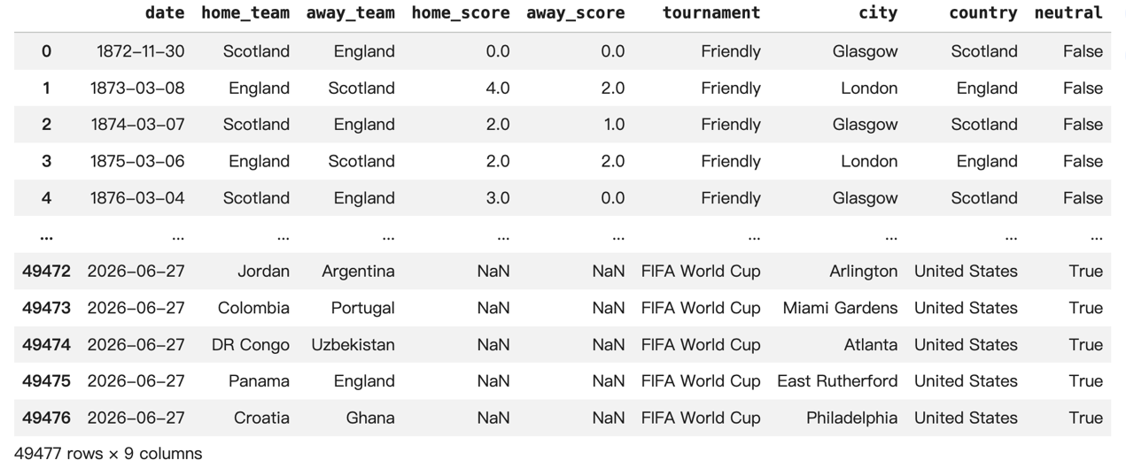Figure 1. Representative sample of the International Football Results dataset
A representative sample of the data set is shown in figure 1. The first few rows display early friendly games between Scotland and England, and the last few rows contain scheduled FIFA World Cup matches in 2026 with missing scores. This sample represents the key features of the data set, including historical match data, team names, final scores, type of competition, venue location, and neutral venue data. It also demonstrates one practical problem in the data: future (unplayed) matches must be removed from the data before modelling since the results are not known.

References
Al-Bustami, A., & Ghazal, Z. (2025). From players to champions: A generalizable machine learning approach for match outcome prediction with insights from the FIFA World Cup. arXiv. https://arxiv.org/abs/2505.01902
Beal, R., Middleton, S. E., Norman, T. J., & Ramchurn, S. D. (2020). Combining machine learning and human experts to predict match outcomes in football: A baseline model. arXiv. https://arxiv.org/abs/2012.04380
FIFA. (2023). Audience report: FIFA World Cup Qatar 2022™. FIFA. https://inside.fifa.com/tournament-organisation/audience-reports/qatar-2022
Jürisoo, M. (2026). International football results from 1872 to 2026 [Data set]. Kaggle. https://www.kaggle.com/datasets/martj42/international-football-results-from-1872-to-2017

