3. Data Problems and Pre-Processing
3.1 Data Problems Identified
Before model development, an initial data audit was conducted to identify potential data quality problems in the international football match dataset. Several issues were identified that could negatively affect the reliability of the machine learning models.
Firstly, the data is missing, especially scores of home and away teams. The majority of these scores were for future games or incomplete matches. The actual result of the matches was not known, and could not therefore be used as labelled training samples. Secondly, duplicated match records were checked since duplicated observations would lead to the same match being used more than once and to an unnecessary bias of the model.
Thirdly, the date attribute was not in a proper datetime format. Football matches are observations that are time dependent; thus, if they are not in chronological order, future observations could be used inadvertently to produce historical features.
Another problem was the number of various tournament names in the original data set. Each specific tournament name would be a categorical feature which could number of categories and would complicate the model.
Last but not least, the raw data is primarily composed of fundamental match data like teams, scores, tournament and venue. The raw attributes themselves are not an accurate measurement of the past history and recent performance of each nation's team. Thus more historic features were needed prior to the training of the model.
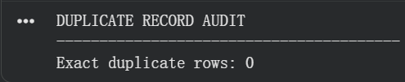
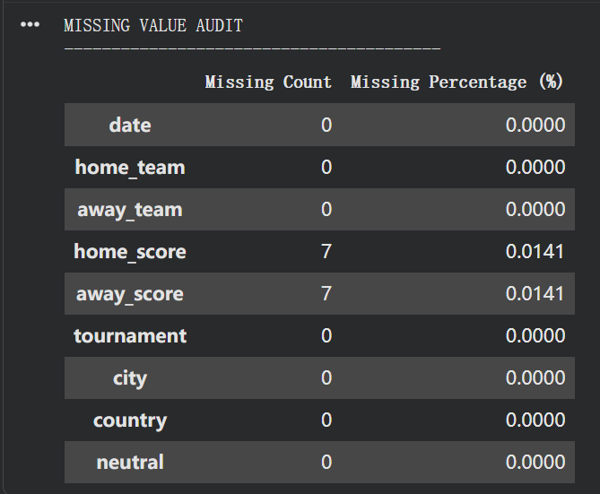

Fig3.1
3.2 Pre-Processing Techniques Applied
The problems identified were solved by several data preprocessing and transformation techniques, which were done to prepare the dataset for machine learning.

Data Cleaning
All matches were first converted to the Pandas datetime format, and then sorted by date. After that, duplicate records were eliminated.
The matches where there are no home_score or away_score fields were isolated from matches in the past that are considered completed. Only complete matches were used to build the labelled modelling dataset as the final result should be known to decide the target class.
The cleaned dataset was then reset and chronologically sorted to give a solid basis for historical feature engineering.

Target Variable Transformation
The classification target is not directly provided in the original dataset, but represents the final match outcome. So to create a new target variable, a comparison of home and away scores created a new variable called result.
Every successfully completed match became a member of one of three classes:
- Home Win
- Draw
- Home Loss
The initial dataset of the football game was changed to become a supervised multi-class classification problem.

Historical Feature Engineering
The original data include match level data but do not directly accurately reflect each team's historical strength. So, historical performances were generated based on the past matches of each team.
Main historic elements consisted of:
- Recent win rate
- Recent draw rate
- Average goals scored
- Average goals conceded
- Recent goal difference
- Historical match experience
The recent-performance statistics were derived from the top five games played by the team just recently, so the model will reflect the teams' form at the moment instead of using a long-term historical approach.
To avoid temporal data leakage, an explicit chronological process was established. Historical features were determined prior to adding the results of matches to team history for matches played on the same date. Thus, the model was not able to 'learn' information that would have been unavailable prior to a match.
In the case of teams with not enough historical data, their overall average statistics were used as a default if they didn't have enough historical data to address the cold start problem.

Feature Transformation
Other relative-strength features were created by looking at the past statistics for each of the two teams that played against each other:
- Win rate difference
- Goal difference difference
- Experience difference
These attributes directly reflect the difference in performance between the home team and the away team and give a greater indication of the information that should be used for classification.
The tournament names were also categorized into a few more general categories:
- World Cup
- Qualification
- Friendly
- Other Competitive
One-hot encoding was subsequently applied to these tournament categories. The neutral attribute was converted into a binary numerical feature.
Feature normalisation was not universally required because Decision Tree and Random Forest models are not sensitive to feature scale. However, StandardScaler was specifically applied to Logistic Regression, where feature scaling is important because the numerical variables have different ranges.

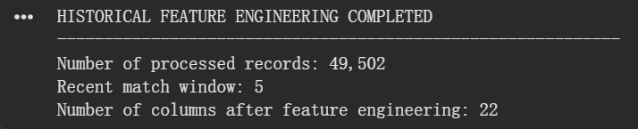

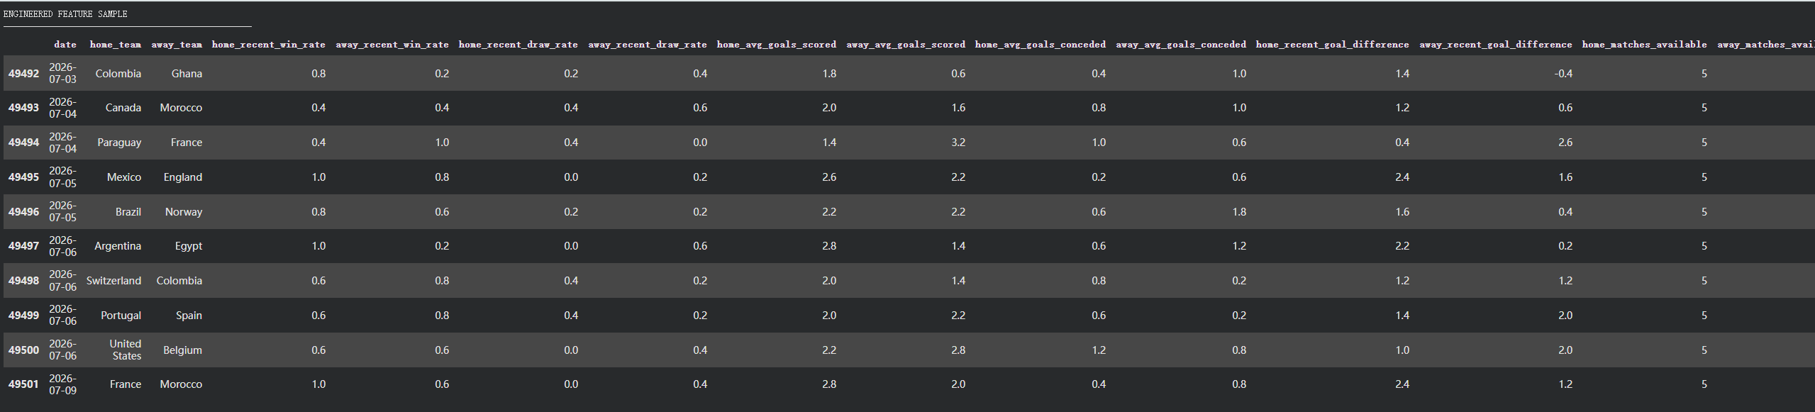
Fig3.2

3.3 Before-and-After Comparison
The pre-processing procedure considerably altered the raw football match data into a machine learning modeling dataset which is structured into a format.
The raw data had information on matches, future matches might not have been recorded, duplicate observations appeared in the data, many individual tournament categories and there was no direct representation of historical team performance.
Only valid completed historical matches were used for model development after the preprocessing. Dates were uniformized and sorted in chronological order, duplicate observations were discarded, the prediction target was created, the tournament data was simplified and encoded, and years of team performance data were added.
The main improvements are summarised in Table 3.1.

Table 3.1. Comparison Before and After Data Pre-Processing
Data Aspect | Before Pre-Processing | After Pre-Processing
Match scores | Included records with missing scores | Completed matches retained for modelling
Duplicate records | Potential duplicate observations | Duplicate records removed
Date | Raw date representation | Converted to datetime and chronologically sorted
Target variable | No explicit prediction target | Home Win, Draw and Home Loss
Team strength | Not directly represented | Historical performance statistics generated
Recent performance | Not available | Recent five-match statistics generated
New-team records | Limited/no historical information | Cold-start values replaced using overall averages
Tournament | Numerous tournament names | Grouped into four categories and one-hot encoded
Relative team strength | Not available | Difference features generated
Neutral venue | Original categorical/Boolean representation | Binary numerical representation
Temporal leakage | Possible if historical features are incorrectly generated | Chronological feature generation prevents future information leakage

In the preprocessing stage, thus, the data were made more consistent and the original dataset, consisting of raw football match data, was converted to a machine-learning-ready dataset with historical, contextual and relative-strength information.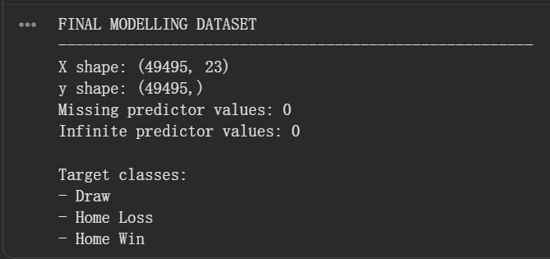
Fig3.3

4. Data Mining Techniques
4.1 Data Mining Techniques Used
The primary data mining technique applied in this project was supervised classification, because the objective was to predict a discrete football match outcome based on historical match information.
The target variable consists of three possible classes:
- Home Win
- Draw
- Home Loss
To compare different classification approaches, three machine learning algorithms were implemented:
- Logistic Regression
- Decision Tree
- Random Forest
Logistic Regression was used as a linear baseline model, while Decision Tree and Random Forest were introduced to capture more complex and nonlinear relationships between historical team-performance variables and match outcomes.
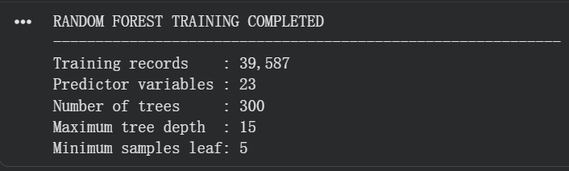
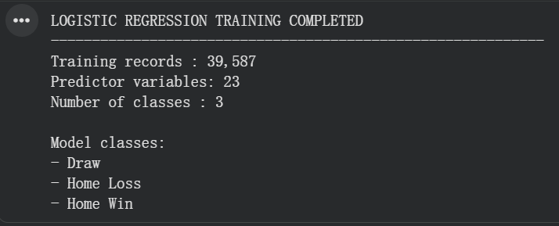
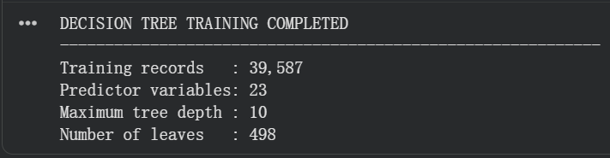

Fig4.1

4.2 Justification of Selected Techniques
Classification was selected because the objective of the project is to assign each football match to one of three predefined outcome classes rather than discovering unknown groups or associations. Therefore, classification is more appropriate than techniques such as clustering or association-rule mining.
Logistic Regression was chosen as a baseline model due to its efficiency and widespread use as a classification model. Its performance will provide a guideline for judging the value of more complicated nonlinear algorithms.
Decision Tree was chosen as it is suitable for situations where there are multiple variables like recent win percentage, goal difference, team experience, tournament conditions, etc., and they can have nonlinear relationships. These relationships can be captured without normalising features and can be captured as interpretable decision structures in Decision Trees.
Random Forest was chosen as an ensemble method to replace Decision Tree. Random Forest can be used to combine the prediction abilities of various decision trees, thereby reducing the variance of a single decision tree, and supplying extra information by conducting feature importance analysis.
The three approaches thus enabled the project to evaluate the performance of a linear baseline model, an interpretable nonlinear model and an ensemble tree-based model under identical experimental conditions.

4.3 Implementation of Data Mining Techniques
The same chronologically prepared modelling dataset was used for training all three classification models. To avoid randomizing historical matches, the first approximately 80% was used in the training set, and the last 20% was used in the testing set.
This chronological splitting strategy is similar to a realistic scenario in a football prediction except that historical information is applied to predict matches that come later.
Logistic Regression
The numerical features were standardised with StandardScaler before being used in Logistic Regression. The classifier was then trained using the scaled training set and tested in the testing set to predict the outcome of the match: win, draw or lose. Sufficient iterations were set for the model to converge while training.
Decision Tree
As tree-based classifiers do not require features to be scaled, the Decision Tree was trained directly on the engineered feature set.
The complexity of the tree was controlled using maximum tree depth, minimum samples per leaf, and minimum samples needed for splitting to prevent over growth of the tree and enhance generalisation. The trained tree was also visualised to show the contribution of the different features to the classification decisions over time.
Random Forest
Random Forest classifier is an ensemble of 300 Decision Trees. To prevent the model from becoming too complex, maximum tree depth and minimum number of samples were controlled.
Additionally, the model computed the importance of the features, which were then utilized to determine the features that most significantly influenced the prediction of football matches. After the models have been developed, they are compared and the best one is selected.
All three models were then trained and used to predict on a chronological testing set. They were judged on the following points in their performances:
- Accuracy
- Precision
- Recall
- Macro F1-Score
Aside from the evaluation of all the matches played in the international tournament during the testing period, a special evaluation was carried out for the FIFA World Cup tournament.
The main criterion to select the final model was the FIFA World Cup Macro F1-Score, since the main objective of this project is to predict the FIFA World Cup.
The best Macro F1 score on the FIFA World Cup subset was obtained by the Decision Tree model. Hence, Decision Tree was chosen as the final prediction model.
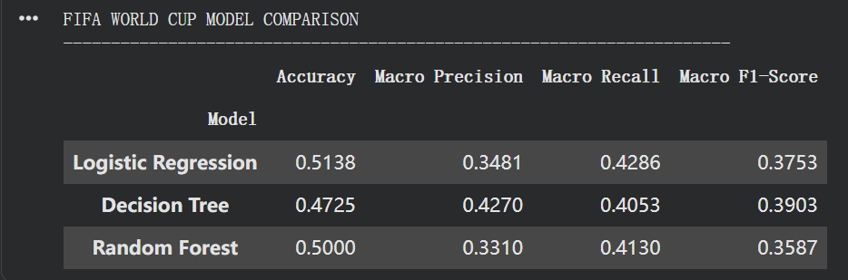
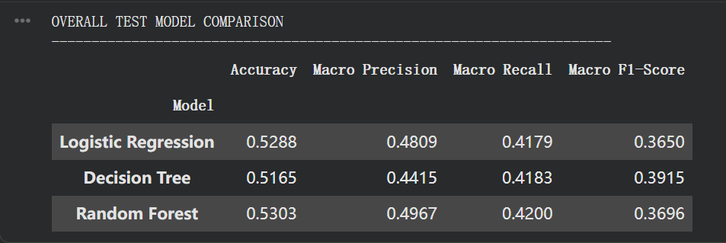
The selected Decision Tree was then retrained with all available completed matches for the final interactive prediction system to be able to use as much historical information as possible.

Fig 4.3

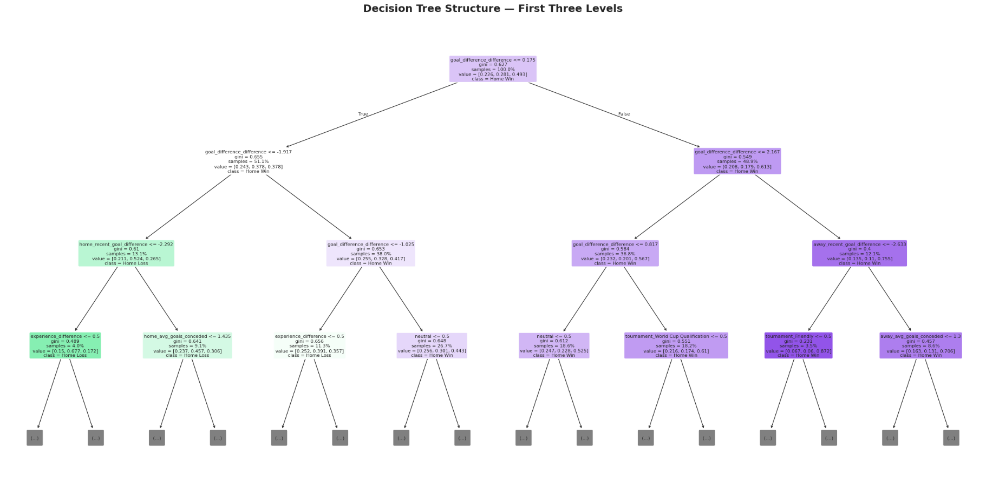
Fig decisionTree

7. Python Implementation
7.1 Structured and Documented Python Implementation
This unit will also cover how to write code in Python using a structured approach and how to document the code.
The entire data mining process was performed in Python on Google Colab. The process of implementation was broken down into easily identifiable steps: Data Loading, Data Auditing, Preprocessing, Feature Engineering, Model Training, Evaluation, Visualisation, and Match Prediction. This modular design allows the source code to be more easily understood, maintained and run.
The primary libraries used in Python for implementing these tools were Pandas and NumPy, both for data manipulation and numerical processing; Scikit-learn for data pre-processing, machine learning and model evaluation; and Matplotlib for visualising results.
The first thing that was done in the pre-processing implementation is to convert the date attribute to date-time, and then sort all the matches chronologically. Matches in the past were distinguished from matches in the future and completed matches from incomplete matches were removed, and duplicate observations were removed. A target variable was then created that was three classes: Home Win, Draw, and Home Loss.
Special functions were created to perform historical feature engineering to compute team performance statistics from previous games. These contained recent win rate, draw rate, average goals scored and conceded, goal difference and historical match experience. Other relative-strength numbers were developed by comparing the statistics of the home and away teams.
Categorical tournament data was then transformed into one-hot encoded categorical data, and the neutral venue indicator was one-hot encoded into numeric data. This feature matrix was then used for training and testing Logistic Regression, Decision Tree and Random Forest classifiers.
Comments, section headings, descriptive variable names, and reusable functions were used to extensively document the implementation. It is a structured approach so that each part of the data mining pipeline can be easily distinguished and understood from the source code.
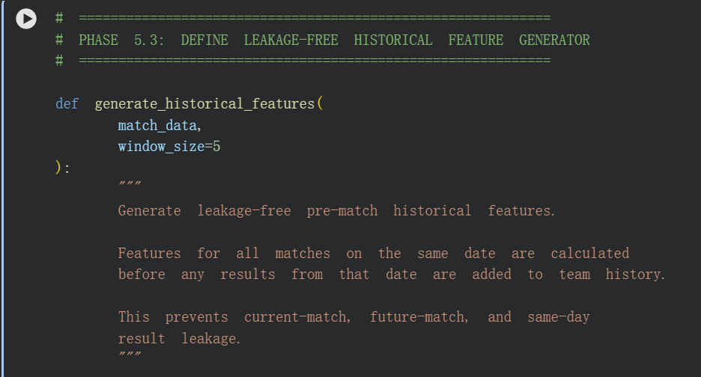

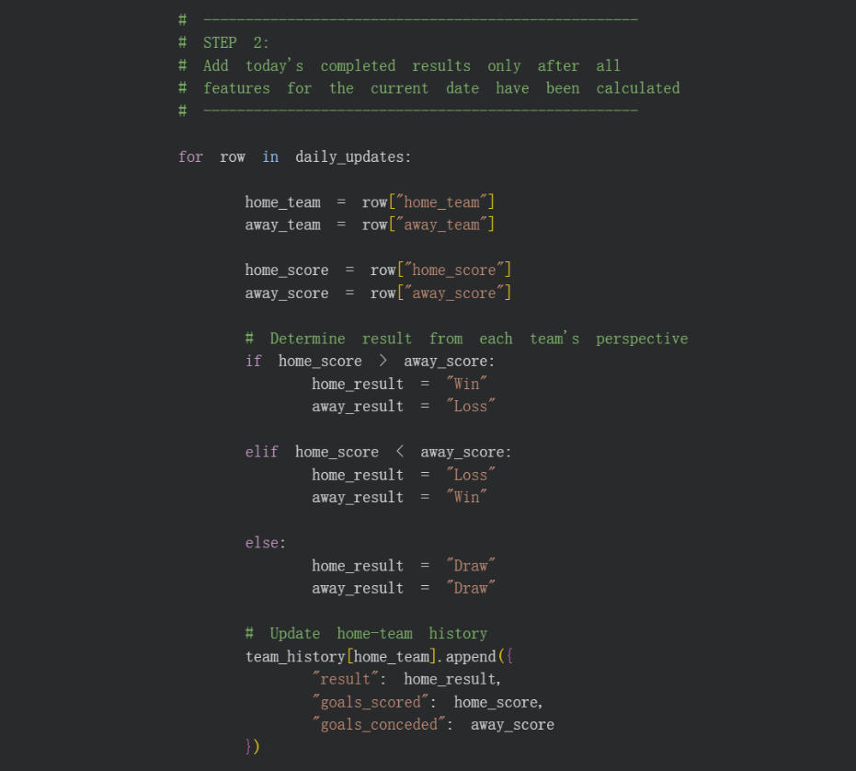
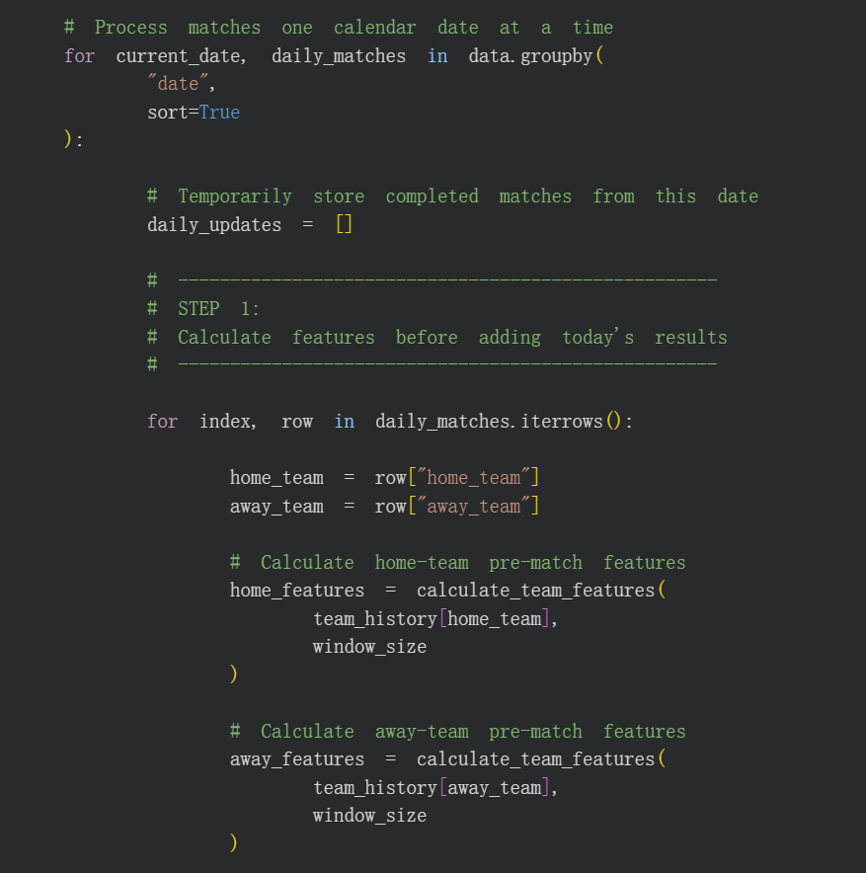
Fig7.1

7.2 Reproducibility and Clarity of Implementation
A number of steps were taken to insure the reproducibility of the experimental results.
The first one is that a fixed random state of 42 (RANDOM_STATE = 42) was used for all machine learning algorithms that include random processes. This guarantees the same behaviour of a model when executed repeatedly with the same dataset and configuration.
Secondly, the data were divided chronologically, rather than randomly. The data from roughly 80% of the historic games was used for training, and the remaining 20% for testing. The implementation also confirmed that the training and the test phase were not overlapping, thus excluding future match data in the training phase.
Thirdly, historical features were created in a chronological order. Predictor variables were computed prior to the entry of the match results in team history for matches played on the same date. This procedure avoids temporal data leakage and keeps all of the history features as information that would have been available before the match.
The same feature set, chronological split, target labels and evaluation procedure were used in all three classification models. The models were evaluated using the same metrics (Accuracy, Precision, Recall, Macro F1-Score) so that they can be compared under the same experimental conditions.
Lastly, the chosen Decision Tree model was retrained with all the available completed historical matches for the interactive prediction system. The prediction function contains the same features as the model development process, allowing the model to be used consistently in training and prediction.
These implementation practices enable to better reproduce, to make transparent, and to clarify the entire data mining process.

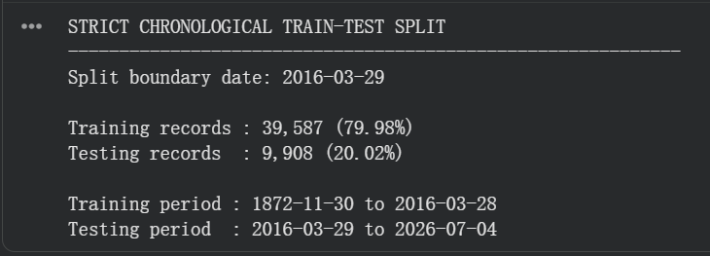

Fig7.2

8. Real-World Prediction Validation
The prediction model was finished in the last phase of the 2026 FIFA World Cup. So as a result,matches played before the completion of the model were not retrospectively treated as real-world predictions. Before the results of the matches were known, three upcoming matches were selected and predicted in order to make a practical evaluation of the completed system: England vs Argentina, France vs England, and Spain vs Argentina.
The historical data set was updated with the latest completed match data available prior to each prediction. This was a particularly crucial requirement as the prediction system is dependent on the recent performance of teams and historical statistics. Recent matches, which are still being played, may alter in-game statistics like recent win rate, draw rate, average goals, goal difference, and team experience. Thus, the model needs to be fed with a set of accurate, complete and of the most current possible data, with the added condition that no data of the match to be predicted is used in the training or generation of the features.

8.1 England vs Argentina Prediction
Before the match, the model generated the following probabilities:
- England Win: 32.4%
- Draw: 25.8%
- Argentina Win: 41.8%
The model therefore predicted Argentina to win, as Argentina had the highest predicted probability of 41.8%.
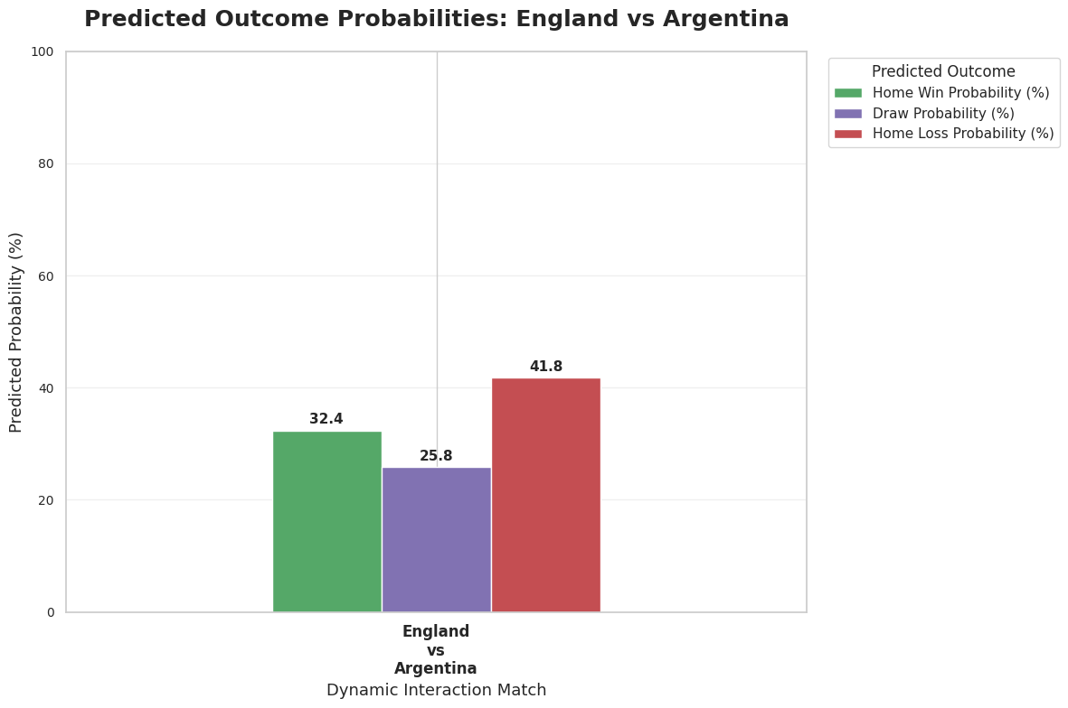
Fig8.1

8.2 France vs England Prediction
Before the match, the model generated the following probabilities:
- France Win: 18.8%
- Draw: 56.2%
- England Win: 25.0%
The model therefore predicted a Draw, with the Draw outcome receiving the highest probability of 56.2%.However, since there are no draws in the World Cup, a prediction that wins without a penalty shootout is considered basically correct.
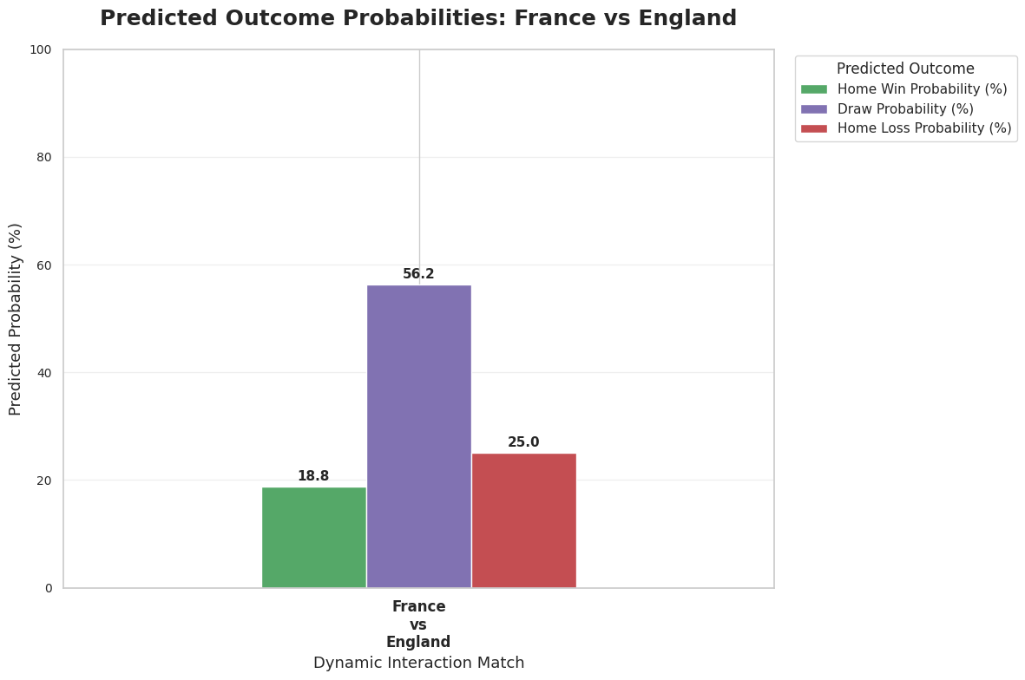
Fig8.2

8.3 Spain vs Argentina Prediction
For the FIFA World Cup Final, the model generated the following probabilities:
- Spain Win: 58.1%
- Draw: 22.6%
- Argentina Win: 19.4%
The model therefore predicted Spain to win the FIFA World Cup Final, with Spain receiving the highest probability of 58.1%.
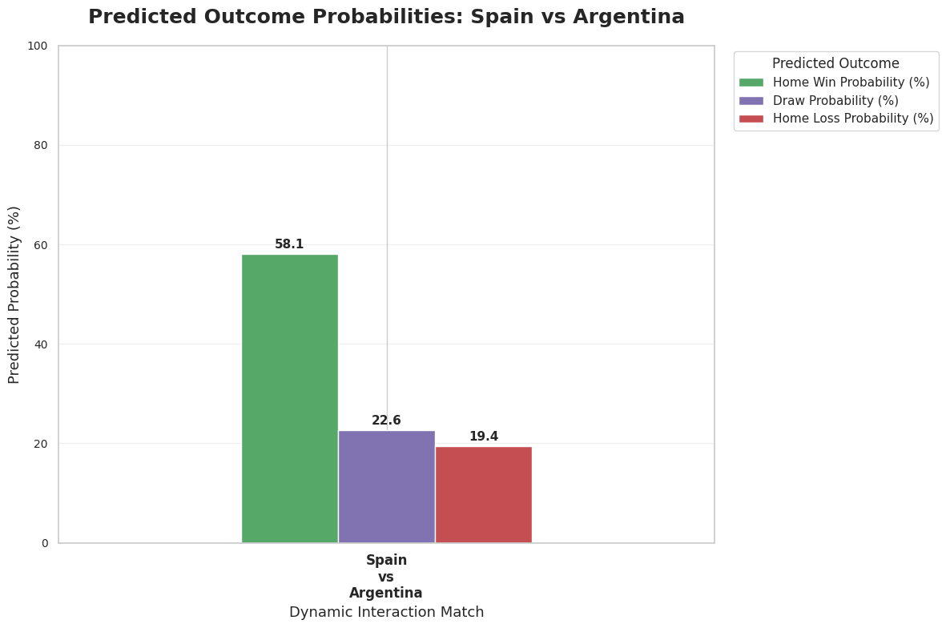
Fig8.3

8.4 Comparison with Actual Match Results
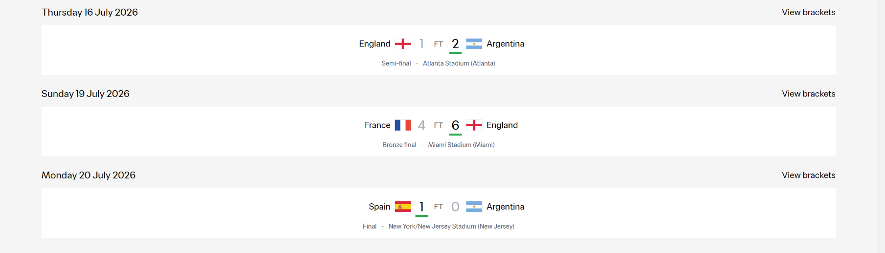
After the three matches were completed, the prospective predictions were compared with the actual FIFA World Cup results, as shown in Figure 8.4.
Fig 8.4

The comparison showed that the model successfully predicted Argentina to defeat England, with Argentina receiving the highest predicted probability of 41.8%. The actual result was England 1–2 Argentina. In the FIFA World Cup Final, the model predicted Spain to defeat Argentina with a probability of 58.1%, and the actual result was Spain 1–0 Argentina. Therefore, both winner predictions were correct.
For France vs England, the model assigned the highest probability to a Draw (56.2%), while England ultimately won the match 6–4. Therefore, this prediction was not fully correct under the three-class classification definition. However, when comparing the two winning outcomes, the model assigned a higher winning probability to England (25.0%) than France (18.8%), indicating that the model correctly identified England as the relatively stronger winning side, although it overestimated the probability of a Draw.
Overall, two of the three prospective matches were predicted correctly according to the highest-probability outcome, while the remaining prediction demonstrated a partially correct directional assessment of the two teams' winning probabilities. These real-world predictions provide additional practical evidence that the model can produce meaningful results for genuinely unseen matches.
It should also be noted that the model was completed only before these final three matches; therefore, earlier World Cup matches were not retrospectively counted as real-world predictions. The experiment further demonstrates the importance of using an accurate, complete, and up-to-date dataset, because newly completed matches directly affect recent-form and historical-performance features used for subsequent predictions.

