5.0 Model validation
Model validation was performed to assess predictive capability of machine learning models formulated in the FIFA World Cup match prediction task. The three supervised classification models compared in this project were: Logistic Regression, Decision Tree and Random Forest. Target variable was based based on three categories: Draw, Home Loss or Home Win.
5.1 Validation Approach and Metrics
The dataset was tested with a chronological train-test split with 80% of match record history used for training and 20% used for testing.
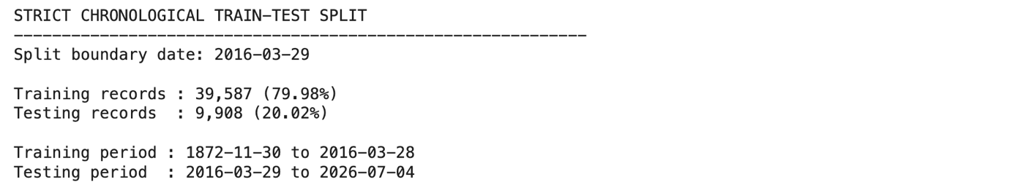
The choice of a chronological split was made as the prediction task in football is time sensitive. This way, the models are trained with previous match data and tested on subsequent matches, more resembling a real-world prediction scenario. It also helps to reduce accidental time data leakage when training models.
The accuracy, macro-precision, macro-recall and macro-F1 score were all calculated to measure the performance of the model. Accuracy represents the percentage of correct predictions of matches. The three outcome classes, however, are not equally represented and some outcomes, such as Draw, are more challenging to foresee the outcome. Macro precision, macro recall and macro F1-score were also included since they measure the model's performance equally for all classes. Confusion matrices were also used to find out the classification number of each model with Draw, Home Loss and Home Win.

5.2 Logistic Regression Validation
Logistic Regression was the first model evaluated in this project. Based on the overall test set,
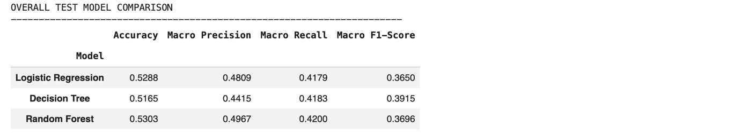
Logistic Regression performed an accuracy of 0.5288, macro precision of 0.4809, macro recall of 0.4176, and macro F1-score of 0.3647. This indicates that the model has correctly predicted the outcomes of a bit over half of all matches.
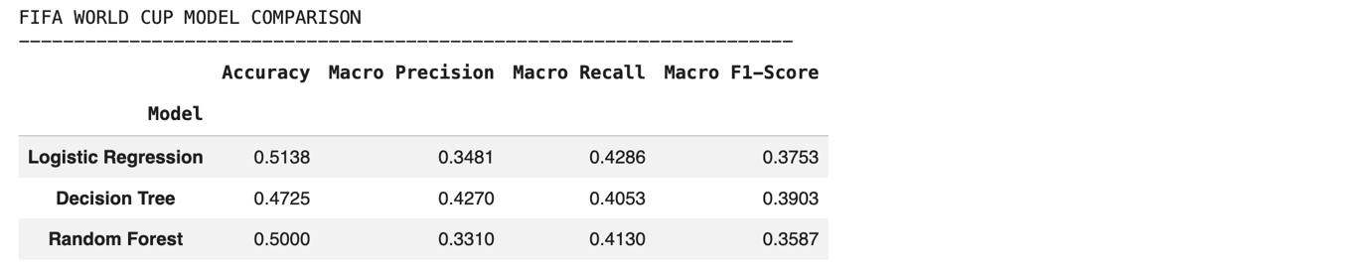
In the case of the test subset used for the FIFA World Cup, Logistic Regression had the highest overall accuracy at 0.5138. Its macro precision was 0.3481, macro recall was 0.4286, and macro F1-score was 0.3753. This suggests Logistic Regression did a fairly good job with World Cup matches on overall predictions.
The overall performance of the classes reveals that Logistic Regression was not able to recognize the results of Draw.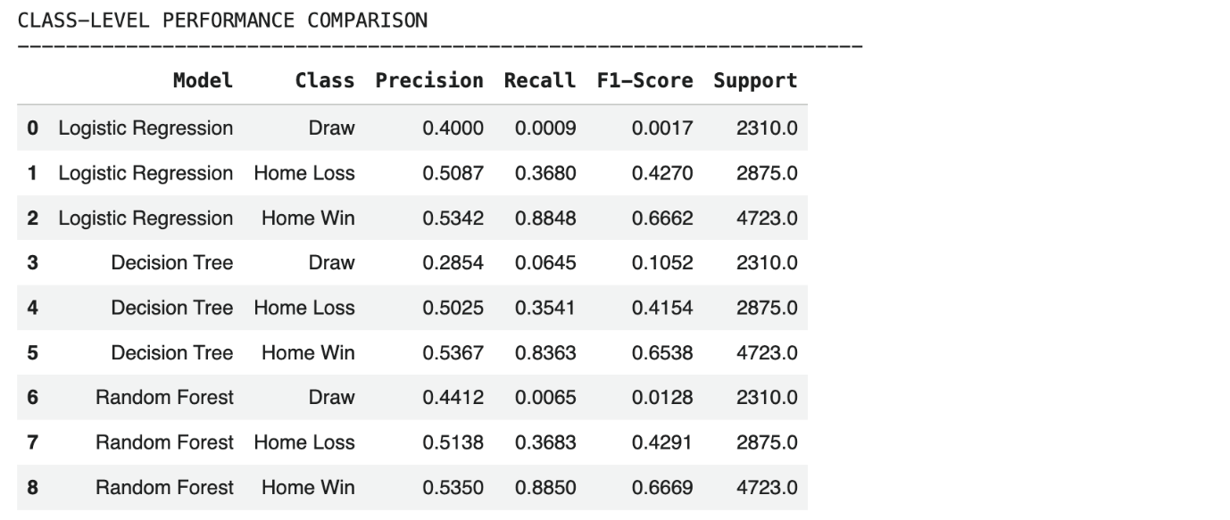
For the overall test set, the F1 score for Draw was only 0.0017 whereas the F1 score for Home Win was much higher at 0.6663. That is, the model to predict Home Win was far superior to Draw Win.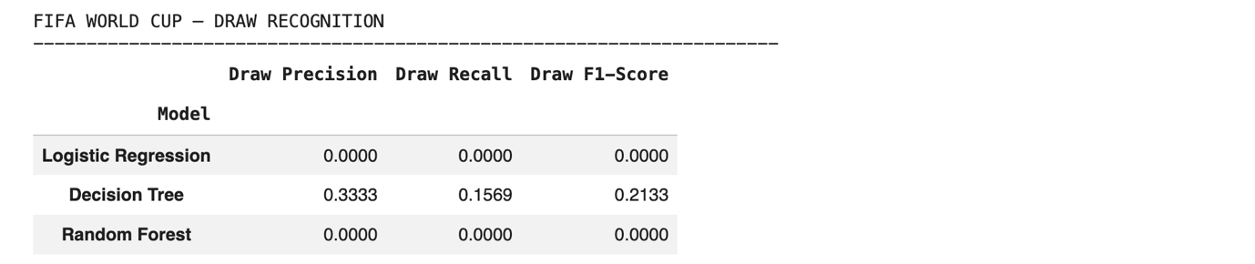
With respect to the FIFA World Cup subset, Logistic Regression did not perform a substantial World Cup draw precision or recall and its F1-score was 0.0000.
However, despite achieving the highest overall accuracy on the FIFA World Cup subset, Logistic Regression failed to recognise Draw outcomes, with a Draw F1-score of 0.0000. Therefore, it was not selected as the final model because its performance was highly unbalanced across the three outcome classes.
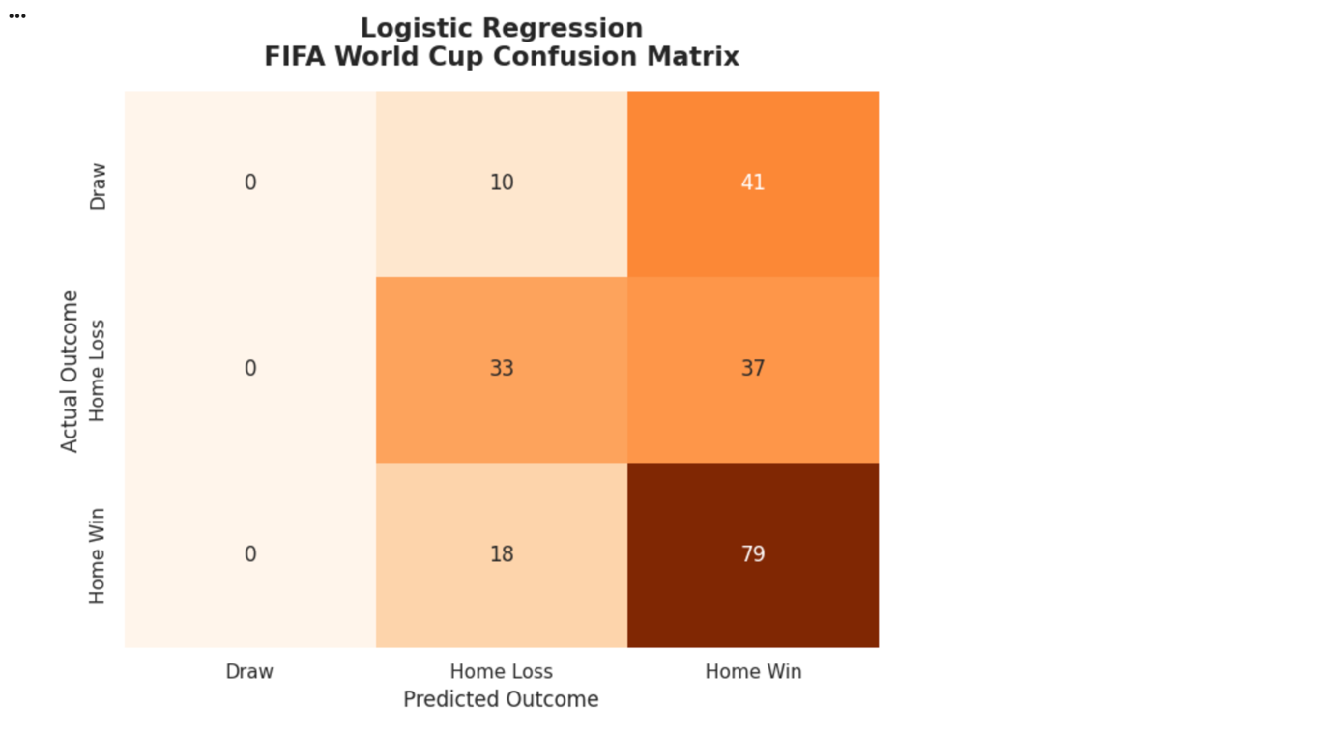

5.3 Decision Tree Validation
Decision Tree was the second model evaluated. On the overall test set,
Decision Tree reached an accuracy of 0.5165, macro precision of 0.4415, macro recall of 0.4183 and macro F1-score of 0.3915. In terms of macro F1 score among the three models, its accuracy was slightly lesser than Logistic Regression and Random Forest but the best.
On FIFA World Cup test subset, Decision Tree's accuracy score was 0.4725, macro precision of 0.4270, macro recall of 0.4053, and macro F1-score of 0.3903. This was the best World Cup macro F1-score for the 3 models. This outcome indicates that the Decision Tree was most balanced.

In the overall test set, its Draw recall was 0.0645 and Draw F1-score was 0.1052.
Decision Tree outperform the other models in Draw outcome recognition. Decision Tree performed better with a Draw precision of 0.3333, a Draw recall of 0.1569 and a Draw F1-score of 0.2133. While these are not yet high, it was the only model that was able to recognise drawn World Cup games in any way. This is significant because Draw is one of the most difficult sporting events to forecast in football odds.
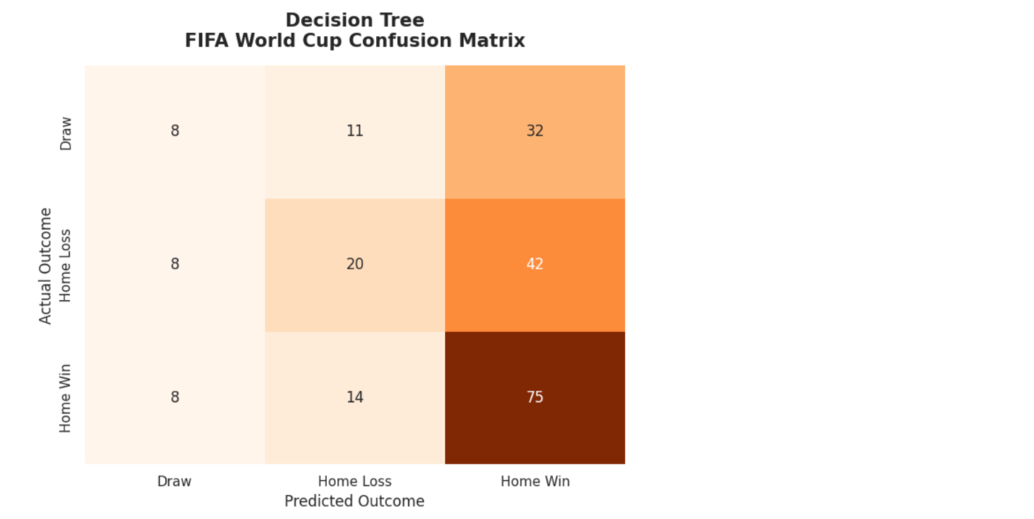

5.4 Random Forest Validation
Random Forest was the third model evaluated. On the overall test set,
Random Forest has overall accuracy of 0.5303. It also gained the macro precision 0.4967, macro recall 0.4200 and macro F1-score 0.3696. As it is seen this is the best overall accuracy and macro precision of the Random Forest.
For the FIFA World Cup test subset,
Random Forest had an accuracy of 0.5000, macro-precision of 0.3310, macro-recall of 0.4130, and macro-F1 of 0.3587. The model made satisfactory accuracy but its macro F1 score is lower than the scores of Decision Tree and Logistic Regression. This implies that Random Forest is not the most balanced between the three outcome classes.
Class-level results indicate that Home Win has been successfully predicted by Random Forest with a Home Win F1-Score of 0.6669. Just like Logistic Regression, however, was not very good at recognizing Draw outcomes. Its overall Draw F1-score was just 0.0128, and on the subset FIFA World,
the precision and recall both equaled 0.0000 and the F1 score was also 0.0000. This indicates that while the overall accuracy of Random Forest was better, it did not work well for drawn World Cup matches.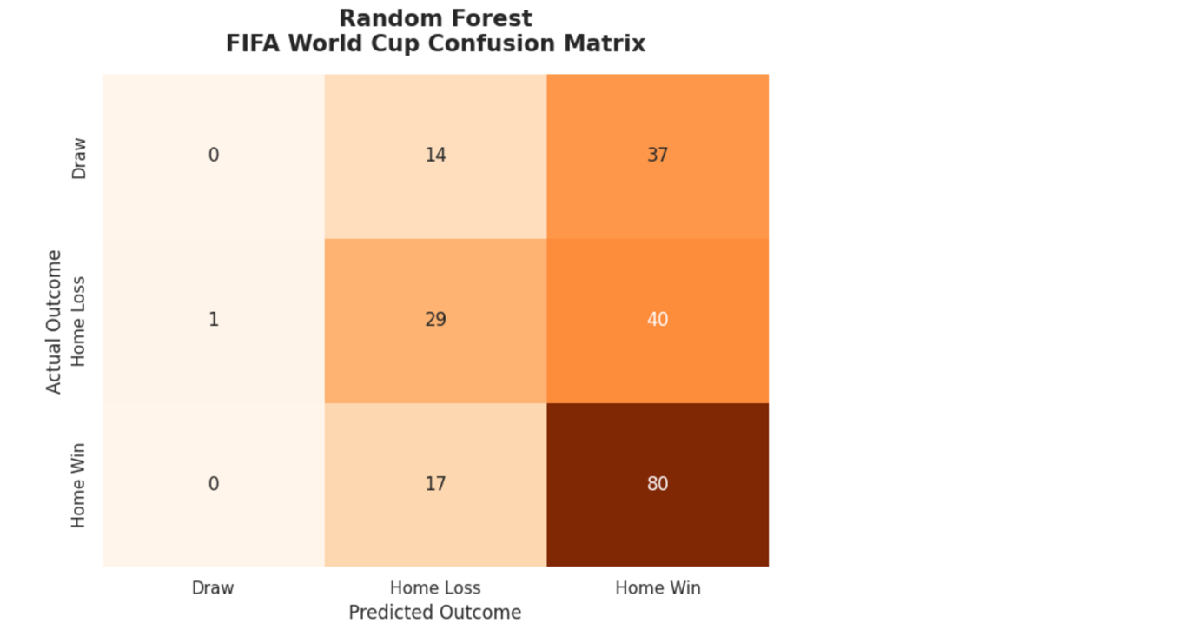

5.5 Model Comparison and Final Model Selection
The model comparison results show that each model had different strengths.
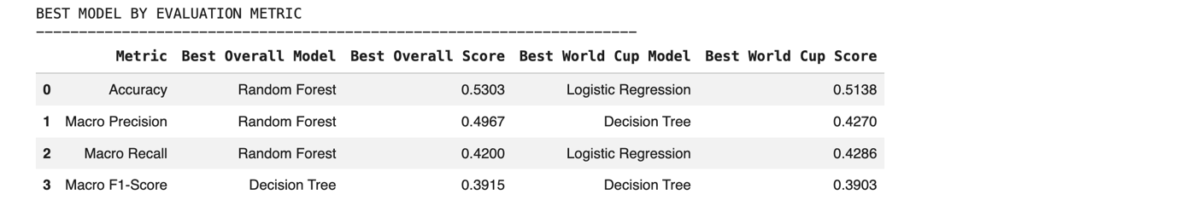 Random Forest showed the best overall accuracy with 0.5303 and Logistic Regression obtained the best FIFA World Cup accuracy of 0.5138. Decision Tree however, had the best overall macro F1-score of 0.3915 and the best FIFA World Cup macro F1-score of 0.3903.
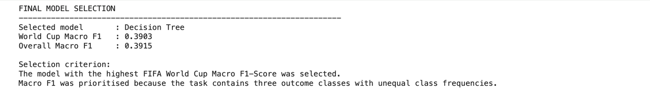
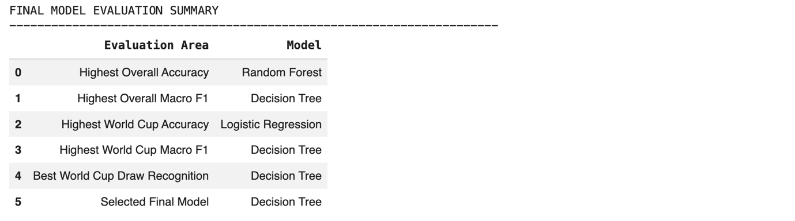
The maximization of macro F1 score over accuracy is used to this project, as the prediction task is based on three outcome classes with unequal distribution. While the model might be more accurate, it might predict the dominant class quite well with inadequate performance on more challenging classes like Draw. Since Decision Tree provided the best macro F1-score and showed the strongest draw recognition performance, it was selected as the final model for FIFA World Cup match prediction.
In general, the results of the validation showed that football match prediction is a multi-class classification problem. All three models performed moderately; however, none of them predicted highly precisely in all outcome classes. This suggests that additional features, improved model tuning, and more advanced modelling techniques may be needed to improve future prediction performance.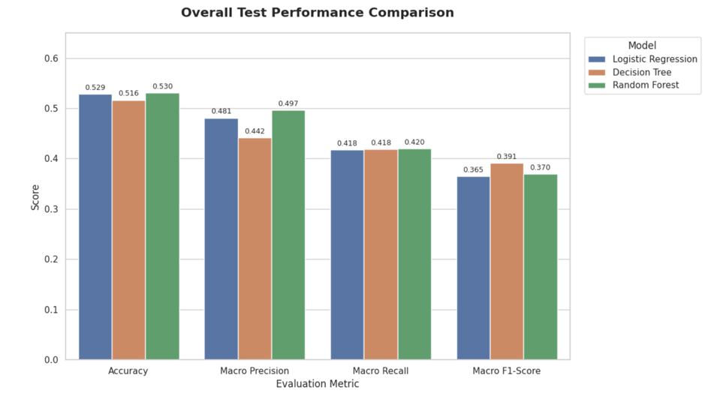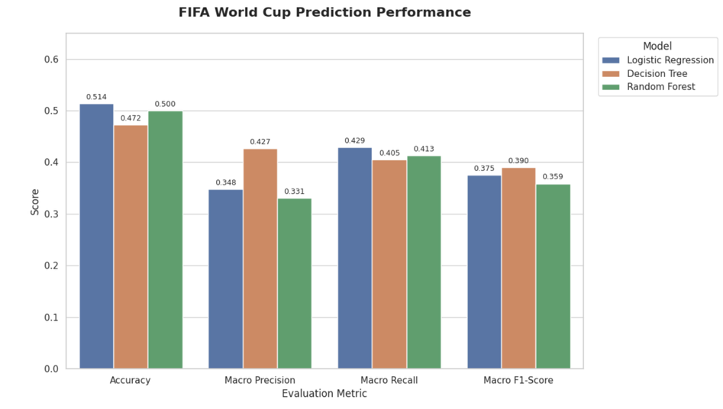
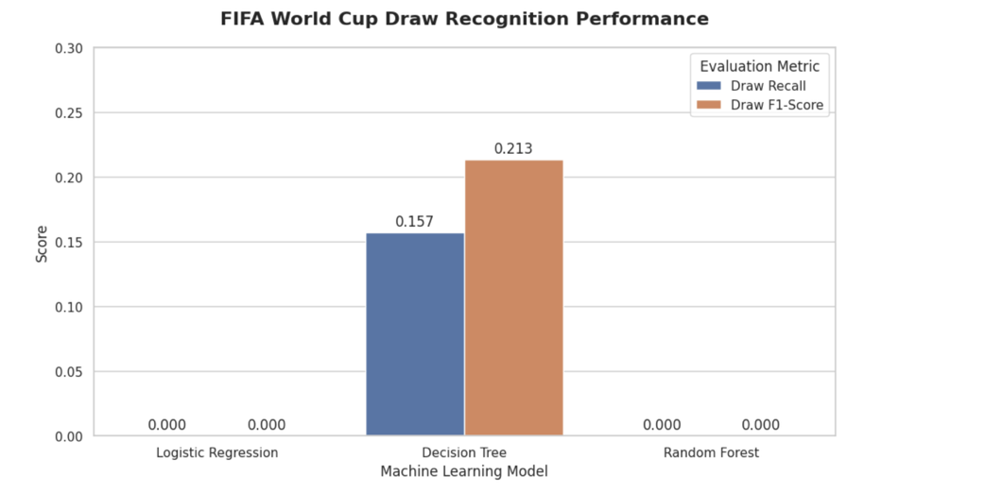

6.0 Conclusion and Future Improvements

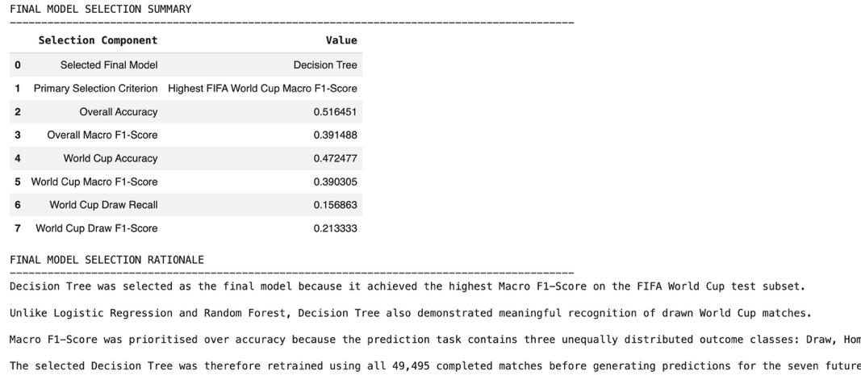
The outcome prediction for FIFA World Cups using a historical dataset of international football matches was successfully developed using a predictive modelling framework. The final modelling data comprised 49,495 completed match records and 23 variables were used to fit and test the models. These predictors were recent performance features, historical experience, team differences, match context, and tournament category features.
Three classification models were implemented: Logistic Regression, Decision Tree, and Random Forest. The results revealed that none of them had high prediction accuracy, illustrating the complexity of predicting outcomes in football match. There are numerous unpredictable factors that go into football results, including team tactics, player health, injuries, match pressure, and unforeseen events during the game. So, a 50% accuracy rate is fair for this type of exercise, considering that Draw, Home Loss, and Home Win are all three outcomes.
The best overall accuracy score of the three models was the Random Forest and highest accuracy score on the FIFA test subset was Logistic Regression. Nevertheless, Decision Tree was chosen as the final model as it obtained the highest FIFA World Cup macro F1-score and the strongest capability to recognize drawn matches. This is significant as the accuracy could potentially mislead if the model does well on the majority classes and not as well on less common or more challenging predictions. The models were compared fairly across all three match outcome classes by using macro F1-score.
Results indicate that historical performance measures and team comparisons can be of help in the prediction of match outcomes. The results demonstrate, however, that predicting football results is still a very complex challenge. The relatively low macro F1-scores show that the models did not perform well in all outcome categories, especially the draw outcomes. This can be due to class imbalance, limited feature representation, or the variability of football games.
For future improvements, several steps can be considered：
- Additional features could be included, such as FIFA ranking, player injuries, team line-ups, recent squad strength, coach changes, betting odds, and match location details.
- Hyperparameter tuning using Grid Search or Random Search could be applied to improve model performance.
- More advanced models such as Gradient Boosting, XGBoost, or ensemble stacking could be tested. Fourth, class imbalance handling techniques could be applied to improve the prediction of difficult classes such as Draw.
- Cross-validation or rolling-window validation could be used to further improve the reliability of the model evaluation.
The project exemplifies the potential applications of data mining and machine learning algorithms in enhancing football match prediction. While the predictive power is constrained, the analysis offers valuable insights into model comparison, feature importance, and the challenges associated with multi-class sports prediction.

