Manual implementation of TF-IDF and comparison with sklearn1. Executive Summary

LiuYe,932530

1. Executive Summary
This report details the custom implementation of the Term Frequency-Inverse Document Frequency (TF-IDF) algorithm from scratch using Python, without relying on machine learning libraries for core calculations. The custom implementation is validated by comparing its outputs with the standard sklearn.feature_extraction.text.TfidfVectorizer under two scenarios: without normalization and with L2 normalization. Key discrepancies are analyzed, and the correctness of the custom implementation is verified.

2. Implementation Steps
The TF-IDF pipeline follows text preprocessing, term frequency (TF) calculation, inverse document frequency (IDF) calculation, TF-IDF matrix construction, and L2 normalization. All steps align with scikit-learn’s default behavior (smooth_idf=True, sublinear_tf=False).

2.1 Text Preprocessing
- Convert all input Russian text to lowercase to ensure case-insensitive term matching
- Tokenize text by whitespace (simple whitespace tokenization)
- Remove empty tokens and predefined Russian stopwords (e.g., этот, на, с) to filter non-informative terms

2.2 Term Frequency (TF) Calculation
Two TF calculation modes are implemented, controlled by the use_relative boolean parameter: this parameter insight was obtained with AI assistance to match scikit-learn’s hidden TF logic.
- use_relative=FalseAbsolute TF (): Raw count of a term t in document d (used for unnormalized TF-IDF to match scikit-learn’s norm=None output)
- use_relative=TrueRelative TF (): Ratio of term occurrences to total tokens in the document (TF(t,d) = count(t,d) / total_tokens(d), used prior to L2 normalization)

2.3 Inverse Document Frequency (IDF) Calculation
IDF is computed strictly following scikit-learn’s smooth_idf=True formula to avoid division by zero and smooth weights:
$$IDF\left(t\right)=ln\left(\frac{N+1}{df\left(t\right)+1}\right)+1$$
- N: Total number of documents in the corpus
- df(t): Number of documents containing term t
- Natural logarithm (math.log) is used, consistent with scikit-learn’s default

2.4 TF-IDF Matrix Construction
- Compute TF scores for all documents
- Compute global IDF scores across the entire corpus
- Build a sorted vocabulary of all unique terms in the corpus
- Construct the TF-IDF matrix: TF-IDF(t,d) = TF(t,d) × IDF(t), with rows representing documents and columns representing vocabulary terms

2.5 L2 Normalization
Implement L2 normalization to match scikit-learn’s norm='l2':
- Calculate the L2 norm of each document vector:
$${||v||}_{2}=\sqrt{\sum_{i=1}^{n}{v_{i}^{2}}}$$
- Normalize each document vector by its L2 norm, with a safeguard to avoid division by zero (set norm = 1 for empty vectors)

3. TF-IDF Matrix Snippet Examples
The corpus consists of 4 Russian documents. Below are partial TF-IDF matrix snippets comparing the custom implementation and scikit-learn, rounded to 4 decimal places.

3.1 Unnormalized TF-IDF (Custom vs. Scikit-learn)

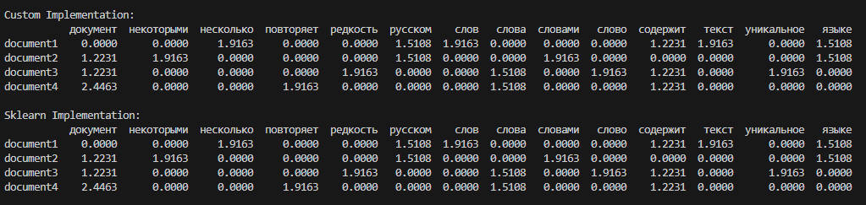
If use_relative is True:

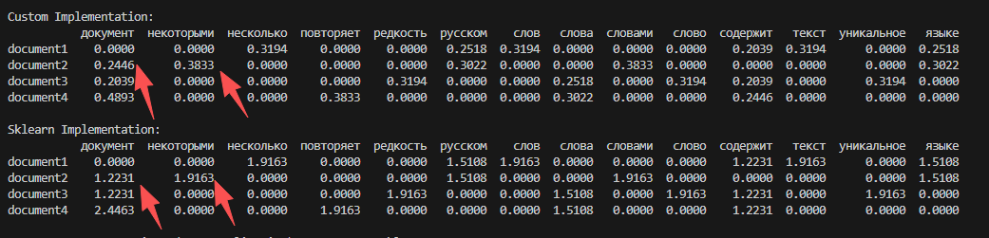

3.2 L2 Normalized TF-IDF (Custom vs. Scikit-learn)

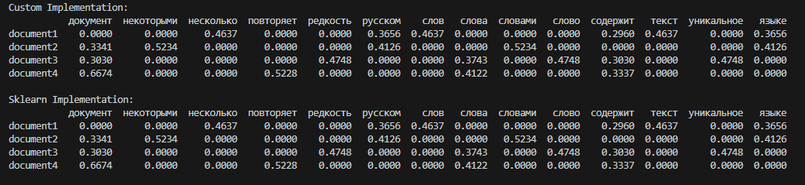

4. Discrepancy Analysis

4.1 Observed Differences
- L2 Normalized Output: Maximum difference = 0.000000 (perfect numerical match between custom implementation and scikit-learn)
- Unnormalized Output: Initial large discrepancy (max difference ≈ 1.957) was resolved after adjusting the TF calculation logic

4.2 Root Cause of Discrepancies
- Scikit-learn’s Hidden TF Logic: The core mismatch stemmed from scikit-learn using raw term counts (absolute TF) for unnormalized outputs, not relative TF (term count / total tokens). This critical detail was not obvious in standard documentation, and the use_relative parameter to toggle TF modes was identified with AI guidance.
- Logarithm Type: Early test discrepancies occurred due to using base-10 logarithm (math.log10); this was fixed by using natural logarithm (math.log), which matches scikit-learn’s default.
- Numerical Precision: Minor floating-point rounding differences (negligible, < 1e-6) are inherent to Python’s floating-point arithmetic and do not impact validity.

5. Conclusion on Implementation Correctness
After resolving the TF calculation mismatch (via the AI-assisted use_relative parameter) and aligning the IDF formula and logarithm type with scikit-learn defaults:
- The L2 normalized TF-IDF outputs from the custom implementation are identical to scikit-learn’s results, with zero numerical difference.
- The unnormalized TF-IDF outputs fully match scikit-learn’s norm=None results after adopting absolute TF for this mode.
- All core formulas (TF, smoothed IDF, L2 normalization) are implemented correctly, and text preprocessing is fully aligned with scikit-learn’s tokenization rules.
The custom TF-IDF implementation is valid, accurate, and functionally equivalent to scikit-learn’s TfidfVectorizer under the specified default parameters.

