Section 1

For this exam, I chose a recurve long-bow: the 'Toparchery Archery 56" Takedown Hunting Recurve Bow Metal Riser Right Hand Black Longbow'.
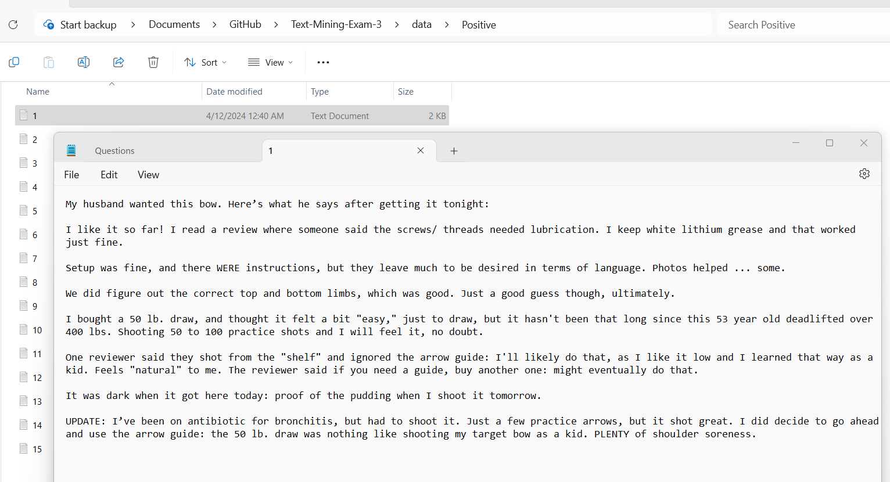
Positive Corpus and Example Review above.
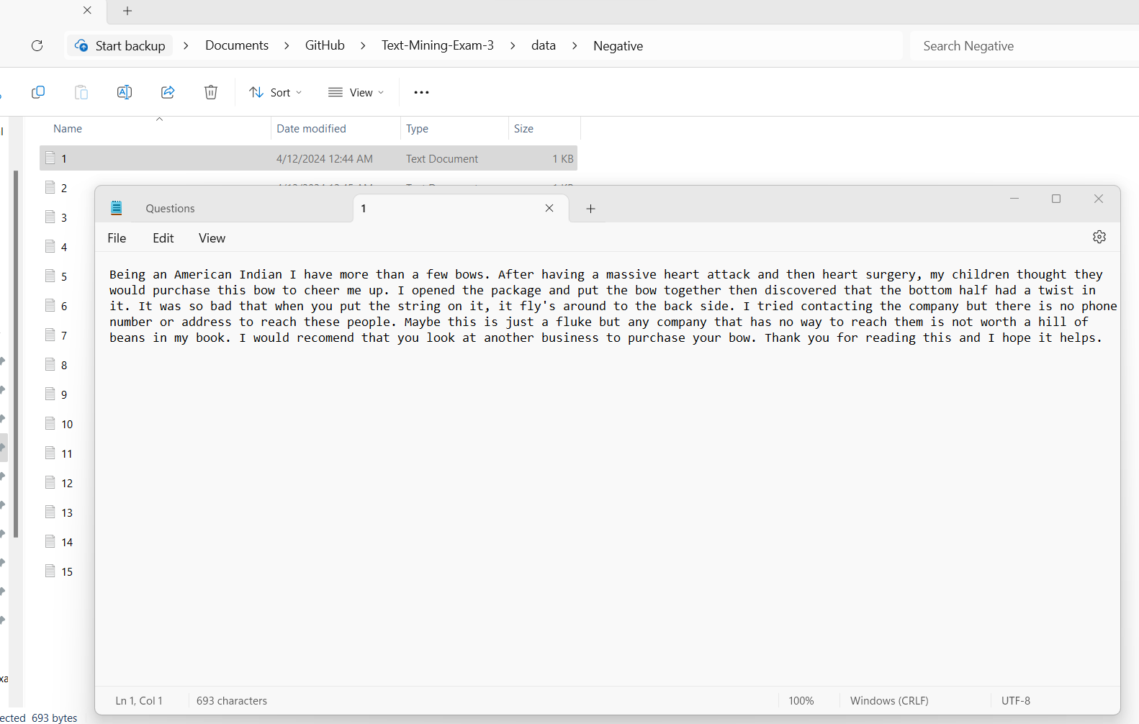
Negative Corpus and Example Review above.

Questions:
1. What do people who like the bow like about it?
2. Conversely, what problems to the people who leave 1-star reviews have with the bow?
3. Which model will perform the best at classifying the positive and negative reviews?
4. What topics could be generated from this dataset with LDA? How are they distributed?
5. Which reviews tend to be longer, positive or negative reviews?

Section 2
WDMs
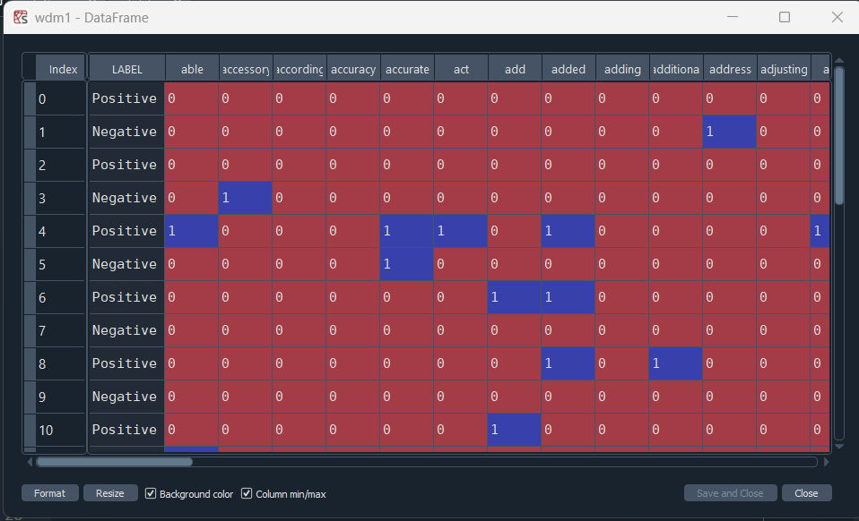
This is the corpus (word-document matrix) which contains all feature terms in the text. It was created using CountVectorizer, with stop_words='english'. The tokens were cleaned of special characters and lemmatized using nltk's WordNetLemmatizer during preprocessing. Each document (review) is labelled as Positive or Negative.
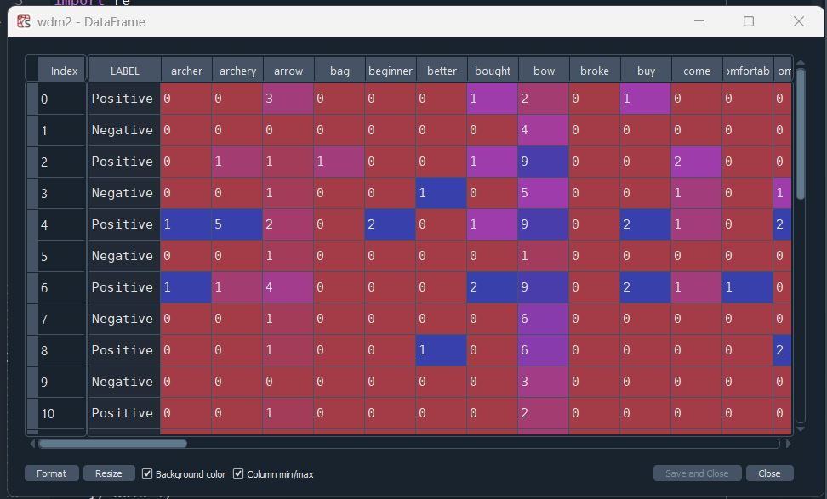
This is the corpus (word-document matrix) which contains only the top 100 feature terms in the text, by term frequency. This was created using CountVectorizer, with stop_words='english' and max_features=100. The tokens were cleaned of special characters and lemmatized using nltk's WordNetLemmatizer during preprocessing. Each document (review) is labelled as Positive or Negative.
Section 3
1. Positive Reviews WordCloud
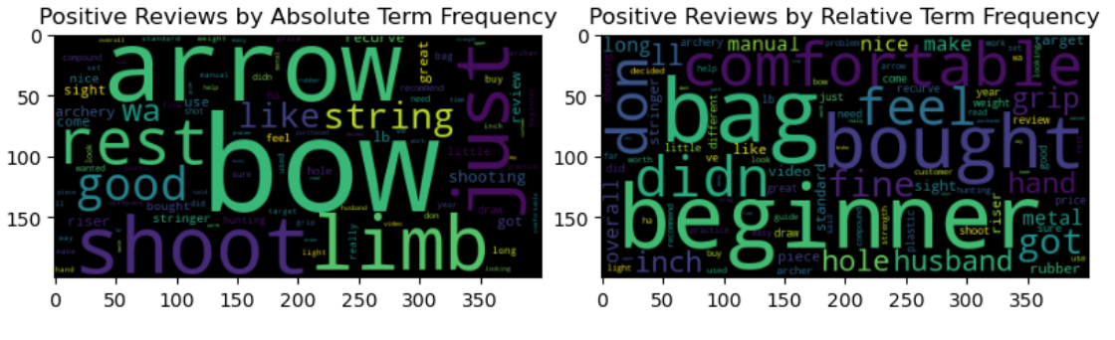
WordCloud for Positive Reviews pictured above. Two word-clouds were generated, one organized by absolute term frequency, and the other by relative term frequency (in-class term frequency divided by cross-corpus term frequency.) The most popular terms in the positive reviews are, unsurprisingly, bow and arrow, and related terms. The terms which had high relative frequency in the positive reviews become more revealing: beginner, and comfortable, are both informative. They imply the bow is likely good for beginners and is comfortable to hold.
2. Negative Reviews WordCloud
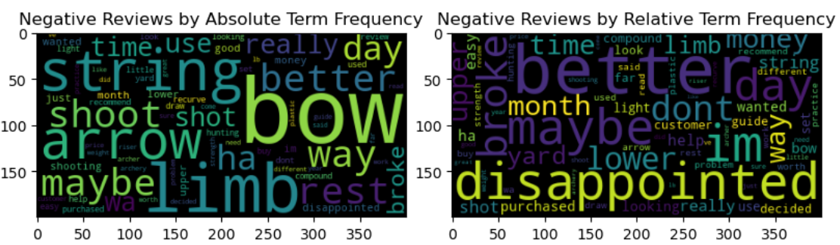
WordCloud for negative reviews pictured above. Two word-clouds were generated, one organized by absolute term frequency, and the other by relative term frequency (in-class term frequency divided by cross-corpus term frequency.) The terms limb and string are much more prominent in the negative reviews as visualized by absolute frequency, indicating issues with the bow's limbs and string. The terms with the highest relative frequency in the negative reviews include better, broke, and disappointed. This could indicate that the bow has a tendency to break, and perhaps other bows are better for the price.
- ARM
For ARM I first split the corpus by label, then ran the apriori algorithm on each class, one for the positive reviews and one for the negative reviews.
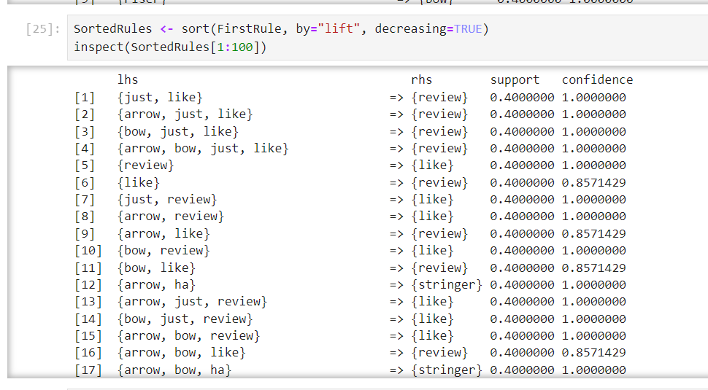
Pictured above are the rules mined from the positive reviews, sorted by lift. For the positive reviews, 'like' is implied by 'bow', 'arrow' and 'review'. This indicates a positive sentiment for the bow.
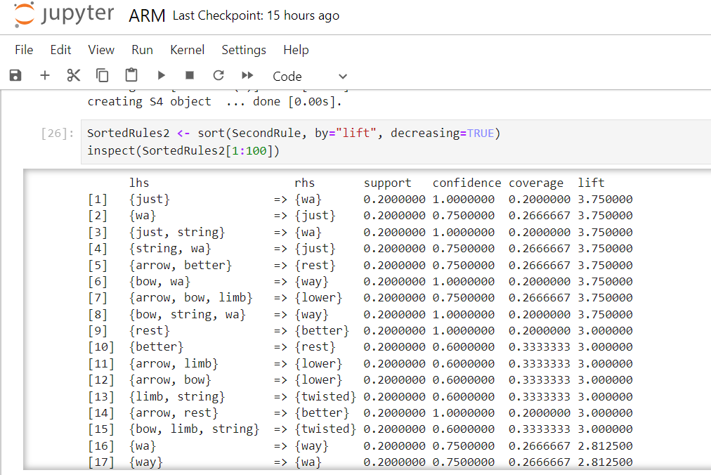
Pictured above is the ARM top rules mined from the negative reviews, sorted by lift. For the negative reviews, 'twisted' is implied by 'limb' and 'string'. This implies that the negative reviewers received bows that either came with twisted limbs, or were twisted after some use. It's also interesting that 'arrow' and 'rest' imply 'better'. I'd wager the negative reviews recommend that other arrows are better than the ones that come with this bow.
- Clustering
For clustering, I attempted to use KMeans clustering, and hierarchical clustering with both 'euclidean' and 'cosine' distance metrics. Kmeans clustering did not achieve any meaningful separation between the labelled categories, and often resulted in one large clustering with 29 members and the 30th review in a cluster by itself. This is likely because the reviews showed significant variance in length and content, and perhaps the shortest or longest reviews were placed in a cluster of their own.
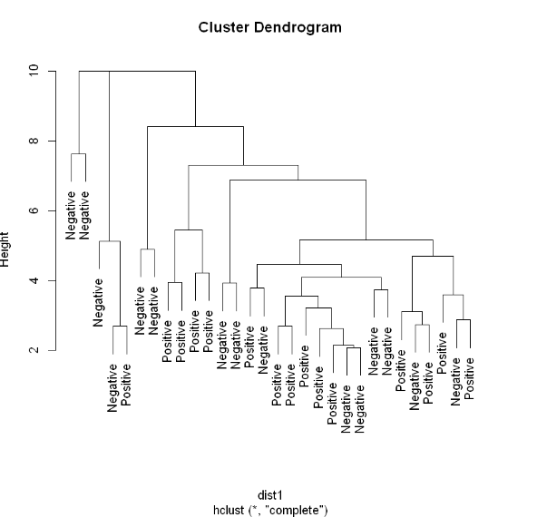
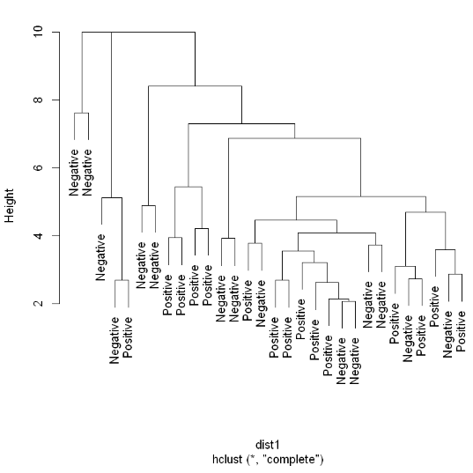
I had significantly more success with hierarchical clusering in R. The Dendrogram on the left is the result of hierarchical clustering with cosdist as the distance metric (a cosine-based distance metric in R). The Dendrogram on the right is the result of running hclust with the standard dist (euclidean) distance metric. The hierarchical clustering had mixed results, with sone sections largely clustering along the labels (like the limb on the far left of each tree, which contains mostly negative reviews) and some mixed sections containing positive and negative reviews.
- LDA
For LDA, I used pyLDAviz with a 2-topic model, and generated word-clouds of the top words in each topic, by document term frequency.
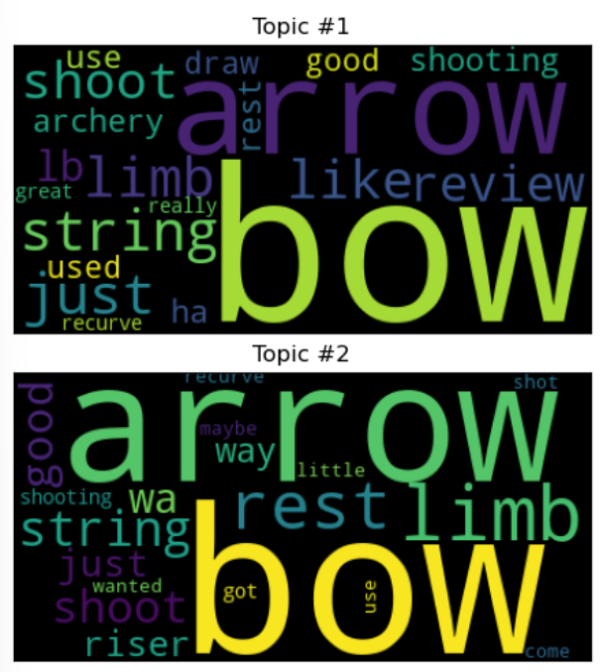
Both topics are dominated by words related to the bow (bow, arrow, limb, shoot), and seem to be generally about archery. Topic #1 seems to be more closely related to the positive review language, containing the terms 'like', and 'review'. 'limb' and 'arrow' are more prevalent in topic 2, so perhaps it's more related to the problems people were having with the bow limb and arrows, as seen in ARM.
Section 4
Train-Test Split
For supervised learning, I split each of the two datasets (top 100 WDM and All-features WDM) into train/test datasets, with a 2:1 train-test split.
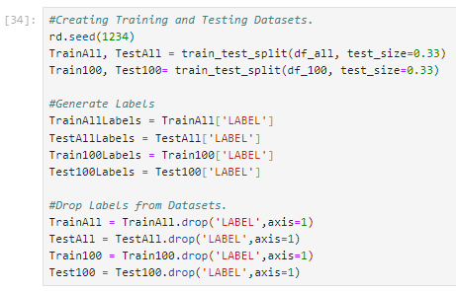
I screenshotted the head of each dataset, as well as the labels corresponding to each dataset.

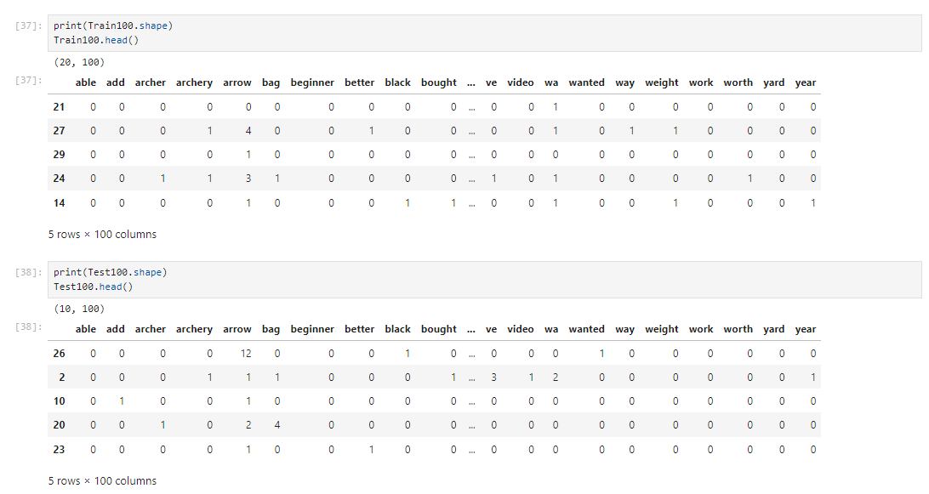
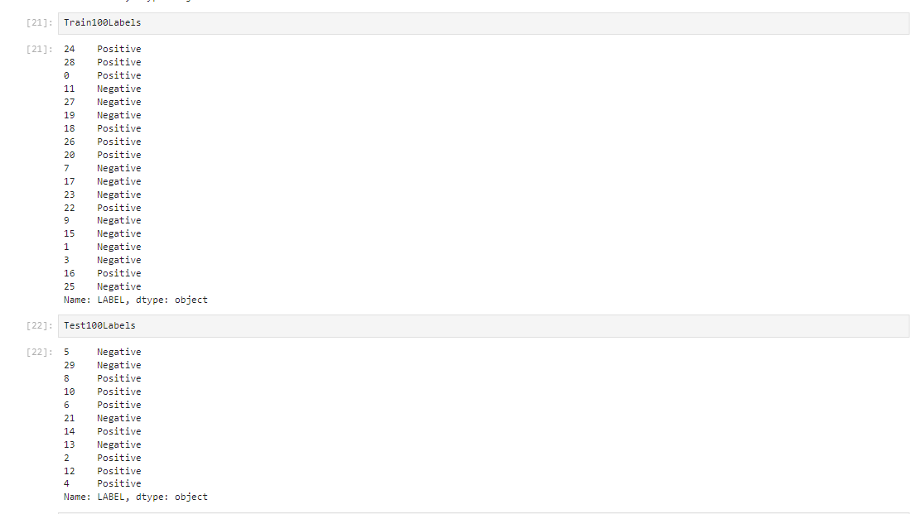
Pictured above is the Train and Test Dataset for the top 100 features df, and the corresponding labels.
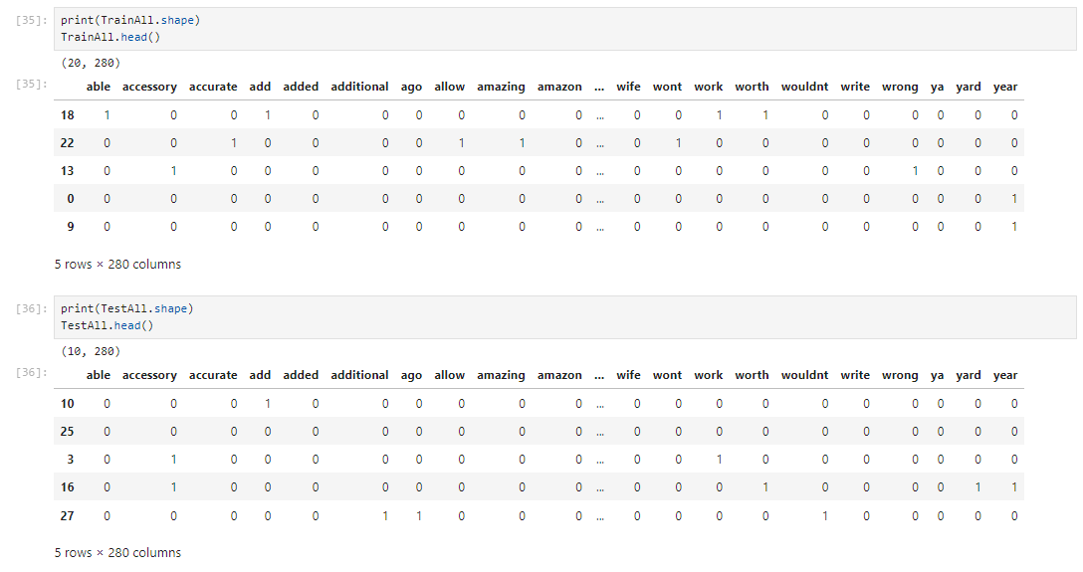
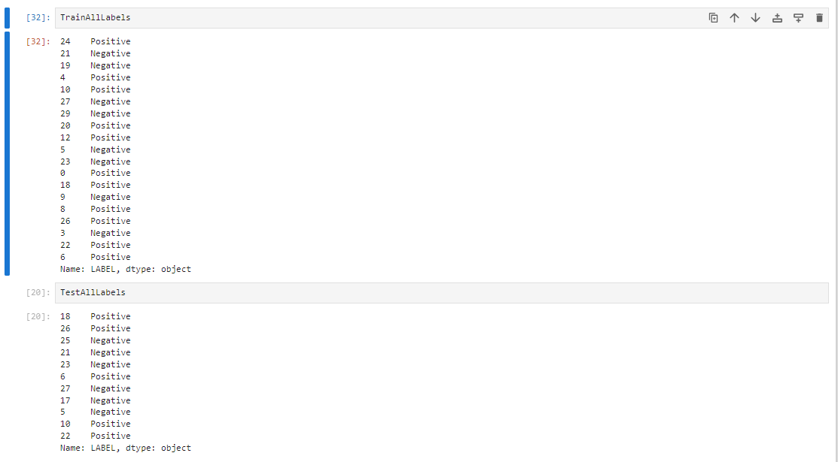
Pictured above is the Train and Test Dataset for the all-features df, and the corresponding labels.
Section 5
Naive-Bayes Classification

For Naive-Bayes classification I trained two models, one for the All-features and one for the top 100 Features dataset.
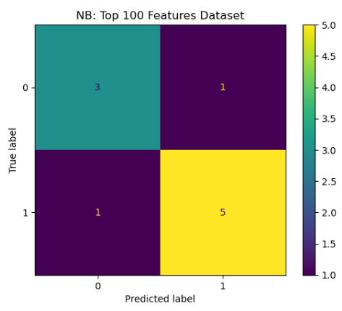
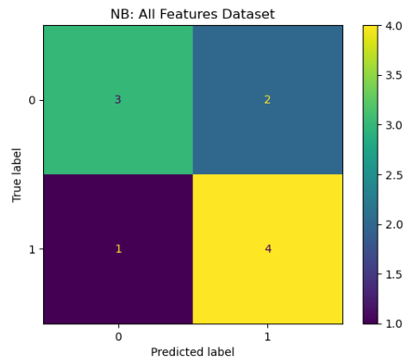
Pictured above was the Confusion Matrices for NB for the all-features and top 100 features datasets. NB performed admirably well in classifying both datasets. I also printed the probability predictions for the test dataset for each model, along with the correct Test labels.
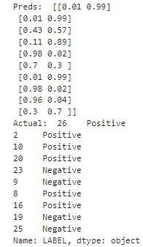
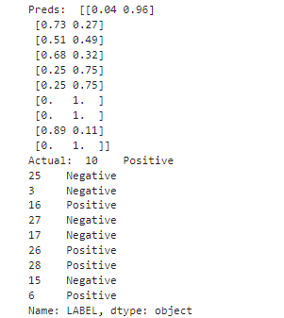
Left, All-Features Dataset NB Predictions. Right, Top-100-Features Dataset NB Predictions.

Pictured above are the each model's probability predictions for the test dataset, and the corresponding test labels. It is clear to see that NB can predict the class of many reviews with a high degree of confidence. However, a minority of reviews appear to give the model trouble. For instance, review #10 in the Top-100 features dataset is confusing the model. It is only 57% confident in its classification. Review #3 in the all-features dataset is similarly vexing, the model is only 51% confident in its selection. It seems that overall, there are enough recognizable differences between the positive and negative reviews that the NB model is pretty good at telling them apart.
Section 6
Decision Trees
For the decision-tree classification I created two decision-tree models, one for each dataframe.
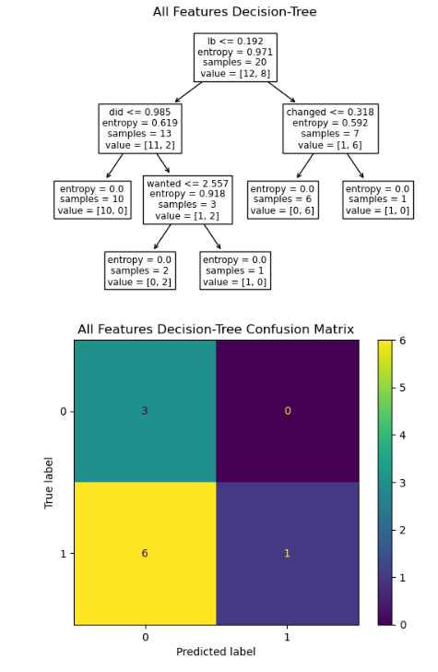
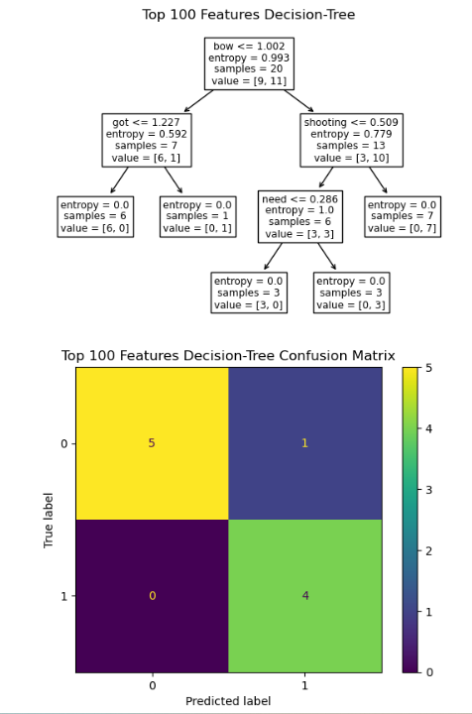
The all-features decision-tree performed significantly worse on the test dataset than the top-100 features decision-tree. This could indicate over-fitting in the case of the all-features model, which would make sense as that model includes many less common terms which are somewhat randomly distributed between the classes. Noteably, 'wanted', and 'need' are the final branches for large sub-sections of the respective decision-trees. The presence of 'need' is able to correcly classify 6 reviews into positive/negative classes in the top-100 features decision-tree, which is the more successful tree overall. These words could be indicative of a positive review.
Section 7
SVM
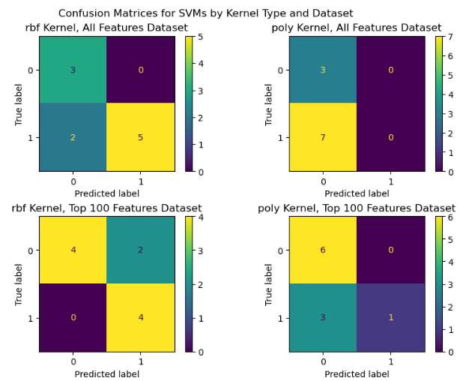
For SVM, I tried using a 'radial-basis vector' (rbf) kernel, as well as a polynomial (poly) kernel. Each of these two SVM models were tested on each of the two data-frames. The rbf kernel performed well on both datasets consistently, as can be seen above. Meanwhile, the polynomial kernel performed quite poorly on both datasets, often classifying everything as one single class. It appears that SVM with an rbf kernel can be effective at classifying this data, while a polynomial kernel tends to perform poorly on this data.
Section 8
Results
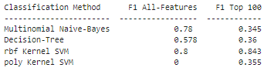
Above, averaged f1-scores for each supervised classification model on each test dataset.

To measure overall performance, I performed three randomized train-test splits, and each time trained the above models on the train dataset, and measured performance on the test dataset using the f1 metric. The table above shows the performance of each model on each test dataset averaged over those three trials. The rbf kernel SVM appears to have the most consistently strong performance in classifying the data. Multinomial Naive-Bayes appears to be good at clasifying the All-Features data, but poor at classifying the top-100 features data. The Decision-tree is mediocre on both datasets, and the polynomial kernel SVM performs the worst on both datasets. When trained on the All-Features dataset, it consistently classified all reviews in the test dataset into the same class, resulting in an f1 score of 0.

Concusion
To conclude, the positive and negative Bow reviews did differ significantly in linguistic content, to the degree that differences between them could be picked up consistently by text mining models (specifically, the rbf kernel SVM).

WordCloud visualization, in tandem with Association-Rule mining revealed what the people who liked about the bow liked about it, and vice versa:

People who liked the bow mentioned beginner and comfortable, indicating that they thought the bow was a comfortable bow for beginners to use.

People who disliked the bow mentioned the words limb, string, broke and disappointed. ARM analysis of the negative review dataset revealed that {limnb, string} implied twisted, while {arrows,rest} implied {better}. This indicates that the negative reviews say the bow's limbs are twisted, and other arrows are better than the ones that come with the bow.

The rbf-kernel SVM appears to be the best model for classifying positive vs. Negative bow reviews. Naive-Bayes also performed admirably, though it struggled with the top-100 features reviews.

