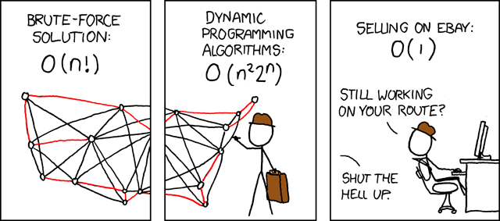
Competitive Programming Hakpak
by Evan Partidas
xkcd: Travelling Salesman Problem

public static int BS(int[] arr, int query){
int low = 0,high = arr.length;
while(low<high){
int mid = (low+high)/2;
//Insert comparator here
int cmp = arr[mid] - query;
if(cmp==0){
return mid;
}
else if(cmp>0){
high = mid;
}
else {
low = mid+1;
}

}
return -1;
}
public static int BFS(int[] arr, int query){
//Binary Floor Search
int low = -1,high = arr.length;
while(low+1<high){
int mid = (low+high)/2;
//Insert comparator here
int cmp = arr[mid] – query;
if(cmp>0){
high = mid;
}
else {
low = mid;
}
}
return low;
}
Regular Binary search.
-Search Complexity of O(log n) where n is the size of the array.
-Will return an index of the number query.
-Will return -1 if the element is not present.
-Array must be sorted.
-Can be modified to work for any comparator simply by modifying the way cmp is calculated.
Floored Binary search.
-Search Complexity of O(log n) where n is the size of the array.
-Will return the largest index that contains a value less than or equal to the given query.
-Will return -1 if no element that satisfies the conditions is present.
-Array must be sorted.
-Can be modified to work for any comparator simply by modifying the way cmp is calculated.
-Useful when searching for up to what point a given input/solution/etc. is valid.

For c++ look into function upper_bound and lower_bound in the algorithm library. upper_bound can be used as a floor search by subtracting 1 from the MEMORY LOCATION returned by it.
Segmented Tree

//All global variables needed
int lo[],hi[],delta[],query[],size;

//This is use-defined. (Note sums don’t work with this implementation of lazy propagation)

static final int IDENTITY = Integer.MAX_VALUE;//Identity for Min

int queryFunction(int a,int b){
return Math.min(a,b);//Min Function (Clearly)
}

void init(int node, int li,int ri){

lo[node] = li;
hi[node] = ri;
if(li==ri)
return;
int mid = (li+ri)/2;
init(node*2+1,li,mid);
init(node*2+2,mid+1,ri);
}
public SegmentTree(int n){
size = 4*n;
lo = new int[size];
hi = new int[size];
delta = new int[size];
query = new int[size];

init(0,0,n-1);
}

void prop(int node){
delta[2*node+1]+=delta[node];
delta[2*node+2]+=delta[node];
delta[node]=0;
}
void update(int node){
query[node] = queryFunction(
query[2*node+1]+delta[2*node+1],
query[2*node+2]+delta[2*node+2]);
}

int query(int node,int li,int ri){
if(ri<lo[node]||hi[node]<li)
return IDENTITY;

if(li<=lo[node]&&hi[node]<=ri)
return query[node]+delta[node];

prop(node);

int ret = queryFunction(
query(2*node+1,li,ri),
query(2*node+2,li,ri));
update(node);

return ret;
}
void increment(int node,int li,int ri,int val){
if(ri<lo[node]||hi[node]<li)
return;

if(li<=lo[node]&&hi[node]<=ri){
delta[node]+=val;
return;
}

prop(node);

increment(2*node+1,li,ri,val);
increment(2*node+2,li,ri,val);

update(node);
}

Suffix Array

int N,C[MAXN],RA[MAXN],TMP[MAXN],SA[MAXN],LCP[MAXN];
char STR[MAXN];
void initSA(){
int i,k=1,r;
for(i=0;i<N;i++)
RA[i]=STR[i],SA[i]=i;
for(k=1;k<N;k<<=1){
countsort(k,max(N+1,300));
countsort(0,max(N+1,300));
TMP[SA[0]]=r=0;
for(i=1;i<N;i++){
TMP[SA[i]]=
(RA[SA[i]]==RA[SA[i-1]] && RA[SA[i]+k]==RA[SA[i-1]+k])?r:++r;
}
for (i = 0; i < N; i++)
RA[i] = TMP[i];
if (RA[SA[N-1]] == N-1) break;
}
}
void countsort(int k,int size){
//Stable Countsort
int i;
for(i=0;i<size;i++)
C[i]=0;
for(i=0;i<N;i++)
C[i+k<N?RA[i+k]:0]++;
for(i=1;i<size;i++)
C[i]+=C[i-1];
for(i=N-1;i>=0;i--)
TMP[--C[SA[i]+k<N?RA[SA[i]+k]:0]] = SA[i];
for(i=0;i<N;i++)
SA[i]=TMP[i];
}
int lcp(){
int len=0;
int prefix=0;
int i;
for(i=1;i<N;i++)
TMP[SA[i]]=SA[i-1];
for(i = 0;i<N-1;i++){
while(STR[i+len]==STR[TMP[i]+len]) len++;
prefix = max(len,prefix);
len = max(len-1,0);
}
return prefix;
}

