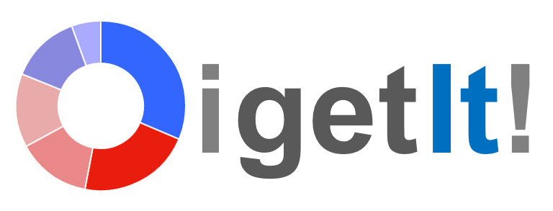

CONTACT  Haily Marzullo  OIGETIT, Inc  310 948 3769  haily@oigetit.com  www.oigetit.com | FOR IMMEDIATE RELEASE

Welcome to OIGETIT Blog
Press Release

Washington D.C, May 6, 2015 — OIGETIT has rolled out with some amazing new ideas and one of them is to start our blog. On our blog, OIGETIT will be sharing articles, opinions, and exclusive details on exciting things we are working on. Follow our blog to keep up with OIGETIT!

What is OIGETIT you might ask?

OIGETIT revolutionizes online search delivering real-time results in a blink of an eye. With its advanced web search, you discover immediate, trending, and revealing information about any person, place, or things. You become instantly exposed to the latest local, national, and world news.

OIGETIT is in popular demand. We have the information you want and faster than any other search engine. Out of millions of pages of information on the web, OIGETIT captures, reads, and delivers to you the exact information you need in seconds! OIGETIT also detects behavior and social sentiment in real-time by monitoring the Internet and how it’s changing from positive to negative or vice versa.

We offer a truly dynamic search engine providing comprehensive trending results.

Best,
Haily

Haily Marzullo
Deputy Director
Social Media and Marketing
OIGETIT Inc,
718 7th Street, 2nd Floor
Washington, DC 20001
www.oigetit.com

OIGETIT, Inc. 718 7th Street, 2nd Floor, Washington DC, 20001 Haily Marzullo haily@oigetit.com www.oigetit.com

