HIPAA HITECH Express Upgrade

Jan 18, 2016

This morning QI Partners began implementing the first in a series of upgrades that will make HIPAA HITECH Express much more versatile and easy to use. Today’s changes may seem minor, but they pave the way for many improvements to come. Current users will find new features for organizing the document libraries and the incorporation of our online Risk Assessment into the tool. These are previews of new features that will improve visibility, flexibility and simplicity in attaining and showing HIPAA compliance.

Today’s upgrade standardizes the view of all documents into a common format.

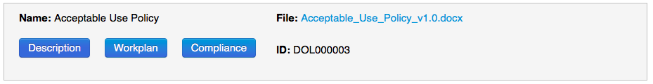

Since each of your documents actually consists of a set of versions, we give that set a name. In this case it is “Acceptable Use Policy.” The name and description can be changed. The current file is shown to its right, and a persistent identifier for this chain of documents is below that. When you upload a document it becomes the latest version (or maybe the first) in a chain of documents. HIPAA HITECH Express has some documents that we suggest (we call them required documents in tasks). But you can also upload “Additional Security Documents” that help support the workplan tasks. Administrators can also upload documents directly to the Library. When uploading an “Additional Security Document” you can either add it to an existing document chain, or you can create a new document chain.

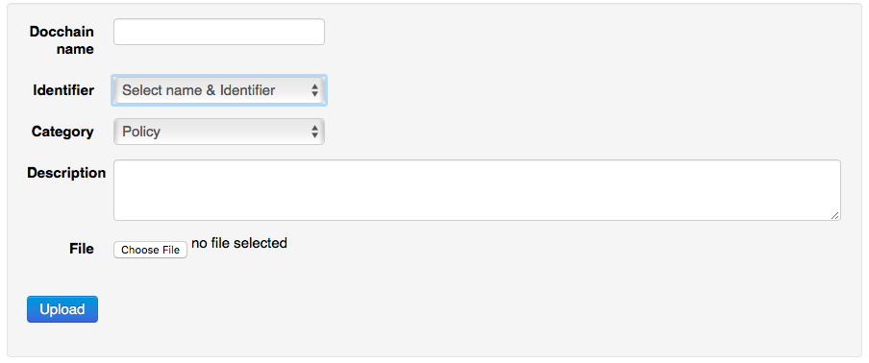

You enter a name into the text field called “Docchain name”, or select an existing one from the “Identifier” drop-down list. Once created, you can update it with new versions as necessary.

In the near future we will associate Docchains with the compliance requirements in HIPAA and reports will give you a very clear view of how you cover the full range of HIPAA requirements.

Another feature that you will find in this upgrade is a folder structure in the library. This is a highly flexible and usable tool for organizing the documents you are collecting.

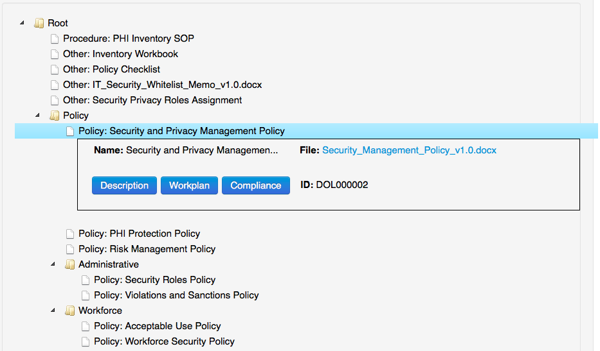

All documents start in the root, but an administrator can create and name folders and move the documents into them in whatever way is appropriate for the organization at the moment. They can easily be renamed or deleted. This gives a great deal of flexibility to manage the process of reviewing or organizing documents.

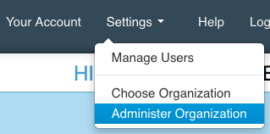The Administrator role for the organization has the ability to manage the folders, and all documents in them, using pages available in the “Setting” menu dropdown.

This opens up a view with the Create, Rename and Delete buttons for folders as well as the icons for naming Docchains, setting categories, adding new versions and editing descriptions and annotations.

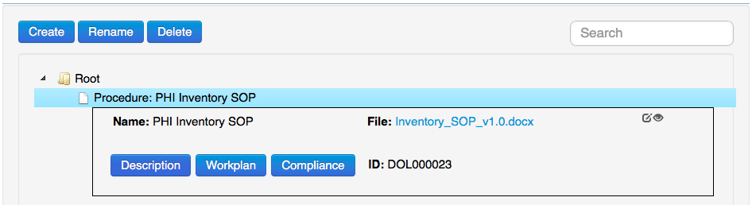

Note the search button in both Administrator and Library views. This is very versatile for finding the document you are interested in.

Risk Assessment

This update integrates the QI Express Risk Assessment tool into HIPAA HITECH Express.

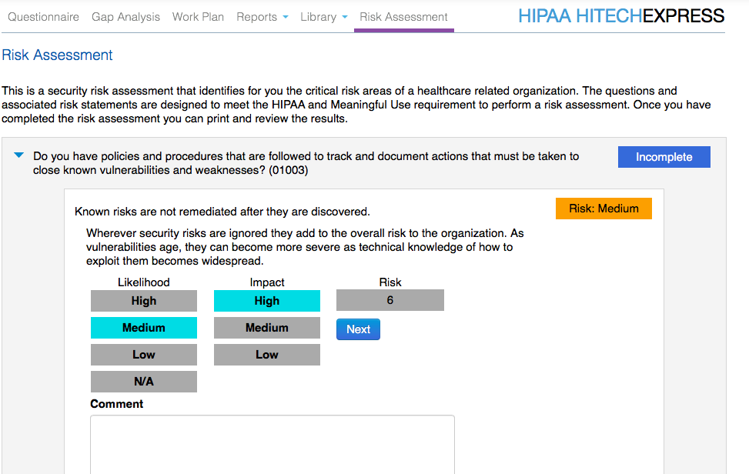

It can be completed independently of the rest of HIPAA HITECH Express or used to validate gap prioritization. It uses a simple but standard methodology to characterize risk using the likelihood and impact components of risk. Likelihood is the probability that the risk statement is true and represents a weakness in the security of the organization. Impact represents the potential for damage or harm. Security related questions are broken into risk statements and the results are used to set the Risk values in the Gap Analysis. A Risk Assessment Report is also generated and can be stored as a Docchain in the Security Document Library.

As mentioned above, this is the beginning of a major upgrade to the capabilities of HIPAA HITECH Express and lays the ground work for our long term plans to make your compliance activities easier to plan, manage and execute. We look forward to working with you to make it easier to meet the ever increasing demand for security and privacy in our healthcare system.

Eric Hummel

CTO & Co-Founder

QI Partners