Evan Smith
What to Expect from Your NHL Draft Pick?
- Introduction
Once a year, the teams of the National Hockey League (NHL) come together to select new players in a 7-round draft. Unlike basketball and football, almost none of the players drafted play in their first year, and few will suit up for 23-player roster at all. This makes drafting players and setting expectations difficult for fans and general managers alike. For this project I sought to find trends in recent NHL statistics to find the results teams should expect from their draft picks depending on the round and how height and weights may correlate with different statistical performances. With this I will answer what can we expect from an NHL draft pick?
- Data Collection
I got my data from three websites. I began by getting draft data, such as player draft rounds and pick numbers, from https://www.eliteprospects.com/draft/nhl-entry-draft/year. I created a loop to access the different years from 2006, which I selected due to a cancelled 2005 season, to 2022, as most 2023-2025 draft picks are expected to currently be in the juniors and would skew the data. I then wrote the html files into their own folders in the raw data folder. The draft data supplied 3412 data points.
The next data source I accessed was https://www.hockey-reference.com/leagues/NHL_+ year +_skaters.html, which provided statics for the season specified by ‘year’ in which I could analyze and work with. I chose a year range of 2010 to 2025 as the 2006 players likely would not have been fully judged until 2010. I repeated this process for the https://www.hockey-reference.com/leagues/NHL_+ year +_goalies.html link to get the HTML code for the goalie data. The season statistics provided 17263 data samples to work with.
I used a third source, https://moneypuck.com/data.html, where I downloaded an Excel file containing player’s heights, weights, birth dates, numbers and more, though I only retained the former two for my calculations. I attached the Excel file to the raw data folder. This source has 3201 data samples.
- Data Cleaning
From my draft data files, I created a method to parse the html table and clean the data by checking if the players had at least one game appearance. If the players game stats were blank, I assigned them values of 0 so I could use the players in the metrics. Additionally, I assigned players with a ‘-‘ as their goal stat to the goalie position, as that is how eliteprospects marked goalies. I needed to change the values to 0 to prevent errors in the calculations for my data analyzing.
After creating a method to parse my first data source, I discovered Pandas had a read_html method. I used the method to convert the HTML code to a data frame. From there, I went through the data from each season and checked whether a player had appeared in seasons before. If that was the case, I summed their stats to get their career statistics and not just one individual season’s. For the goalie data, I added an additional check to get the best save percentage and quality start percentage for a season.
The data from my third source, the downloaded Excel file, is the only one that came in CSV form, and not as an HTML document. This allowed me to read it into a Pandas dataframe with the read_csv method. I made a method to change the height values from being in feet and inches to being in just inches, making numerical values easier to work with, along with renaming the position columns from ‘L’ and ‘R’ to be ‘F’, allowing for easier merging below.
Once the data from each source was parsed and cleaned, I began merging the data tables based on player name and position. With the data merged into one large data frame, I split it into three smaller data frames based on the player’s position. I finished by writing each of the position-based data frames to their own CSV files in the processed folder.
It is thanks to the data processing described above that I was able to connect a player’s draft information (such as round and pick number), career statistics (such as goals and assists), and physical data (such as height and weight).
- Data Analysis
I began my data analysis by finding the probability that a player plays in a single game based on the round they were drafted by calculating the number of players per round who have more than 0 games played and dividing by the total number of players drafted in said round. These results showed at least 93 percent of all first-round draft picks play at least one game in their career. From here we see a drop to about 67 percent of second-round picks playing at least one game. The third round is where we see a split between positions occur with forwards and defenders falling to about 46 percent and goalies remaining around 57 percent. Rounds 4-7 have about an equal proportion of draft picks playing one game between forward and goalies, but there is a noticeable decrease in defender values, with less than one-fifth of sixth round defender draft picks playing in an NHL game.
I repeated the above analysis but by comparing the proportion of skaters who played at least 42 games (half a season) and goalies who played at least 15 NHL games. These results show no more than half of skaters drafted in the second round, and less than 30 percent from the third round on play at least half an NHL season. However, from rounds 1-3, goalies have an about equal proportion of appearing in at least 15 career games. From round 4 onward, skaters and goalies have an about equal chance of meeting the margins.
The above findings show the importance of first and second round selections for yielding NHL ready skaters. They also suggest that teams in need of a goalie can afford to wait until the second or third round for their selection and should instead opt for a forward or defender in the earlier two rounds.
I followed the probability calculations with the generations of a linear regression model using sklearn. If fit the model on draft positions and key stats such as goals and hits, then it would predict the stats for a player based on provided draft positions. The mean absolute error results of this prediction were quite poor, especially for the later rounds. This led me to change to a polynomial regression, which better captured the changes in slope between rounds. The polynomial regression mean absolute error was substantially lower than linear regression, though it did have issues predicting hits.
I made an additional Polynomial regression to predict the ideal heights and weights for each statistic. This found that the optimal height in all categories is 72 inches for forwards and 76 inches for defenders. For the optimal height for weights, 206 pounds is ideal for scoring for forwards, but 216 is ideal for defensive stats like blocking and hitting. The ideal defender weight is 217 all around.
I followed the regression analysis up by generating correlation matrices for the key stats. As we could see with the regression results, there is a noticeable negative correlation with the round number and the average player stats per season (Note it is negative as higher rounds are later picks). There are two correlations which stand out from the matrices. The hits stat has the second lowest correlation, being about -0.3, while the +/- stat has a positive correlation of 0.11. However, the latter could be attributed to players in later rounds having less ice time and thus less chance of being negatively affected in the +/- category.
More of the data analysis I did will be covered in the visualization section.
- Visualizations
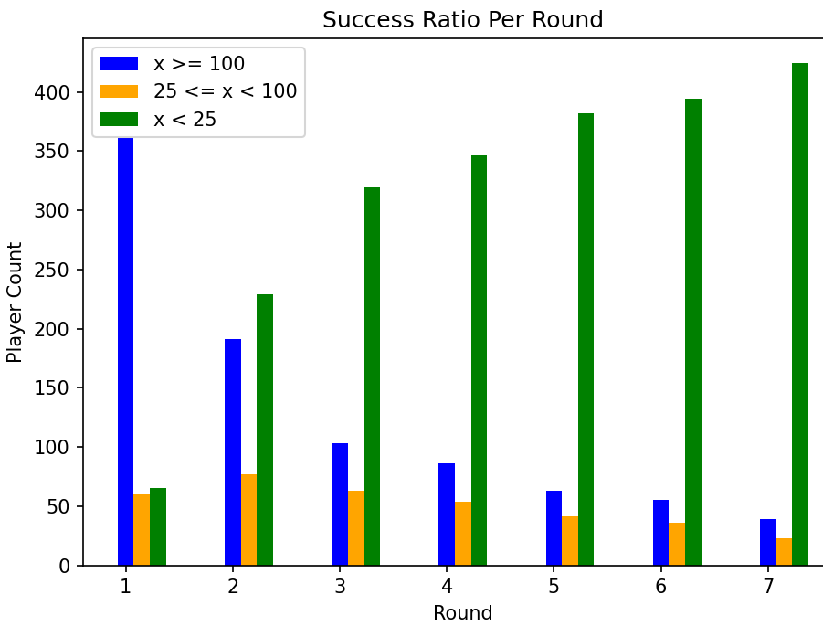
The bar plot on the left displays the number of players who played the marked number of games seperated by round. We can see how there is almost a certainty a 1st round player will play at least 100 games, and that any play after round 3 will probably faill to reach 25. This shows the scale of difficulty for finding a diamond in the rough late rounder. 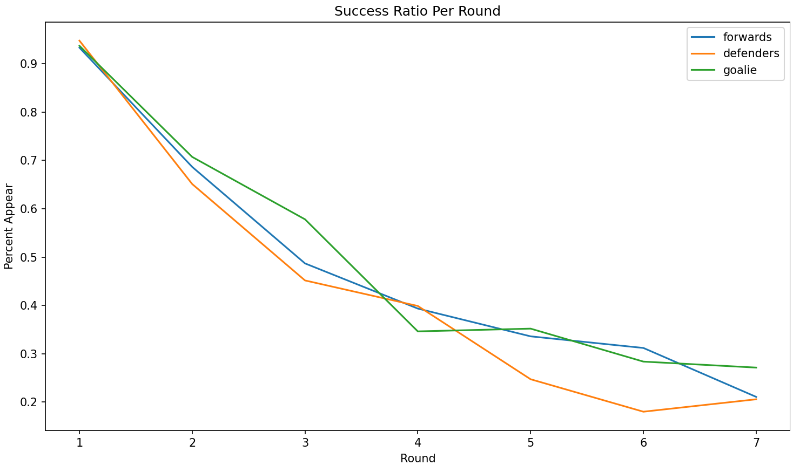 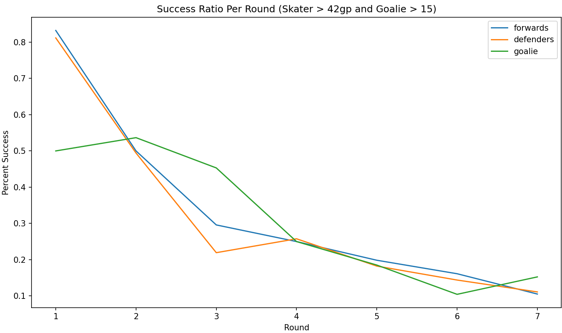
In the two graphs above, we see the percentage of draft picks by position who appeared in at least one game and for those who have appeared in a ‘successful number’ of games. We see the positions follow a roughly similar trend throughout the first graph, but differ more in the second. The goalie percentages stay closer for the first few rounds, while defenders face sharper drop offs in the third round, and a recovery in the fourth.
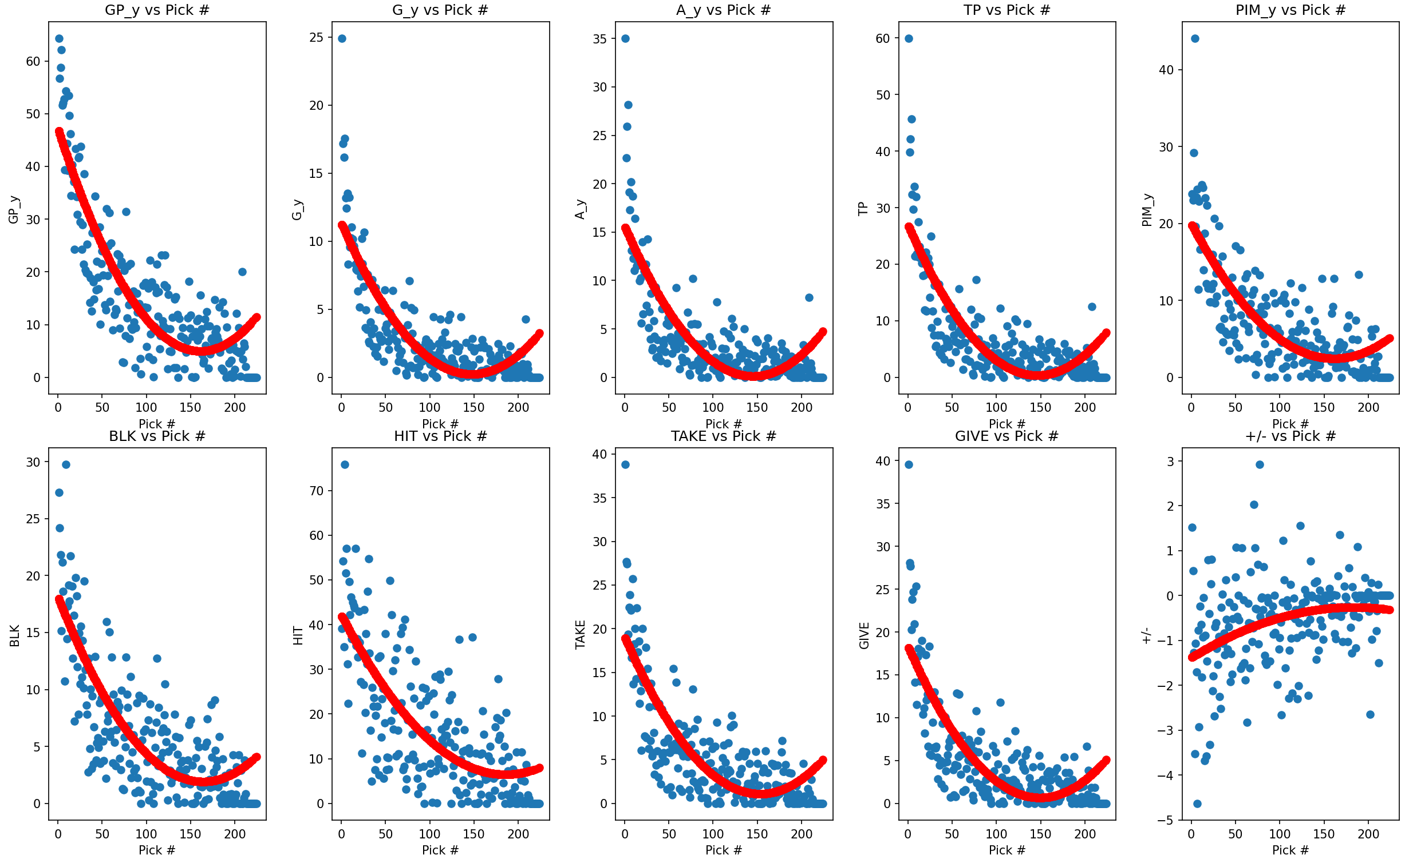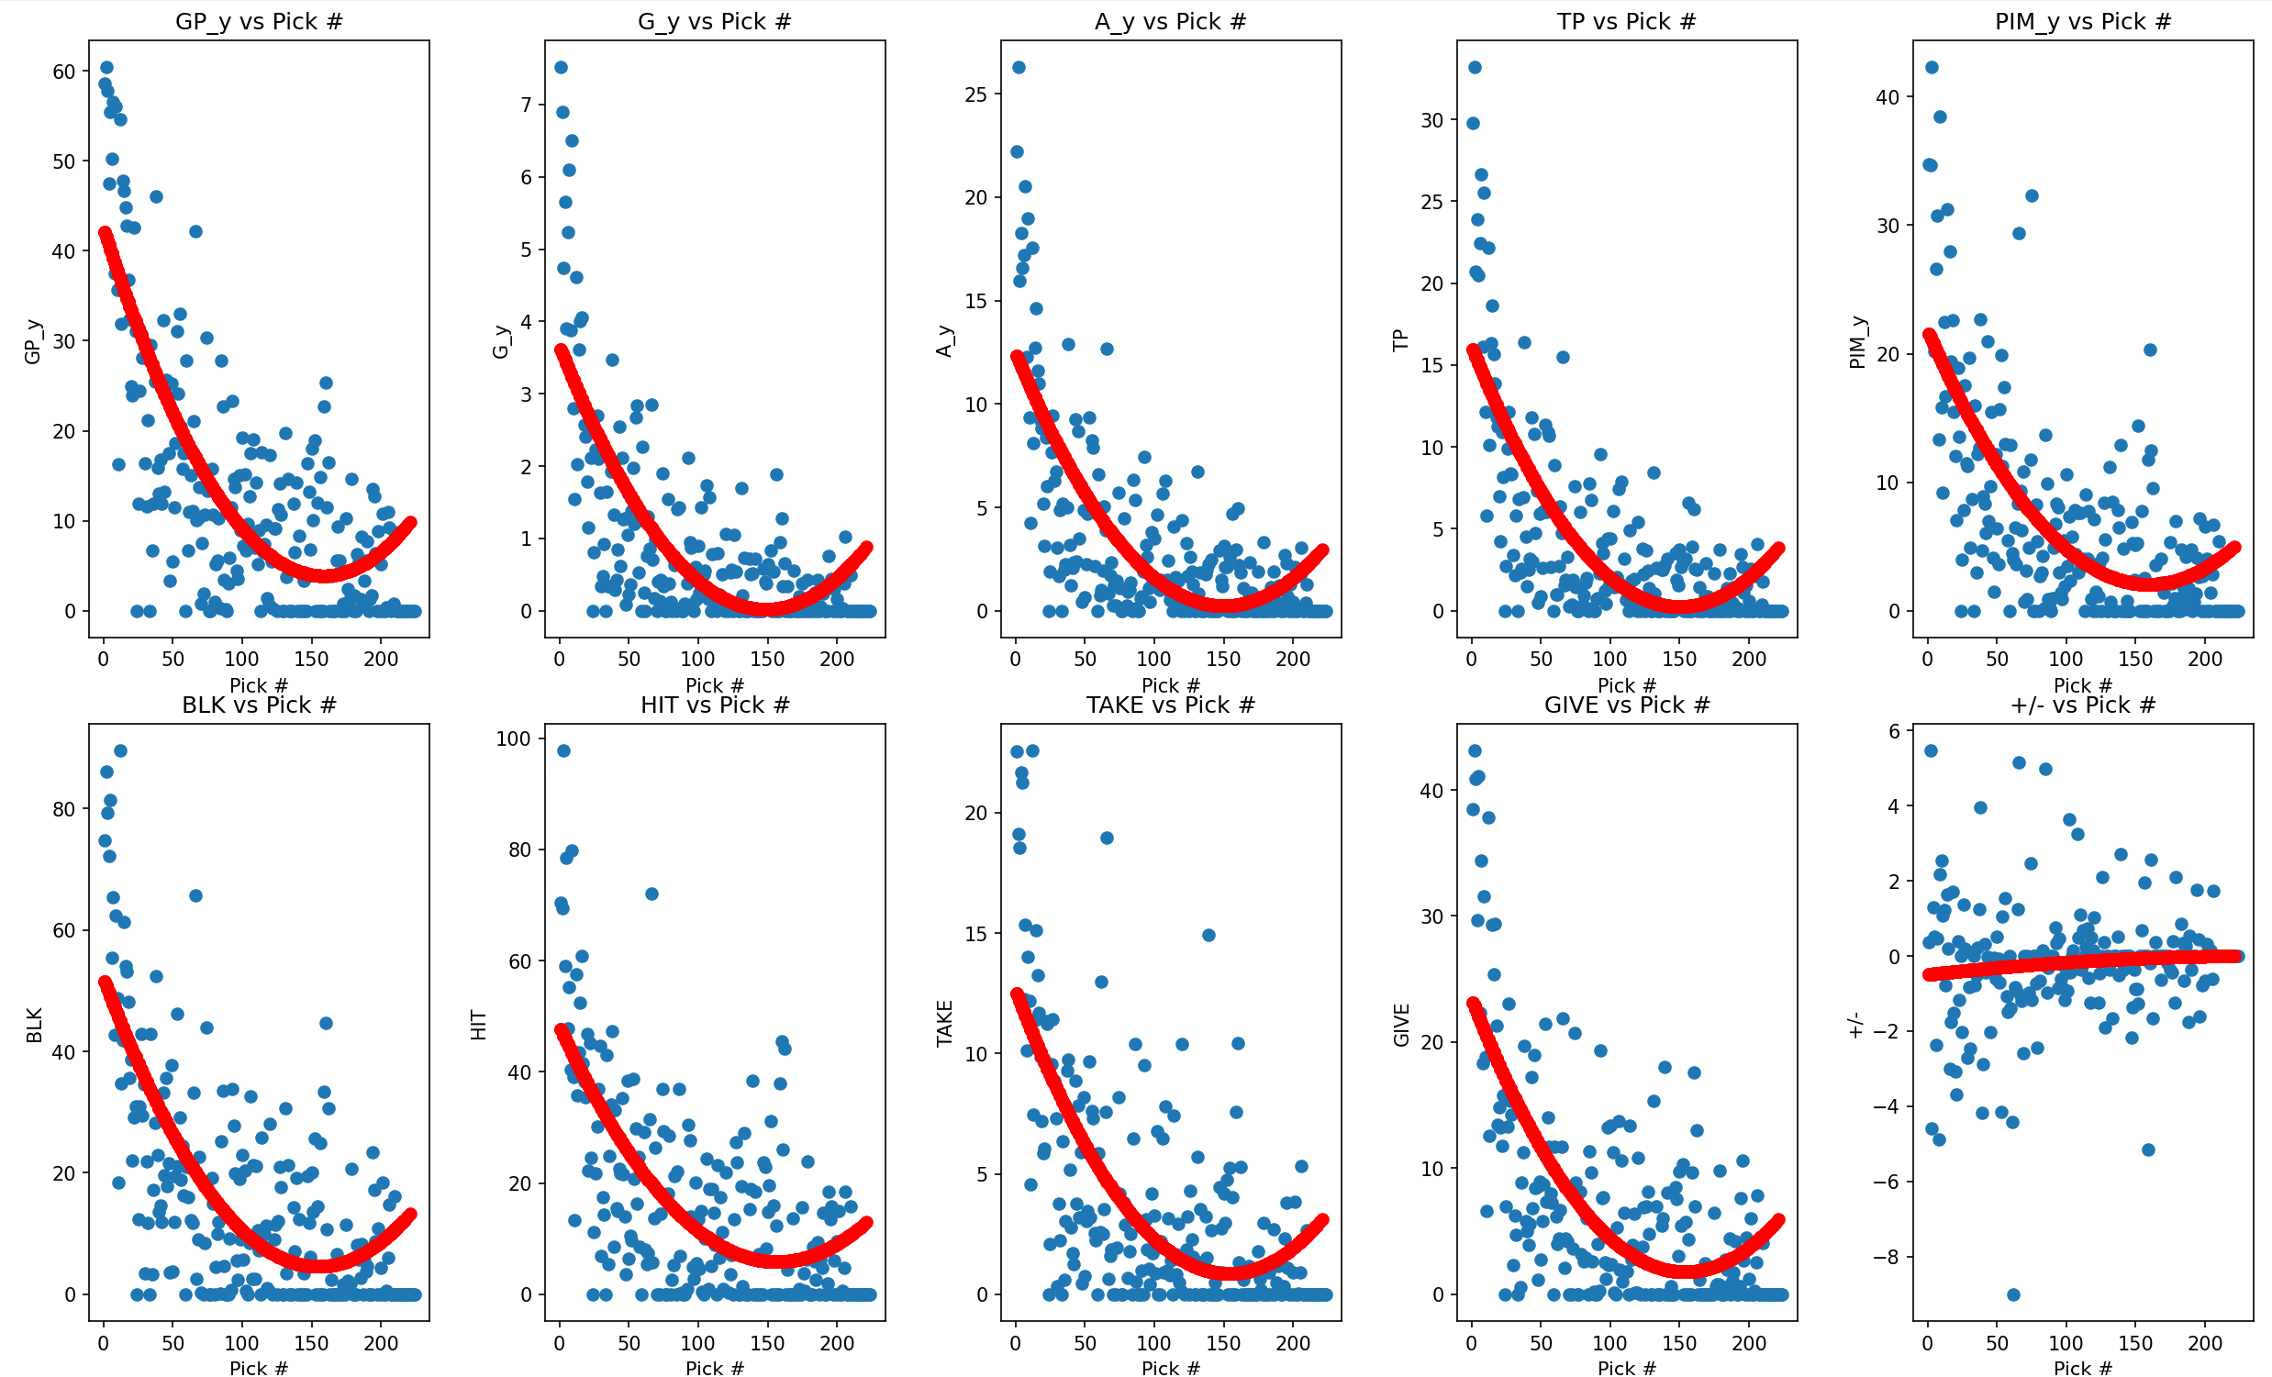
The above two graphs display the polynomial regression line printed over the data statistics per draft pick number. The statistics for forwards is displayed on the left and the statistics for defenders is displayed on the right. We can see a noticable curve across most stats, with the exception of +/-. However, the +/- is skewed as players who have never been called up have results of 0, which is better than the average player result of a negative.
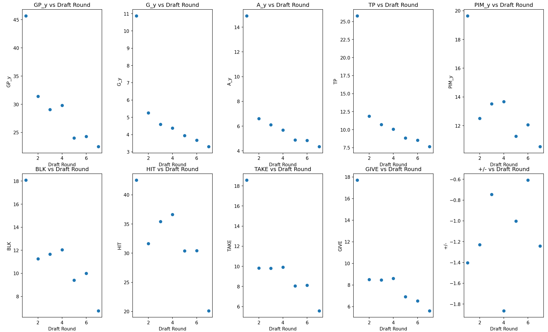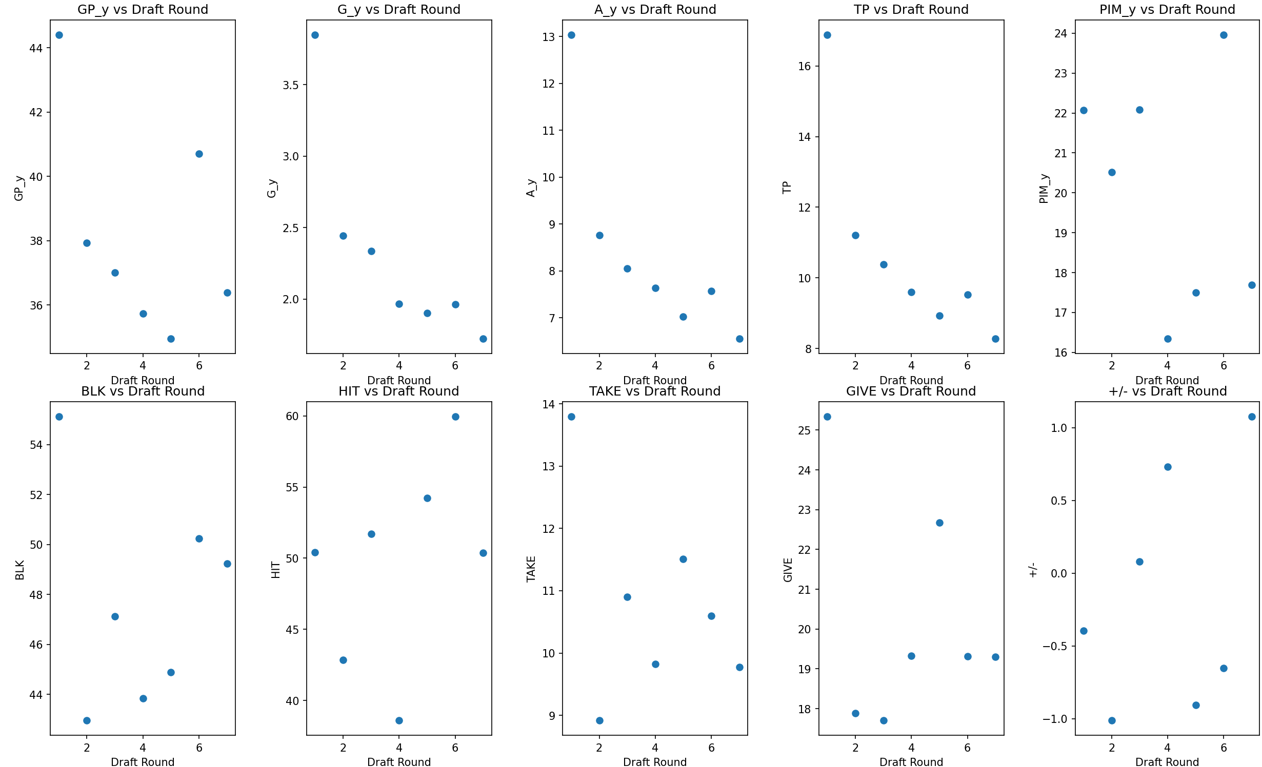
While the regression shown in earlier graphs does a good job showing the trends across the draft data, it fails to highlight an important detail involving the hit and block statistics. Unlike the majority of the other statistics, players drafted in rounds 3 and 4 averaged higher numbers of hits and blocks in a season compared to players drafted in round 2. In fact, defenders drafted in round 3 averaged a higher number of hits than those drafted in the first round. This is important to notice as it shows additional value in the third round where despite having much lower scoring odds, you can find players who offer a better chance of having strong defensive focused abilities and playing styles, perfect for the bottom two lines.
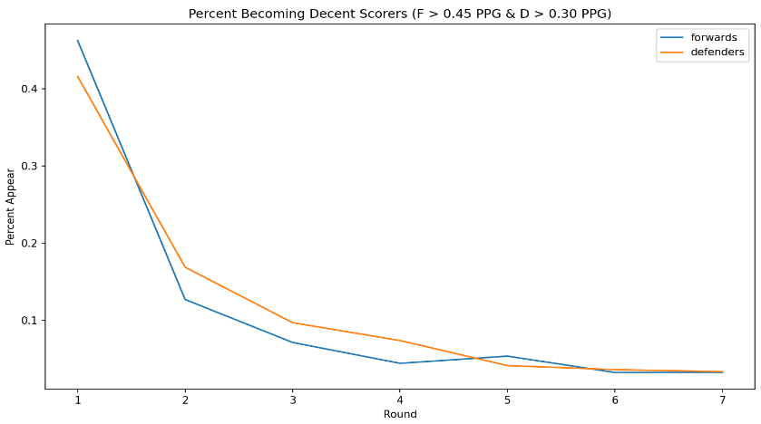
The last chart I can fit on this document graphs lines to show the change in proportion of draft picks by round who become a ‘decent scorer,’ where forwards score more than 0.45 points per game and defenders more than 0.3 points per game. This shows us how large the drop off is between getting a high scoring player in the first round and in the second round. By the fourth round most drafts won’t have a single player who will score at the above rate.

- Conclusion
The most immediate takeaway from my project is the importance of a first-round pick. A team’s choice to trade away a first-round pick translates to likely trading away their only chance at a decent scoring player. The drop each of the first three rounds is more substantial than I or many other hockey fans recognize. We can also see a possible blueprint for how teams should begin most of their drafts. The first round should be largely focused on drafting a skater with abilities focused on scoring. The second round is the best time to draft a goalie, though historical success in round 3 grants the freedom to wait till then. If a goalie is not a need for a team or they are willing to wait, scoring ability should remain the focus of round 2 and a forward close to 206 pounds should be drafted. Goalies are still valuable in round 3, but for drafting forwards and defenders, teams should target players that weigh around 216 pounds and focus on defensive abilities. This continues for round 4 while rounds 5-7 have low success rates regardless of who is drafted.
The impact of this project can be utilized for fans trying to predict who their team might draft, dynasty fantasy hockey players who are trying to predict what newly drafted players will be useful for what stats in the future, and even teams looking for trends in drafted player results hoping to decide on who to draft or what their trade assets could be worth.
- Future Work
Given more time I would like to use current minor league data to predict where current minor leaguers may get drafted and their future statistics. Additionally, I would have liked to further explore with more advanced data and statistics to get more insight into the lesser seen parts of hockey statistics and results. Once all that is finished, I would try to use this data to predict the results of current hockey players and future players and turn said predictions into fantasy projections.
If I were to repeat this project, I would reuse my sources as I found them easy to navigate and not overly complicated to read into Panda’s data frames. My sources had large quantities of data and results which allowed me to complete this project. I was uncertain whether large Excel files would count as a source so I did not include more files from the moneypuck website but if I were to recreate this project I would try to utilize more files from there as they have a larger quantity of statistics than my current sources.

