cmpt 371 – Team 3 Requirements document

Virtual Reality Medical Imaging Software with Luxsonic Technologies Inc.

January 28, 2017

# Executive Summary

This document provides information to describe the features that will be included in the produce: virtual reality medical imaging software. All members of Dr. Nathaniel Osgood’s CMPT 372 Team 3 will have an important role in the development and implementation of this program. Using the Unity 5 engine, the Oculus Rift VR headset, and other necessary hardware and software, we plan to deliver a functional program by the end of the project.

The planned functionality of the program falls into three categories: must-have, should-have, and could-have. Must-have features will be those promised by our team to deliver to Luxsonic by the end of the project. These features will be included in our step through graphical user interface concept shown in the appendix of this document. Each must-have feature will include a description and set of possible user actions and scenarios. The should-have features are those that we plan to implement, but due to time constraints, cannot promise by the end of the project. A short description of these features is provided, along with the likelihood of being able to deliver them. Finally, could-have features are those that we will be unlikely to implement due to time or other constraints, but should be taken into consideration when designing the software. With the information provided in this document, Luxsonic should have an in-depth vision of the expected project for our first deliverable and final product. Since we will be employing an incremental development approach, many of the features are subject to change due to budget concerns and Luxsonic’s input.

Table of Contents

Executive Summary i

1 Premise 1

2 Product 1

3 Platform and Software 1

4 Functionality 1

5 Must-Have System Actors and Their Actions 2

5.1 Actor: User 3

5.1.1 Action: Initialize Program 3

5.1.2 Action: Quit Application 4

5.1.3 Action: Load DICOM File 4

5.1.4 Action: Exit Workspace 6

5.1.5 Action: Select Images to Display 6

5.1.6 Action: Remove Images from Display 7

5.1.7 Action: Adjust Contrast 8

5.1.7 Action: Adjust Brightness 9

5.1.8 Action: Apply Filter 9

5.1.9 Action: Zoom 10

5.1.10 Action: Pan 10

5.1.11 Action: Rotate 10

5.1.12 Action: Flip 11

5.1.13 Action: Move Monitor 11

5.1.14 Action: Resize Monitor 12

5.2 Actor: DICOM Decoder 12

5.3 Actor: DICOM File Folder 12

6 Should-Have Actions 12

6.1 Anti-motion sickness features 12

6.2 Create 3D models from DICOM images to view and manipulate 12

6.3 Use of Oculus Rift Touch Controllers 13

7 Could-Have Actions 13

7.1 Create animation of time lapsed images 13

7.2 Have an aesthetically pleasing selection of background environments 13

7.3 Dictate/Write Reports within the virtual workspace 13

7.4 Action: Be able to query and download files from the server 13

8 Conclusion 13

9 Appendix A: Graphical User Interface 15

# Premise

This document is the requirements outline between the student software engineers of Dr. Nathaniel Osgood’s CMPT 371 Team 3 and our client Luxsonic. Our team consists of 11 members: Brady, Brianne, Evan, Heramb, Ix, Jack, Janelle, Kevin, Kyle, Mackenzie, and Nhi. Our primary goal is to engineer a piece of software to replace a radiologist’s traditional workspace with virtual reality 3D medical imaging software. We will first prioritize the rendering of 2D DICOM images and later advance to 3D. This document will include a description of actors (entities which may interact with the software system), actions which those actors may take on the system, scenarios, use case diagrams, and prototype interfaces to help foster understanding of the software.

# Product

The product will be a virtual reality based medical imaging software. Using Unity and Oculus Rift our teams’ goal is to engineer a piece of software to improve the workflow of medical imaging professionals. The software will create a configurable 3D space that contains virtual analogues of the tools used daily by radiologists. The software will support and display images that comply with the Digital Imaging and Communications in Medicine (DICOM) standard in both 2D and 3D views. Users will be able to cycle through these images as well as adjusting the depth, contrast, and zoom of the image. The product will support the display of multiple images at once, and will be controlled primarily using a mouse and key board. Optional support for the Oculus Rift’s Touch controllers will be implemented by the end of the project. The images displayed within the application may be rearranged within the 3D environment of the workplace according to the user’s preferences. The team will also tackle any problems relating to motion sickness or eye strain to ensure the product is usable for long hours.

# Platform and Software

The application will be developed for 64-bit Windows systems capable of running Oculus Rift software. The engine used to create the software for the project will be Unity 5.4 and all project code will be written in C# and stored in a Github repository. Assets provided in Unity’s Asset Store for virtual reality may downloaded and used if necessary to assist with development of the project. Any additional software not mentioned above may be used and will be disclosed in future versions of this document.

# Functionality

It is important that this program be user-friendly for any radiologists who wish to use the program. The goal is that it should be easy to handle regardless of any one user’s technological background. The actions within the program should be intuitive and responsive. Careful consideration will be given to how each feature will work within the VR space, to optimize for ease of use and feasibility. Within a virtual environment, the health risks (such as nausea, muscle tension or dissociation) must be taken into account. The team will determine if any of the features or capabilities implemented could have adverse effects. These risks will be assessed on a regular basis and the software adjusted accordingly. Therefore, it is necessary that amendments will be made to this document on a regular basis. After each deliverable, the product will be evaluated on its features, impact on user health, and its usability.

# Must-Have System Actors and Their Actions

This section will list actions that are integral to the functionality of the software. It will describe the features necessary to allow the developed software to be functional. Optional features that we would like to implement will be outlined in the following section.

Actors are possible entities (human or not) which may interact with the software system. Here we describe the purpose of each actor along with the details and process of each action. Several considerations made for each action include pre-conditions (what must happen before an action’s scenario can occur), post-conditions (the result expected at the end of a scenario), and error-conditions (what may occur that prevents a scenario from reaching the expected end-point).

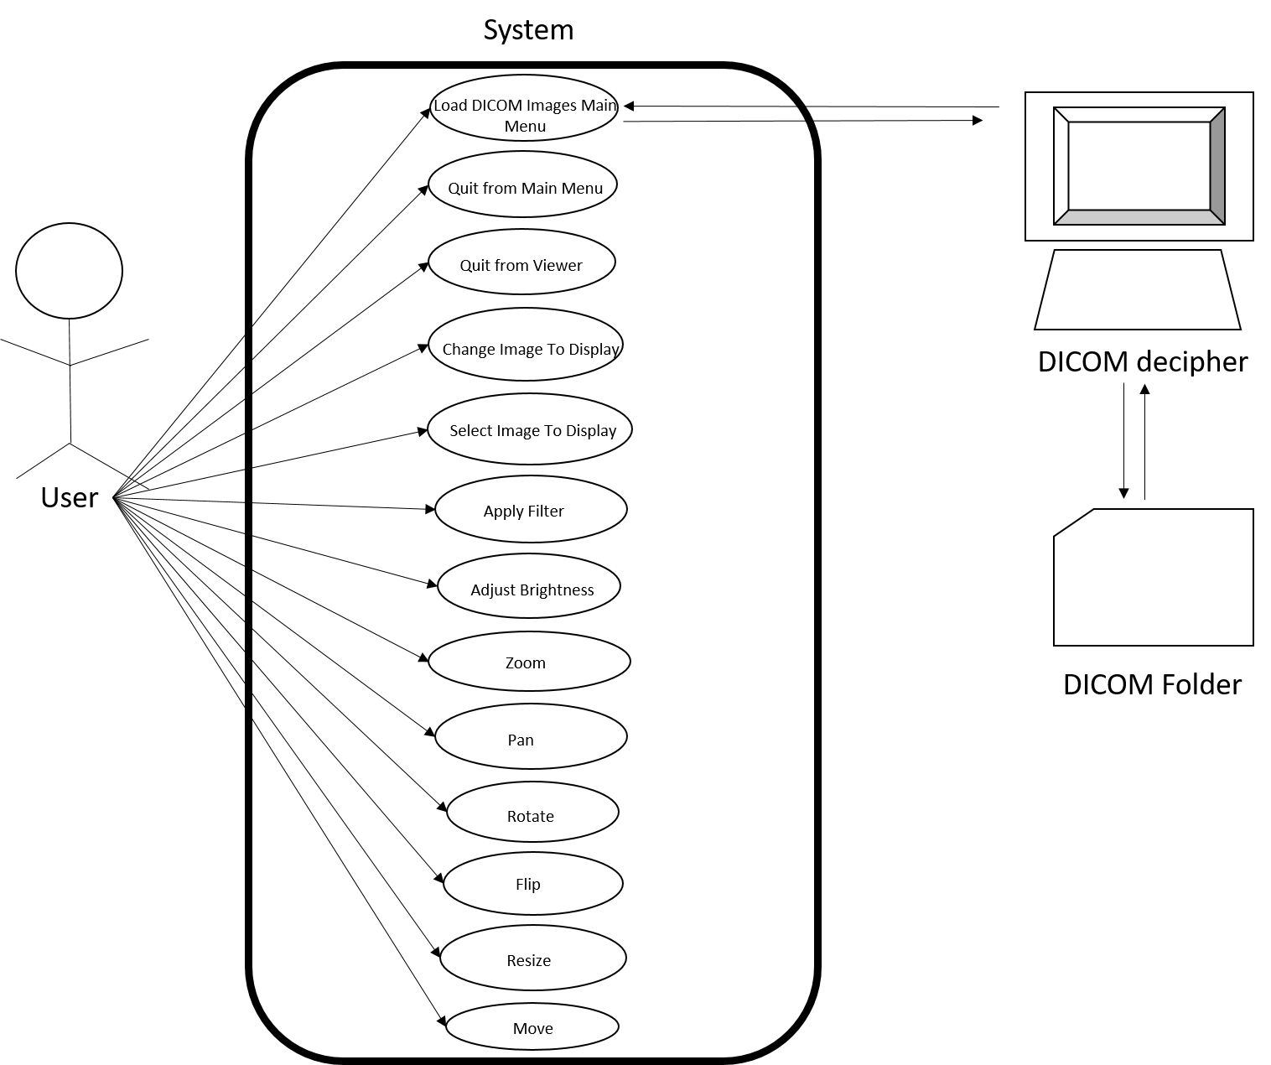

*Figure 1: System Diagram for the software  
This diagram represents the minimum set of features required for the software to be functional.*

## Actor: User

The User is the person interacting with the system. The User will initialize the program, select files for use, and use the workspace to interact with the specified files. When interacting with the files, the User may change the contrast of, brightness of, apply filters to, zoom in and out of, pan across, rotate, flip, move, and resize the image.

### Action: Initialize Program

The use case begins when the User presses “Start” in the main menu. The workspace will then be displayed.

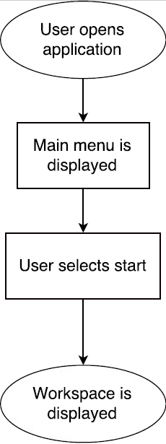

*Figure 2: Use-case diagram for the Initialize Program action*

* Pre-condition: None
* Post-condition:
  + The workspace is displayed
* Basic path:

1. Use case begins when user opens application
2. A main menu is displayed with option to start or exit the program
3. User selects “start”
4. Workspace is displayed

* Alternate path: None
* Error-condition path: None

### Action: Quit Application

The use case begins when the User chooses “Exit” on the main menu. The application will then close.

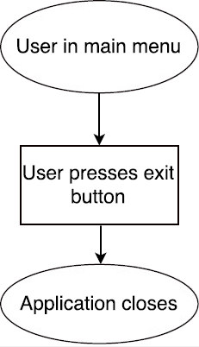

*Figure 3: Use-case diagram for the Quit Application action*

* *Pre-condition:* 
  + User is in the main menu
* *Post-condition:* 
  + The application is closed
* *Basic path:*

1. The use case begins when the user presses the “exit” button
2. The application is closed

### Action: Load DICOM File

The use case begins when the User selects “Load Files” in the workspace. A menu prompting the User to select files will appear. Once User chooses the files, the menu will then confirm the User’s selection. If the User chooses “yes”, the chosen files will be displayed in the workspace.

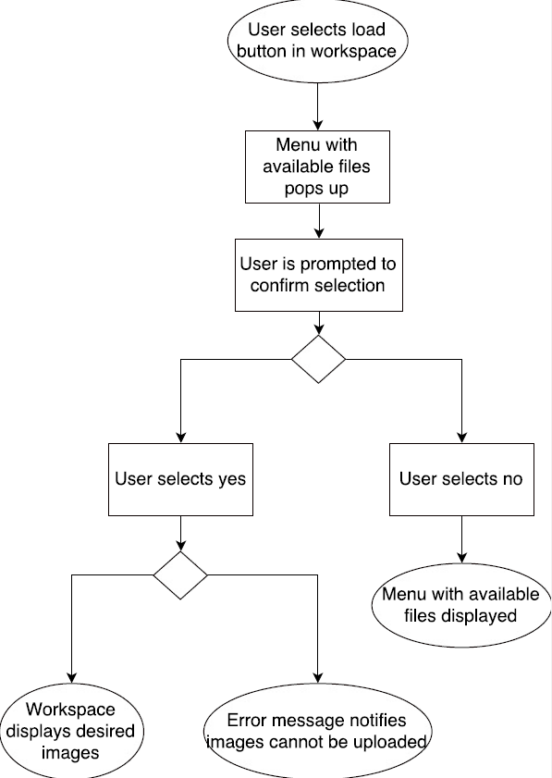

*Figure 4: Use-case diagram for the Load DICOM File action*

* Pre-condition:
  + The user is currently in the workspace
* Post-condition:
  + Files loaded into the system and available to display.
* Basic path:

1. The use case begins when user selects “load files” in the workspace.
2. Menu with available files prompts user to select images.
3. Menu prompts user to confirm selection.
4. User presses “Yes”
5. The selected files are displayed in the workspace environment

* Alternate path:

1. User Presses “No”
2. Menu with available files is displayed

* Error-condition path: File not found

1. User presses “Yes”
2. Error message notifies user which files cannot be loaded
3. The remaining valid files (if any) are displayed in the workspace

### Action: Exit Workspace

The use case begins when the User selects “Exit Workspace” in the workspace environment. The files in use are returned to their default format, any relevant workspace settings are saved, and the user is directed to the main menu.

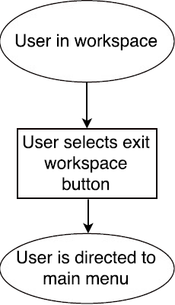

*Figure 5: Use-case diagram for the Exit Workspace action*

* *Pre-condition:* 
  + User is within workspace environment
* *Post-condition:* 
  + Unsaved files are returned to their default settings. The application is closed.
* *Basic Path:*
  1. The use case begins when the user presses the “exit workspace” button.
  2. The files are restored
  3. The user is directed to the main menu
  4. Refer to Action: Main-menu Quit System

### Action: Select Images to Display

The use case begins when the User selects images to display from the loaded DICOM files. The user will then confirm the addition of these images to the display. If they choose “yes”, the images will be added. If not, the images will not be added to the display.

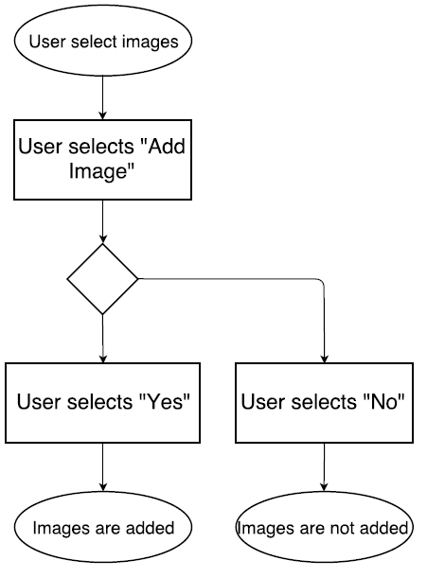

*Figure 6: Use-case diagram for the Select Images action*

* *Pre-condition:* 
  + The user is currently in the workspace.
* *Post-condition:* 
  + The desired images are displayed in the workspace.
* *Basic Path:*

1. Use case begins when the user selects images to display from the loaded DICOM files.
2. The User will select “display images”
3. The selected images are displayed in the workspace environment.

### Action: Remove Images from Display

The use case begins when the User toggles the “Remove” mode within the workspace. The User will then confirm the removal of the selected images. Finally, the User will toggle “Remove” mode off.

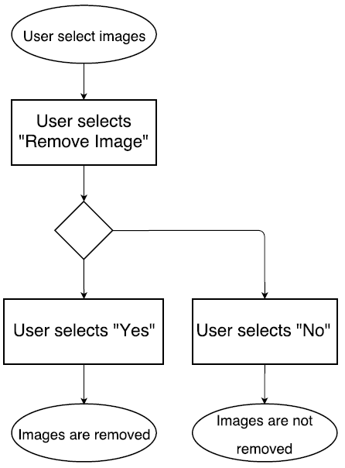

*Figure 7: Use-case diagram for the Remove Images action*

* *Pre-condition:* 
  + At least one image is displayed in workspace.
* *Post-condition:* 
  + The removed images are no longer displayed in workspace.
* *Basic path:*
  1. Use case begins when the User toggles the “Remove” button in the workspace.
  2. The User will select the images to remove.
  3. The system will remove the images from the workspace.
  4. The User will toggles the “Remove” button to exit Remove mode.
  5. The selected images are no longer displayed in the workspace environment

### 5.1.7 Action: Adjust Contrast

The use case begins switch when the user selects an image within the workspace to adjust its contrast settings. The user can then adjust the contrast settings or can choose not to apply the contrast by toggling its effects with a switch.

* *Pre-condition:* 
  + At least one image is displayed in workspace.
* *Post-condition:* 
  + Desired contrast settings are applied
* *Basic path:*
  1. The use case begins when the user selects an image.
  2. The user selects contrast settings.
  3. The user increases or decreases the contrast. Adjustments are displayed in real time.
* *Alternative path:*

1. The user toggles the contrast effect off.
2. The image’s contrast returns to its default value.

### Action: Adjust Brightness

The use case begins when the user selects an image within the workspace to adjust its brightness settings. The user can then adjust the brightness settings or can choose not to apply brightness change by toggling its effects with a switch.

* *Pre-condition:* 
  + At least one image is displayed in workspace.
* *Post-condition:* 
  + Desired brightness settings are applied
* *Basic path:*
  1. The use case begins when the user selects an image.
  2. The user selects brightness settings.
  3. The user increases or decreases the brightness. Adjustments are displayed in real time.
* *Alternative path:*

1. The user toggles the brightness effect off.
2. The image’s brightness returns to its default value.

### Action: Apply Filter

The use case begins when the user selects an image within the workspace to apply a filter to. The user can then choose a filter for the picture or can choose not to apply the filter by toggling its effects with a switch.

* *Pre-condition:* 
  + At least one image is displayed in workspace.
* *Post-condition:* 
  + Desired filter settings are applied
* *Basic path:*
  1. The use case begins when the user selects an image.
  2. The user selects filter settings.
  3. The user selects desired filter. Adjustments are displayed in real time.
* *Alternative path:*

1. The user toggles the filter off
2. The image returns to its unfiltered state

### Action: Zoom

The use case begins when the user selects an image within the workspace to adjust its zoom settings. The user can then adjust the zoom settings or can choose not to apply the zoom by toggling its effect with a switch.

* *Pre-condition:* 
  + At least one image is displayed in workspace.
* *Post-condition:* 
  + Desired zoom settings are applied
* *Basic path:*
  1. The use case begins when the user selects an image
  2. The user selects zoom settings.
  3. The user zooms in or out of the current image. Adjustments are displayed in real time.
* *Alternative path:*

1. The user toggles the zoom effect off
2. The image returns to its default zoom value

### 

### Action: Pan

The use case begins when the user selects an image within the workspace to adjust its position within the monitor. The user can then adjust its position, or can choose not to apply the pan by toggling its effect with a switch.

* *Pre-condition:* 
  + At least one image is displayed in workspace.
* *Post-condition:* 
  + Desired zoom settings are applied
* *Basic path:*
  1. The user case begins when the user selects an image.
  2. The user selects the pan tool.
  3. The user adjusts the position of the current image. Adjustments are displayed in real time.
* *Alternative path:*
  1. The user toggles the pan effect off
  2. The image returns to its default position

### Action: Rotate

The use case begins when the user selects an image within the workspace to rotate. The user can then rotate the image or can choose not to apply the rotate changes by toggling its effect with a switch.

* *Pre-condition:* 
  + At least one image is displayed in workspace.
* *Post-condition:* 
  + Desired rotate settings are applied
* *Basic path:*
  1. The use case begins when the user selects an image
  2. The user selects rotate settings.
  3. The user rotates the current image left or right. Adjustments are displayed in real time.
* *Alternative path:*

1. The user toggles the rotate effect off
2. The image returns to its default rotation.

### Action: Flip

The use case begins when the user selects an image within the workspace to flip. The user can then flip the image backwards or upside-down, or can choose not to apply the flip changes by toggling its effect with a switch.

* *Pre-condition:* 
  + At least one image is displayed in workspace.
* *Post-condition:* 
  + Desired flip settings are applied
* *Basic path:*
  1. The use case begins when the user selects an image
  2. The user selects flip settings.
  3. The user flips the current image backwards or upside-down. Adjustments are displayed in real live time.
* *Alternative path:*

1. The user toggles the flip effect off
2. The image returns to its default orientation

### Action: Move Monitor

The use case begins the user selects a monitor within the workspace to move. The user can then move the monitor to the desired location within the virtual environment.

* *Pre-condition:* 
  + At least one monitor is displayed in workspace.
* *Post-condition:* 
  + Monitor is moved to desired location
* *Basic path:*
  1. The use case begins when the user selects a monitor to move
  2. The user moves the image to the desired location in the workspace.

### Action: Resize Monitor

The use case begins when the user selects a monitor within the workspace to resize. The user can then resize the monitor to the desired size.

* *Pre-condition:* 
  + At least one monitor is displayed in workspace.
* *Post-condition:* 
  + Monitor is resized to desired size.
* *Basic path:*
  1. Use case begins when the user selects a monitor to resize.
  2. The user resizes the monitor to the desired size.

## Actor: DICOM Decoder

The DICOM Decoder will be an external actor to our system. Its goal will be to search for and decode DICOM files. It will take the deciphered DICOM file and send its contents to our program where they will be stored for use by the user.

## Actor: DICOM File Folder

This File Folder will store DICOM files to be handled by the DICOM Decoder and then sent to our program. Currently this actor will simply be a local folder on a specific computer.

# Should-Have Actions

The “Should Have” section lists the functions that may be added in future versions of this project not described in the current deliverable. These are features we hope to implement, given time and budget, and additional features that will either enhance or be necessary to implement these functions.

## Anti-motion sickness features

Since we are dealing with virtual reality, it is important to take into account the side effects of using this emerging technology. Other virtual reality programs have shown that nausea, dizziness, eye strain, and several other health problems can arise when using this technology. Certain individuals have been shown to be more susceptible to these health risks, but there are ways to counteract and lessen these risks. Throughout the project, we will be researching and working on ways to alleviate some of these risks.

## Create 3D models from DICOM images to view and manipulate

Creating 3D representations of images in DICOM files would assist radiologists by aiding visualization. The user should be able to rotate, move, and zoom in on the model for better viewing. This feature will require additional research into attributes of DICOM standards, and would introduce a new set of user actions into the system.

## Use of Oculus Rift Touch Controllers

Use of the Oculus Rift’s Touch controllers will greatly improve the software’s usability. Relying on just a mouse and keyboard places an unreasonable expectation of touch-typing ability on the user. For the first deliverable, the use of controllers will not be guaranteed, but the option to use controllers will be implemented in future deliverables of the project.

# Could-Have Actions

Due to time constraints, we may not be able to include all of the components that we would like to. These are ideas that can improve the functionality and utility of the program. The following are a few aspects that could be added to the software in future versions if time permits.

## Create animation of time lapsed images

For time series images of the same object, we could potentially create a time-lapse animation for better viewing. This animation could be saved in the workspace for the user to reference.

## Have an aesthetically pleasing selection of background environments

To contribute to a more enjoyable and friendly virtual experience, we could add a selection of background environments that the user can select from. This feature would only be for aesthetic purposes.

## Dictate/Write Reports within the virtual workspace

The ability to report on images while using the software would improve a radiologist’s workflow. Due to the nature of holding controllers or blind use of keyboard and mouse, being able to type up reports could be difficult in practice. Dictation of reports using the Oculus Rift’s microphone could be a feasible alternative to written reports. Methods of implementing this feature will be investigated if time permits.

## Action: Be able to query and download files from the server

Ideally, the system should be able to access and download DICOM files from a PACS. The user would have the ability to query specific files to be viewed and manipulated by the program. Being able to interface with this system is beyond the scope of a 3-month development cycle, but the implications of such an interface will be considered in future iterations of the application’s design.

# Conclusion

This requirements document describes the features that will included in the VR medical imaging processing software. CMPT 371 Team 3will work towards developing, testing, assessing risks, and managing communication between Luxsonic and ourselves for the duration of this project. Our goal will be to provide Luxsonic with a program that incorporates the features specified above. The team will prioritize ease of use, and seek to minimize health risks to users to the best of our abilities.

# Appendix A: Graphical User Interface

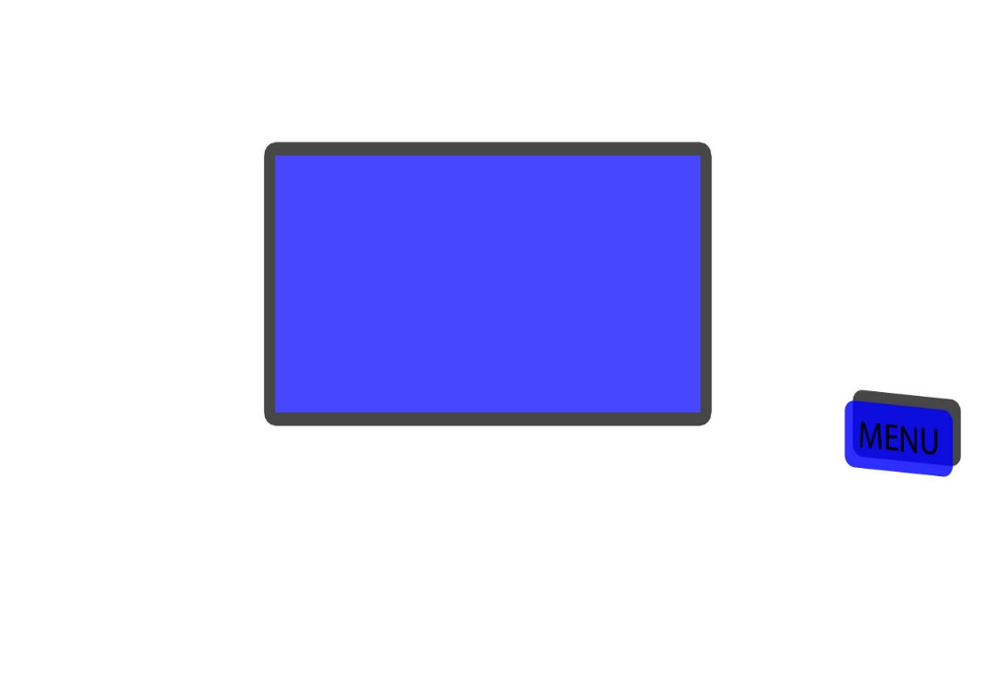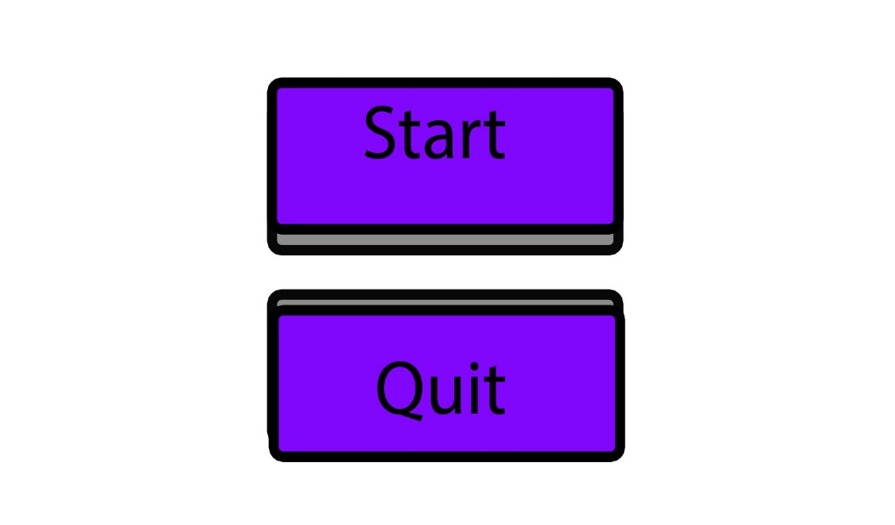

Monitor

**Figure 15. Main Menu**

Once the program has started, the Main Menu’s “Start” and “Quit” buttons will be displayed.

**Figure 16. Monitor / Menu Screen**

Once the user has pressed “Start”, a monitor is displayed with a “Menu” Button. Pressing the menu button gives further interactivity.

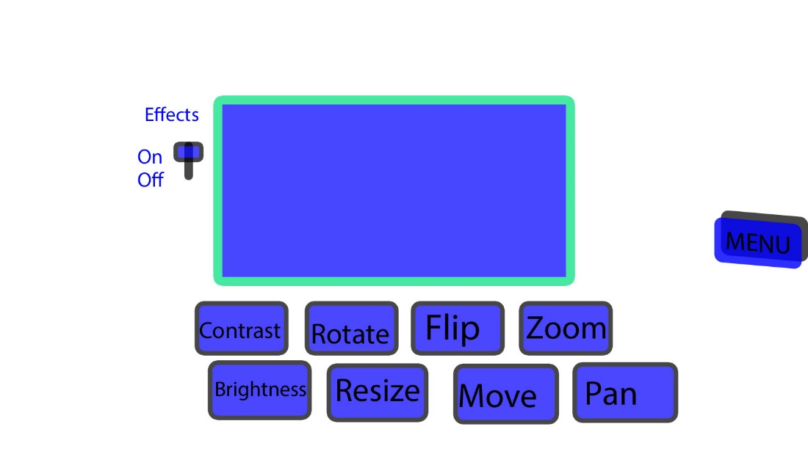

**Figure 17. Image Selection Screen.**

When a user interacts with a monitor, buttons for “Contrast”, “Rotate”, “Flip”, “Zoom”, “Brightness”, “Pan”, “Resize” and “Move” appear.

When “Contrast”, “Rotate”, ”Brightness”, “Flip” or the “Zoom” button is depressed, the mouse wheel will adjust the image. Only one button may be depressed at a time.

When the Pan button is depressed, the image may be dragged to a different position within the monitor.

When the resize button is depressed, the image will be able to be scaled up/down by grabbing the top right corner.

When the “move” button is depressed, the monitor may be dragged into a different position within the workspace environment

Monitor

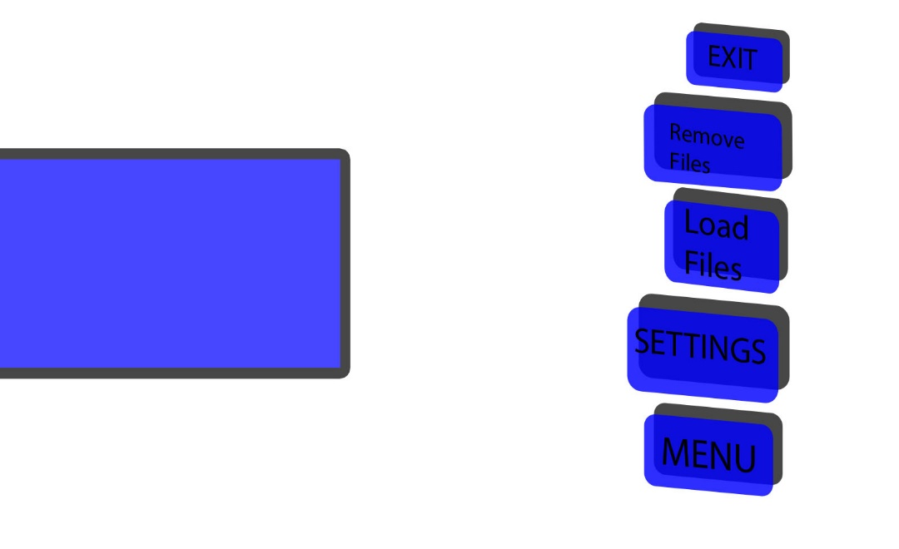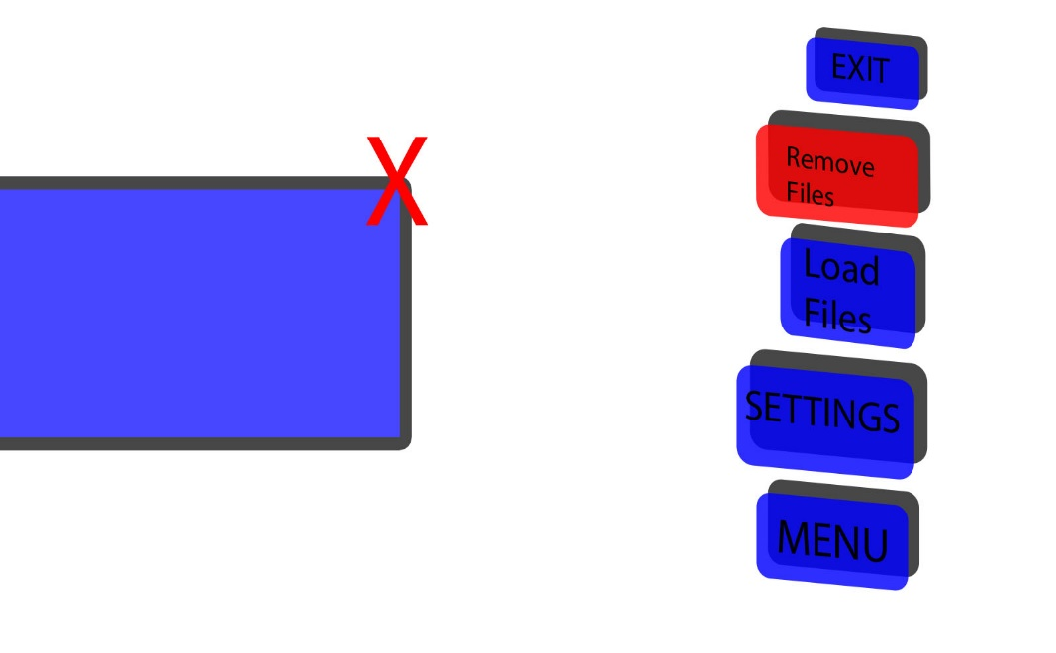

Monitor

**Figure 18. Main Menu “Expand”**

Once the user has pressed the menu button, the interactive options are displayed: “Remove Files”, “Load Files”, “Settings” and “Exit”.

“Load Files” will allow a user to open a DICOM file. Once loaded, the first image is displayed on the monitor. The images on the monitor can be scrolled through with the mouse wheel.

The exit button terminates the application.  
  
Remove Files allows DICOM image files to be removed from the monitor.

Monitor

**Figure 19. Remove Files Menu**

Once the user has pressed the Remove Files button, a “red X” will appear on the monitor to allow the file to be removed from the monitor.