cmpt 371 – Team 3 Requirements document
  - Virtual Reality Medical Imaging Software with Luxsonic Technologies Inc.
January 22, 2017

Executive Summary
This document provides information to describe the features that will included in the virtual reality 3D image processing software. All members of Dr. Osgood’s Computer Science team will have an important role in the development and implementation of this program. Using Unity 5, Oculus Rift, and other hardware and software we plan to deliver a functional program by the end of the project. The planned functionality of the program falls into three categories: must-have, should-have, and could-have. Must-have features will be those promised by our team to deliver to Luxonic by the end of the project. These features will be included in our step through graphical user interface concept shown in the appendix of this document. Each must-have feature will include a description and set or possible actions and scenarios. The should-have features are those that we plan to implement, but due to time constraints, we cannot promise they will be delivered by the end of the project. A short description of these features is provided, along with the likelihood of being able to deliver them. Finally, could-have features are those that we will be unlikely to implement due to time or other constraints. With the information provided in this document, Luxonic should have an in-depth vision of the expected project for our first deliverable. Since we will be employing an incremental development approach, many of the features are subject to change due to time and Luxonic input.

Table of Contents
Executive Summary i
1 Premise 1
2 Product 1
3 Platform and Software 1
4 Functionality 1
5 Must-Have System Actors and Their Actions 2
5.1 Actor: User 2
5.1.1 Action: Initialize the Program 2
5.1.2 Action: Load File 3
5.1.3 Action: Main-menu Quit System 3
5.1.4 Action: Workspace Quit System 3
5.1.5 Action: Select Images to Display 4
5.1.6 Action: Select Images to Remove from Display 4
5.1.7 Action: Adjust Contrast 5
5.1.8 Action: Adjust Brightness 5
5.1.9 Action: Apply Filter 5
5.1.10 Action: Zoom 6
5.1.11 Action: Rotate 6
5.1.12 Action: Flip 7
5.1.13 Action: Move 7
5.1.14 Action: Resize 7
5.2 Actor: DICOM Decipher 8
5.3 Actor: DICOM File Folder 8
6 Should-Have Actions 8
6.1 Action: Be able to query and download files from the server 8
6.2 Action: Have three images displayed at the same time 8
6.3 Action: Anti-motion sickness features 8
6.4 Action: Create 3D models from DICOM images to view and manipulate 9
6.5 Action: Use of Oculus Rift Controllers 9
7 Could-Have Actions 9
7.1 Action: Create animation of time lapsed images 9
7.2 Action: Have an anesthetically pleasing selection of background environments 9
7.3 Action: Be able to access the computer desktop from the virtual reality 9
7.4 Action: Write Reports within the virtual workspace 9
8 Conclusion 10
9 Appendix A: Graphical User Interface 11

Premise
This document is the requirements contract between the student software engineers of Dr. Nathaniel Osgood’s computer science class and our client Luxonic. Our team consists of 11 members (Heramb, Janelle, Nhi, Mackenzie, Jack, Brianne, Evan, Ix, Kyle, Kevin, and Brady). Our primary goal is to engineer a piece of software to replace a radiologist’s traditional workspace. We will be developing a virtual reality 3D image processing software. We will first prioritize the rendering of 2D DICOM images and later advance to 3D. This document will include a description of actors, actions, scenarios, use case diagrams and prototype interfaces to help our client gain a better understanding of what our product has to offer.

Product
This product will be a virtual reality based medical imaging software. Using Unity and Oculus Rift our teams’ goal is to engineer a piece of software to improve the workflow of medical imaging professionals. The software will create a configurable 3D space that contains virtual analogues of the tools used daily by radiologists. The software will support and display images that comply with the Digital Imaging and Communications in Medicine (DICOM) standard in both 2D and 3D views. Users will be able to cycle through these images as well as adjusting the depth, contrast, and zoom of the image. The product will support be able to display multiple images at once will be controlled and altered primarily using a mouse and key board (initially). Controls will be eventually be switched to the use of the Oculus Rift controllers by the end of the project. Each image displayed will have tools to adjust various attributes of the images including the contrast and brightness of the images. The team will also tackle any problems relating to motion sickness or eyestrains to ensure the product is usable for long hours and more user friendly.

Platform and Software
The program will be designed on a Linux and PC based system and be executable on systems capable of running Oculus Rift Software. All team collaboration and communication will be done through Slack and a project Wiki. The engine used to create the software for the project will be Unity 5.4 and will be coded in C#. The virtual reality product which the program will be designed for will be the Oculus Rift. All formal documents will be created using Microsoft Word and diagrams will be created through the use of Microsoft PowerPoint. Assets provided in Unity’s free store for virtual reality will downloaded and used to help the project. Any additional software not mentioned above may be used and will be emphasized in future versions of this document. The next section of this document will outline the various actors (roles) that will be involved in the program.

Functionality
It is important that this program be user friendly for any radiologists who wish to use the program. The goal is that it should be easy to handle regardless of any one users’ technological background. The functions used in this program should make sense and feel like they have a logical and straightforward approach to using them. Careful consideration must be given to how each feature will work and how it should be implemented. Many of the features requested by Luxonic are relatively easy to create, but since we are dealing with them in a virtual world, we have plan more carefully for feasibility and ease of use. Within a virtual reality, the health risks are to be taken into account and determined if any of the features or capabilities implemented could have adverse effects. These risks will be assessed on a regular basis so that adjustments can be continually made. It is therefore necessary that changes will be constantly made to this document for each deliverable product. After each deliverable, the product will be assessed on its features, health, and its usability. The current standing of features for the first deliverable will be described and listed in the following sections.

Must-Have System Actors and Their Actions
The “Must Have” section will list actions that are integral to the functionality of the software. It will not include all of the features that we would like to implement, which is outlined in the following section, but rather the features that will be required to allow the developed software to be playable. The purpose of each actor is described along with the details and process of each action. Several considerations made for each action include pre-conditions (what must happen before an action’s scenario can occur), post-conditions (the result expected at the end of a scenario), and error-conditions (what may occur that prevents a scenario from reaching the expected end-point).
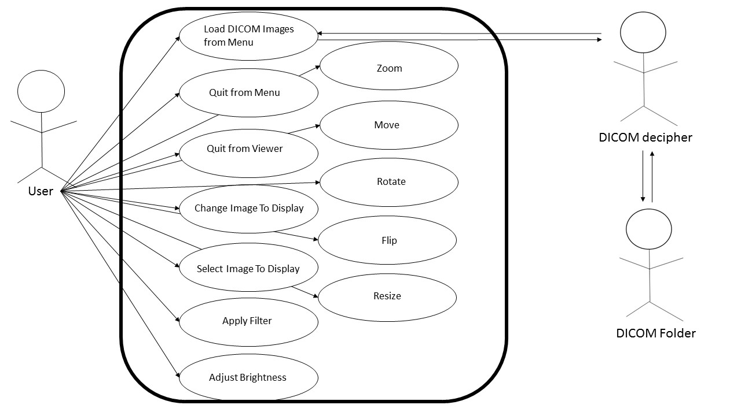
Figure 1. Use-Case Diagram for the program that we will be designing. It shows the actors and their specific actions that will be described in detail down below. NOTE: this use-case represents the first deliverable product that we will present to our client, Luxonic. This diagram will have additional features added to it and adjusted for future deliverables.

Actor: User
The User is the person interacting with the system. The User will initialize the program, select files for use, and use the workspace to interact with the specified files. When interacting with the files, the User may change the contrast of, brightness of, apply filters to, zoom in and out of, pan across, rotate, flip, move, and resize the image.

Action: Initialize the Program
The use case begins when the User presses “Start” in the main menu. The workspace will then be displayed.
- Pre-condition: None
- Post-condition:
  - The workspace is displayed
- Basic path:
- Use case begins when user opens application
- A main menu is displayed with option to start or exit the program
- User selects “start”
- Workspace is displayed
- Alternate path: None
- Error-condition path: None
Figure 2. Sequence Diagram for Initialization.

Action: Load File
The use case begins when the User selects “load files” in the workspace. A menu prompting the User to select files will appear. Once the files have been chosen, the menu will then confirm the User’s selection. If the User chooses “yes”, the workspace will be displayed with the chosen images.
- Pre-condition:
  - The user is currently in the workspace
- Post-condition:
  - Files loaded into the system and available to display.
- Basic path:
- The use case begins when user selects “load files” in the workspace.
- Menu with available files prompts user to select images.
- Menu prompts user to confirm selection.
- User presses “Yes”
- Workspace Environment is displayed with images available.
Figure 3. Sequence Diagram for loading a file.
- Alternate path:
- User Presses “No”
- Menu with available files is displayed
- Error-condition path: The Game Host presses “No” at the confirmation prompt
- User presses “Yes”
- Error message notifies user that files cannot be loaded

Action: Main-menu Quit System
The use case begins when the User chooses “exit” on the main menu. The application will then close.
- Pre-condition:
  - User is in the main menu
- Post-condition:
  - The application is closed
- Basic path:
- The use case begins when the user presses the “exit” button
- The application is closed
Figure 4. Sequence Diagram for quitting from the main menu.

Action: Workspace Quit System
The use case begins when the User selects “exit workspace” in the workspace environment. The files in use are restored to their default format and the user is directed to the main menu. The User will then follow Action: Main-menu Quit System.
- Pre-condition:
  - User is within workspace environment
- Post-condition:
  - Files are restored. The application is closed.
- Basic Path:
  - The use case begins when the user presses the “exit workspace” button.
  - The files are restored
  - The user is directed to the main menu
  - Refer to Action: Main-menu Quit System
Figure 5. Sequence Diagram for quitting from the workspace.

Action: Select Images to Display
The use case begins when the User selects images to display from the loaded DICOM files. The user will then confirm the addition of these images to the display. If they choose “yes”, the images will be added. If not, the images will not be added to the display.
- Pre-condition:
  - The user is currently in the workspace.
- Post-condition:
  - Desired images are displayed.
- Basic Path:
- Use case begins when the user selects images to display from loaded the DICOM files.
- The User will select “display images”
- A menu will prompt the User to confirm
- The User will select “yes”
- The selected images are displayed in the workspace environment.
- Alternate path:
- The User will select “no”
- The selected images will not be displayed

Figure 6. Sequence Diagram for adding images

Action: Select Images to Remove from Display
The use case begins when the User select images displayed in the workspace to be removed. The User will then confirm the removal of the selected images. If the User selects “yes”, the images will be removed from the display. If not, the images will remain on the display.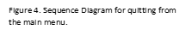
- Pre-condition:
  - At least one image is displayed in workspace.
- Post-condition:
  - Image is no longer displayed in workspace.
- Basic path:
  - Use case begins when the user selects images to no longer display in the workspace
  - The User will select “remove images”
  - A menu will prompt the User to confirm
  - The User will select “yes”
  - The selected images are no longer displayed in the workspace environment
- Alternate path:
Figure 7. Sequence Diagram for removing images.
- The User will select “no”
- The selected images will not be removed

Action: Adjust Contrast
The use case begins when the user selects an image within the workspace to adjust its contrast settings. The user can then adjust the contrast settings and select “Apply Changes” or can choose not to apply the contrast changes by selecting “Cancel.”
- Pre-condition:
  - At least one image is displayed in workspace.
- Post-condition:
  - Desired contrast settings are applied
- Basic path:
  - The use case begins when the user selects an image.
  - The user selects contrast settings.
  - The user increases or decreases the contrast. Adjustments are displayed in live time.
Figure 8. Sequence Diagram for adjusting contrast
  - The user selects “Apply Changes”
  - The changes are applied to the image
- Alternative path:
- The user selects “Cancel”
- The changes are not applied to the image

Action: Adjust Brightness
The use case begins when the user selects an image within the workspace to adjust its brightness settings. The user can then adjust the brightness settings and select “Apply Changes” or can choose not to apply the brightness changes by selecting “Cancel.”
- Pre-condition:
  - At least one image is displayed in workspace.
- Post-condition:
  - Desired brightness settings are applied
- Basic path:
  - The use case begins when the user selects an image.
  - The user selects brightness settings.
  - The user increases or decreases the brightness. Adjustments are displayed in live time.
Figure 9. Sequence Diagram for adjusting brightness
  - The user selects “Apply Changes”
  - The changes are applied to the image
- Alternative path:
- The user selects “Cancel”
- The changes are not applied to the image

Action: Apply Filter
The use case begins when the user selects an image within the workspace to apply a filter to. The user can then choose a filter for the picture and select “Apply Changes” or can choose not to apply the filter by selecting “Cancel.”
- Pre-condition:
  - At least one image is displayed in workspace.
- Post-condition:
  - Desired filter settings are applied
- Basic path:
  - The use case begins when the user selects an image.
  - The user selects filter settings.
  - The user selects desired filter. Adjustments are displayed in live time.
  - The user selects “Apply Changes”
  - The changes are applied to the image
- Alternative path:
- The user selects “Cancel”
- The changes are not applied to the image
Figure 10. Sequence diagram for applying filter

Action: Zoom
The use case begins when the user selects an image within the workspace to adjust its zoom settings. The user can then adjust the zoom settings and select “Apply Changes” or can choose not to apply the zoom changes by selecting “Cancel.”
- Pre-condition:
  - At least one image is displayed in workspace.
- Post-condition:
  - Desired zoom settings are applied
- Basic path:
  - The use case begins when the user selects an image
  - The user selects zoom settings.
  - The user zooms in or out of the current image. Adjustments are displayed in live time.
Figure 11. Sequence diagram for zooming
  - The user selects “Apply Changes”
  - The changes are applied to the image
- Alternative path:
- The user selects “Cancel”
- The changes are not applied to the image

Action: Rotate
The use case begins when the user selects an image within the workspace to rotate. The user can then rotate the image and select “Apply Changes” or can choose not to apply the rotate changes by selecting “Cancel.”
- Pre-condition:
  - At least one image is displayed in workspace.
- Post-condition:
  - Desired rotate settings are applied
- Basic path:
  - The use case begins when the user selects an image
  - The user selects rotate settings.
  - The user rotates the current image left or right. Adjustments are displayed in live time.
  - The user selects “Apply Changes”
Figure 12. Sequence diagram for rotating image
  - The changes are applied to the image
- Alternative path:
- The user selects “Cancel”
- The changes are not applied to the image

Action: Flip
The use case begins when the user selects an image within the workspace to flip. The user can then flip the image backwards or upside-down and select “Apply Changes” or can choose not to apply the flip changes by selecting “Cancel.”
- Pre-condition:
  - At least one image is displayed in workspace.
- Post-condition:
  - Desired flip settings are applied
- Basic path:
  - The use case begins when the user selects an image
  - The user selects flip settings.
  - The user flips the current image backwards or upside-down. Adjustments are displayed in live time.
  - The user selects “Apply Changes”
  - The changes are applied to the image
- Alternative path:
- The user selects “Cancel”
Figure 13. Sequence diagram for flipping image
- The changes are not applied to the image

Action: Move
The use case begins when the user selects an image within the workspace to move. The user can then move the image to the desired location.
- Pre-condition:
  - At least one image is displayed in workspace.
- Post-condition:
  - Image is moved to desired location
- Basic path:
  - The use case begins when the user selects an image to move
Figure 14. Sequence diagram for moving an image
  - The user moves the image to wanted location in workspace.

Action: Resize
The use case begins when the user selects an image within the workspace to resize. The user can then resize the image to the desired size.
- Pre-condition:
  - At least one image is displayed in workspace.
- Post-condition:
  - Image is resized to desired size.
- Basic path:
  - Use case begins when the user selects an image to resize.
  - The user resizes the image to wanted size.
Figure 14. Sequence diagram for resizing an image.

Actor: DICOM Decipher
The DICOM Decipher will be an external actor to our system. Their goal will be to search and decipher DICOM files. It will take the deciphered DICOM file and send its contents to our program where they will be stored into a list for use by the user.

Actor: DICOM File Folder
Initially, we will have a file folder, which will store DICOM files to be taken and uncompressed by the DICOM Decipher and then sent to our program. Currently this actor will simply be a local folder on a specific computer. In time, this actor will represent the server used by the radiologists that stores all patient DICOM files.

Should-Have Actions
The “Should Have” section lists the functions that will be added in future versions of this project not described in the current deliverable. These are features Luxonic has asked for specifically that we expect to implement and additional features that will either enhance or be necessary to implement these functions.

Action: Be able to query and download files from the server
As specified by Luxonic, the system should be able to access and download DICOM files from their server. The user should have the ability to query specific files to be viewed and manipulated by the program. Being able to save and send modified DICOM files to the server will be discussed at a later point in time.

Action: Have three images displayed at the same time
In the next deliverable, the user will have the ability to view three images at once. This will allow for easy comparison between images of the same DICOM file. The ability to change which files are visible will be included in this feature.

Action: Anti-motion sickness features
Since we are dealing with virtual reality, it is important to take into account the side effects of using this emerging technology. Other virtual reality programs have shown that nausea, dizziness, eye strain, and several other health problems can arise when using this technology. Certain individuals have been shown to be more susceptible to the health risks, but there are ways which can counteract and lessen these risks. Throughout the project we will be researching and working on ways to alleviate some of these risks for the program we are designing.

Action: Create 3D models from DICOM images to view and manipulate
Creating 3D representations of images in DICOM files would be an interesting tool to develop. The user should be able to rotate, move, and zoom in on the model for better viewing. While this feature is currently out of scope of the knowledge our development team possesses, we will devote significant time into determining if we can develop such a feature for Luxonic. While we cannot promise such a feature will be deliverable in three months’ time, we will attempt to implement it.

Action: Use of Oculus Rift Controllers
The use of controllers to perform all the necessary functions in this program will be key. Relying on just a mouse and keyboard would be difficult in the end, and would become potentially too difficult for use. For the first deliverable, the use of controllers will not be implemented. Controllers will be implemented in future deliverables of the project.

Could-Have Actions
Due to time constraints, we may not be able to include all of the components that we would like to. These are ideas that can improve the functionality and utility of the program. The following is a few aspects that could be added in future versions if time permits it.

Action: Create animation of time lapsed images
For images that are a series of time stamps of the same object, we could potentially create a video animation of the time lapse for better viewing. This animation could be saved and added to the DICOM file.

Action: Have an anesthetically pleasing selection of background environments
To contribute to a more enjoyable and friendly virtual experience, we could add a selection of background environments that the user can select from. This feature would only be for anesthetic purposes, and would only be considered if we have the time

Action: Be able to access the computer desktop from the virtual reality
While a nice feature to have, this ability may not be possible or feasible for the current length of the project. While we will look into this, it is not something we can promise to be deliverable.

Action: Write Reports within the virtual workspace
An important utility, being able to write reports within the virtual workspace would be an important asset. Currently, the team is in the middle of discussing possible ways to implement such a feature. Due to the nature of holding controllers, being able to type up reports could be difficult in practise. Methods of implementing this feature will be looked into in depth if time permits it.

Conclusion
This document provides information to describe the features that will included in the virtual reality 3D image processing software. Team three from Dr. Osgood’s Computer Science class will work towards developing, testing, assessing risks, and managing communication between Luxonic and ourselves for the duration of this project. Our goal will be to provide Luxonic with a program that incorporates the features specified above. This program will be feasible, easy to use, and have minimal risk on health on users. These are the promises we make to Luxonic and work towards accomplishing them to the best of our abilities.

Appendix A: Graphical User Interface
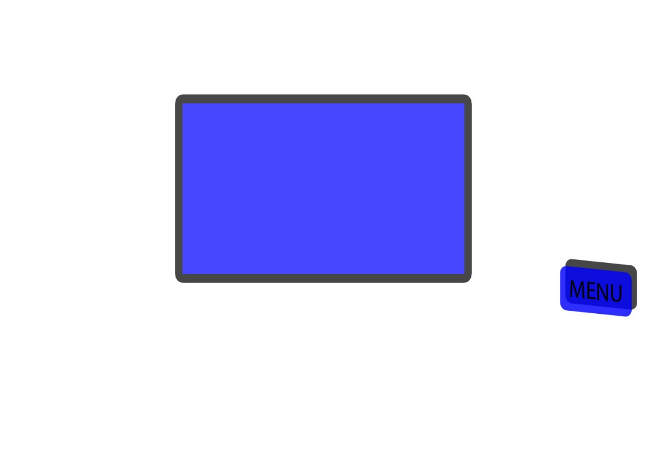
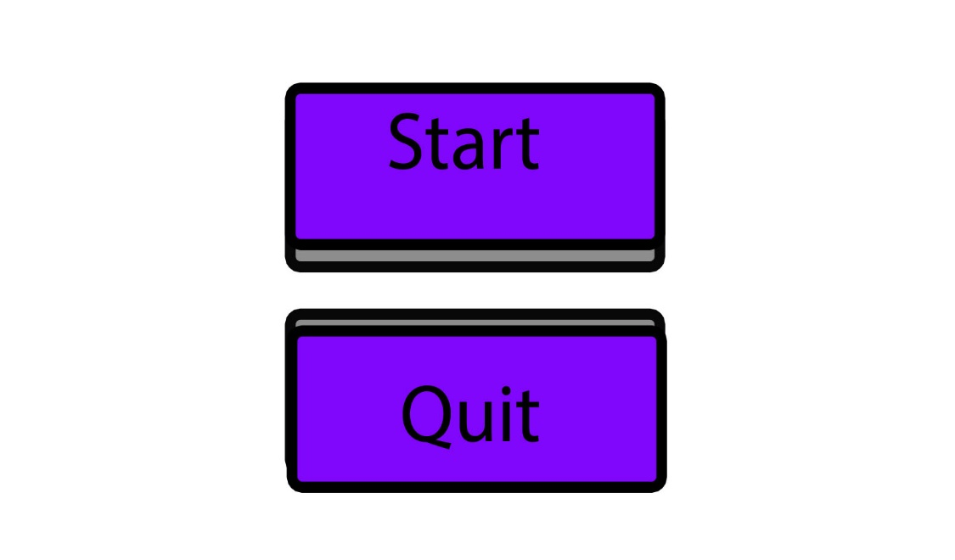
Monitor
Figure 15. Main Menu
Once the program has started, the “Start” and “Quit” buttons will be displayed.

Figure 16. Monitor / Menu Screen
Once the user has pressed “Start”, a monitor will be displayed with a “Menu” Button. Pressing the menu button gives further interactivity.

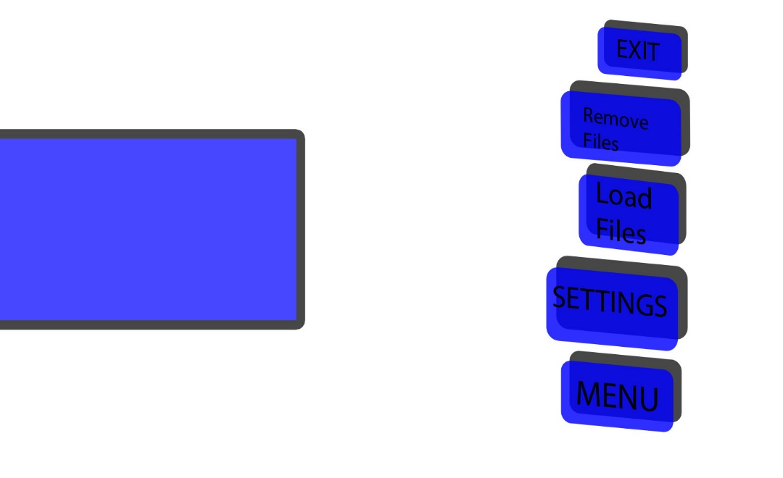
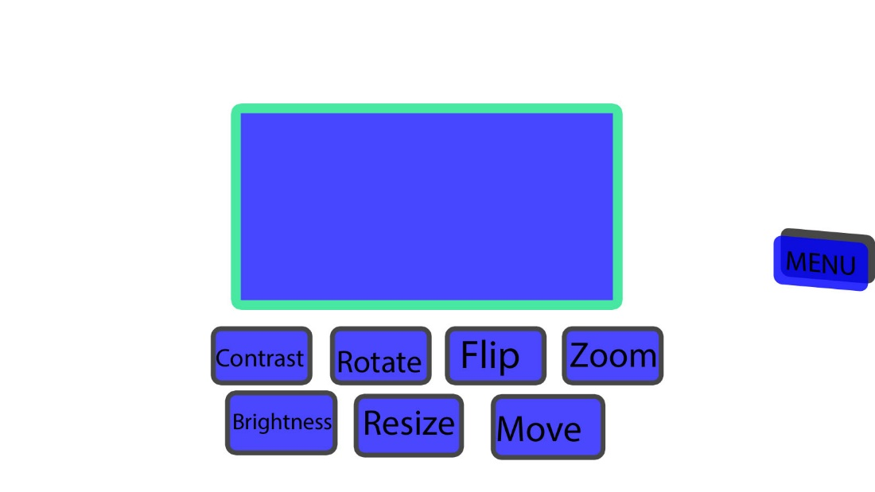
Figure 18. Main Menu “Expand”
Once the user has pressed the menu button, the interactive options are displayed: “Remove files”, “Load Files”, “Settings” and “Exit”.
The load filed will allow a user to open a DICOM file. Once loaded, the first image is displayed on the monitor. The images on the monitor can be scrolled through with the mouse wheel.
The exit button terminates the application.
Remove Files allows DICOM image files to be removed from the monitor.
Monitor
Monitor
Figure 17. Image Selection Screen.
When a user clicks on a monitor via mouse press, buttons for “Contrast”, “Rotate”, “Flip”, “Zoom”, “Brightness”, “Resize” and “Move” appear.
When “Contrast”, “Rotate”, ”Brightness”, “Flip” or the “Zoom” button is depressed, the mouse wheel will adjust the image. Only one button may be depressed at a time.
When the resize button is depressed, the image will be able to be scaled up/down by grabbing the top right corner.
When the “move” button is depressed, the screen may be dragged into a different position.

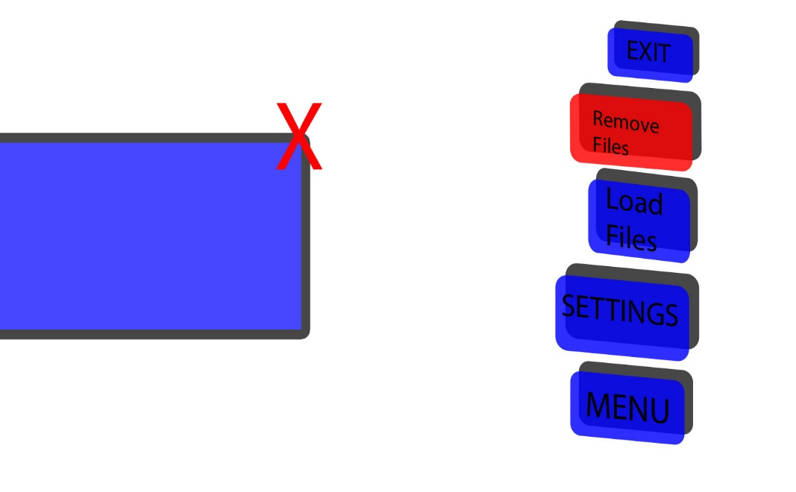
Monitor
Figure 19. Remove Files Menu
Once the user has pressed the Remove Files button, a “red X” will appear on the monitor to allow the file to be removed from the monitor.

