## Some Class Name

### CRC

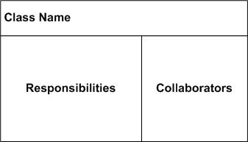

### Description / Overview

Some paragraph about this class Some paragraph about this class Some paragraph about this class Some paragraph about this class Some paragraph about this class Some paragraph about this class Some paragraph about this class Some paragraph about this class Some paragraph about this class Some paragraph about this class Some paragraph about this class Some paragraph about this class Some paragraph about this class.

### Instance Variables

#### Some Variable

Data Type:String

Some blurb about this variable Some blurb about this variable Some blurb about this variable Some blurb about this variable Some blurb about this variable.

#### Another Variable

Data Type:Integer

Some blurb about another variable Some blurb about another variable Some blurb about another variable Some blurb about another variable Some blurb about another variable.

### Method Overview

[*public void method1(String arg0, String arg1)*](#_Void_method1(String_arg0,)

[*public void method2(String arg0)*](#_Void_method2(String_arg0))

[*public void method3(String arg0, Integer arg1)*](#_Void_method3(String_arg0,)

[*private void method4()*](#_Void_method4())

### Method Writeups

#### public void method1(String arg0, String arg1)

This method does some stuff with two strings This method does some stuff with two strings This method does some stuff with two strings

#### public void method2(String arg0)

This method does some stuff with a string This method does some stuff with a string This method does some stuff with a string This method does some stuff with a string This method does some stuff with a string

#### public void method3(String arg0, Integer arg1)

This method does things This method does things This method does things This method does things This method does things This method does things

#### private void method4()

This method doesn’t do much This method doesn’t do much This method doesn’t do much