|  |
| --- |
| Linkage 3.3 |
| User’s Guide |

|  |
| --- |
| David Rector  Monday, July 11, 2016 |

## Table of Contents

Table of Contents 2

Installation 3

Running the Linkage Program 3

Simple Mechanism Tutorial 5

Mouse Operations 9

Keyboard Operations 10

Things You See in the Menu, Tool, and Tool Bar 12

Things That You See in a Mechanism 21

Connector and Point Alignment 28

Connector and Point Properties 29

Curved Sliding Connector Paths 32

Link and Line Properties 34

Locked Links 38

Gears and Chains 38

Gear Ratio 38

Quick Gear Tutorial 40

Gear Fastening 41

Link, Line, and Point Dimensions 42

Parts List 44

Coordinates 45

Types of Simulations 45

Manual Controls for Automatic Simulation 46

Status 47

Drawing during Simulation 47

Exporting 48

Exporting Videos 48

Exporting Images 49

Printing 51

File Format 51

Sliding Mechanism Tutorial 51

Limitations 53

Customer Support 57

Index 58

## Installation

The installation file, called linkage.msi (or linkage2.msi), can be run by double clicking on the file name. It can also be run from a browser at the time it is downloaded. The installation program will show a few dialog boxes and will ask for a location to install the program. Once the installation is done, there should be a Linkage entry in the Start Menu program list or on the Start Screen, as well as an icon on the desktop.

Windows XP users may need to install Windows XP Service Pack 3. Linkage was developed and tested on Windows 7 but has worked on Windows XP with the most recent service pack installed.

If you are an experienced Windows user and want to get started with creating a mechanism, skip to the tutorial on page 5.

## Running the Linkage Program

Linkage, for lack of a better name, is a computer program that lets you design and edit a two dimensional mechanism and then simulate the movement of that mechanism. The editing and simulation are both done in the same window and are part of the same user interface.

Run Linkage using the desktop icon, the start menu Linkage entry, or however programs are usually run on the computer. The window in Figure 1 will appear.

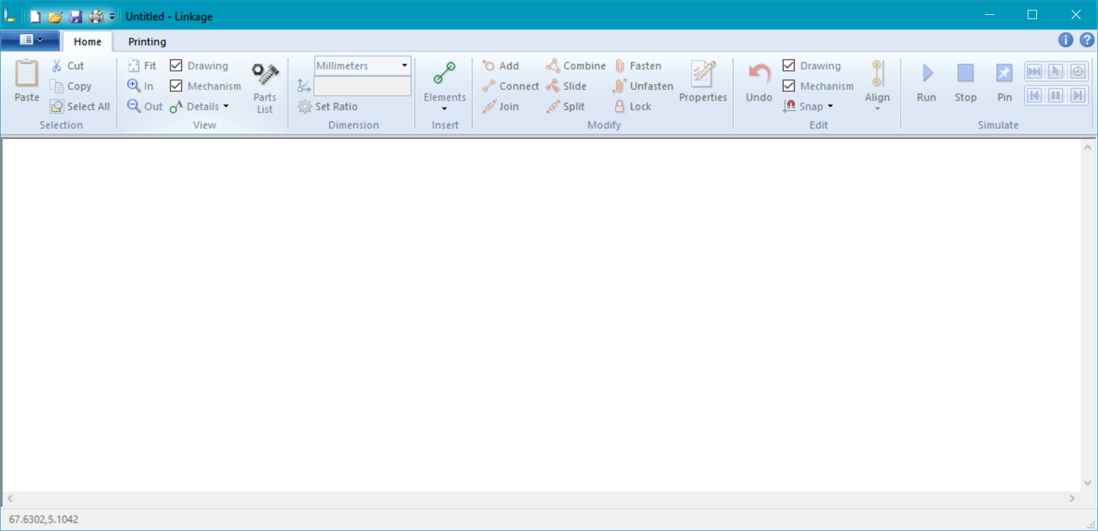

Figure 1. Linkage Window

This is the Linkage window above. The Linkage program can be used to edit a single mechanism at a time. To edit more than one mechanism at a time, run another copy of the program.

All functions of the Linkage program are accessible in the tool bar and quick access menu at the top of the window. Editing is done using the mouse and keyboard within the edit area of the window. The keyboard can be used to access common menu and tool bar features as well as modify the way a mouse action works. The keyboard cannot be used to move, rotate, etc., elements of the mechanism. This is a mouse-driven editor.

The **Main** menu, or “**File**” menu, is just to the left of the **Home** tab near the top of the window. There is a **Samples** menu item that allows a sample mechanism to be opened. Select the top-left example mechanism in the gallery and the mechanism shown in Figure 2 will be displayed in the Linkage window.

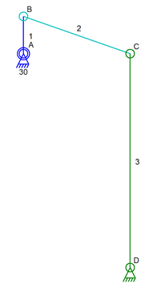

Figure 2. Simple Example Mechanism

This is a four bar linkage. Click on the **Run** button  in the tool bar or press the **R** key. The mechanism movement will be animated in the window. Press the **Stop** button  or press the **S** key to stop the mechanism. The display is reset back to the original position when the simulation is stopped.

* The mechanism cannot be modified while a simulation is running.
* The simulation can be paused or moved one step at a time. This is described later.

## Simple Mechanism Tutorial

This is a short tutorial for creating a simple mechanism like the one described in the previous section.

1. Run the Linkage program.
2. Move the mouse pointer to the center of the window and right-click at that location. A visual list of elements will show up.

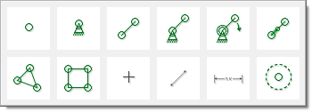

Figure 3. Popup Element Gallery

1. Move the mouse pointer over the fifth element from the left and click on it. This is an anchor that is also an input, along with a link. When the simulation runs, this will rotate automatically like a motor.
2. Move the mouse pointer down and to the right and repeat the previous operation, but insert the fourth element from the left. This is an anchor that is not an input. An anchor is just a connector that is connected to the “ground”. The ground is the one link in the mechanism that is not displayed. It is like the ground that your house sits on or like the frame of a car.   
     
   The mechanism should look similar to what is shown below.

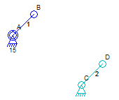

Figure 4. Tutorial Mechanism after Step Four

1. Click on the connector labeled B by clicking near the center of the circle. If the B label is not visible and you need to see it then click on the **Details** button in the tool bar then click on the **Labels** button to enable labels.

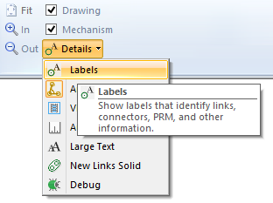

Figure 5. Labels Option in Tool Bar

1. Hold down the **Shift** key while clicking on the connector labeled **D**. This should leave connector **B** selected because you held down the **Shift** key. You should see both selected with a dotted line between them and some black squares around the entire selected area. The black squares are the adjustment handles or knobs and can be used to stretch or scale the selected elements.

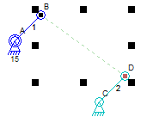

Figure 6. Tutorial with Two Connectors Selected

1. Click on the **Connect** button in the tool bar.

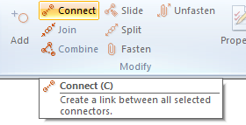

Figure 7. Connect Button in Tool Bar

The mechanism should look like the one in Figure 8. This is a fully functional mechanism because all connectors and links can be simulated.

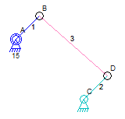

Figure 8. Tutorial Mechanism Almost Done

1. To remove the selection of the two connectors, click with the mouse pointer pointing to some blank area in the window. Continue once nothing in the mechanism is selected.
2. Click on connector **D** and hold down the mouse button. Move the mouse pointer up and to the right to drag the connector to a new position. Release the mouse button when the connector is in the new position. It is important to make sure that link 2 is longer than link 1. If it is not long enough, the mechanism might bind. Binding is when the parts don’t fit together in a way that lets the mechanism run continuously.

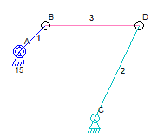

Figure 9. Finished Tutorial Mechanism

1. Figure 9 shows the finished mechanism. Click on the **Run** button in the tool bar and the mechanism will be animated in the window. Link 1 will rotate clockwise around anchor A and link 2 will move back and forth.

## Mouse Operations

| **Key, Button, and Movement** | **Action** |
| --- | --- |
| Left Button Click | Clicking at the center of a connector will select it.  Clicking on any line of a link will select it.  Clicking on the stroke distance knob of an actuator will select it. Any other selected elements will be deselected. Releasing the mouse button will deselect the stroke distance knob.  Clicking on an unselected element will remove the selection from any other elements.  Clicking on a selected element or elements will change the mode of the selection from stretch mode to rotate mode or vice-versa.  Clicking on the stretch handles around the selected elements allows the selected elements to be stretched.  Clicking on the rotate handles around the selected elements allows them to be rotated.  Clicking on the rotate center marker within selected elements allows the center of rotation to be moved. |
| Left Button Drag | Dragging selected elements moves them.  Dragging the linear actuator stroke distance knob changes the stroke distance of the linear actuator.  Dragging the stretch handles stretches the selected elements.  Dragging the rotate handles rotates the selected elements.  Dragging the rotate center mark changes the center point used for rotation. Once elements are selected or deselected, the center mark will revert to the center of the selected elements.  Dragging outside of any selected elements will drag a selection box for selecting multiple elements within the box when the mouse button is released. |
| Control Key or Shift Key and Left Button Drag | This is identical to a left button drag but snapping is disabled when the control or shift key are held during the drag operation. |
| Control Key or Shift Key and Left Button Click | Clicking on an unselected element will select it without removing the selection on any other elements.  Clicking on a selected element will remove the selection without removing the selection on any other elements. |
| Right Button Click | Clicking and releasing the right button without moving the mouse will then show the popup element gallery window if the mouse cursor is over an empty location in the document. An element selected from this window will be inserted into the mechanism at the location of the click.  Clicking and releasing the right button without moving the mouse will then show the properties dialog box for the connector or link if the mouse cursor is over a connector or a link.  Clicking and dragging with the right button will pan the view of the mechanism. This essentially moves the entire mechanism within the window. |
| Scroll Wheel | Moving the mouse scroll wheel towards the top of the mouse (away from your body) will zoom in on the mechanism. This makes the mechanism appear larger.  Moving the mouse scroll when away from the top of the mouse (towards your body) will zoom out from the mechanism. This makes the mechanism appear smaller. |

## Keyboard Operations

| **Keys** | **Action** |
| --- | --- |
| A | Add a connector to the selected link. |
| B | Combine the selected elements. |
| C | Connect the selected connectors. |
| F | Fasten the selected elements. |
| G | Change the selected connectors into anchors (**G**round). |
| J | Join the selected connectors. |
| L | Make a sliding connection with the selected connectors. |
| P | Show the properties of the selected connector or selected link. |
| R | Run the mechanism simulation. |
| S | Stop the mechanism simulation. |
| U | Unfasten the selected elements. |
| Control - A | Select all elements in the mechanism. |
| Control - C | Copy selected elements to the clipboard. |
| Control - N | Create a new empty mechanism. |
| Control - O | Open an existing mechanism from a file. |
| Control - P | Print the Mechanism. |
| Control -S | Save the mechanism. |
| Control – V  Insert | Paste elements from the clipboard into the document. |
| Control - X | Copy selected elements to the clipboard and delete them from the mechanism (Cut). |
| Control - Z  Alt – Backspace | Undo the last operation. |
| Delete | Delete the selected elements. |
| Tab | Select the next element in the mechanism after the element currently selected. |
| Shift-Tab Control-Tab | Select the previous element in the mechanism before the element currently selected. |
| +  = | Zoom In. |
| -  _ | Zoom Out |
| ← | Step Simulation Backward. The “[” key also works here. |
| → | Step Simulation Forward. The “]” key also works here. |
| Shift ← | Step Simulation Backward 10 steps. A simulation step is the amount that the simulation moves in 1/30th of a second. |
| Shift → | Step Simulation Forward 10 steps. A simulation step is the amount that the simulation moves in 1/30th of a second. |

## Things You See in the Menu, Tool, and Tool Bar

The tool bar, the main menu, the quick menu, and the popup element gallery, can all be used to modify a mechanism or the mechanism file in the following ways:

| **What You See** | **Action** |
| --- | --- |
|  | Create a new empty mechanism. |
|  | Open a mechanism stored on disk or elsewhere. |
|  | Open one of the sample mechanisms. A set of small pictures are shown and a sample can be picked from them. Tool tips show a short description of the sample mechanisms. |
|  | Save the current mechanism to disk or elsewhere using the existing file name. |
|  | Save the current mechanism to disk or elsewhere. |
|  | Show export choices in a sub menu. Exporting creates files that are used by other programs but can never be read back into the linkage program. See The Image, Animation, DXF, and Motion Path export actions below. |
|  | Create a PNG or JPEG file showing the mechanism in its starting state. |
|  | Create an AVI file with an animation of the running mechanism. |
|  | Create a DXF file with the mechanism in its starting state.  ***This feature is only partially working and created DXF files that may not have the entire mechanism. Some features like polygons/poly-lines or groups lines are not working and links with more than two connectors are not treated as a single entity in the DXF file. Use this data with caution.*** |
|  | Create a text file with coordinate information for the motion path draw by drawing connectors. |
|  | Print the current mechanism. |
|  | Print immediately without showing any print options. |
|  | Show a preview of how the mechanism will print. |
|  | Configure printers. |
|  | Print the mechanism actual size on multiple sheets of paper. This option might cause some blank sheets to print if the mechanism doesn’t cover the entire printing area. ***There is no test for giant mechanisms, so the program could print large numbers of pages if care is not taken when using this feature***. |
|  | Close the Linkage program. |
|  | Open a previously saved mechanism based on the *File Name* appearing in the main menu. |
|  | Insert the Clipboard contents into the mechanism. |
|  | Cut the selection and put it on the Clipboard. |
|  | Copy the selection and put it on the Clipboard. |
|  | Select all links and connectors. |
|  | Show the insert menu. This menu contains elements that can be inserted into the mechanism. |
|  | Add a single lone connector. This element appears on the tool bar and on the popup element gallery. |
|  | Add a single lone anchor. This element appears on the tool bar and on the popup element gallery. |
|  | Add a link with two connectors. This element appears on the tool bar and on the popup element gallery. |
|  | Add a link with an anchor and a connector. This element appears on the tool bar and on the popup element gallery. |
|  | Add a link with a rotating anchor and a connector. This element appears on the tool bar and on the popup element gallery. |
|  | Add a linear actuator link. This element appears on the tool bar and on the popup element gallery. |
|  | Add a link with three connectors. This element appears on the tool bar and on the popup element gallery. |
|  | Add a point. This element appears on the tool bar and on the popup element gallery. |
|  | Add a line. This element appears on the tool bar and on the popup element gallery. |
|  | Add a measurement line. This element appears on the tool bar and on the popup element gallery. |
|  | Add a gear. This element appears on the tool bar and on the popup element gallery. |
|  | Add a connector to the selected link. A link can have any number of connectors. A single link must be selected to add a connector to it. |
|  | Create a link between all selected connectors. |
|  | Convert the selected connectors into a single connector. |
|  | Change all of the selected connectors and links into a single link. The combine feature is not available if the connectors on a link are selected but that link itself it not selected. |
|  | Slide one connector between two others.   Select only three connectors to enable this function. Two of the connectors must be part of the same link and the third must not be part of that same link. The order of selection does not matter. The connector that is not on the same link as the others will become the sliding connector. |
|  | Disconnect all of the links that share the selected connector. The positions of some of the connectors will change to make them all visible and easily accessible with the mouse. |
|  | Fasten all of the selected elements on the drawing layer to the selected link in the mechanism, or fasten the selected gears to the selected link.  Fastened drawing elements are moved during simulation with the link to which they are fastened. Fastened elements are drawn identically to non-fastened elements and the fastening can only be seen during simulation.  Fastened gears rotate with the link that they are fastened to. Or the link is moved as the fastened gear is rotated. |
|  | Unfasten the selected elements. |
|  | Lock the selected link so that it cannot change size or shape. |
|  | Change the properties for the selected element. The rotation speed of a connector and the visual appearance of a link are a few of the properties that can be set for these objects. This button is only available when a single element in the mechanism is selected. |
|  | Show the align menu. This menu contains alignment and adjustment functions that can be performed on the selected links and connectors. |
|  | Allow an angle, in degrees, to be entered and then align the three selected connectors to form that specified angle. |
|  | Align the three selected connectors to form a right triangle. The third selected connector is rotated around the second to the correct location. |
|  | Align the four selected connectors to form a rectangle. The third selected connector is rotated around the second to the correct location to form a right triangle and the fourth connector is moved into position to form the rectangle. |
|  | Align the four selected connectors to form a parallelogram. The fourth selected connector is moved into position to form the parallelogram. |
|  | Align the selected connectors along a horizontal line. The first selected connector is left in place and the rest of the selected connectors are aligned to it. |
|  | Align the selected connectors along a vertical line. The first selected connector is left in place and the rest of the selected connectors are aligned to it. |
|  | Align the selected connectors in a line. The first and last selected connectors are left in place and the rest of the selected connectors are aligned between them.  **An older version of the software would line up the connectors in a line with the first two selected. Now the connectors are lined up between the first and last selected!** |
|  | Align the selected connectors in a line and space them evenly along that line. The first and last selected connectors are left in place and the rest of the selected connectors are aligned between them.  **An older version of the software would line up the connectors in a line with the first two selected. Now the connectors are lined up between the first and last selected!** |
|  | Flip the selected elements horizontally. Rotating anchor direction is reversed when flipping the anchor. |
|  | Flip the selected elements vertically. Rotating anchor direction is reversed when flipping the anchor. |
|  | Run the mechanism in real time while showing the animation in the window. All movement is automatic based on the speeds set for the various input elements. |
|  | Stop the simulation and reset it to its original condition. |
|  | Stop the simulation. The position of all links and connectors at the moment that the simulation is stopped becomes their new position. |
|  | Simulate the mechanism movement and show the results of any drawing connectors in the window. The simulation is stopped once the drawing information has been generated. |
|  | Interactively run the mechanism in real time while showing the animation in the window. All inputs and actuators are controlled manually. No input or actuator will move more than a few times the configured speed to ensure that the simulation is accurate. |
|  | Manually run the mechanism in real time while showing the animation in the window. The entire mechanism is controlled manually. The mechanism will not move more than twice as fast as when running automatically to ensure that the simulation is accurate. |
|  | Pause the simulation and allow stepping forward and backward. If the simulation is not running, it is started and paused immediately. |
|  | Step the simulation forward .033 (1/30) second. |
|  | Step the simulation backward .033 (1/30) seconds. |
|  | In the View panel, check this option to display the drawing layer.  In the Edit panel, check this option to allow editing of the drawing layer. |
|  | In the View panel, check this option to display the mechanism layer.  In the Edit panel, check this option to allow editing of the mechanism layer. |
|  | Show a menu of various details to show or hide. |
|  | Show labels that identify links, connectors, PRM, and other information. This is a selection on the Details |
|  | Show the hint lines for making right angles, rectangles, and parallelograms. More information is available later in the Alignment section. |
|  | Show the dimensions of all links in the document. |
|  | Show the video area that is captured when recording a video of a simulation. |
|  | Use a larger font for all text. |
|  | Causes new links to be inserted as solid links. When not selected, new links are inserted in the standard line style. |
|  | Enabled debugging mode (for me the developer). The effect of this will change in different versions of the program, but at this time, it changes the labels to show internal numbering of the elements in the mechanism. |
|  | Display the mechanism as a Parts List. The Parts List contains the links and connectors of the mechanism separated from each other and rotated to a horizontal position. Links with more than two connectors get rotated so that their longest side is along the bottom if the link in relationship to the screen, image, printout, etc. |
|  | Select the measurement units for the mechanism. This is saved with the mechanism and set whenever a mechanism is loaded from a file or from the sample gallery. |
|  | The following different values are seen and can be set using this edit control in the tool bar. The last selected connectors is moved when the value is changed in a way that affects just a single connector.  The x and y coordinates of a single selected connector are shown and can be set. Enter coordinates in the form “x,y”.  The distance between two selected connectors are shown and can be set by entering a single numeric value.  The distance between two selected connectors can be set using a percentage value to alter the current distance as per the percentage. Enter a number followed immediately by a percent sign like this: “12%”.  The angle between three selected connectors is shown and can be set by entering the number of degrees as a single numeric value*. The angle cannot be set if it will could cause a sliding connector to be moved.*  The length of a link with only two connectors can be seen, *but not changed*, when that type of link is selected. To change the length, select the connectors instead of the link.  The ratio of two gears can be set by entering two numeric values in the form “x:y”. The first value is the value representing the size of the first selected gear. The second value applies to the second selected gear. This is a size ratio, not a final drive ratio.  The overall size, or scale, of a set of selected elements can be changed by entering a percentage like this: “120%”. Scaling like this is done if more than two connectors are selected or if a combination of connectors and links are selected. Note that the scale value is not shown since it would always be 100% for the selected elements. Just enter the desired percentage into the empty box with a percent sign to scale elements this way. |
|  | Allows the ratio to be entered for two selected gears. This also allows the gears to be used as sprockets for a chain connection (or pulleys for belts). |
|  | Show a menu of snap options including the Auto Join option. |
|  | When selected, snap connectors to align with other connectors, ends of lines, and points, while dragging selected elements. |
|  | When selected, snap connectors to align with an invisible grid while dragging selected elements. *The grid size is picked automatically based on the zoom level.* |
|  | Enables the automatic joining of connectors (makes them into one) when one is dropped directly on another. The Object Snap must be on or this feature will not be enabled.  Once joined, there will be only a single connector possibly shared by multiple links. A Split operation will be needed to break the connector into two or more separate connectors.  *Connectors that are not part of a link cannot be auto joined.* |
|  | Zoom and pan the window so that the document is centered and is as big as possible in the window. The nearest standard zoom level is used and the mechanism may appear smaller than expected because of this. |
|  | Show the mechanism larger. |
|  | Show the mechanism smaller. |
|  | Open the User Guide document. The User Guide is a PDF document. |
|  | Show program copyright and version information. |

## Things That You See in a Mechanism

The mechanism with links and connectors is visible in the window along with various other pieces of information. Everything that may be seen in the window is described in the following table.

| **What You See** | **What It Means** |
| --- | --- |
|  | An individual connector represents the connection of one link to another or the place where a link could be connected. The connector is shown as a circle around the point of connection. A connector can exist without any links.  When labels are enabled and a name has not been given to the connector, a letter will be shown near the connector for identification.  Connectors will usually be the same color as the link to which they belong or black if they connect two or more links together. |
|  | An anchor is a connector that is attached to the “ground.” The location of this connector will not change during a simulation. Links connected to this anchor can rotate around it freely when the mechanism is simulated. |
|  | A rotating anchor rotates all of the links that are connected to it. The RPM of the rotation is shown below the anchor and can be set by double-clicking or right-clicking on the connector, or selecting it and clicking on the **Properties** button in the toolbar, and then typing in a new RPM value. Positive RPM values are for clockwise rotation. Negative RPM values are for counter-clockwise rotation. |
|  | A sliding connector is a connector that slides between two other connectors on another link. The sliding connector is shown as a square when it has been set to slide between other links.  A sliding connector may also be stationary or appear stationary while the other link defined by the other two connectors slides through this sliding connector. An anchor can also be a sliding connector. |
|  | A link is a set of two or more connectors that are a single part in the mechanism. When labels are enabled and a name has not been given to the link, a number will be shown near the middle of the link. |
|  | A ground link might be visible in the Parts List if there is no other link connecting all of the anchors to each other. |
|  | When two or more connectors are at the same screen location, there is an extra arc draw to show this overlap. Two or more connectors at the same screen location don’t connect links together, they are simply at the same location. When two links *are* connected, there is only a single connector at the connection point. This arc is not shown during the simulation. |
|  | A point is a reference marker and is not part of the mechanism or simulation. A point will show up as a cross or plus sign when it is not part of a line. Points can be manipulated just like connectors. |
|  | A line is a reference marker and is not part of the mechanism or simulation. A line is two points connected together. Lines can be manipulated just like links. |
|  | A point or the end point on a line can have a reference circle drawn around it at a specified radius. |
|  | A gear appears as a circle that is colored like a link. The connector label appears in the typical label position. The link also has a label that is shown to the left of the connector label. There is a line drawn on the gear to show movement during the simulation. |
|  | A polygon is a set of lines connected together. Lines can be connected just like links but these polygons have no function and are reference markers. |
|  | A measurement line is a reference marker and is not part of the mechanism or simulation. This is identical to a plain reference line except for the measurement that is displayed and the style of the ends of the line. There is very little visual difference between a measurement line and an automatic dimension line, except that measurement lines can be drawn anywhere. |
|  | A link can have as many connectors as needed. When there are three or more connectors, the link will be shaded a light color similar to the line color of the link. The numeric identifier will be shown close to the center of the link.  A connector within the area of a link that is part of that link will not have a line of any sort showing it as part of the link. It will simply be within the link area and if not connected, will be shown in the link color. |
|  | A link can have regular connectors as well as sliding connectors. Sliding connectors are only shown as squares when they are sliding between two other links. Otherwise, they are just normal connectors. |
|  | A linear actuator changes length during the simulation and any attached links will be moved appropriately. The CPM, or cycles per minute, shown below the link ID number and can be set by double-clicking or right-clicking on the link, or selecting the link and clicking on the **Properties** button in the toolbar, and then entering a new value for CPM. Positive CPM values are for actuators that get longer when they start moving. Negative CPM values are for actuators that get shorter when they start moving.  The small circle on the actuator is the stroke distance knob. The stroke distance knob can be dragged to change the stroke distance, or the amount of travel of the actuator. Dragging the stroke distance knob causes any elements that were selected to be deselected. The stroke distance knob does not remain selected after it is released. |
| or | A selected connector shows with a small square in the middle of it. A connector is selected by clicking on it with the left mouse button. Multiple connectors and links can be selected by holding the Control or Shift key while clicking on each with the left mouse button.  The last selected connector will be a red color but all previous selected connectors will be shown with a black square in them. Some operations may treat the first or last selected connector in a special way depending on the operation. If the order of more than two selected connectors is important than there may be other hint markings or lines to show this. For instance, if three connectors are selected and the Angles view option is selected then an angle radius arc will be shown around the second selected connector. |
|  | A connector that draws while the mechanism is animating or simulating will show a tiny pencil icon and the label will be in a different location from the label on a non-drawing connector. |
|  | A link that is lock will be show a little padlock icon before the label. A locked link cannot change size or shape, but can be rotated. |
|  | Gears that are connected to each other (having a ratio set) will be drawn touching each other and at sizes appropriate to the size ratio that was set. |
|  | Gears that are connected to each other (having a ratio set) and set to use a chain/belt connection will be drawn not touching each other, at sizes appropriate to the size ration that was set, and with dotted lines showing where the chain or belt would go. The size of the gears is arbitrary, except for the ratio, because the distance between the gears does not change the ratio.  *The dotted chain line* ***will not move*** *like a chain during the simulation but the gears will rotate as if connected by a chain.* |
|  | Links can be drawn as solid looking objects in addition to the regular drawing style. A border is drawn outside of the connectors and around them. |
|  | The path of a sliding connector is drawn as a dotted line when the path is inside of a solid looking link or between connectors on a link that are not adjacent to each other. |
|  | The path of a sliding connector can be curved in some situations. The path is always drawn as a dotted line. |
| or | A selected link shows with a red or grey rectangle around it. A link is selected by clicking within the link with the left mouse button. A link is not automatically selected when one of the connectors of the link is selected. Multiple links and connectors can be selected by holding the Control key or Shift key while clicking on each with the left mouse button.  The last selected link will be surrounded by a red rectangle but all previous selected links will be shown with grey rectangles. Some operations may treat the last selected link in a special way depending on the operation. |
|  | A grey dashed box appears around a link when you select another link or connector that is fastened to it. For drawing elements, the link they are fastened to may be any place else in the mechanism. For gears, the fastened gear and link share a connector.  The grey dashed box might appear if any of a set of elements is selected. This indicates that one or more of the selected elements is fastened to, or has elements fastened to it. |
|  | Any connector or gear that cannot be properly moved during simulation will be shown with a set of red lines around it as long as the animation is running. Those lines will not appear during editing. Links cannot stretch or shrink and a mechanism is not guaranteed to work properly when simulated. Simulation done without animation will not cause this information to be shown.  If the mechanism cannot move past a specific position due to limitations in the mechanism, the mechanism will appear stuck with these indicators shown until the simulation is stopped. |
|  | Grab handles for stretching, or scaling, and resizing the selected elements of the mechanism will be shown as small black boxes around the selected elements. Clicking on one of the selected elements without dragging the selection will cause the rotate controls to appear. Clicking and dragging one of the grab handles allows the selected elements to be resized. Dragging a corner grab handle will maintain the aspect ratio of the resized elements. |
|  | Rotation controls are shown as small arrows at the corners of the area containing the selected elements. These appear if an already selected set of links or connectors is clicked again (without the shift or control keys pressed).  There is also a center mark that can move moved to change the point of rotation. Clicking and dragging one of the arrows allows the selected elements to be rotated.  The center mark will snap to other connectors as it is moved near them. It does not snap to any other locations. |
|  | When stretching one or more selected elements, a dotted line will appear showing the actual area of the mechanism being stretched. Stretching is done based on the locations of the connectors that are selected or are part of selected links. This is not the same area that is enclosed by the grey box around each of the selected elements even though the grab handles are draw along the edges of that larger box. |
|  | Select a group of connectors and links by drawing a box around them. Draw the box starting in an empty location in the window or the element under the mouse cursor will be selected instead of the selection box being drawn.  Only the center point of connectors is used to determine what is selected. The circles, triangles, text, and any other graphics are ignored during this type of selection and need not be enclosed in the selection box to have the associated connector or link become selected. |
|  | During an interactive simulation, controls are shown in the bottom of the window. Each control consists of a text label, a line representing the range of movement of the input or actuator, and a control box. The box can be moved anywhere between the sides of the range indicator line and part of the mechanism will move to match its position.  For a rotating anchor, moving the control box from the far left to the far right of the range indicator line will rotate the input one complete revolution.  For a linear actuator, moving the box from the far left to the far right of the range indicator line will move the actuator from its shortest length to its longest length. This is only1/2 of a complete cycle but allows the full range of the actuator to be used. |
|  | When two or more connectors are selected, a set of hint lines are shown that indicate how the connectors will be aligned if an alignment is done. There are many ways to align connectors but any number of connectors can be aligned horizontally, vertically, or in line. Other alignment options are:   * Two connectors can have the distance between them changed. * Three connectors can be arranged to form a right triangle or they can be aligned to form any angle desired. * Four connectors can be arranged to form a parallelogram or a rectangle.   The hint lines are not shown when dragging or rotating the selected connectors. |
|  | Hints are shown whenever a selected connector is snapped to align with some other connector or the grid. The connector snap hint is drawn between the connector that is snapped and the unselected connector used for alignment. There are separate hint lines for horizontal and vertical alignments. |
|  | Hints are shown whenever a selected connector is snapped to align with some other connector or grid. The grid hint line is drawn to the edge of the window through the connector that is snapped. There are separate hint lines for horizontal and vertical alignments. |
|  | When the grid is displayed, it is drawn as light blue lines. The grid sizes itself automatically depending on the zoom level; it cannot be set to any specific values at this time. |
|  | Automatic dimensions, can be shown for all links of a mechanism. The default units for measurements are millimeters and the default scaling is 1:1 so that 1mm in the mechanism is roughly 1mm on the screen of most monitors. There is very little visual difference between an automatic dimension line and a measurement line but automatic dimensions are shown to measure some other existing link or line. |
|  | A blue box on the screen that is centered and is of a 16:9 size ratio represents the area used for saving a video of the mechanism simulation. This is a different shade of blue from the shade used for the mouse selection box. Anything outside of this area is not captured in the video. |
|  | When there are no elements of the mechanism available for showing dimensions, and when dimensions are enabled, this ruler will appear to show the current zoom and dimensions in the window. |

## Connector and Point Alignment

Connectors and Points can be aligned to each other in a variety of ways. The snap feature causes selected elements to jump to an aligned position whenever one of the selected elements is almost lined up horizontally or vertically with any unselected connector or point in the mechanism. A dotted line is draw from the selected element to the unselected element that is being used for the alignment. This feature can be temporarily turned off when dragging elements by pressing and holding the Control or Shift keys during the drag movement.

A set of selected connectors and points can be aligned to each other to form a right angle, rectangle, parallelogram, vertical line, horizontal line, or a line. The last element selected will be marked with a red square in the connector. The rest of the selected elements will be marked with black squares. There will be a dotted line drawn between the connectors and an angle arc drawn at the second selected connector. These markings are hints for which elements will be moved when the alignment is done.

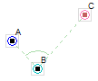

Figure 10. Three Selected Connectors

In this picture, connector A was the first selected and connector B was the second. These connectors will not move. Connector C will rotate to the proper location to form a right angle at B when performing a right angle alignment.

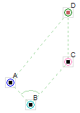

Figure 11. Four Selected Connectors

In this picture, four connectors are selected. If a rectangle is requested then the angle at B will be changed by rotating C to the right location. Then connector D will be moved so that ABCD is a rectangle. If only a parallelogram is requested then the angle at B will not be changed and only D will move to the correct position.

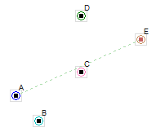

Figure 12. Five Selected Connectors

When five or more connectors and points are selected, the only hint line that is drawn is the hint for lining up the elements with the first and last selected.

## Connector and Point Properties



Figure 13. Properties Button

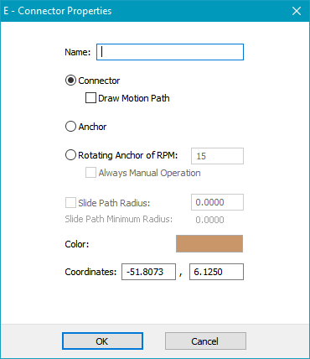

Figure 14. Connector Properties

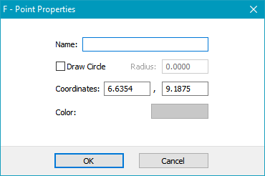

Figure 15. Point Properties

The connector properties dialog box in Figure 14 shows what settings are available for connectors. Figure 15 shows the point properties. Double-click or right click on a connector to show the Connector Properties or click on the Properties button. The different settings are:

| **Selection** | **Meaning** |
| --- | --- |
| Name | This is the name of the connector. It will be displayed after the connector identifier when labels are enabled. |
| Connector | The connector can connect links together so that they rotate around the connector. A connector can be part of a single link with no connections or it can connect two or more links together. |
| Draw | When the Draw property is set for a connector, the connector causes a line to be drawn along the path taken by the connector during simulation. The line, which is more accurately a curve, is drawn in a light grey as the simulation is run and remains visible until the mechanisms is changed in some way that could make the path invalid. |
| Anchor | The anchor is a connector attached to the “ground”. The ground is like one large link that is the base for all other connections in the mechanism. |
| Rotating Anchor | A rotating anchor provides rotational movement to selected parts of the mechanism. When simulated or animated, any links that connect to this anchor will rotate at the given RPM. |
| RPM | The revolutions per minute can be set for rotating anchors. This number can be any number although integers are better when using multiple rotating anchors to avoid mechanisms that have too much variation. Positive RPM values cause clockwise rotation and negative values cause counter-clockwise rotation. |
| Always Manual Operation | When the AMO property is set for a rotating anchor, movement of the anchor is controlled manually during all simulations. When this property is not set, the rotating anchor rotates automatically during simulation. |
| Draw Circle | Draw a circle of the given radius around the point on the drawing layer as a reference marker. |
| Radius (for Draw Circle) | The drawing circle radius can be entered. A value of zero will disable the circle drawing. |
| Slide Path Radius | The path of a sliding connector can be curved when simple sliding connector configurations are used. The radius can be entered as a positive or negative value to set both the radius and the direction of the arc. If the path appears on the wrong side of a link, change the radius from positive to negative or vice-versa. |
| Slide Path Minimum Radius | The minimum allowed radius is shown for the slide path. A slide path cannot have a radius that is less than half the distance between the limit connectors. |
| Color | The color of the connector or point can be set by clicking on the color box. |
| Coordinates | The x and y coordinates in Millimeters or Inches are shown in two edit boxes. If either or both are changed then the connector will move to the given coordinates when the OK button is pressed. |

## Curved Sliding Connector Paths

Sliding connectors can have curved paths. The Curve is an arc between the two limit connectors.

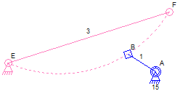

Figure 16. Curved Sliding Connector Path

The configuration of the connections in Figure 16 and in Figure 18 have sliding connectors that are used to position the links. These are the valid types of connections that can be made using sliding connectors on curved paths. Many other variations of these types of mechanisms can be designed.

Figure 19 shows the type of curved path that cannot be simulated. Although the invalid curved paths would work in a physical world, the simulator algorithm necessary to handle this situation has not yet been implemented.

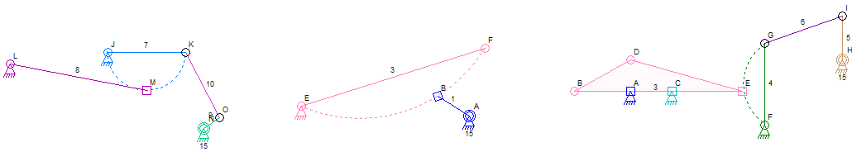

Figure 17. Valid Sliding Connector Curved Paths

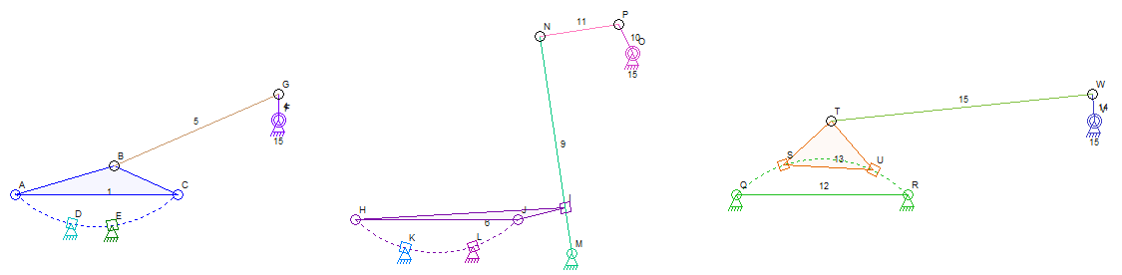

Figure 18. More Valid Sliding Connector Curved Paths

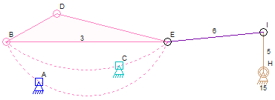

Figure 19. Invalid Sliding Connector Curved Path

## Link and Line Properties



Figure 20. Properties Button

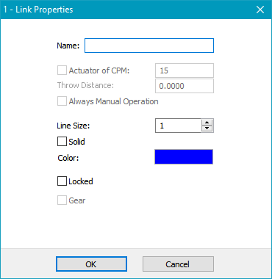

Figure 21. Link Properties

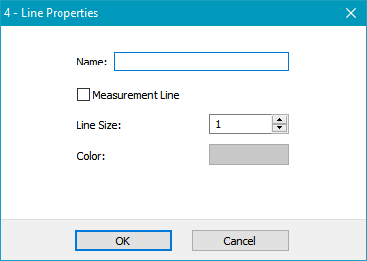

Figure 22. Line Properties

The Link Properties dialog box in Figure 21 shows the settings that are available for links. Figure 22 shows the line properties. Double-click or right click on a link to show the Link Properties or click on the Properties button.

The link properties is shown if more than one element is selected and one of them is a link. This makes it easy to change the visual style of all of the selected links without worrying about having other elements selected.

The different settings are:

| **Selection** | **Meaning** |
| --- | --- |
| Name | This is the name of the link. It will be displayed after the link identifier when labels are enabled. |
| Actuator | A link can be a linear actuator if this option is selected. A linear actuator moves during simulation. The movement is linear like the hydraulic piston on a tractor scoop. The movement is continuous throughout the simulation.  **Only links with two connectors can be actuators.**  Actuators are shown with two different sized and colors and a small circle shows the stroke distance, or total movement distance, of the actuator. The stroke circle can be dragged to a new position to change the stroke distance. |
| CPM | The cycles per minute can be set for an actuator. One cycle is the movement from the start position to the end position and then back again. A positive CPM value will cause the actuator to get longer at the beginning of the simulation, or push. A negative CPM value will cause the actuator to get shorter at the beginning of the simulation or to pull. The actuator cannot be started at a mid-point in its range of movement.  **For “Always Manual Operation”, this value is the maximum CPM that the actuator can have. The actuator will move up to this CPM to get to the manual operation position.** |
| Throw Distance | The throw distance is the distance of travel for a linear actuator. |
| Always Manual Operation | When the AMO property is set for an actuator link, movement of the actuator is controlled manually during all simulations. When this property is not set, the actuator moves automatically during simulation. Set the CPM value to the maximum CPM that is allowed when using AMO. |
| Measurement Line | A line on the drawing layer can be displayed as a plain line with dots at the ends or as a measurement line with measurement information. Automatic dimensions are not added to measurement lines when they are displayed for all other elements. |
| Line Size | The thickness of the lines used for drawing the link can be set from 1 to 4. |
| Solid | Links are normally drawn as single lines from one connector to another or as a polygon between the connectors. Making a link solid will cause the lines to be drawn outside of the connector circles and will give the impression that the link of a solid material.  Actuators can be drawn solid but there will always be two lines between the connectors with one line wider to show the stroke distance for the actuator.  A solid link (link 12) is shown here next to a non-solid link (link 11). |
| Color | The color of the link or line can be set by clicking on the color box. Gears that are fastened to links will take the color of the link and not the color set here. |
| Locked | The Lock check box shows if the selected link is locked. A locked link cannot change shape or size. |
| Gear | The Gear check box shows if the selected link is a gear. This control is disabled since this setting cannot be changed. |

## Locked Links

A link can be locked and can then not change shape or size. The lock is set by selecting the link and clicking on the Lock button in the tool bar. To unlock a link, open the link properties box for the link and uncheck the Locked checkbox.

When any connector of a locked link is moved, all of the connectors of the locked link are moved. Rotating one or more connectors of a locked link will rotate all of the connectors. Locked links are not stretched and any stretching actions are ignored for locked links.

In one special case, moving a connector on a locked link will actually rotate that connector. If the connector is part of only one locked link and if the locked link has two connectors, an attempt to move the connector will result in it rotating around the other connector of the locked link. This is helpful for changing the length of one or more other connectors while leaving the locked link connections to the rest of the mechanism unchanged. Figure 23. Locked Link Rotation Special Case Figure 23 shows a selected connector B that will rotate around connector A if connector B is moved.

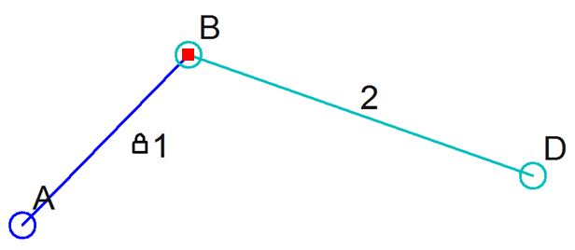

Figure 23. Locked Link Rotation Special Case

## Gears and Chains

Gear and chain connections can be simulated in the Linkage program. A chain connection is just a special type of gear connection and the “sprockets” are still called “gears.” If you are designing a mechanism that uses belts and pulleys then the word “gear” applies to the pulleys and the word “chain” applies to the belt. The naming of these elements doesn’t change how they function.

### Gear Ratio

The gear ratio that the Linkage program uses is a size ratio. It is not the same as a typical gear ratio where the first number is the relative speed or rotations of the input gear and the second number is the speed or rotations of the output gear. The Linkage program does not keep track of which gear is the input and which is the output. Instead, the first number is the relative size of the first selected gear and the second number is the relative size of the second selected gear. If the gears are selected in the opposite order, the numbers would be displayed in the opposite order.

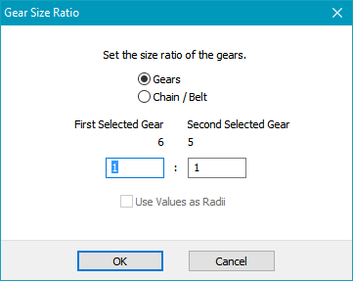

Figure 24. Gear Size Ratio

The different gear size ratio settings are:

| **Selection** | **Meaning** |
| --- | --- |
| Chain / Belt | Selecting the Chain/belt option results in the gears (pulleys or sprockets in real life) being displayed smaller than if they were gears to allow for some space between them. The size, aside from the sizes being appropriate for the ratio, is arbitrary and does not reflect any real-life size requirements like it does with gears. The simulator turns one gear the same direction as the other. |
| First Selected Gear | The label for the first selected gear is shown over the input box for that gear. |
| Second Selected Gear | The label for the second selected gear is shown over the input box for that gear. |
| *Ratio Numbers* | The two text inputs are for the size ratio numbers. Entering 1 in one box and a 1 in the other results in a 1:1 ratio and both gears will be the same size. The actual size will be determined by how far apart the gear centers are on in the mechanism. If a 1 is entered in the left box and a 2 is entered in the right box, the second selected gear will be show two times bigger than the first selected gear. Again, the actual sizes will be determined by the distance between the gear centers. |
| Gears | Setting the Gears option results in the gears being displayed touching each other. The simulator then turns one gear the opposite direction of the other gear. |

Note that the ratio can be set using the dimension input box in the tool bar, but the Gear and Chain / Belt settings cannot be set there. The dimension input box also does not give a hint about which gear was selected first. For that, rely on the color of the selection box around the gears.

### Quick Gear Tutorial

This tutorial is less detailed than the first mechanism tutorial. Refer to that tutorial of any of these steps seem confusing.

1. Right click in the window to display the Element Popup Gallery.
2. Select the Gear element .
3. The gear will be inserted into the mechanism at the point where the mouse was clicked.

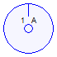

Figure 25. Gear Tutorial with a Single Gear

1. Click somewhere in the windows that is not on the gear to unselect the gear and connector.
2. Click on the connector at the center of the gear and then click on the **Properties** button in the tool bar.
3. Change the property of the connector so that it is a rotating anchor. The default speed of 15 RPM is fine for now.



Figure 26. Gear Tutorial with a Single Gear on a Rotating Anchor

1. Repeat the above steps nearby in the window. This time, make the connector an anchor, but not a rotating anchor.

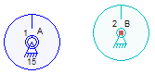

Figure 27. Gear Tutorial with Two Gears

1. The mechanism should look something like that shown above. Now click on the let gear and then hold the Shift key and click on the right gear.

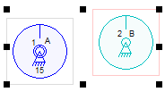

Figure 28. Gear Tutorial with Two Selected Gears

Notice that the second selected gear has a red rectangle. This hint will help when setting gear ratios later.

1. Click on the **Set Gear Ratio** button in the tool bar. Enter the number 1 in the left text box and a 2 in the right text box. This sets the size of the second selected gear to be twice the size of the first selected gear.

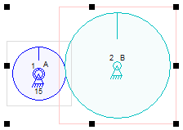

Figure 29. Gear Tutorial with a 1:2 Size Ratio

That’s it. Run the simulator and the second gear should turn at ½ the speed of the first, and in the opposite direction.

### Gear Fastening

Some complex mechanisms will need to have a gear move a link. To accomplish this, a gear can be fastened to a link. This is only allowed when the gear and the link share a connector. Select the gear and the link and then click on the **Fasten** button in the tool bar. Now, when the gear is turned by another gear, the link will move appropriately, as if the gear and link are all one element. If the link is being moved, the action is similar and the gear is rotated to match the rotation of the link. In either case, the connector at the center of the gear does not need to be an anchor; It can be any connector and can move about in the mechanism taking the gear with it.

A gear can also be fastened to an anchor in order to make it stationary. When a gear is fastened to an anchor, it will not rotate even its center connector is a rotating anchor.

Sample gear mechanisms in the Linkage program show the various types of gear mechanisms that can be created.

## Link, Line, and Point Dimensions

With Auto Dimensions enabled, the dimensions for all links and lines will be shown as well as position information for all ground connectors. Coordinates are shown for points.

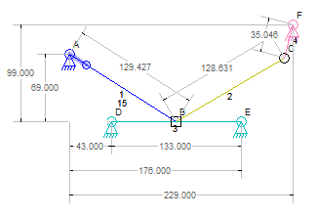

Figure 30. Link Dimensions

Dimensions for links will be drawn so that they are aligned to the link. The dimensions can then be used to manufacture a link without regard to the position of the link within the mechanism or on the page.

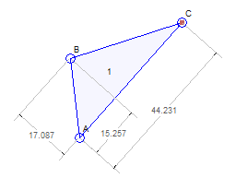

Figure 31. Three Connector Link Dimensions

Links that have three or more connectors are displayed with dimensions that are aligned to the longest adjacent pair of connectors. Figure 31 shows a three connector link with this type of alignment. The dimensions show the locations of the connectors as offsets relative to the two used for alignment.

Anchors, also called ground connectors, include dimensions. These dimensions are show relative to the leftmost anchor and to the bottom most anchor. The anchors do not need to be part of a single link to see these dimensions. If there are only two anchors in the mechanism then the distance between them diagonally is also shown since this might be a useful measurement. Figure 30 has anchors that are down with dimensions.

Dimensions are shown in the units that have been selected in the tool bar. The type of unit is saved with the mechanism.

## Parts List

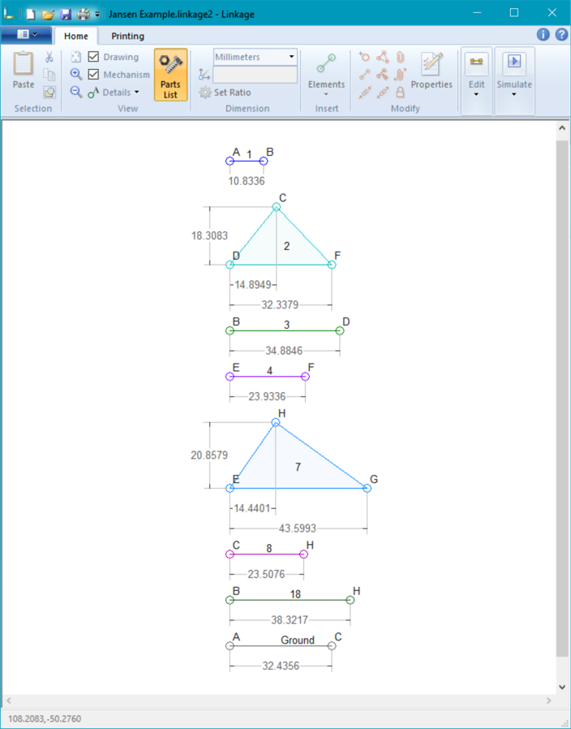

Figure 32. Parts List View

The Parts List view shows all of the links of a mechanism separate and aligned in a vertical list. If Auto Dimensions are enabled, the links are separated enough to show the horizontal dimensions of all of the connectors on the link. The mechanism cannot be altered in this view because link connections are not accessible. *Some editing of properties like color, etc. may be available in future versions of the program.* The image export, video export, printing, and other exporting features all use the Parts List if it is enabled.

Use the Parts List button in the toolbar to switch to and from the Parts View.

## Coordinates

The Linkage program uses the Cartesian coordinate system. The x coordinate increase to the right and the y coordinate increases upwards. New mechanisms start with 0,0 in the middle of the window. Angles are measured in degrees and are generally shown as an angle between two lines. Angles values are never shown as reflex angles. If an angle could be described as greater than 180 degrees then it is sometimes displayed as a value from 0 to 180 measured in the opposite direction (negative). Angles can however be input as any degree value.

Earlier version of Linkage used an inverted coordinate system that matches the internal coordinates of the computer screen. The y coordinates would increase going down. Old mechanisms may need to be flipped when opening them with a newer version of the program.

Coordinates can usually be entered with more decimal places than are shown. Most coordinates are displayed with four decimal places like 0.1234 but more can be entered and the higher accuracy is used for the coordinate until changed.

## Types of Simulations

Other than a fully automatic simulation, there are also interactive and manual simulations. These types of simulations add manual controls to the window. For an interactive simulation, each input or actuator can be controlled manually. For manual simulations, the entire mechanism can be controlled manually.

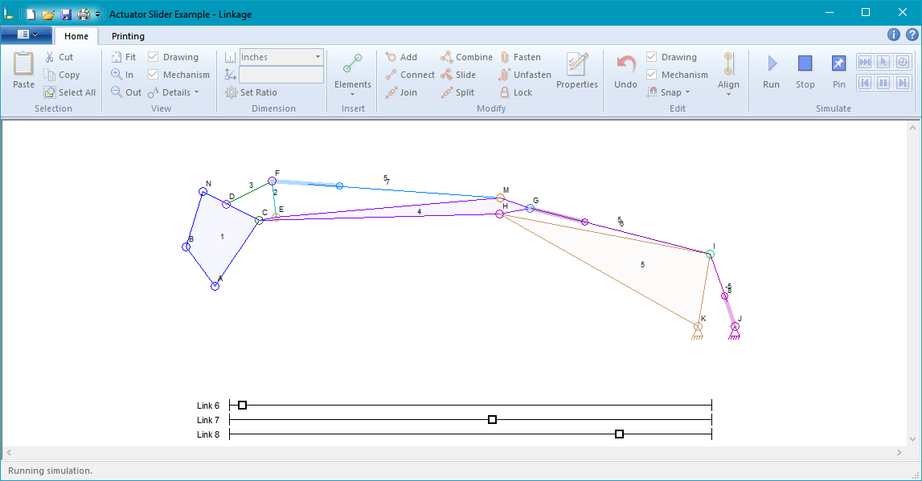

Figure 33. Interactive Simulation

For interactive simulations, each input and each actuator will be listed at the bottom of the window next to a sliding control as seen in Figure 33. Drag the handles (squares) side to side to move the associated input or actuator. The link or connector will be listed using the ID shown in the mechanism when labels are visible.

The manual simulation looks almost identical to the interactive simulation except that there is a single control at the bottom of the window for controlling the entire mechanism.

### Manual Controls for Automatic Simulation

Individual connectors and links can be configured for manual control regardless of the type of simulation that is run. The controls will look the same as described earlier for *Interactive and Manual Simulations* but controls will only be shown for those elements that are set for manual control.

If a simulation is done that is not animated then the manual controls will not be moved during that simulation.

## Status

The status bar will show some helpful information in some situations. During normal operations, it will show the position of the mouse pointer within the mechanism in inches or millimeters, depending on the selected units.

During drag operations, the status will show the position of the mouse pointer except for in two special cases. One is if the selected elements are snapped to the grid or to another object in which case the position used for the snap is show. The other case is if a single connector is selected in which case the position of that connector is shown.

During the creation of a video, the status will show a message about the video capture. This can include the time that has passed in the simulation if a specific amount of time has been requested for the video capture.

## Drawing during Simulation

Any or all of the connectors can be set to draw while simulating. This allows for analysis of the linkage movement. The drawing option is selected by modifying the properties of the selected connector. Figure 34 shows a mechanism while simulating and grey curves are draw by the connectors as they move.

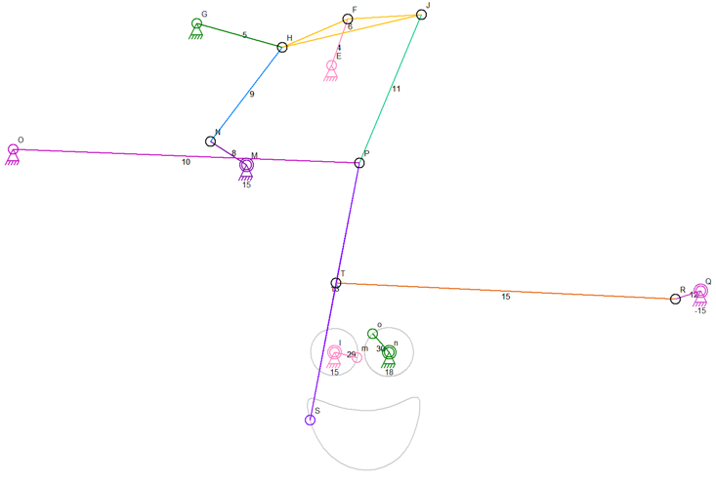

Figure 34. Smile Drawing Example

## Exporting

### Exporting Videos

The linkage program can run an animated simulation and save the animation in an AVI file. The compression algorithm used, or codec, can be selected when the simulation is about to be started.

The video is a copy of the image seen in the center area of the editor window except for manual controls at the bottom. The video will be 960 x 540 pixels in size for the standard quality and 1920 x 1080 for the high quality, or HD, video.

For all videos, any part of the mechanism that cannot be seem in the video area will not be included in the video. The video area can be visualized by selecting the Video Area option in the toolbar details menu.

The animation may play slower than normal when creating a video due to the processing needed to draw the animation in the window and in the video file. High quality video records much more slowly than standard quality.

Labels, dimensions, and any other visual information that is seen on screen are also shown in the video.

### Exporting Images

A mechanism can be saved to an image file that is either a JPEG file or a PNG file. The size of the final image can be selected from a few choices, as can the relative size of connectors, text, and other parts of the picture. The margin can also be set to accommodate text, dimensions lines, and other parts o f the image that might get cut off at the edge of the image.

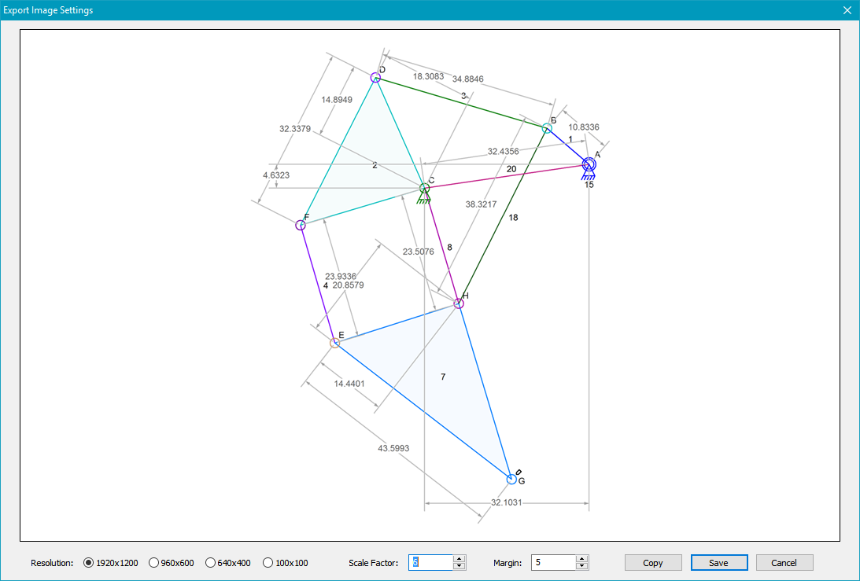

Figure 35. Export Image Settings

The Export Image Settings are set after selecting the Export-Image items in the main menu. There are three image sizes to select from when exporting images. The Scale factor value controls the size of text, connector circles, line thickness, and dimension line positions. The Margin option controls the margin as a percentage of the image size. The Copy button will copy the image to the clipboard for pasting into other programs. Press the Save button to save the image to a file. The file extension, .jpg or .png, will select the image file format.

## Printing

A set of printing options is available in the tool bar. The printing buttons are also available in the main menu, but the option for printing actual size is only in the tool bar.

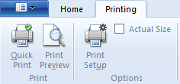

Figure 36. Printing Options in the Tool Bar

A mechanism can be printed to any Windows supported printer. The mechanism is shrunk to fit the page if the **Actual Size** option is not checked. Labels, dimensions, and any other visual information that is seen on screen are also shown in the printed image. If the mechanism is printed actual size and it is larger than a sheet of paper, it will be printed on multiple sheets.

## File Format

The Linkage program stores data in files that normally have a .linkage2 extension. The content of the file is ASCII text in an XML format specific to the Linkage program. The files can be read using notepad or other text editor. The same format of data is also used when copying and pasting mechanisms or parts of mechanisms. This results in the clipboard containing text that could be pasted into a text editor.

The clipboard data and the data in files do not contain information about the simulation or the drawing information for connectors that draw during simulation.

The contents of the XML file can be modified by other programs and then used in the Linkage program.

## Sliding Mechanism Tutorial

Sliding connectors are more complex than regular connectors. A sliding connector has a location on a link but also has a set of connectors on another link that define the slide path. This short tutorial shows how to create a sliding connection between links.

1. Create enough of a mechanism so that there are two links where one of the connectors on one of the links will slide on the other link. In the picture above, there are two links that each have an anchor. One of the anchors is an input.

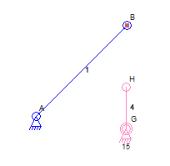

Figure 37. Starting Point for a Sliding Connection

1. Select the three connectors used for the sliding connection. Two of the connectors are on the same link and are the limits to the sliding connection. The third selected connector will be the one that slides. The order of selection does not matter.

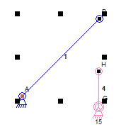

Figure 38. Selecting Connectors for a Sliding Connection

Only three connectors can be selected and two of them must be on one link and the third on another link. If the three selected connectors are all on the same link or if none of them is on the same link as another, a sliding connection cannot be made.

Notice that the Slide function is only available in the tool bar if the connection is possible.

1. Click on the Slide icon in the tool bar. The one connector is converted to be a sliding connector and is moved to the midpoint between the other two connectors.

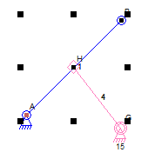

Figure 39. A Sliding Connection

## Limitations

There are a few minor limitations, and some known bugs, in the Linkage program.

1. There is a minimal amount of momentum handled in the simulation. If any step in the simulation computes more than one possible position for an element, the position nearest the next expected position is used. Because the momentum handling is minimal, and because only visible positions of the elements are ever computed during the simulation, it is possible for a mechanism to become broken where some part has moved past an invalid position to a new but improper valid position. This is more likely to happen when running an interactive or manual simulation where the mechanism can be moved faster than normal. Very fast inputs and actuators can also cause this problem during a normal simulation.
2. Linear actuators do not work like real world hydraulic cylinders. It is possible to draw an actuator that looks unrealistic when compared to similar looking real world counterparts. This is because there may be real world linear actuators that look and move differently from typical and well known hydraulic mechanisms. This is only a visual issue and does not affect functionality.

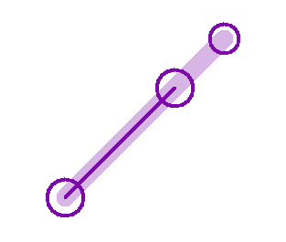

Figure 40. Odd Looking But Functional Linear Actuator

1. ~~The Join function cannot be used to join a sliding connector with a non-sliding connector due to a bug in the software. Use the Attach function to create a new link with the sliding connector as one of the two ends of the link.~~
2. A mechanism that has multiple rotating anchor connectors all set to different RPM values could draw a very complex pattern. This program has a limit to the amount of drawing data maintained and if the drawing connector does not get back to the initial starting position within the given amount of simulation time, the beginning part of the line/curve may begin to disappear when animating or not appear at all when simulating. Mechanisms of the required complexity to do this are not normally used in real-world situations.
3. Some sliding connector configurations that can work in real life cannot be simulated due to their complexity. Each different type of sliding connector configuration is a special case for the simulator and some special cases have been overlooked or require an iterative approach to simulation that cannot be handled at this time.  
     
   The example below cannot be properly simulated but is also not detected as incorrect due to there being three sliders. Many other unresolved configurations that involve multiple sliders also exist. This mechanism is not functional in real life.

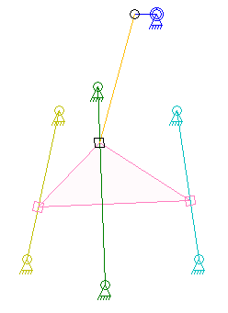

Figure 41. Three Sliders Cannot Be Simulated

1. Using two links to make an elbow does not work. The picture below shows a motor that should open the door at the top of the “box” but it will not work because the simulator cannot resolve the connection through two links from the rotating anchor to the door.

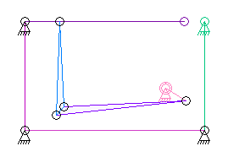

Figure 42. "Elbow" Link Cannot Be Simulated

1. Some mechanisms that can work in real life cannot be simulated. This is because the simulation code is made to be efficient and fast and a mechanism that has more than two flexible connections to fixed connectors requires an interpolation algorithm, or large numbers of simultaneous equations, for finding the position of the links in the mechanism.

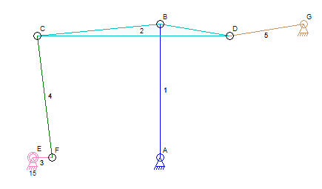

Figure 43. Mechanism with Too Many Flexible Connections

The mechanism in Figure 43 cannot be simulated because none of the connectors can be fixed into position on link 2 before the other connectors have been fixed into position. The algorithm to do this type of simulation is complex but also potentially too slow to allow for a real-time animation to be shown.

1. Two sliders on two links is not handled by the simulation.

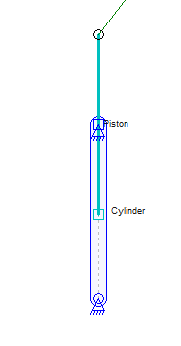

Figure 44. Two Sliders on Two Different Links

The mechanism in Figure 44 shows a link called “Cylinder” that has a sliding connector anchor at the top. There is also a “Piston” link with a sliding connector. The Cylinder sliding connector slides on the Piston link and the Piston sliding connector slides on the Cylinder link. The simulator does not handle this even though it is a perfectly rational mechanism. It is a special case that is not currently handled.

## Customer Support

Linkage is not a commercial product. This is a personal project done out of my interest in mechanical simulations. If you want to get some help or want to provide feedback, feel free to contact me at [rectorsquid@gmail.com](mailto:rectorsquid@gmail.comI) and I will do what I can for you. Suggestions are always welcome.

## Index

Actuator, 9, 18, 23, 26, 36, 37, 45, 46, 53, 54

Add, 10, 14, 15

Align, 16, 17

Align Menu, 16

Aligned, 17, 27, 28, 42

Alignment, 19, 28

Anchor, 6, 9, 14, 15, 17, 22, 26, 31, 32, 40, 41, 43, 52, 54, 55, 57

Angle, 17, 20, 24, 27, 28, 45

Angles, 24, 45

ASCII, 51

Auto Dimensions, 19, 27, 42

Auto Join, 20

Automatic, 27, 37, 46

Automatic Dimensions, 27, 45

AVI, 13, 48

Belt, 24, 38, 39, 40

Binding, 8

Cartesian, 45

Chain, 20, 24, 38, 39, 40

Chains, 38

Color, 32, 37

Combine, 10

Connect, 7, 8, 10

Connect Button, 7

Connector, 6, 7, 8, 9, 10, 11, 14, 15, 16, 17, 20, 21, 22, 23, 24, 25, 26, 27, 28, 29, 30, 31, 32, 33, 34, 37, 38, 40, 41, 42, 46, 47, 51, 52, 53, 54, 57

Connectors, 8, 10, 11, 13, 14, 15, 16, 17, 18, 19, 20, 21, 22, 23, 24, 25, 26, 27, 28, 29, 31, 32, 33, 36, 37, 38, 42, 43, 46, 47, 49, 51, 52, 53, 54, 56

Coordinates, 32, 42, 45

Copy, 11, 14, 51

CPM, 23, 37

Cut, 11, 14

Delete, 12

Details, 6, 19, 49

Dimensions, 19, 27, 37, 42, 43, 45, 49, 51

Disconnect, 16

Distance, 9, 20, 23, 24, 27, 32, 36, 37, 39, 43

Draw, 26, 31, 32

DXF, 13

Element, 6, 9, 10, 12, 14, 15, 16, 26, 28, 36, 40, 41, 53

Export Image, 50, 51

Exporting, 13, 48, 49

Fasten, 10, 16, 41

Fastened, 16, 25, 37, 41

File Menu, 4

Flip, 17

Font, 19

Four Bar, 5

Gear, 15, 16, 20, 23, 25, 37, 38, 39, 40, 41

Gears, 16, 20, 24, 25, 37, 38, 39, 40, 41

Grid, 20, 27, 47

Hints, 27

Home Tab, 4

Images, 49

Installation, 3

Interactive, 26, 45, 46, 53

Join, 11, 16, 20, 54

JPEG, 13, 49

Label, 6, 23, 24, 26, 39

Labels, 6, 7, 49, 51

Layer, 16, 18, 32, 37

Left Button, 9

Left Click, 9

Linear Actuator, 9, 15, 23, 26, 36, 37, 53

Link, 6, 8, 9, 10, 11, 14, 15, 16, 20, 21, 22, 23, 24, 25, 26, 27, 31, 32, 34, 35, 36, 37, 38, 41, 42, 43, 46, 51, 52, 54, 55, 56, 57

linkage.msi, 3

Lock, 16, 37, 38

Locked, 37, 38

Main Menu, 4

Manual, 32, 37, 45, 46, 49, 53

Measurement Line, 15, 23, 27, 37

Mechanism, 3, 4, 5, 6, 8, 9, 10, 11, 12, 13, 14, 16, 18, 19, 21, 22, 23, 24, 25, 26, 27, 28, 31, 38, 39, 40, 41, 42, 43, 45, 46, 47, 49, 51, 52, 53, 54, 56, 57

Motion Path, 13

Open, 11, 12, 13, 14, 21

Parallelogram, 17, 27, 28

Parts List, 19, 22, 45

Parts View, 45

Paste, 11

Pause, 18

PNG, 13, 49

Point, 9, 15, 21, 22, 26, 28, 31, 32, 37, 40

Print, 11, 13, 14

Properties, 10, 11, 16, 31, 36, 38, 47

Ratio, 20, 24, 25, 27, 38, 39, 40, 41

Rectangle, 17, 25, 27, 28, 41

Right Button, 10

Right Click, 5, 10, 31, 36

Right Triangle, 17, 27

Rotating, 17, 31, 38, 40

Rotation, 26, 38

RPM, 22, 31, 32, 40, 54

Run, 3, 5, 9, 11, 18, 41

Run Button, 5, 9, 18

Samples, 4

Save, 11, 13, 51

Scale, 7, 20

Scaling, 25, 27

Select All, 11, 14

Slide, 16, 32, 53

Sliding, 11, 16, 20, 22, 23, 25, 32, 33, 46, 51, 52, 53, 54, 57

Sliding Connection, 11, 51, 52

Sliding Connector, 23, 32, 33, 34, 51

Snap, 20, 26, 27, 28, 47

Solid, 19, 24, 25, 37

Split, 16

Status Bar, 47

Step, 6, 12, 18

Stop, 5, 11, 18

Stop Button, 5, 18

Stroke, 9, 23, 36, 37

Tool Bar, 4, 5, 6, 7, 9, 12, 14, 15, 20, 38, 40, 41, 43, 51, 53

Tutorial, 5, 6, 7, 8, 40, 41, 51

Undo, 11

Unfasten, 11, 16

Units, 19, 27, 43, 47

Video, 19, 27, 47, 49

Windows XP, 3

XML, 51

Zoom, 12, 21

Zoom In, 12

Zoom Out, 12