**Homework Guidelines**

**Homework can be completed as a Group Assignment**

For the sake of your understanding of this course's material, it is important that you complete assignments based on what you know. Homework provides you the opportunity to test yourself in a flexible learning environment - at home, with the ability to open the textbook to fill in any gaps you may encounter - with a lower risk of losing points for errors. This is the motivation for having each of you complete homework independently without any cross collaboration. By forcing each of you to answer questions independently, you demonstrate the degree to which you are prepared to answer questions asked on the spot (e.g. during an exam, or during a job interview) without the luxury of textbooks and Internet searches.

This independent understanding is still desired, but now that groups have been formed, I will allow homework to be completed and turned in as a group. This will allow you all to think critically about these questions, discuss it among yourselves, and come to a consensus on what your answers will be. Everybody within your group will share the same grade. However, you are not allowed to collaborate with other groups.

**No Handwritten Answers**

This homework will require some written responses and some diagrams. For the written responses, use a standard word processor like Microsoft Word, LibreOffice Writer, Google Docs, or LaTeX. Drawings can be made using Microsoft PowerPoint or Google Drawings[1], among others. You can explore other tools as well, just search around and verify the tool you are considering is compliant with the design aspects that are presented in class.

Please create your answers in a digital format, export to a PDF, upload that PDF to Canvas, and turn in a hard copy. Google Docs is especially convenient for real-time remote collaborative writing with your groupmates. For those of you considering LaTeX, ShareLaTeX and Overleaf are good online editors.

***Protip***: if you’re using Google Docs, you can create subscripts and superscripts by selecting a piece of text and pressing Ctrl + Comma or Ctrl + Period, respectively.

**One Problem per Page**

In the past, many students turned in a single piece of paper with all answered questions smooshed onto it. This did not leave my grader or I with adequate room to provide suggestions on how a design could be improved nor explanations on errors. The process of design work is to work in iterative stages: the first stage will be rather messy (and can be hand-written), the second stage will have things cleaned up, and so on. The final stage is what you should turn in, and it should be free of scratched-out work and high-density drawings.

Only answer one problem on *at least* one page, and refrain from super-compact answers that leaves more than 1/2 of the page empty. Ideally, leave somewhere between 1/4 to 1/2 of a page empty so that we can make annotations.

Finally, you don’t need to print off this page when turning in the hard copy.

|  |  |
| --- | --- |
| Names: __________________________    _________________________________  _________________________________ | Lecture Section: _______  Group Number: _______ |

**CS 2300 – Homework 1**

Due: Tuesday, Sept 18th at the start of class

Turn in a hard copy in class, and upload a PDF to Canvas

Total possible points: 65 points

**Problem 1.** *(10 points)*

Design an ER diagram for keeping track of information about votes taken in the U.S. House of Representatives during the current two-year congressional session. The database needs to keep track of each U.S. STATE's name (e.g., *Texas*, *New York*, *California*) and include the region of the state (whose domain is {*Northeast*, *Midwest*, *Southeast*, *Southwest*, *West*}). Each CONGRESS_PERSON in the House of Representatives is described by his or her name, plus the district represented, the start_date when the congressperson was first elected, and the political party to which he or she belongs (domain of {*Republican*, *Democrat*, *Independent*, *Other*}). The database keeps track of each BILL (i.e. proposed law), including the bill_name, the voting_date on the bill, whether the bill passed (domain of {Yes, No}), and the sponsor (the congressperson(s) who sponsored - that is, proposed - the bill). The database also keeps track of how each congressperson voted on each bill (domain of {Yes, No, Abstain, Absent}).

Draw an ER schema diagram for this application on the next page. Clearly state any assumptions you make.

*Page left blank for Problem 1 answer. Use multiple pages if needed.*

**Problem 2.**

Refer to the ER diagram on the next page (titled “Figure for Problem 2”). Which combinations of attributes must be unique for each individual SECTION entity in the UNIVERSITY database to enforce each of the following miniworld constraints (note: some keys can be converted back to regular attributes)? Type your answers in the space provided below.

1. During a particular semester and year, only one section can use a particular classroom at a particular DaysTime value.
2. During a particular semester and year, an instructor can teach only one section at a particular DaysTime value.
3. Departments cannot share the same office and phone number.

**Figure for Problem 2.**

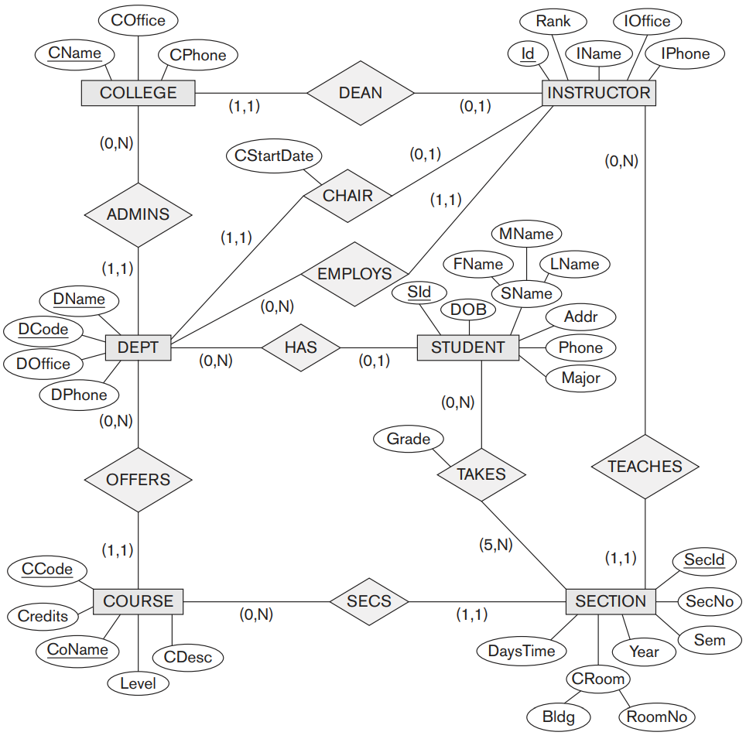

**Problem 3.**

Design ER model specifying key attributes, entity types, relationship types (1:1, 1:N, M:N), and structural constraints (partial or total participations). Make your assumptions and state them (if any). Choose appropriate attributes if not given as part of the requirement analysis.

Consider the following requirements for a University Accommodation Office:

1. Each hall of residence has a name, number, address, telephone number and a hall manager who supervises the operation of the hall. The halls provide only single rooms which have a room number, place number and weekly rent rate. The total number of rooms provided by each residence hall should be able to be computed on the fly.
2. The place number uniquely identifies each room in all of the halls and is used when renting a room to a student.
3. Students may rent rooms throughout the academic year for various periods of time. The data regarding rooms currently rented include the lease number, date that the students started rent period and date that the student wishes to terminate the rent period (if known).
4. Information regarding an undergraduate student includes: student ID, name (first, middle, last), home address (street, city, state, zipcode), date of birth, category of student (e.g. freshman, sophomore).
5. The total number of students living in each hall should be able to be computed.
6. Information about a student’s emergency contact is stored, including name, relationship, address, and contact number.

*Page left blank for Problem 3 answer. Use multiple pages if needed.*

**Problem 4.**

Consider a disk with the following characteristics (these are not parameters of any particular disk unit): block size B = 512 bytes; number of blocks per track = 28; number of tracks per surface = 500. A disk pack consists of 8 double-sided disks.

1. What is the total capacity of a track?
2. What is the total capacity of a cylinder?
3. What is the total capacity of a disk pack?
4. Suppose that the disk drive rotates the disk pack at a speed of 2,400 rpm (revolutions per minute); what are the transfer rate (tr) in bytes/msec and the block transfer time (btt) in msec? What is the average rotational delay (rd) in msec?
5. Suppose that the average seek time is 30 msec. How much time does it take (on average) in msec to locate and transfer a single block, given its block address?
6. Calculate the average time it would take to transfer 20 random blocks, and compare this with the time it would take to transfer 20 consecutive blocks.

1. <https://docs.google.com/drawings/>