|  |  |
| --- | --- |
| Names: __________________________    _________________________________  _________________________________ | Lecture Section: ___________  Group Name: ________________ |

**CS 2300 – Homework Assignment 2**

Due: Thursday, Oct 4th at the start of class

Turn in a hard copy in class, and upload a PDF to Canvas

Total possible points: 65 points

1. The following update operations are applied to the database state from Figure 1 (on the next page), which has the relational schema shown in Figure 2. If there are any integrity violations, discuss which violations occur and why they occur, as well as remedial strategies that enforce these constraints. If an operation is executed successfully, assume the state of the relation is updated to reflect this.

a. Insert <‘Robert’, ‘F’, ‘Scott’, 943775543, ‘1972-06-21’,

‘2365 Newcastle Rd, Bellaire, TX’, M, 58000, 888665555, 1>

into EMPLOYEE.

b. Insert <‘ProductA’, 4, ‘Bellaire’, 2> into PROJECT.

c. Insert <‘Production’, 4, 943775543, ‘2007-10-01’> into DEPARTMENT.

d. Insert <677678989, NULL, 40.0> into WORKS_ON.

e. Insert <453453453, ‘John’, ‘M’, ‘1990-12-12’, ‘Spouse’> into DEPENDENT.

f. Delete the WORKS_ON tuples with Essn = 333445555.

g. Delete the EMPLOYEE tuple with Ssn = 987654321.

h. Delete the PROJECT tuple with Pname = ‘ProductX’.

i. Modify the Mgr_ssn and Mgr_start_date of the DEPARTMENT tuple with Dnumber = 5

to 123456789 and ‘2007-10-01’, respectively.

j. Modify the Super_ssn attribute of the EMPLOYEE tuple with Ssn = 999887777 to

943775543.

k. Modify the Hours attribute of the WORKS_ON tuple with Essn = 999887777

and Pno = 10 to 5.0.

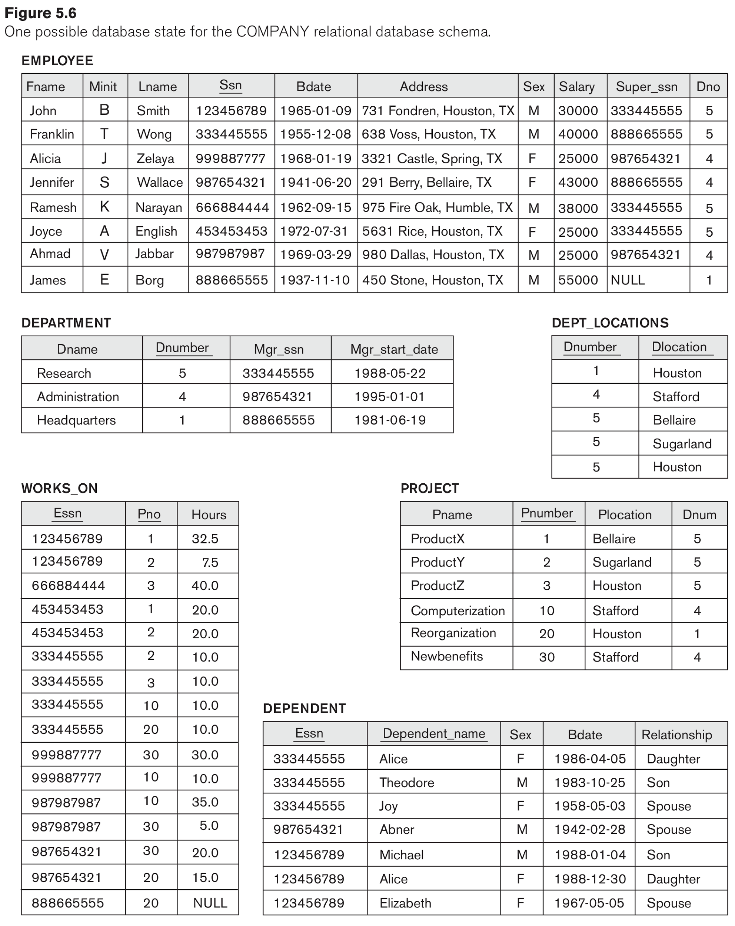

**Data Types:**

EMPLOYEE(Fname:string, Minit:char, Lname:string, Ssn:int, Bdate:string,

Address:string, Sex:char, Salary:int, Super_ssn:int, Dno:int)

DEPARTMENT(Dname:string, Dnumber:int, Mgr_ssn:int, Mgr_start_date:string)

DEPT_LOCATIONS(Dnumber:int, Dlocation:string)

WORKS_ON(Essn:int, Pno:int, Hours:float)

PROJECT(Pname:string, Pnumber:int, Plocation:string, Dnum:int)

DEPENDENT(Essn:int, Dependent_name:string, Sex:char, Bdate:string,

Relationship:string)

**Figure 1.**