**Systems Networking and Software solutions**

**[SNSS]**

© 2022

**Stakeholders**

|  |  |  |
| --- | --- | --- |
| Index | Role | Role Name |
| 001 | Owner |  |
| 002 | Client |  |
| 003 | Financier |  |
| 004 | Technical Implementor |  |

**Signed: Date:**

Client …………………………………………. ……………………………….

TI …………………………………………… ………………………………

**Background of SNSS**

SNSS having been established in the year [ ], is specialized in providing high end technology solutions for both private and public industries. Our solutions are targeted for providing both custom and vendor-based approaches to solving both simple and dynamic business problems. We pride ourselves in long years of positive customer feedback, quicker turnaround times and 360-degree view of insightful data for management decision making process.

**Why systems networking and software solutions:**

* Reduced paperwork
* 360-degree view of company activities
* Minimize operational costs
* Faster delivery of tasks, activities and projects
* Enhanced employee synergy

**What we provide:**

* Custom/ complete networking solutions
* Custom/ complete intranet solutions

**What comes with the Intranet?**

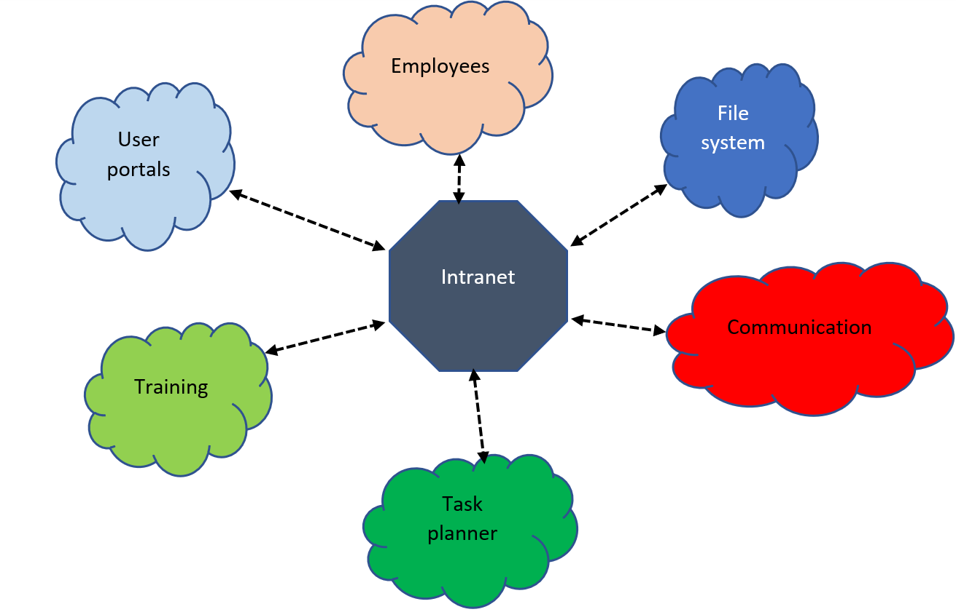

**The requirements:**

* Computer systems: These may vary from company to company. Comprising of the CPU, monitor and the keyboards.
* Networking items. Comprising of routers, LAN cables, servers and switch boards.
* Antivirus software solutions

**Please Note:**

The requirements above may vary from company to company depending on the needs assessed from the site and the size of the organization. Full requirements will be custom made to fit your need as required.

**Contact Us:**

**Mobile:**

**Email:**