**RESEARCH PROJECT PROPOSAL**

**STUDENT NAME**

**RESEARCH AREA**

**PROJECT DURATION**

**PROJECT TITLE:**

**BIOTECHNOLOGY AND FOOD SECURITY IN AFRICA: A BIBLIOMETRIC ANALYSIS**

**Keywords**

Biotechnology, Biotech, microbiology, Biopharmaceuticals, cell implantation Bibliometrics

**ABSTRACT**

Biotechnology as a proponent in agricultural systems has been used to advance life changing economies in some of the states of Africa. Whereas studies around this area emanate from the early periods of the 20th century, research scientists have continually gone ahead to provide in depth analyses, findings and practices to farmers and nations on some of the best solutions to starvation and hunger pandemics across the globe.

Since many of the traditional food retention mechanisms have been overcome with time, modern science is now shifting this attention to the more resistant and adaptive methods in the plant ecosystem. Literature reviews around this area indicate several research procedures are currently underway with massive tests being done on plant and animal organisms. Developing nations in Africa are still faced with rapid food shortages are in need of better scientific research tools and metrics that will help them produce more and healthier food for generations to come.

The challenge with most of the agriculturally productive countries in Africa are the ever changing weather and climatic conditions, mutating pests and diseases and lack of a ready market for their produce or in-place food preservation mechanisms for most of the food products these countries engage in. This paper outlines that in order to prevent itself from falling into the brink of hunger and starvation, postmodern innovations around adaptive smart agricultural systems have to be implemented.

Hence therefore this paper establishes the link required to help African nations achieve maximum food security using the different agricultural products that she produces. The data obtained here are from secondary literature reviews and reports by different scholars and government findings.

**CHAPTER ONE**

**1.1 INTRODUCTION**

Of the 55states in Africa, only close to half have arable land that can produce agriculturally viable products Prăvălie et al (2021). A quarter of these states rely on animal farming whereas close to a third dominate fishing and marine life as their source of the livelihood. According to the Food and Agriculture Organization (FAO), a number of agricultural products by these states are for human consumption and very less is exported or even sent over to industrial factories for food processing and later consumption. Some of the major crops grown in Africa include millet, maize, rice, potatoes and wheat.

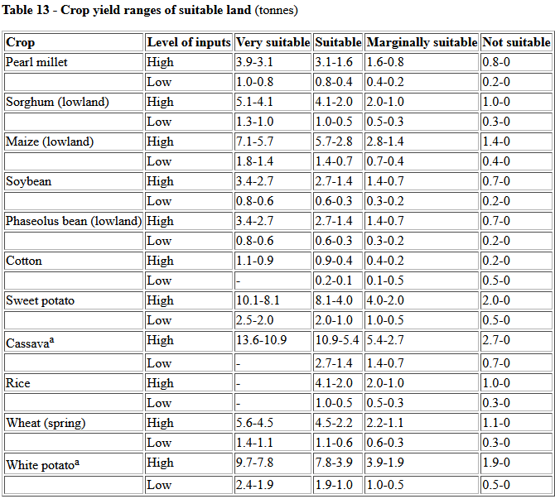

Figure 1 Major food crops in Africa and their suitability (FAO)

However there are Africa countries that have been predominantly known to produce certain agricultural products, these countries are giants at their own game, they produce more than they can consume and as a result they even export it to their neighbors. For instance, according to Ateka et al (2018) Kenya is produces tea and coffee in large scale, some of the coffee is consumed locally under the mandate of the Kenyan Tea Development Agency (KTDA).

Coffee is widely produced in Ethiopia. West Africa leads in the highest production of rice whereas Nigeria, Egypt and South Africa lead in maize farming. Tanzania, Kenya and South Africa lead in the highest production of animal products like milk, beef and skin. Countries along the coastal line like Morocco, Namibia, South Africa and Egypt lead in the production and farming of fish.

According to the Food and Agriculture Organization (FAO), despite the tones of production of food by these dominant countries, Africa can barely fill her granaries, leave alone store it for the future, actually, it is surprising enough that African states still import food from other countries. The results of which if not handled, dimples these states into hunger and starvation. According to the Planet Thoughts (<https://www.planetthoughts.org/?pg=pt/Whole&qid=1873&src=xref>), African imports still exceed her domestic food production

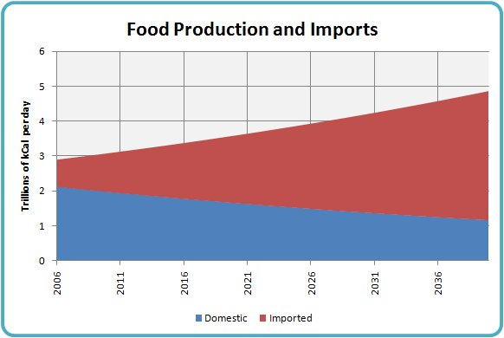

Figure 2 Food production vs. importation in Africa

There are various challenges that have forced these developing states not just to have enough for their stores. They include ever-changing weather conditions with inadequate rainfall to favor crop production, frequent pasts and diseases that kill many if the animals and then finally inadequate mechanization to maximize on production of food from the crops and animals Masipa (2017). It is in this regard therefore that the need for scientific involvement in the production of food for Africa should be incorporated to help farmers maximize production. This can be achieved through Biotechnology.

**Biotechnology**

According to Rischer et al (2020) Biotechnology is defined as the application of the principles of biological science to the raw materials of biological origin. This may include gene mutation, propagation or total transformation. These changes are usually applied at cell level. Microbiologists, Biologists, Geneticists and Research Scientist work hand in hand doing reassert every day to establish the connections and improvements for the food industry across states.

Biotech has been used over the years to build environmentally stronger food crops and modify the nutritional contents of certain food crops across nations. Most developing nations in Africa are currently not able to exploit the full potential and benefits of technology since they do not have enough tools and research scientists to conduct local studies on how they can improve their current agricultural products so these states rely on the research and studies done by other countries, some of which may not confirm to what these developing countries are actually going through so a lot of financial resources are laid to waste away.

**Food Security**

Can be defined as a condition in which a country can optimally produce, consume and store sufficient agricultural food for its citizens Prosekov et al (2018). These should happen regardless of the current climatic conditions, current population size or inflation rates. Also bearing in mind that the whole process should be bearable and not be a burden to the populace or the governing states.

**1.2 BAKGROUND STUDY**

Naturally cultivated food tends not endure over a given period of time under certain conditions. The reason why this happens is due to a number of issues.

Most of the countries around the Sahel region experience very harsh climatic conditions with very little or no rainfall across the year. So instead of crop farming, such regions have also shifted to animal production which does not seem to do well. This happens since inadequate rainfall around the Sahel region does not favor optimal vegetation growth and water points for pastoralists around these regions. A further look at some of the soil conditions of the regions around Africa indicate that fertility has been overused by over tilling certain lands until such lands lose their fertility levels and nutrients.

On the contrary though, overuse if artificial fertilizers in the cultivation of certain crops like rice and maize have led to such soils being dominated by certain levels of soil nutrient capacities, hindering the establishment and growth of other crops that could have potentially grown on such areas. Encroachment by forest fires across farming lands have also drained away the soil components such as soil turning organisms, superficial fertility and PH level consistence. Small scale farmers who cannot afford to buy or prepare top dressing manure to reclaim such lands end up with no or limited soil productivity at all. In some regions pests and deceases massively lower crop production both at small and large scale, during harvest time, the yield cannot contain a projection of a few years ahead.

On the other hand, animal production across developing states in the continent has had its own share of pain as well. Some of the challenges to animal production have span across pests and diseases, inadequate or poor grazing lands and persistent droughts across farm lands. Currently, barely can the pastoralists and framers I production feed themselves let alone export whatever they have to other countries. Cases have risen where dairy products reduced in yield and the beef products were not sufficient enough for industrial manufacturing and canning. The same has happened to poultry, where the eggs produced by the birds were lightweight and nutrient deficient.

Population in most of the African states have been rising significantly. Currently, Nigeria, Ethiopia, DR Congo, Egypt and South Africa are the leading their population statistics, with Nigeria topping at a population number of 206 million persons. Majority of the population in these Africa countries are the youth between the ages of 18 and 35. Due to the higher rising numbers, developing states in Africa may not have enough food to feed these people and so as a result, hunger sets in. There have also been reported cases of hunger and starvation caused deaths in most of the developing states.

Another factor leading to the current food insecurity in the developing African states is due un-implementation of policies that can foster food security in these states. Well policies might be there, but they are not well structured in a way that can help put up the right production mechanisms to facilitate the production and feeding programs for these regions. Even currents that have got rich arable lands still struggle with these. Most astounding is the fact that in countries that dominate massive production of the agricultural products, corruption malpractices still curtail efficient production and storage of such. Individuals are willing to curtail and hoard the locally produced products at the expense importing these products from other countries at the cost of the government funds, upon which they get their cuts.

In lieu of these, there have been proposals by government agencies across the African states to invest in research and development, nanotechnology and biotechnology as a key tool towards boosting food security in Africa. Most of the staple food consumed among African states include rice, wheat, maize, beef, eggs, chicken and milk. Currently consultations, partnerships and government projects are shifting focus into Biotech science as one of the key proponents to establishing efficient production in the African food market.

This paper shall discuss in detail how African states and countries should use Biotechnology in the Agricultural sector to ensure that the African states feed themselves for now and in the future.

**1.3 PROBLEM STATEMENT**

Africa as we know it, does not currently have enough food to feed her children. Most of the countries are either at the brink of starvation, or are currently starving. The UNDP annual report of 2015 estimates that approximately 10 out of the 54 states in Africa cannot completely feed their citizens and as a result have to rely on donations from other NGOs, the United Nations Development Program UNDP AND THE United Nations High Commission for Refugees UNHCR.

Majority who are affected are the war torn countries like Somalia, South Sudan, Chad, Northern Nigeria and some parts of Congo. This has led to a number of refugees currently fleeing and leaving their countries to search for fresh food and water and peace in neighboring states, but the bigger elephant in the room remains hunger and starvation, especially from their children and women and the old generations tagging along.

The greater problem being the inability of the African states being unable to produce healthy, sufficient food for her continent, both for the current and future generations. Since its inceptions, African development Bank AFDB program together with its counterpart, the United Nations Science and Cultural Organization has tried to partner with these African states to develop research centers across the development nations in order to train, engage, innovate and research on current problem solutions to the food crisis in their specific countries so as to be able to produce agriculturally and diet viable food for the continent.

The partner organizations have managed to come in to fund some of these projects by either giving loans or grants to the individual states so as to achieve this mandate. Some of the specific research areas along this field include:

Soil fertility study and appraisal. Research has gone into the specific identification of the current and future soils states, how to improve the soil composition, and nutrient content, over a longer period of time so as to support farmers trying to grow a certain crop within their states. Research scientists have spent days and nights trying to come up with solutions on the soil viability for rice farmers in Nigeria and South Africa, maize production in Kenya and Nigeria and banana cultivation in Somali and Uganda.

Biotechnology scientists are also studying plant cell compositions, DNA strands and genome viability. The primary goal here include the potential ability of having to modify plant cell DNA and genome status so as to develop a match stronger species. Examples under this category have been witnessed in Eastern Kenya, where there was development of the ‘katumani’ maize species that was drought resistant and matured within a very short period of time regardless of the harsh weather and climatic conditions of the regions.

Further highlighting, there is need to address the following research questions that arise from the problem statement discussed above and they are:

1. What is the current connection between Food security and Biotechnology in Africa?
2. What measure are the African States currently taking to achieve sustainable food security in Africa for the current and future generations?
3. How can Biotechnology be used to achieve food security in the African States?
4. What are some of the limitations of Biotechnology as a possible solution to food security in Africa?

Where does Biotechnology stand as a science of the future in improving food security in Africa?

As a result of this research, government states, organizations and scientists will be able to provide possible solutions to their current member states on how they can utilize Biotech to achieve food security among themselves.

**1.4 PROJECT AIMS AND OBJECTIVES**

From the above research questions that have arisen, we can therefore formulate the following project aims and objectives:

The project aims to achieve the following:

1. To establish the connection between food security and biotechnology
2. To establish current processes being undertaken to achieve food security in Africa
3. To establish how biotechnology can be used to achieve sustainable agricultural production
4. To determine the limitations of Biotechnology as a possible solutions to Food security in Africa
5. To determine the future stance of Biotechnology in food production in Africa

**CHAPTER TWO**

**2.1 LITERATURE REVIEW**

According to Tonukar et al (2010), research has already started spanning out among Biopharmaceutical industries, Biochemical engineers and Biologists in bid to unravel the food insecurity status in Africa. Their studies also show that despite the upcoming support and numerous innovations that have been discovered across the continent, there is still very little to show for this work and as a result, the African states are still languishing in hunger and starvation occasioned by poor crop and animal yields.

Further research by Abah et al (2010) indicate that the African population has been increasing very year yet the amount of Arable land is still the same, as a result, many of the Africans states can no longer feed their people, moreover, most of the African states are yet to reap the benefits of the currently ongoing biotechnology studies and innovations being enjoyed by developed nations or in their own developing states. However, as the use in plant biotechnology rises, African states are yet to recognize that there could be harmful effects predisposed by the use of and modification of plant metabolism, genome structure and biochemistry, these could also affect the ecological stance of the plant environment as highlighted by Sawicka et al (2020).

Seid et al (2021), there is need to address climatic changes in line with Biotechnology Engineering and Biotechnology modifications. Biotechnology Engineering will focus on the research scientist coming up with new solutions to green Biotechnology that go against averse climate changes across the African continent. Biotechnological modifications change the current plant DNA codes to adaptive climatic conditions. Adenle et al (2019), food security must be achieved through a technological approach. African states must be in the front line advocating for tech approaches in the fight against hunger and starvation, by making the right policies and implementing these policies will help development of sustainable food in agriculture.

According to Muhzinji and Ntuli (2019), there is need to embrace Genetically modified organisms GMO as the missing opportunity in addressing food security in Africa and that the Cartagena Protocol on Biosafety states that GMOs are have potential I uplifting small scale farmers across the continent to sustainable agricultural yields.

The above preliminary research that have been done by previous authors have a strong indication that biotechnology is still necessity in the fight towards a sustainable secure food system by highlighting that policies need to be in place, biotech implantations and modifications need to be reviewed and revised to enable growth of much stronger and highly adaptive plant and animal species.

These are concurrent with the aims and objectives that the researcher is pursuing, however as a weakness, their studies do not reveal exactly how specific countries in Africa are using Biotechnology to grow their food needs, how if any there are limitations or oppositions that are currently associated with biotechnology in crop and animal production, what does biotechnology mean for the African food production i.e. is it something that the continent can sustain, will it still be viable say 20 years from now, and lastly are the African states willing to embrace long term ideas on Biotech. These are some of the questions that researcher will seek to illustrate I this study.

**CHAPTER THREE**

**3.1 RESEARCH METHODOLOGY**

The primary research method for this particular study will be based on Bibliometric studies. A consistent case by case study of the works previously done by other authors in the field of Biotechnology will be keenly identified, reviewed and mapped out, thereafter, statistical and mathematical inferences on the data sets will be conducted.

Once the required variables from the datasets are established, certain classification methods will be developed to identify models methods from which a conceptual framework will be drawn. Based on these, the tool used for data analyses shall be the Viosviewer software. From here statistical and mathematical approaches of variable constraints shall be measured against the primary project objectives and aims to achieve the desired output.

**REFERENCES**

Tonukari, N. J., & Omotor, D. G. (2010). Biotechnology and food security in developing countries. *Biotechnology and Molecular Biology Reviews*, *4*(1), 13-23.

Abah, J., Ishaq, M. N., & Wada, A. C. (2010). The role of biotechnology in ensuring food security and sustainable agriculture. *African Journal of Biotechnology*, *9*(52), 8896-8900.

Sawicka, B., Umachandran, K., Skiba, D., & Ziarati, P. (2020). Plant Biotechnology in Food Security. In *Natural Remedies for Pest, Disease and Weed Control* (pp. 163-177). Academic Press.

Seid, A., & Andualem, B. (2021). The Role of Green Biotechnology through Genetic Engineering for Climate Change Mitigation and Adaptation, and for Food Security: Current Challenges and Future Perspectives. *Journal of Advances in Biology & Biotechnology*, 1-11.

Adenle, A. A., Wedig, K., & Azadi, H. (2019). Sustainable agriculture and food security in Africa: The role of innovative technologies and international organizations. *Technology in Society*, *58*, 101143.

Muzhinji, N., & Ntuli, V. (2021). Genetically modified organisms and food security in Southern Africa: conundrum and discourse. *GM Crops & Food*, *12*(1), 25-35.

Prăvălie, R., Patriche, C., Borrelli, P., Panagos, P., Roșca, B., Dumitraşcu, M., ... & Bandoc, G. (2021). Arable lands under the pressure of multiple land degradation processes. A global perspective. *Environmental Research*, *194*, 110697.

<https://www.fao.org/3/w0078e/w0078e05.htm>

Ateka, J. M., Onono, P. A., & Etyang, M. (2018). Productivity and its determinants in smallholder tea production in Kenya: Evidence from Bomet and Nyamira counties of Kenya.

Masipa, T. (2017). The impact of climate change on food security in South Africa: Current realities and challenges ahead. *Jàmbá: Journal of Disaster Risk Studies*, *9*(1), 1-7.

Rischer, H., Szilvay, G. R., & Oksman-Caldentey, K. M. (2020). Cellular agriculture—industrial biotechnology for food and materials. *Current opinion in biotechnology*, *61*, 128-134.

Prosekov, A. Y., & Ivanova, S. A. (2018). Food security: The challenge of the present. *Geoforum*, *91*, 73-77.