**NAME**

**COLLEGE NUMBER**

**ARTIFICIAL INTELLIGENCE AND DATA MODELLING**

The terms AI data and Big data are used interchangeably

**Introduction**

for (i in siteInfo .users)

{

    for (j in siteInfo.users[i])

    {

        x = siteInfo.users[i][j];

        console.log(x);

    }

}

The array above retrieved from an unstructured database fetches an object called site info and returns the associated array of items within the object. This is the way this type of database works.

Google has one particular product called Firebase. This is a tool that gives the developer and organisational access to so many features including the Firebase data tools. This type of database does not define data in any kind of row or columns. Another type of database in use is MongoDB, widely used for the same, reasons as the Firebase. Also, the latest introduction to data storage winch in essence is not even stored in web 3.0. You see when the internet was invented, it all began from a static site to dynamic systems, and now to smart systems and now the whole system is almost going back to web 1,0 but smartly and silently.

Instead of manually storing data in some scattered or unstructured database systems, the data now creates and destroys itself, users are identified by sessions and identifications. This is what cryptocurrency now trades in. No one knows the database or the particular data that is inside those applications. Instead, what we have are smart contracts. Smart contracts are barely owned by various partners who run the etherium grid and every computer on the networks identified by the key id of a particular user, when the user wants to trade or buy ether, the particular smart contract is run on the blockchain is called, stored in the system temporarily until l the transaction is marked as complete then contact is destroyed. Nowhere does the smart contact keep user details. This is for the same reasons why we say that blockchain technology is safe and secure for transactions, it’s also safe in the long run. Can be it hacked? No.

The next step in the data process is data analysis and storage. Developers and data engineers have come up with several tools, algorithms and languages that will sweeten the life of a data scientist/ scholar/ application engineer by making it easier to analyse data very fast. You see traditionally, after the introduction of the common business-oriented language COBOL, introduced the COBOL tool in the 1960s, other scientists in the same domain have introduced scientific analysis tools like FORTRAN and SCALA that focused on analysing data in the field of geography science.

Later on, developers would take advantage of the missing opportunity that was there for the engineers and thereafter leverage on the needs of getting calculations and arithmetic applications on their dataset. This is where the development of statistical languages such as R came in. R has been a powerful child in trying to help get quick summary statistics on the concerned measures of central tendencies, summaries on the values of comparison and also by helping give the required forecasting and the data descriptive features and values of such datasets. Moreover, the language has an inbuilt mode so which will enable the researcher to quickly get whatever kind of insights that they need from such dataset. Some of the models applied in this language include:

* Linear regressions
* Logistic regressions
* ARIMA models
* KNN model
* Random forest and decision trees

The models have been effective in trying to help scientists discover the relationships between datasets and still be able to predict the future outcomes of such inputs by forecasting the models through a fit function. Even though old and powerful, Python has been used to wrangle data during the whole data cleaning process, analysis and even building models to predict the dataset. Data analysis and features of this application include the ability to gather data from the internet through certain custom tools like beautiful soup. Once his data collection and preparation is ready then Pythons inbuilt libraries like Numpy, SciePy and pandas have been used as tools in trying to make the data visualisation process much easier.

Nonetheless, an old but still widely used approach to data analysis is a tool that we all know, Microsoft Excel is a tool that benefits almost every user and basic analyst regardless of the experience or age of the researcher. Using Microsoft office, as we shall see in the later chapters to come, an individual can quickly clean their dataset, get measures of central tendencies and then apply the relevant required functions on the data analyses tool pack to quickly get meaningful information from the dataset, as we shall discuss in the last part of this research papers in the analyses part.

Software as a service (SAS) is a web tool that has been specifically designed to help the user quickly get around their analysis. With key attention to the analyses of the products and outputs derived from the dataset that they intend to use. Moreover, in this particular study, the SAS tools shall form the basis of our analysis with key objectives and instructions being sent on how we can use the SAS software to convert the CSV dataset of our choice into the correct .bat file that we can use on our application to make meaningful and useful data derivations from. Through a click and drag, we shall be quickly able to get the right analysis that is needed for this work.

All these introductions are necessary order to help the company to understand and measure the requirements of developing an effective business information system with closer attention being paid to the datasets, systems and whether to consume the structured or unstructured database, the method and language of analysis and the kind of models to apply for each dataset. Finally, the two tools considered here for the development and management of the AI application shall be the SAS online tool and the earlier mentioned SQL language to help management understand the features and capabilities of AI applications.

**Artificial intelligence and Data Science**

Moreover, we cannot discuss Artificial intelligence without bringing in the factor of Data science. AI is an intelligent tool that relies on data science to monitor and operationalize its quest for smart systems. Before an AI agent is constructed, usually, a bunch of datasets is taken through numerous training and retraining, collected over large volumes of time and scale, after which this data is subjected to modelling.

The reason why a good amount of data is used is sent into the system is because of the need to learn, and this is where we derived the term machine learning, the machine learns by respective algorithms of classification, so, when the model is finality fit into it, then it quickly searches its memory table and assigns the correct value or response to the data in questions. AB testing requires that 80% of the data we use should be for training and then the other 20% should be for testing. Look at the diagrams below:

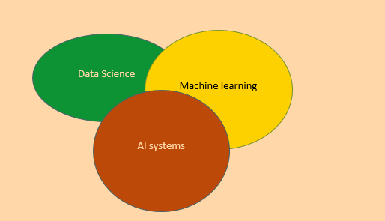

The figurative description above shows the narrow description that sits between the three disciplines, to build a good AI agent, we must have the correct data in place, which we gave discussed above, then, once this data is ready, it has to be trained very well, and then modelled in a manner that the AI systems can recognize.

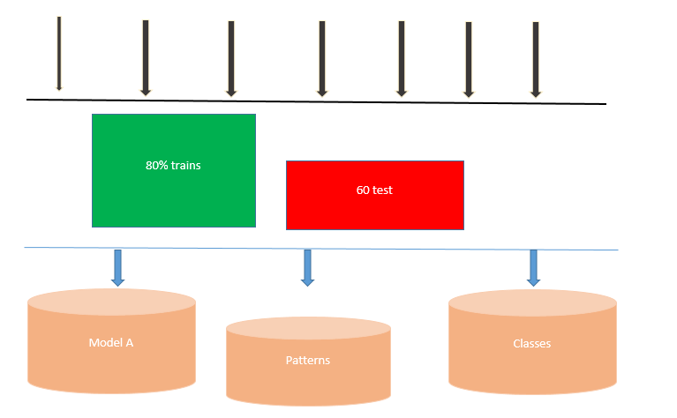

Incoming datasets

Then the resulting model can now be used to build the smart AI agent as a case example below:

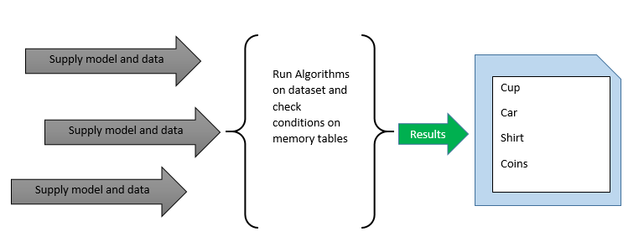

The models and the datasets are supplied to the logical memory of the AI agent and then suing the earlier predefined classifier, a new pattern or cause for action is identified in the memory tabled and assigned to the object in question. Generally, this is how smart systems work. However. This may look complex but in reality and behind the scenes, the AI algorithms have several conditional stamens that help it make the right choice on the item from the memory tables to pick and based on the closest, it decides which one best describes the subject in question:

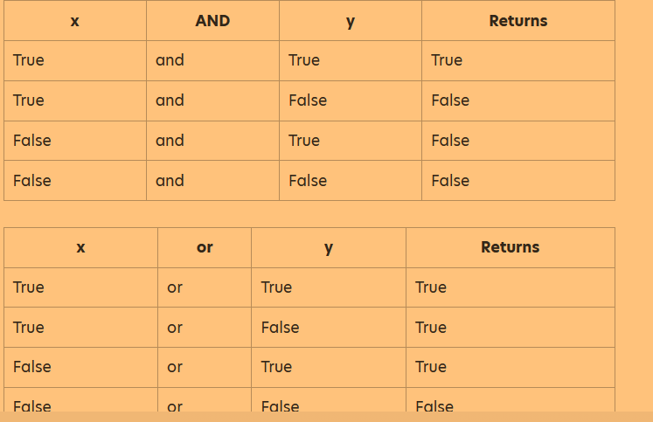

A good case is with an AI agent that checks user geographical location and automatically sets time to the user:

import time;

IF userSays = = currentTime():

THEN:

return:

Lookup_local _time()

print("Speak “It is:" . + [%time%]"

END:

**AI data modelling and experimentation**

Since artificial intelligence relies on machine learning to help build the correct agents, we shall try to build a successful model that can be used with any AI agent or robotics to help classify objects and materials.

**The methodology:**

We shall use the dataset IRIS, availed as an open ’/public dataset and can be accessed via the open link available at: <http://archive.ics.uci.edu/ml/machine-learning-databases/iris/iris.data>, the dataset can also be accessed on R as an inbuilt package. Further, we shall use the Rstudio IDE, together with several packages that come inbuilt with R.

**Aims and objectives**

1. To use machine learning to classify different flowers

During the experiment, we shall try to establish whether a given property fits the classification of the flower as either Iris flower or not. Traditionally, we are all aware that a flower has a sepal and a petal, and in most cases the sepals are green, but this is not true for the Iris flower family, as below:

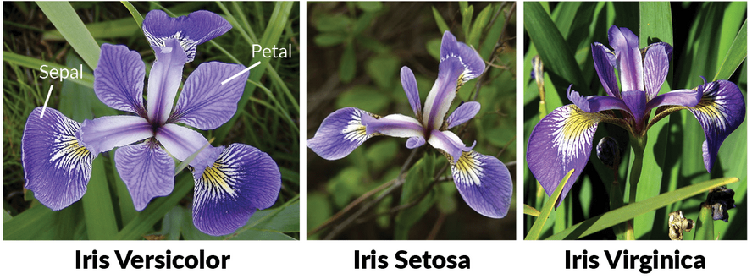

The first process is to run quick visualisations on the dataset by loading it into the Rstudio IDE:

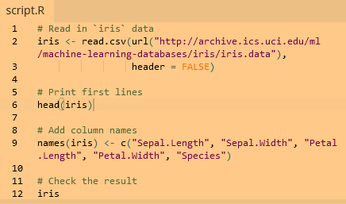

Get a scatter plot distribution of the dataset:

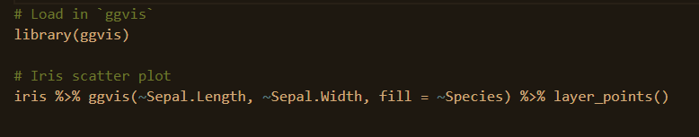

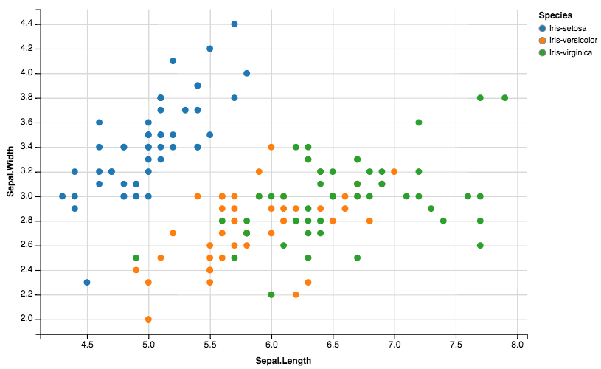

There is a high correlation in the dataset between in the setosa family, unlike the other strains where the relationship is much more spread. Now that we have an understanding of the dataset, let’s apply the machine learning model to it, which in this case we shall employ the KNN model:

The next step is to set our seed population then split our set into train and test while assigning in the relevant expected probabilities during prediction

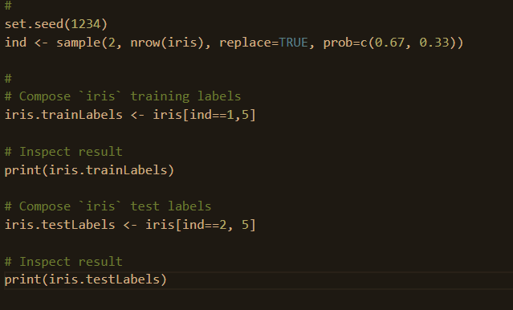

Evaluating the model on Chisq and comparing the prediction models against the test tables reveals that almost all objects in the flower family were correctly classified and so what this means is that our model is correct and may not need any longer adjustments:

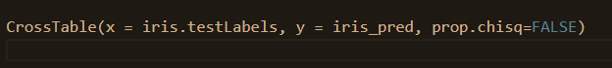

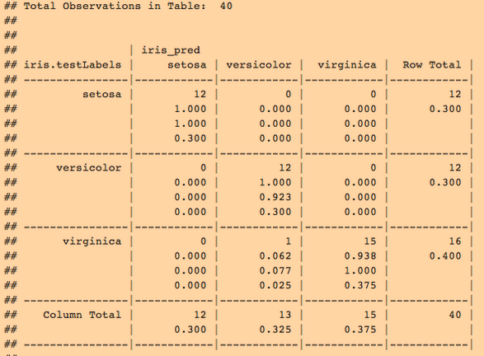

**Summary and conclusions**

Since robotics is coming a key player in the industrialisation and automation of the process, serious studies need to go into how we handle data. The understanding of the data components that include data acquisition, processing and modelling are significant to building efficient artificial intelligent machines. However, this data needs to be well stored, storage mechanisms can either be on structured or unstructured database systems.

Further, the current and future smart agents are going to rely heavily on big data, which is the primary food for smart agents. These agents need to process big data continues to make accurate predictions and causative behaviours that match their real-time environment. There are quite several models that can be applied to smart agents to help make the right decisions, however, in this project, the KNN model was proved to have almost correctly classified all the datasets supplied to it. Finally, smart technology is the future of science and innovation, there is a need to train more data scientists and engineers who will readily pick up such roles in the future.

**REFERENCES**

Cohen, R., 2020. Introduction to Data Management, Life History, and Demography.

Corea, F., 2019. Introduction to Data. In An Introduction to Data (pp. 1-5). Springer, Cham.

Rabasa, A. and Heavin, C., 2020. An Introduction to Data Science and Its Applications. In Data Science and Productivity Analytics (pp. 57-81). Springer, Cham.

Cuocolo, R., Perillo, T., De Rosa, E., Ugga, L. and Petretta, M., 2019. Current applications of big data and machine learning in cardiology. Journal of geriatric cardiology: JGC, 16(8), p.601.

Laughter, E. and Sayed-Mouchaweh, M. eds., 2019. Predictive maintenance in dynamic systems: advanced methods, decision support tools and real-world applications. Springer.

Tran, T.O., 2020. Database Systems.

Ilin, I., Klimin, A. and Shaban, A., 2019. Features of Big Data approach and new opportunities of BI-systems in marketing activities. In E3S Web of Conferences (Vol. 110, p. 02054). EDP Sciences.

Grover, V., Chiang, R.H., Liang, T.P. and Zhang, D., 2018. Creating strategic business value from big data analytics: A research framework. Journal of Management Information Systems, 35(2), pp.388-423.

Zhu, H., 2020. Big data and artificial intelligence modeling for drug discovery. Annual review of pharmacology and toxicology, 60, pp.573-589.

Golding, N., 2019. greta: simple and scalable statistical modelling in R. Journal of Open Source Software, 4(40), p.1601.