**RESEARCH PROJECT**

**STUDENT NAME**

**RESEARCH AREA**

**PROJECT DURATION**

**PROJECT TITLE:**

**BIOTECHNOLOGY AND FOOD SECURITY IN AFRICA: A BIBLIOMETRIC ANALYSIS**

**Keywords**

Biotechnology, Biotech, microbiology, Biopharmaceuticals, cell implantation Bibliometrics

**ABSTRACT**

Biotechnology as a proponent in agricultural systems has been used to advance life changing economies in some of the states of Africa. Whereas studies around this areas emanate from the early periods of the 20th century, research scientists had continually gone ahead to provide in depth analyses, findings and practices to farmers and nations on some of the best solutions to starvation and hunger pandemics across the globe.

Since many of the traditional food retention mechanisms had been overcome with time, modern science is now shifting this attention to the more resistant and adaptive methods in the plant ecosystem. Literature reviews around this area indicate several research procedures were currently underway with massive tests being done on plant and animal organisms. Developing nations in Africa were still faced with rapid food shortages were in need of better scientific research tools and metrics that will help them produce more and healthier food for generations to come.

The challenge with most of the agriculturally productive countries in Africa were the ever changing weather and climatic conditions, mutating pests and diseases and lack of a ready market for their produce or in-place food preservation mechanisms for most of the food products these countries engage in. This paper outlines that in order to prevent itself from falling into the brink of hunger and starvation, postmodern innovations around adaptive smart agricultural systems had to be implemented.

Hence therefore this paper establishes the link required to help African nations achieve maximum food security using the different agricultural products that she produces. The data obtained here were from secondary literature reviews and reports by different scholars and government findings.

**CHAPTER ONE**

**1.1 INTRODUCTION**

Of the 55states in Africa, only close to half had arable land that can produce agriculturally viable products Prăvălie et al (2021). A quarter of these states rely on animal farming whereas close to a third dominate fishing and marine life as their source of the livelihood. According to the Food and Agriculture Organization (FAO), a number of agricultural products by these states were for human consumption and very less is exported or even sent over to industrial factories for food processing and later consumption. Some of the major crops grown in Africa include millet, maize, rice, potatoes and wheat.

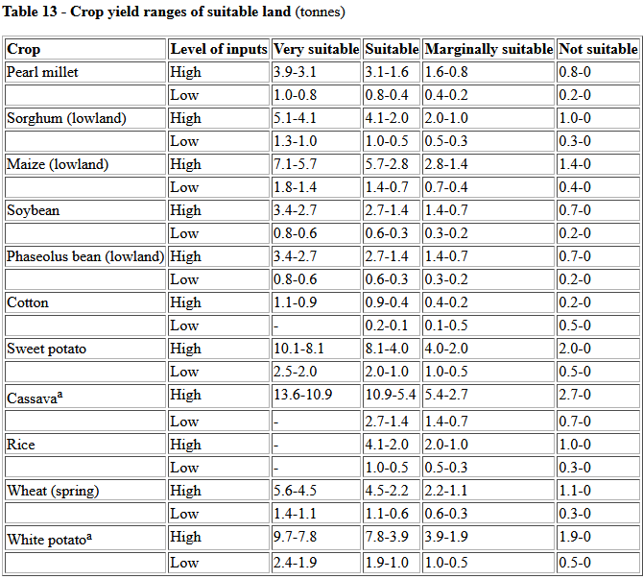

Figure 1 Major food crops in Africa and their suitability (FAO)

However there were African countries that had been predominantly known to produce certain agricultural products, these countries were giants at their own game, they produce more than they can consume and as a result they even export it to their neighbors. For instance, according to Ateka et al (2018) Kenya is produces tea and coffee in large scale, some of the coffee is consumed locally under the mandate of the Kenyan Tea Development Agency (KTDA).

Coffee is widely produced in Ethiopia. West Africa leads in the highest production of rice whereas Nigeria, Egypt and South Africa lead in maize farming. Tanzania, Kenya and South Africa lead in the highest production of animal products like milk, beef and skin. Countries along the coastal line like Morocco, Namibia, South Africa and Egypt lead in the production and farming of fish.

According to the Food and Agriculture Organization (FAO), despite the tones of production of food by these dominant countries, Africa can barely fill her granaries, leave alone store it for the future, actually, it is surprising enough that African states still import food from other countries. The results of which if not handled, dimples these states into hunger and starvation. According to the Planet Thoughts (<https://www.planetthoughts.org/?pg=pt/Whole&qid=1873&src=xref>), African imports still exceed her domestic food production

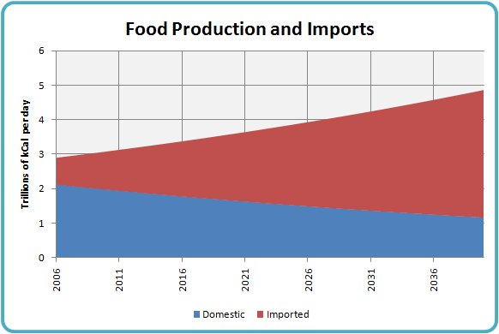

Figure 2 Food production vs. importation in Africa

There were various challenges that had forced these developing states not just to keep enough for their stores. They include ever-changing weather conditions with inadequate rainfall to favor crop production, frequent pasts and diseases that kill many if the animals and then finally inadequate mechanization to maximize on production of food from the crops and animals Masipa (2017). It is in this regard therefore that the need for scientific involvement in the production of food for Africa should be incorporated to help farmers maximize production. This can be achieved through Biotechnology.

**Biotechnology**

According to Rischer et al (2020) Biotechnology is defined as the application of the principles of biological science to the raw materials of biological origin. This may include gene mutation, propagation or total transformation. These changes were usually applied at cell level. Microbiologists, Biologists, Geneticists and Research Scientist work hand in hand doing reassert every day to establish the connections and improvements for the food industry across states.

Biotech has been used over the years to build environmentally stronger food crops and modify the nutritional contents of certain food crops across nations. Most developing nations in Africa were currently not able to exploit the full potential and benefits of technology since they do not had enough tools and research scientists to conduct local studies on how they can improve their current agricultural products so these states rely on the research and studies done by other countries, some of which may not confirm to what these developing countries were actually going through so a lot of financial resources were laid to waste away.

**Food Security**

Can be defined as a condition in which a country can optimally produce, consume and store sufficient agricultural food for its citizens Prosekov et al (2018). These should happen regardless of the current climatic conditions, current population size or inflation rates. Also bearing in mind that the whole process should be bearable and not be a burden to the populace or the governing states.

**1.2 BAKGROUND STUDY**

Naturally cultivated food tends not endure over a given period of time under certain conditions. The reason why this happens is due to a number of issues.

Most of the countries around the Sahel region experience very harsh climatic conditions with very little or no rainfall across the year. So instead of crop farming, such regions had also shifted to animal production which does not seem to do well. This happens since inadequate rainfall around the Sahel region does not favor optimal vegetation growth and water points for pastoralists around these regions. A further look at some of the soil conditions of the regions around Africa indicate that fertility has been overused by over tilling certain lands until such lands lose their fertility levels and nutrients.

On the contrary though, overuse of artificial fertilizers in the cultivation of certain crops like rice and maize had led to such soils being dominated by certain levels of soil nutrient capacities, hindering the establishment and growth of other crops that could had potentially grown on such areas. Encroachment by forest fires across farming lands had also drained away the soil components such as soil turning organisms, superficial fertility and PH level consistence. Small scale farmers who cannot afford to buy or prepare top dressing manure to reclaim such lands end up with no or limited soil productivity at all. In some regions pests and deceases massively lower crop production both at small and large scale, during harvest time, the yield cannot contain a projection of a few years ahead.

On the other hand, animal production across developing states in the continent has had its own share of pain as well. Some of the challenges to animal production had span across pests and diseases, inadequate or poor grazing lands and persistent droughts across farm lands. Currently, barely can the pastoralists and framers I production feed themselves let alone export whatever they had to other countries. Cases had risen where dairy products reduced in yield and the beef products were not sufficient enough for industrial manufacturing and canning. The same has happened to poultry, where the eggs produced by the birds were lightweight and nutrient deficient.

Population in most of the African states had been rising significantly. Currently, Nigeria, Ethiopia, DR Congo, Egypt and South Africa were the leading their population statistics, with Nigeria topping at a population number of 206 million persons. Majority of the population in these Africa countries were the youth between the ages of 18 and 35. Due to the higher rising numbers, developing states in Africa may not had enough food to feed these people and so as a result, hunger sets in. There had also been reported cases of hunger and starvation caused deaths in most of the developing states.

Another factor leading to the current food insecurity in the developing African states is due un-implementation of policies that can foster food security in these states. Well policies might be there, but they were not well structured in a way that can help put up the right production mechanisms to facilitate the production and feeding programs for these regions. Even currents that had got rich arable lands still struggle with these. Most astounding is the fact that in countries that dominate massive production of the agricultural products, corruption malpractices still curtail efficient production and storage of such. Individuals were willing to curtail and hoard the locally produced products at the expense importing these products from other countries at the cost of the government funds, upon which they get their cuts.

In lieu of these, there had been proposals by government agencies across the African states to invest in research and development, nanotechnology and biotechnology as a key tool towards boosting food security in Africa. Most of the staple food consumed among African states include rice, wheat, maize, beef, eggs, chicken and milk. Currently consultations, partnerships and government projects were shifting focus into Biotech science as one of the key proponents to establishing efficient production in the African food market.

This paper shall discuss in detail how African states and countries should use Biotechnology in the Agricultural sector to ensure that the African states feed themselves for now and in the future.

**1.3 PROBLEM STATEMENT**

Africa as we know it, does not currently had enough food to feed her children. Most of the countries were either at the brink of starvation, were starving. The UNDP annual report of 2015 estimates that approximately 10 out of the 54 states in Africa cannot completely feed their citizens and as a result had to rely on donations from other NGOs, the United Nations Development Program UNDP and the United Nations High Commission for Refugees UNHCR.

Majority who were affected were the war torn countries like Somalia, South Sudan, Chad, Northern Nigeria and some parts of Congo. This has led to a number of refugees currently fleeing and leaving their countries to search for fresh food and water and peace in neighboring states, but the bigger elephant in the room remains hunger and starvation, especially from their children and women and the old generations tagging along.

The greater problem being the inability of the African states being unable to produce healthy, sufficient food for her continent, both for the current and future generations. Since its inceptions, African development Bank AFDB program together with its counterpart, the United Nations Science and Cultural Organization has tried to partner with these African states to develop research centers across the development nations in order to train, engage, innovate and research on current problem solutions to the food crisis in their specific countries so as to be able to produce agriculturally and diet viable food for the continent.

The partner organizations had managed to come in to fund some of these projects by either giving loans or grants to the individual states so as to achieve this mandate. Some of the specific research areas along this field include:

Soil fertility study and appraisal. Research has gone into the specific identification of the current and future soils states, how to improve the soil composition, and nutrient content, over a longer period of time so as to support farmers trying to grow a certain crop within their states. Research scientists had spent days and nights trying to come up with solutions on the soil viability for rice farmers in Nigeria and South Africa, maize production in Kenya and Nigeria and banana cultivation in Somali and Uganda.

Biotechnology scientists were also studying plant cell compositions, DNA strands and genome viability. The primary goal here include the potential ability of having to modify plant cell DNA and genome status so as to develop a match stronger species. Examples under this category had been witnessed in Eastern Kenya, where there was development of the ‘katumani’ maize species that was drought resistant and matured within a very short period of time regardless of the harsh weather and climatic conditions of the regions.

Further highlighting, the following research questions that arose from the problem statement discussed above were addressed as follows:

1. What is the current connection between Food security and Biotechnology in Africa?
2. What measure were the African States taking to achieve sustainable food security in Africa for the current and future generations?
3. How can Biotechnology be used to achieve food security in the African States?
4. What were some of the limitations of Biotechnology as a possible solution to food security in Africa?

Where does Biotechnology stand as a science of the future in improving food security in Africa?

As a result of this research, government states, organizations and scientists will be able to provide possible solutions to their current member states on how they can utilize Biotech to achieve food security among themselves.

**1.4 PROJECT AIMS AND OBJECTIVES**

From the above research questions that arose, the following project aims and objectives were formulated:

The project aimed to achieve the following:

1. To establish the connection between food security and biotechnology
2. To establish current processes being undertaken to achieve food security in Africa
3. To establish how biotechnology can be used to achieve sustainable agricultural production
4. To determine the limitations of Biotechnology as a possible solutions to Food security in Africa
5. To determine the future stance of Biotechnology in food production in Africa

**CHAPTER TWO**

**2.1 LITERATURE REVIEW**

According to Tonukar et al (2010), research has already started spanning out among Biopharmaceutical industries, Biochemical engineers and Biologists in bid to unravel the food insecurity status in Africa. Their studies also show that despite the upcoming support and numerous innovations that had been discovered across the continent, there is still very little to show for this work and as a result, the African states were still languishing in hunger and starvation occasioned by poor crop and animal yields.

Further research by Abah et al (2010) indicate that the African population has been increasing very year yet the amount of Arable land is still the same, as a result, many of the Africans states can no longer feed their people, moreover, most of the African states were yet to reap the benefits of the currently ongoing biotechnology studies and innovations being enjoyed by developed nations or in their own developing states. However, as the use in plant biotechnology rises, African states were yet to recognize that there could be harmful effects predisposed by the use of and modification of plant metabolism, genome structure and biochemistry, these could also affect the ecological stance of the plant environment as highlighted by Sawicka et al (2020).

Seid et al (2021), there is need to address climatic changes in line with Biotechnology Engineering and Biotechnology modifications. Biotechnology Engineering will focus on the research scientist coming up with new solutions to green Biotechnology that go against averse climate changes across the African continent. Biotechnological modifications change the current plant DNA codes to adaptive climatic conditions. Adenle et al (2019), food security must be achieved through a technological approach. African states must be in the front line advocating for tech approaches in the fight against hunger and starvation, by making the right policies and implementing these policies will help development of sustainable food in agriculture.

According to Muhzinji and Ntuli (2019), there is need to embrace genetically modified organisms GMO as the missing opportunity in addressing food security in Africa and that the Cartagena Protocol on Biosafety states that GMO had the potential in uplifting small scale farmers across the continent to sustainable agricultural yields.

The above preliminary research that had been done by previous authors had a strong indication that biotechnology is still necessity in the fight towards a sustainable secure food system by highlighting that policies need to be in place, biotech implantations and modifications need to be reviewed and revised to enable growth of much stronger and highly adaptive plant and animal species.

These were concurrent with the aims and objectives that the researcher was pursuing, however as a weakness, their studies did not reveal exactly how specific countries in Africa were using Biotechnology to grow their food needs, how if any there were limitations or oppositions that were associated with biotechnology in crop and animal production, what does biotechnology mean for the African food production i.e. is it something that the continent can sustain, will it still be viable say 20 years from now, and lastly were the African states willing to embrace long term ideas on Biotech? These were some of the questions that researcher sought to illustrate during this study.

**CHAPTER THREE**

**3.1 RESEARCH METHODOLOGY**

The primary research method for this particular study was based on Bibliometric studies. A consistent case by case study of the works previously done by other authors in the field of Biotechnology was keenly identified, reviewed and mapped out, thereafter, statistical and mathematical inferences on the data sets were conducted.

Once the required variables from the datasets were established, certain classification methods were developed to identify models and methods from which a conceptual framework was drawn. Based on these, the tool used for data analyses was the Viosviewer software. From there statistical and mathematical approaches of variable constraints were measured against the primary project objectives and aims to achieve the desired output.

**CHAPTER FOUR**

**4.1 DATA COLLECTION**

To achieve a more focally aligned output of the required data, the researcher chose to apply the Biblio-metric analysis as a due process on the collection, categorization, sampling, analysis and the representation of the results and output of the findings.

**Bibliometric analysis**

What is it? According to the IGI global research website definition located at <https://www.igi-global.com/dictionary/education-literature-development-responsibility/2406>, defines Bibliometric analysis as the attempt by data scientists to quantitatively define the quality of an academic materials, journals, papers and books based on certain measurable statistics such as citation rates. Nonetheless, when doing statistical measurements and quantifications, care must be taken to define what actually quality in this contact is and how much should quality just mean.

This meant that each document was to be carefully analyzed and rated in order to understand the extent to which the quality in question was being referred to. This was so since the quality per document may differ from one document to another and from one research article to the next. Other factors that were a constraint in defining the document quality include:

**The technology at the time of document publishing**: For instance, the underlying technologies surrounding the development and study of bioengineering food materials had continued to change with each and every growing decade, objects that could not be studied because of the limitation of the technological conditions at the time can now be thoroughly looked and observed, their innate features discussed and presented. The growing need for technology has also led to the improvement of the classification and engineering of the organism within the ecological zones, and more research and paperwork is currently still ongoing to discover the same.

Moreover, latest classes of genes and bacteria families were still being identified. So, if Bibliometric analysis was going to be done to existing paper works and publications of documents then technological advancements was one item that was to be looked at in totality since the quality of a given research paper was to be measured in regards to the prevailing technological awareness and advancements at that time.

**Pre-existing policies and bilateralism:** Nations had had bigger roles to play when it comes to setting precedence in the research and adoption of biotechnology. Perhaps previously and prior to the adoption of certain policies within certain states, this could had been a limiting factors to studies that were done at this particular time in history. In example were cases where countries and nations had not opened fully to the adoption and establishments of polices that could trigger the research in the direction of the adoption of biotechnology in the different states. However, with time, countries had continued to adopt clearer cut policies and strategies within its scientists and the world population at large.

With the need to catch up with the world, different countries were now funding projects for scientists to continue doing studies and developments in these fields. Bilateral agreements and partnerships had foreseen researchers delve deeper into more scientific studies geared towards the development of Biotechnology in these states. Bilateral partnerships had equally increased funding of some of the developing nations in Africa and now more power and interests had been added to scholars to do more documenting in this field. So, yes, this factor has been a constraint in defining the quality as a metrics of bibliometric applications since policies and partnerships differ from state to state and the various authors and researches can only document based on their own personal experiences in those established states.

**The publicity rates**: The publicity rates of different authors can also determine the extent to which the bibliometric material is rated. For instance, it’s a well-known fact that experienced researchers and scientist with several years of experience had most likely invested much into the publications of different articles and books. In light of this, such scientists were most likely to be top rated and highly valued than other researchers with less experience since they won’t deliver as much articles and books as their counterparts. In summary it was deduced that the more the number of the publications, the more the citation rates. This was also contrary to the fact that even a researcher could only conduct one high quality paper.

**4.2 DATASET DESCRIPTION:**

Since no actual data was collected for this process, the approach used here was based on the selection and usage of the Viossoftware under the method of Bibliometeric analysis. The method involved the identification of the topic under study which in this case was the study of the biotechnology and its significance in the food security status of the African continent. The next step was to identify the sources and literature materials of sourcing the relevant materials for the chosen topic.

There were various websites with both premium and free features that were supported by the owners that provide the user the capabilities of exporting the data within them. The amount of data to export from these websites were limited to the status of the subscription amount. For instance, free accounts fetch small amounts of data unlike premium accounts that supply large amounts of data and the data may be supplied in batches for the intended purpose. The following websites contained some of the data for these bibliomteric analysis:

**Scopus:** Is located at [www.scopus.com](http://www.scopus.com) , the website provides premium features and download options for mostly premium accounts.

**Dimensions:** Is also another dataset provider whose data is located at app.dimensions.ai. All premium features can also be accessed for free, though the amount of the data provided may be lower than the normal or usual data that was expected.

For this particular project, the researcher chose the dataset available on the Dimensions website and a total of 2500 records exists in the dataset. A quick snip into the dimensions looks like the following:

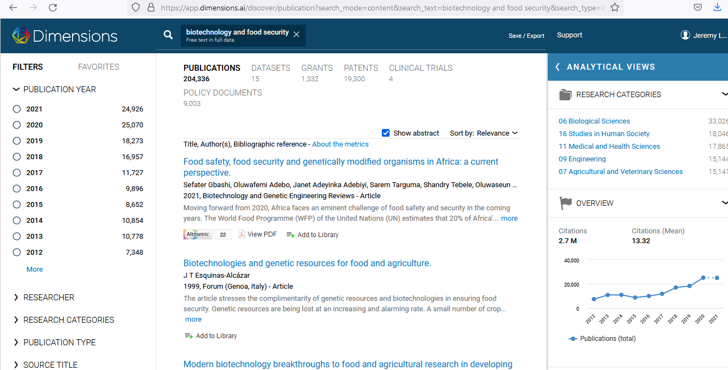

As seen from the image above, the researcher chose a dataset based on the selection of the biotechnology and food security as a topic and the resulting match gave out a total of 2000 plus records of author publications, citations and the connect as we shall see below under the metadata description. The records had also been taken across the years up to the current year of this study which is 2021.Further, for the last ten years, the documents had been cited over two million times with each citation rising gradually over the years.

**4.2.1 Metadata descriptions**

The dataset downloaded from the website is in the map file type and has the following features and attributes of metadata:

*ID:* Each document was associated with each identifier unique to it known as an id,

*Label:* The text indication given to the file type

*Sub-labels:* were noted below the main labels

*Description:* The description feature is used to describe the inner details of the document and the file, include the type of the HTML file format associated with it

*URL:* Is an indication of the website that is currently associated with the particular website, clicking the item on the network map will result in the website associated with the item on the map to open and load in a new browser window

X: the horizontal coordinate of an item

Y: the vertical coordinate of an item

Weight: which is taken as a non-negative value and shows the prominence of an item within the network maps. Also during visualizations, the items with the highest weight show more dense occupation of on the maps

Score: Is a criteria for coloring items within the maps

Color: the colors that a user can define based on the three primary colors in the overlay that include red, green and blue

A quick view into the generated dataset looks like below:

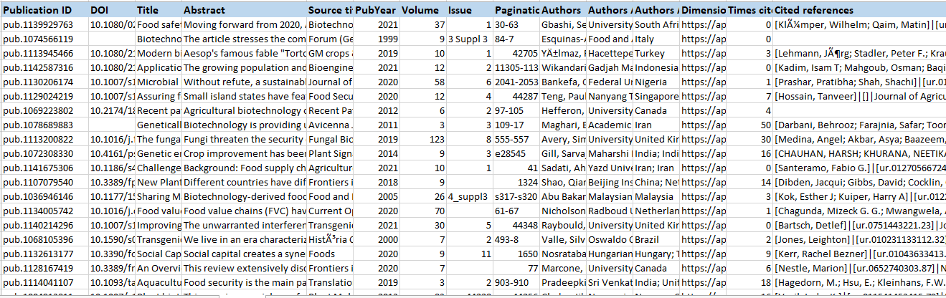

The use of the Viosviewer in Bibliometric analysis comes in handy for data scientists and scholar’s duet to it’s highly significance values in the identification and selection of items that include:

**The removal of any copyright statements:** Most of the items that were presented for analysis had copyright disclaimers appended within the documents, the software provides the ability to select the option of removing the copyright feature from its systems, and the resulting document is one free with the disclaimer.

**Sentence detection:** Using Apache OpenNLP library, algorithms were obtained and used to detect sentence within the document, these sentences were later used to establish maps based on associated networks with other documents

**Part of speech tagging**: Is a rich feature part of the Apache OpenNLP algorithm that assigns nouns, verbs and adjectives to the sentience and uses this to assign the relevant part of the speech to the text in question.

**Noun phrase identification:** Using the relevant algorithms, the noun and phrases were identified within the documents and can easily be used for matching the documents together.

**Noun phrase unification**: By removing alpha numeric values from sentences, converting lower values to upper case values, converting upper case values to lower case, then converting the lower case value to upper, shows the powerful artificial intelligence based values of the software program

**Map network visualizations**: the program provides the ability to create maps and visualize the outputs from the provided inputs and display the results by showing how these documents and journals were connected to each other.

**4.2.2 DATA WRANGLING:**

Initial steps towards the analysis process involves data cleaning. The sample dataset described above and obtained from the websites had not met the required pedigree of tables columns needed and required for the establishment of the format both in maps and network sets analysis. To achieve the required output, all the columns had to be dated and formatted with the following header names:

* Id
* Label
* Description
* X axis
* Y axis
* Cluster
* Weight
* Score

After which second process involved inserting all the necessary data within the columns respectively associated with them. Further to which formatting of the data types to match the required columns variables was also done. For instance, in cases where there were strings as input variables, and the required inputs were integers, were also replaced accordingly. This is to ensure that at the time of interpretation by the VOSviewer software, the calculations and algorithms could easily do its work.

The final process in the data wrangling process involved the removal of spaces and null values from the data entered. This is a good practice in the data analysis process to ensure that the final result set is a combination of all values that only meet the specified criteria as per the aims and the objectives of the research.

**Analysis**

Below is the table snippet summary of the data presented for analysis?

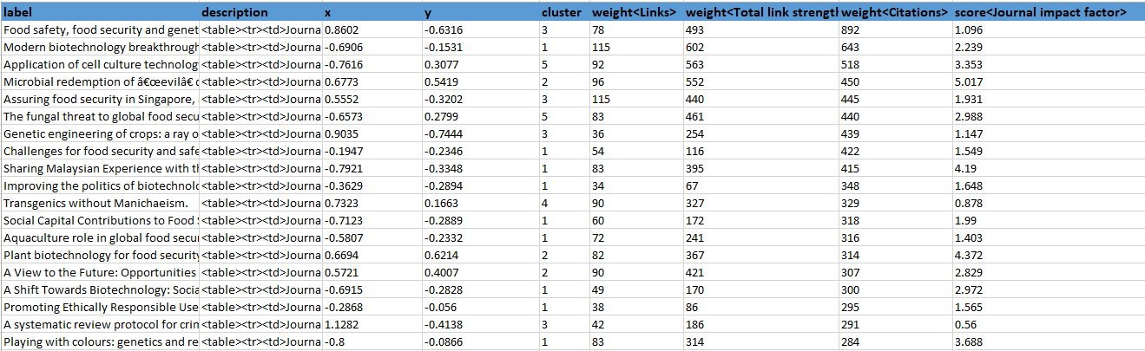

The above datasets consist of 233 records which were split into map files and network files, for loading onto the Viosviewer IDE.

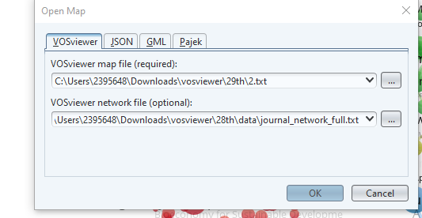

The analysis of the dataset presented for Bibliometric analysis of the VIOSsoftware produced the following outputs:

**Calculating the relationships within related text data:**

In this phase the researcher attempted to establish the connection among text within the dataset supplied. Using a natural language processing algorithm specifically built for this task established that of the 233 rows of data supplied produced relatiohips as shown:

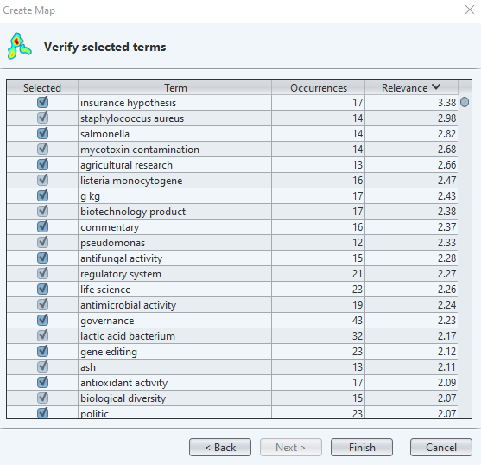

The table above derived from the tool shows the number of text occurrences within the journal citations and their relevant scores according to the subject study.

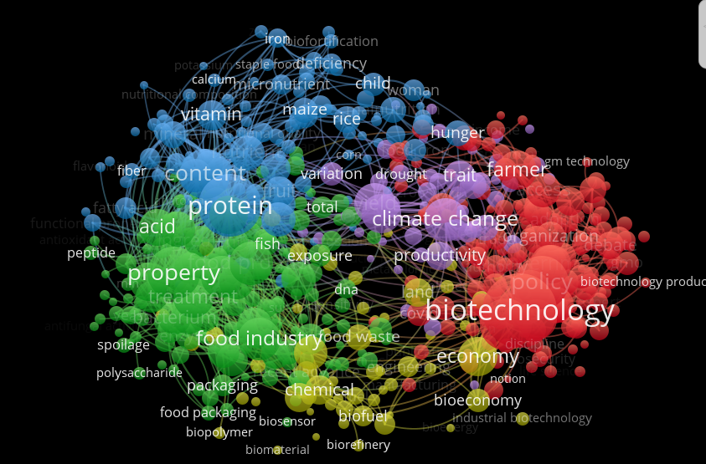

The red zone shown in the analysis shown closer relationships between the texts citations within the data produced within these regions. Further, more analysis revealed that there were more text contains related to the study of Biotechnology as a discipline, followed by food security and then microbial activities within the organisms environment. This kinds of analysis is significant in understanding the topic of study for this particular research as more documentations and articles had been equally done on the same topic which helps the researcher in this case to better achieve the aims and objectives derived from this topic.

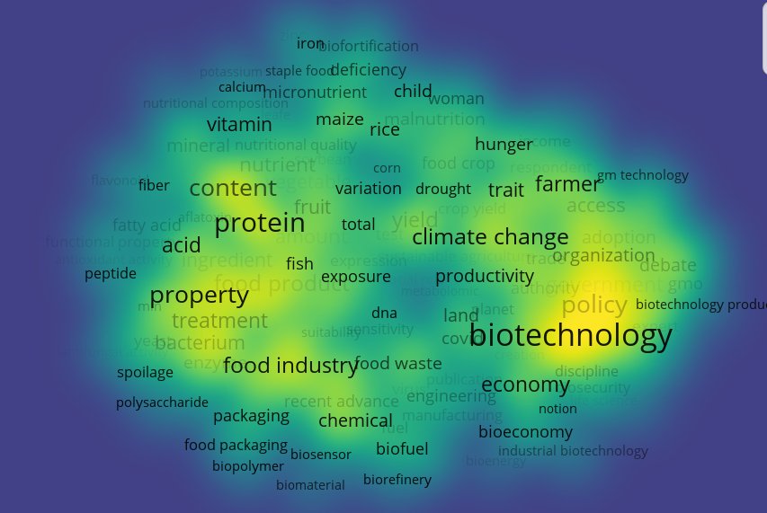

If we look at the density visualization derived from the same dataset, three major topic terms come out; that’s is biotechnology, food and protein content. This is in regards to the relationship of the search items derived from the items and maps.

**4.3.1 ANALYSIS BASED ON AUTHORSHIP, CO-AUTHORSHIPS**

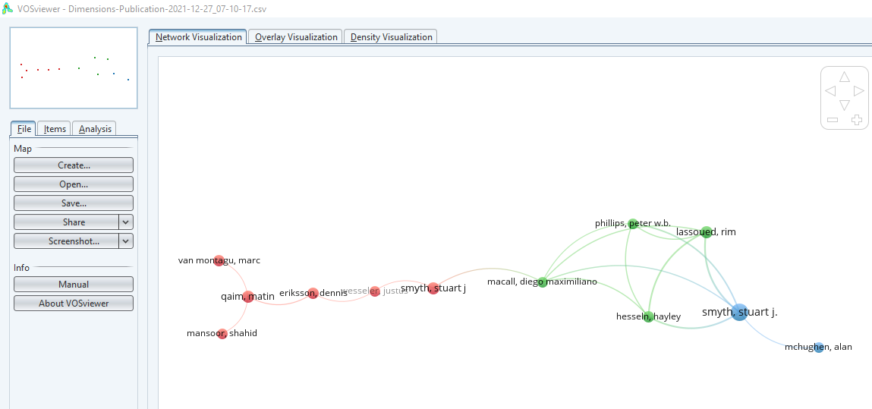

The analysis established further that of 233 records from this set, there existed a cross relationship among the journals and the publications that were availed during analysis. Potentially this could mean that there is similarity in citations and the number of references derived from these authors. Similarly, what this analysis also communicates is that the authors dominate this topic among the 233 records selected for analysis.

In the figure below; the analysis presented a number of journal labels/ topics that were closely related to each other, with each density showing the dominant subject. The topics that were closely related to each other form more dense clusters.

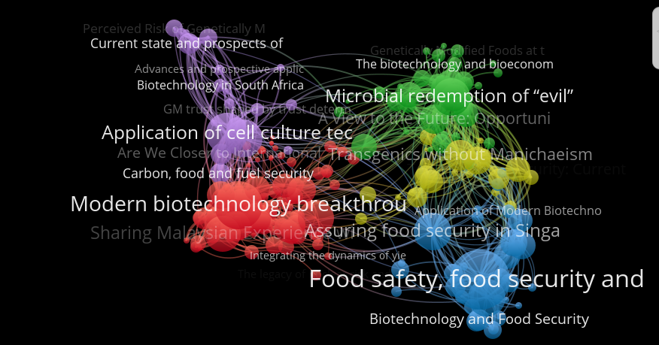

**CHAPTER FIVE**

**5.1 DISCUSSION OF FINDINGS**

The relationship between Food security and Biotechnology is a breakthrough in agricultural sciences. From the Bibliomteric studies and analyses done in this project, it is evident that scientist, scholars and other research teams were delving deep, into how organizations and communities, companies and corporations can harness the full power of Biotechnology, by formatting the cell genome, re-engineering the cell biology of plants and also putting more resources and study into understanding genomics and its implication on the potential increase in yield.

Further, this study has also revealed that the Bibliometrics analyses done on the dataset revealed that most of the food security issues in Africa, were more of quantitative issues rather than qualitative, from the density maps below, this is very evident if we consider the two major heat map topics, that is cell culture and modern biotechnology as some of the conspicuous topics that had been quite delved on by authors and writers from this field.

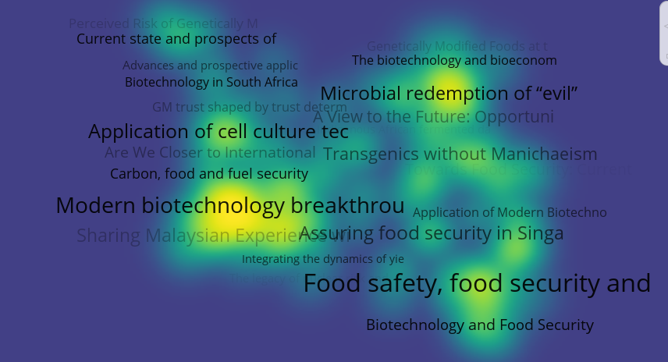

**5.2 RECOMMENDATIONS AND CONCLUSIONS**

Whereas Biotechnology is still rather a new topic, more studies still needs to be done. Most of Africa’s food issues were based on the yield quantities. The research scientists and biochemical engineers should come up with foods that were more weather resistant, enduring and were capable of multiplying in proportions that can fill the continents granaries so that these developing nations should stop relying on imports, but rather also participate in exporting these products.

Another element that has also come out during these study is that nations should continue to invest in their research and development teams, if need be, independent parastatals need to be established to allow these intituotonsto come up with innovative agricultural approaches that were bio-engineered and will help solve the problems surrounding these states.

Finally, there is the other part of biotechnology that was greyed out during these study, and yet forms a very elemental proportion of the concerns raised in these researches. The implication of cell biology and engineering poses a potential health to the human gene. There had been rising concerns of potential carcinogenic infections to the human body based on the plant cell gene re-engineering. Since this is a serious issues, African states should critically access the downside effects of addressing the food security issues within the continent without posing any potential risks to her populace.

**REFERENCES**

Tonukari, N. J., & Omotor, D. G. (2010). Biotechnology and food security in developing countries. *Biotechnology and Molecular Biology Reviews*, *4*(1), 13-23.

Abah, J., Ishaq, M. N., & Wada, A. C. (2010). The role of biotechnology in ensuring food security and sustainable agriculture. *African Journal of Biotechnology*, *9*(52), 8896-8900.

Sawicka, B., Umachandran, K., Skiba, D., & Ziarati, P. (2020). Plant Biotechnology in Food Security. In *Natural Remedies for Pest, Disease and Weed Control* (pp. 163-177). Academic Press.

Seid, A., & Andualem, B. (2021). The Role of Green Biotechnology through Genetic Engineering for Climate Change Mitigation and Adaptation, and for Food Security: Current Challenges and Future Perspectives. *Journal of Advances in Biology & Biotechnology*, 1-11.

Adenle, A. A., Wedig, K., & Azadi, H. (2019). Sustainable agriculture and food security in Africa: The role of innovative technologies and international organizations. *Technology in Society*, *58*, 101143.

Muzhinji, N., & Ntuli, V. (2021). Genetically modified organisms and food security in Southern Africa: conundrum and discourse. *GM Crops & Food*, *12*(1), 25-35.

Prăvălie, R., Patriche, C., Borrelli, P., Panagos, P., Roșca, B., Dumitraşcu, M., ... & Bandoc, G. (2021). Arable lands under the pressure of multiple land degradation processes. A global perspective. *Environmental Research*, *194*, 110697.

<https://www.fao.org/3/w0078e/w0078e05.htm>

Ateka, J. M., Onono, P. A., & Etyang, M. (2018). Productivity and its determinants in smallholder tea production in Kenya: Evidence from Bomet and Nyamira counties of Kenya.

Masipa, T. (2017). The impact of climate change on food security in South Africa: Current realities and challenges ahead. *Jàmbá: Journal of Disaster Risk Studies*, *9*(1), 1-7.

Rischer, H., Szilvay, G. R., & Oksman-Caldentey, K. M. (2020). Cellular agriculture—industrial biotechnology for food and materials. *Current opinion in biotechnology*, *61*, 128-134.

Prosekov, A. Y., & Ivanova, S. A. (2018). Food security: The challenge of the present. *Geoforum*, *91*, 73-77.