Multiple choice decision making

Name of student

Name of professor

University

Course

Date

**Decision problem**

For this particular problem, we are going to consider a case whereby a farmer would like to choose a geographical location for his farm location, the geographical locations are in three main sites that include the highlands, lowlands and the plane lands. The following are some of the characteristic features that the farmer is looking for:

* Rain above 300ml per month
* Soil fertility (Nitrogen content of above 40%)
* Soil ph. of between 5-8
* Salinity value of not more than 0.3

In trying to arrive at his multiple choice decision making problems, the following is the summary of the matrix problems:

|  |  |  |  |  |
| --- | --- | --- | --- | --- |
| Land location | Salinity | PH | Fertility | Rainfall |
| Uplands |  |  |  |  |
| Low lands |  |  |  |  |
| Plain lands |  |  |  |  |

**Question 1:**

The choice benefit of each selection is based on an independent alternative for each location and they are as follows:

The probability tool used for this calculation is found on

<https://www.calculator.net/probability-calculator.html>

For calculating one variable on salinity:

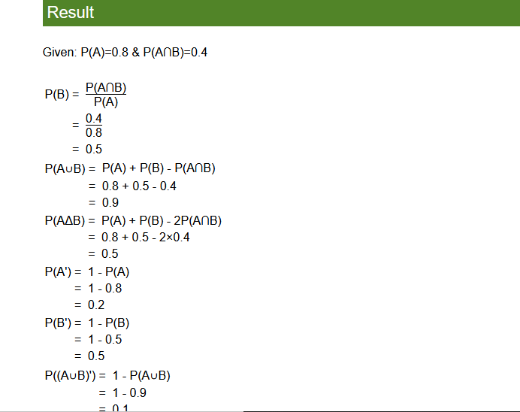

**Generated confidence level;**

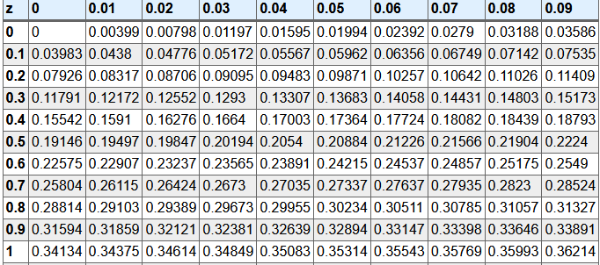

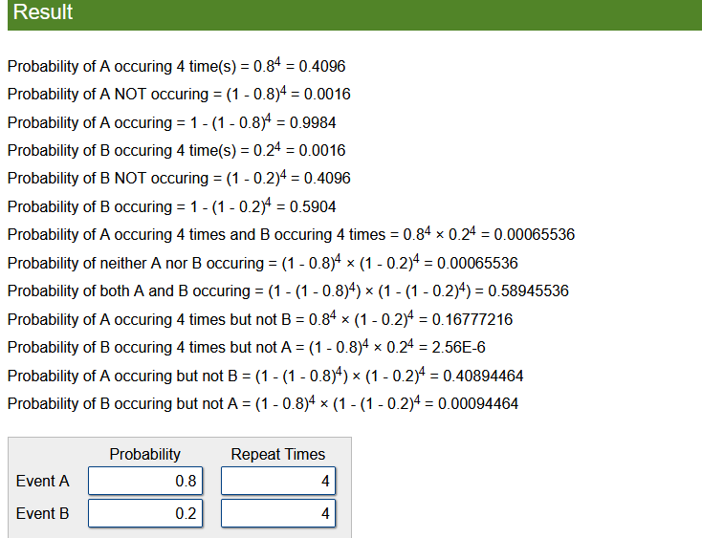

|  |  |  |  |  |
| --- | --- | --- | --- | --- |
| Land location | Salinity | PH | Fertility | Rainfall |
| Uplands | 0.8 | 6.9 | 80% | 90% |
| Low lands | 0.4 | 5.0 | 50% | 60% |
| Plain lands | 5.9 | 3.2 | 10% | 15% |

Suppose the famer would like to grow coffee, his selection is most likely to pay off in the uplands regions, while if he did the same for animal beef rearing, his selection is likely to make sense in the plain lands regions where it will pay off.

**Question 2**

The selections may not be the same for all the 4 variable checks under selection that is salinity, pH, nitrogen content and rainfall.

**Question 3**

Suppose we are to use a weighted scoring model for this:

|  |  |  |  |  |
| --- | --- | --- | --- | --- |
| Land location | Salinity | PH | Fertility | Rainfall |
| Uplands | 8/17 | 7/15 | 8/14 | 9/14 |
| Low lands | 4/17 | 5/15 | 5/14 | 6/14 |
| Plain lands | 5/17 | 3/15 | 1/14 | 2/14 |
| Total score | 12 | 15 | 14 | 17 |

Each and every selection made for these options have their own downsides and upsides, however for maximum output, the famer would then consider the maximum total output resulting from each selection as follows:

|  |  |  |  |  |  |
| --- | --- | --- | --- | --- | --- |
| Land location | Salinity | PH | Fertility | Rainfall | Total |
| Uplands | 0.47 | 0.47 | 0.57 | 0.64 | 2.15 |
| Low lands | 0.24 | 0.33 | 0.36 | 0.43 | 1.36 |
| Plain lands | 0.29 | 0.2 | 0.07 | 0.14 | 0.7 |
| Total score | 12 | 15 | 14 | 17 | 58 |

**AHP Analysis**

Suppose the famer would like to grow coffee, his selection is most likely to pay off in the uplands regions, while if he did the same for animal beef rearing, his selection is likely to make sense in the plain lands regions where it will pay off.

|  |  |  |  |  |  |
| --- | --- | --- | --- | --- | --- |
| Land location | Salinity | PH | Fertility | Rainfall | Total |
| Uplands | 0.47 | 0.47 | 0.57 | 0.64 | 2.15 |
| Low lands | 0.24 | 0.33 | 0.36 | 0.43 | 1.36 |
| Plain lands | 0.29 | 0.2 | 0.07 | 0.14 | 0.7 |
| Total score | 12 | 15 | 14 | 17 | 58 |

From the results, it can be seen that uplands is more preferred since it has got the weighted scoring model based on the input selections made for each variable type.

REFRENCES

<https://www.calculator.net/probability-calculator.html>