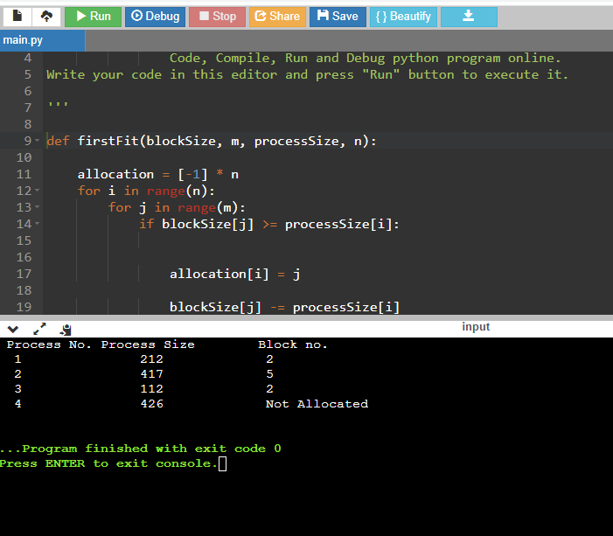

Make sure all code begins from the margin , no spaces to avoid indentation error and use the below link to run code:

https://www.onlinegdb.com/online_python_compiler