Information visualization

Name of student

Name of professor

University

Course

Date

Data visualization has become a significant part of today’s business decision making. In a data driven world, there is need to explore various options that can be drawn from the various datasets that are currently offered in the industry. Python is a great tool to achieve data analysis and visualization. It has powerful (built with several algorithms), that can be used by data engineers to draw meaningful conclusions from their datasets.

In this particular exercise, various options are explored towards establishing the inferences that can be drawn from the Garmin Nuvi series of machines. This company specializes in the production and manufacturing of GPS enabled machines that are used in marine, air and road systems. These objects provide actual and elaborate global positioning satellites positions, map their subjects (the aircraft/car or ship) to which they have been installed to an active database where they are tracked live.

Further, this activity utilizes one of the publicly availed datasets on Wikipedia that has some of the available information on Garmin product series. The car dataset pilot series was chose for analysis and presentation of the final outcome to management was done for decision making. The overview of the dataset looks like below:

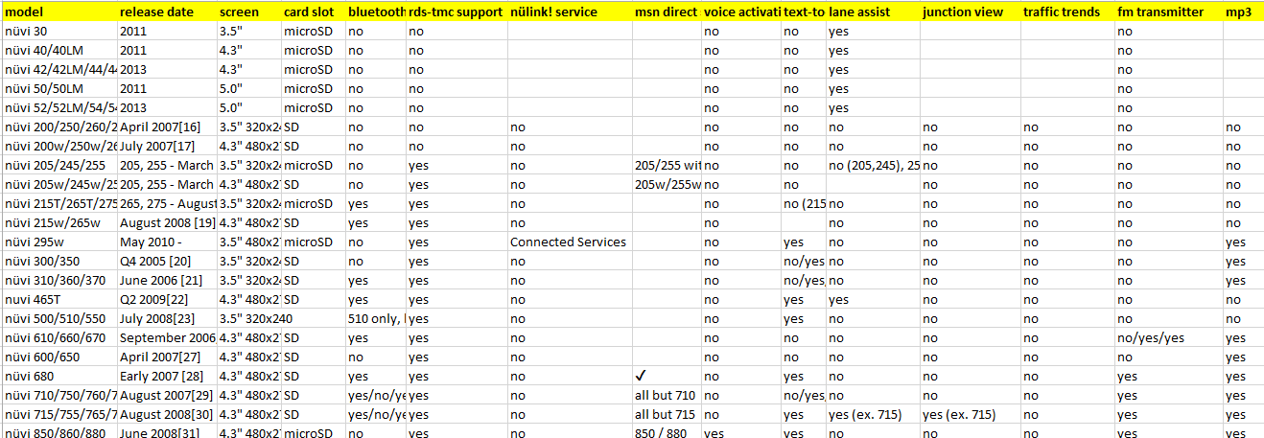

Since the purpose of this assignment is to help the management choose from a wide variety of data visualization tools, the following were identified:

* Microsoft excel
* Python Spyder IDE
* Python Jupyter notebook

Analysis on Python Spyder Studio

#import numpy as np

#import sklearn

#import math

import pandas as pd

dataset = pd.read_csv('nuvi_models.csv')

print(dataset);

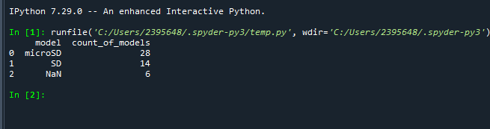

plt.bar(dataset['model'], dataset['count_of_models'])

plt.title("Micro SD distributions")

plt.xlabel('model')

plt.ylabel('count_of_models')

plt.show()

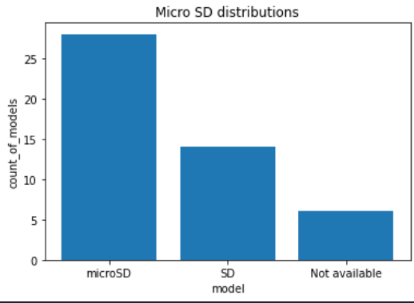

The above snapshot is a summary of the Nuvi models against the memory slot types available. The analysis shows that micro SD is leading as the most preferred memory in the Nuvi technology.

import pandas as pd

import matplotlib.pyplot as plt

dataset = pd.read_csv('nuvi_card_slots.csv')

print(dataset);

x = ['microSD', 'SD','Not_assigned']

no = [2,9,1]

not_sure =[2.1,1,0.1]

yes = [2,4,0]

fig, ax = plt.subplots()

ax.plot(x, no)

ax.plot(x, not_sure)

ax.plot(x, yes)

plt.title("Card Slot vs Fm transmitter distributions")

plt.show()

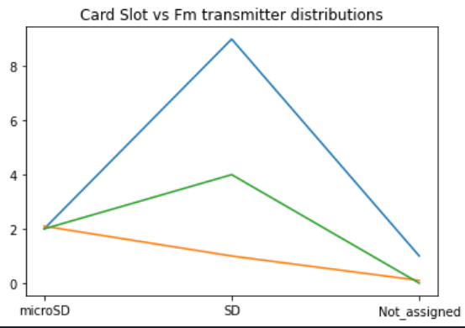

Further, the above snapshot indicates that majority of the Nuvi model card slots do not have an FM transmitter frequency. This knowledge would be very important to management if they were trying to choose from a variety with this criteria.