Name of student

Name of professor

University

Course

Date

1. Interface tour

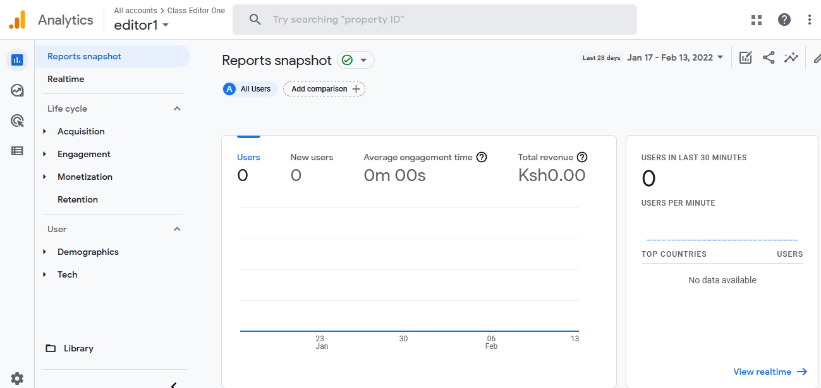

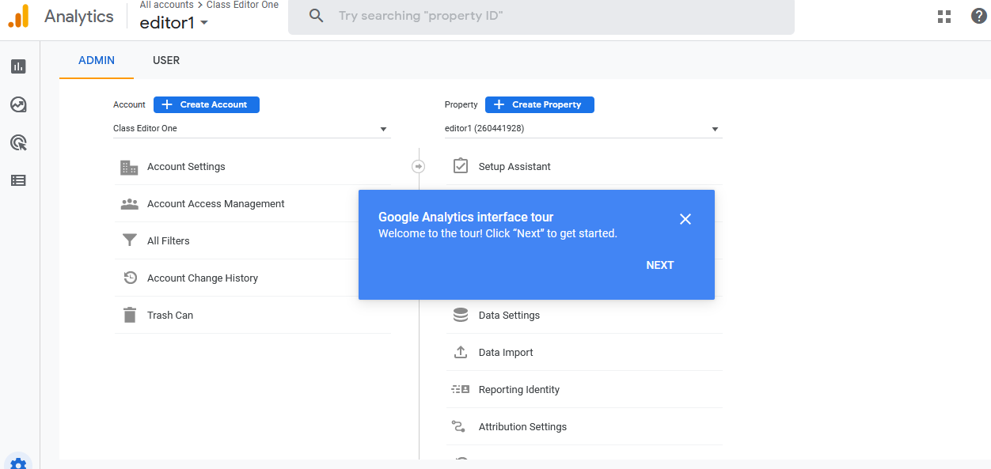

1. **Connecting to your target web site using tracking code**

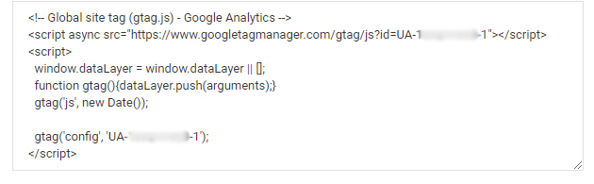

1. **Real-time Monitoring Report**

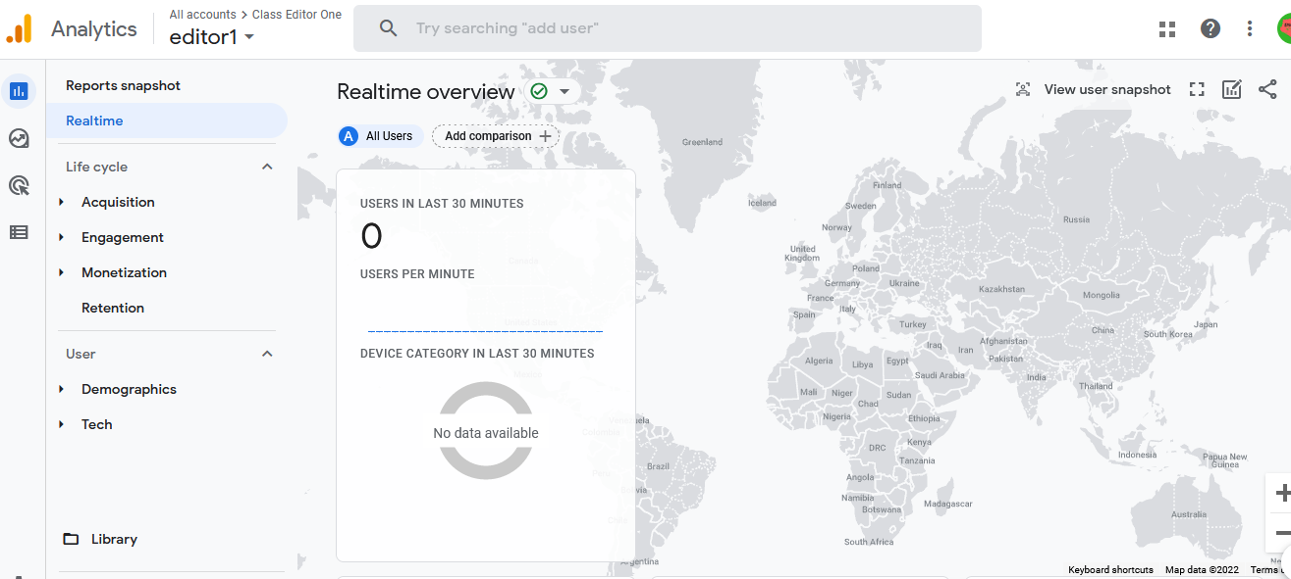

1. **Audience Analysis** **Report**

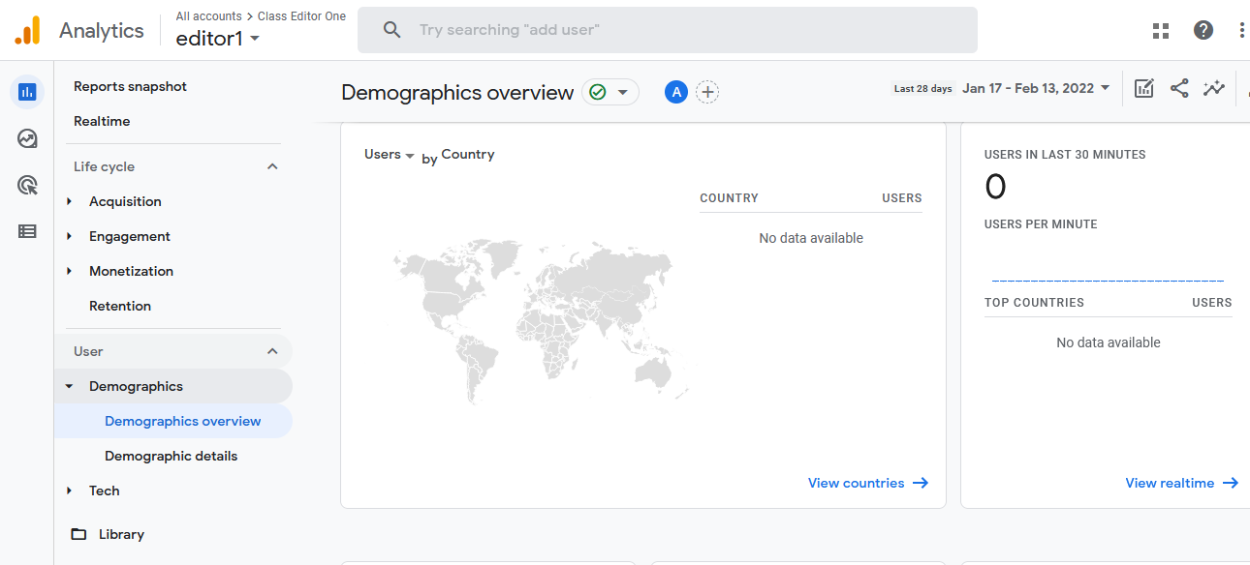

1. **Acquisition Report**

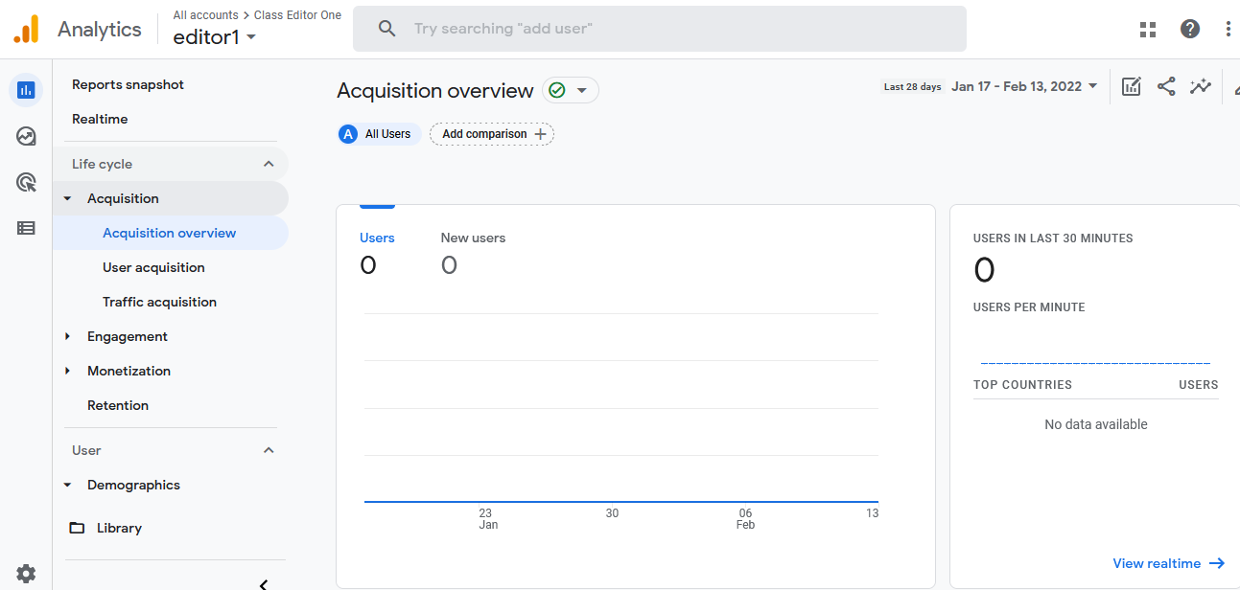

1. **Behavior Report**

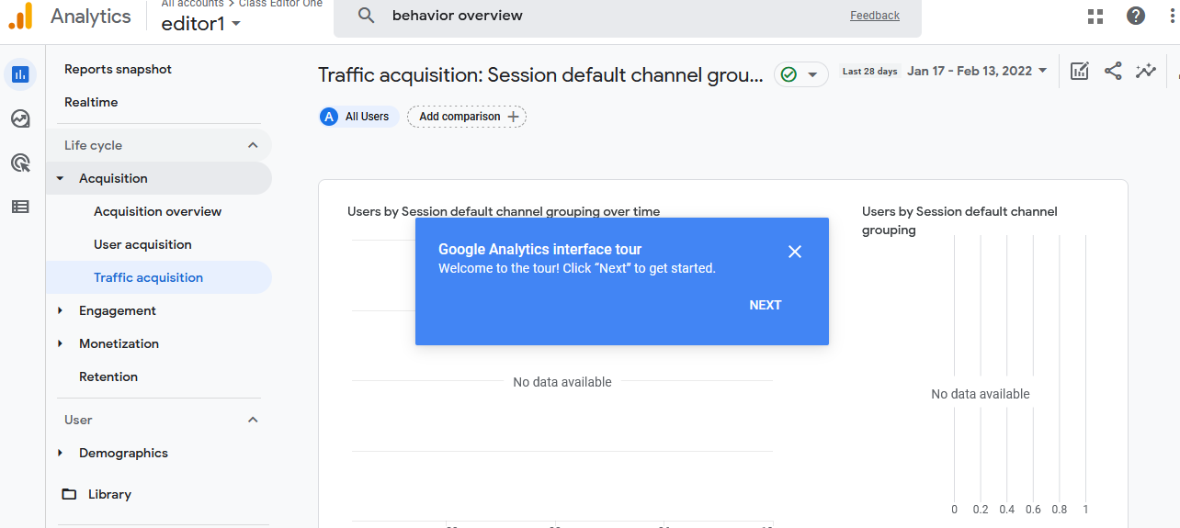

1. **Conversion Report**

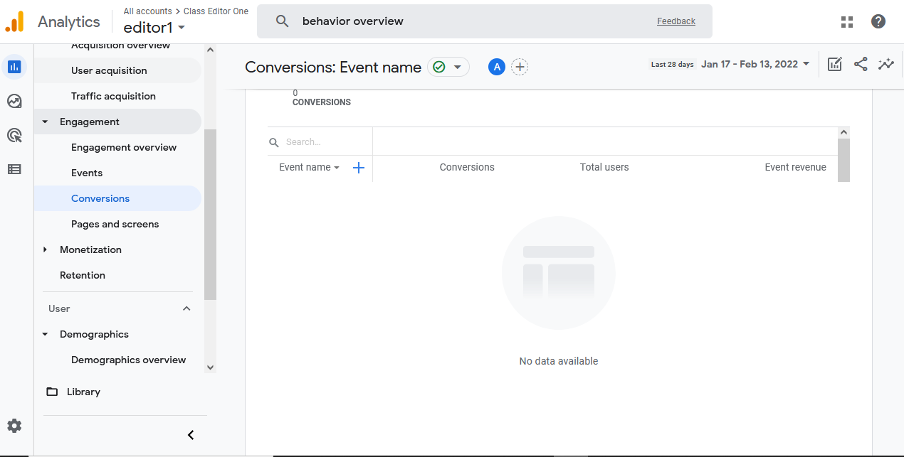

**References**

https://analytics.google.com/analytics/academy/